UNITED STATES
SECURITIES AND EXCHANGE COMMISSION
Washington, D.C. 20549
FORM 10-Q
☒ |  |  | QUARTERLY REPORT PURSUANT TO SECTION 13 OR 15(d) OF THE SECURITIES EXCHANGE ACT OF 1934
For the quarterly period ended June 30, 2026
OR
☐ |  |  | TRANSITION REPORT PURSUANT TO SECTION 13 OR 15(d) OF THE SECURITIES EXCHANGE ACT OF 1934
For the transition period from to
Commission file number: 001-33137

EMERGENT BIOSOLUTIONS INC.
(Exact Name of Registrant as Specified in Its Charter)
Delaware |  |  |  |  |  | 14-1902018
(State or Other Jurisdiction of  Incorporation or Organization) |  |  |  |  |  | (I.R.S. Employer  Identification No.)
300 Professional Drive
Gaithersburg, |  |  | MD |  |  | 20879
(Address and zip code of Principal Executive Offices)
(240) 631-3200
(Registrant's Telephone Number, Including Area Code)
Securities registered pursuant to Section 12(b) of the Act:
Title of each class |  |  |  |  |  | Trading Symbol |  |  |  |  |  | Name of each exchange on which registered
Common Stock, $0.001 par value per share |  |  |  |  |  | EBS |  |  |  |  |  | New York Stock Exchange
Indicate by check mark whether the registrant: (1) has filed all reports required to be filed by Section 13 or 15(d) of the Securities Exchange Act of 1934 during the preceding 12 months (or for such shorter period that the registrant was required to file such reports), and (2) has been subject to such filing requirements for the past 90 days. ☒ Yes ☐ No
Indicate by check mark whether the registrant has submitted electronically every Interactive Data File required to be submitted pursuant to Rule 405 of Regulation S-T (§232.405 of this chapter) during the preceding 12 months (or for such shorter period that the registrant was required to submit such files). ☒ Yes ☐ No
Indicate by check mark whether the registrant is a large accelerated filer, an accelerated filer, a non-accelerated filer, a smaller reporting company, or an emerging growth company. See the definitions of "large accelerated filer," "accelerated filer," "smaller reporting company," and "emerging growth company" in Rule 12b-2 of the Exchange Act.
Large accelerated filer |  |  | ☐ |  |  | Accelerated filer |  |  | ☒
Non-accelerated filer |  |  | ☐ |  |  | Smaller reporting company |  |  | ☐
 |  |  |  |  |  | Emerging growth company |  |  | ☐
If an emerging growth company, indicate by check mark if the registrant has elected not to use the extended transition period for complying with any new or revised financial accounting standards provided pursuant to section 13(a) of the Exchange Act. ☐
Indicate by check mark whether the registrant is a shell company (as defined in Rule 12b-2 of the Exchange Act). Yes ☐ No ☒
As of July 30, 2026, the registrant had 51,273,336 shares of common stock outstanding.

Emergent BioSolutions Inc. and Subsidiaries
Form 10-Q
TABLE OF CONTENTS
 |  |  |  |  |  | Page
Part I. Financial Information
Item 1. |  |  | Financial Statements |  |  | 5
 |  |  | Condensed Consolidated Balance Sheets—June 30, 2026 and December 31, 2025 |  |  | 5
 |  |  | Condensed Consolidated Statements of Operations—Three and Six Months Ended June 30, 2026 and 2025 |  |  | 6
 |  |  | Condensed Consolidated Statements of Comprehensive Income (loss) —Three and Six Months Ended June 30, 2026 and 2025 |  |  | 7
 |  |  | Condensed Consolidated Statements of Cash Flows—Six Months Ended June 30, 2026 and 2025 |  |  | 8
 |  |  | Condensed Consolidated Statements of Changes in Stockholders' Equity—Three and Six Months Ended June 30, 2026 and 2025 |  |  | 9
 |  |  | Notes to Condensed Consolidated Financial Statements |  |  | 10
Item 2. |  |  | Management's Discussion and Analysis of Financial Condition and Results of Operations |  |  | 28
Item 3. |  |  | Quantitative and Qualitative Disclosures About Market Risk |  |  | 46
Item 4. |  |  | Controls and Procedures |  |  | 47
Part II. Other Information
Item 1. |  |  | Legal Proceedings |  |  | 48
Item 1A. |  |  | Risk Factors |  |  | 48
Item 2. |  |  | Unregistered Sales of Equity Securities and Use of Proceeds |  |  | 50
Item 3. |  |  | Defaults Upon Senior Securities |  |  | 50
Item 4. |  |  | Mine Safety Disclosures |  |  | 50
Item 5. |  |  | Other Information |  |  | 51
Item 6. |  |  | Exhibits |  |  | 51
 |  |  | Signatures |  |  | 52

2
EMERGENT BIOSOLUTIONS INC.
PART I. FINANCIAL INFORMATION
CAUTIONARY NOTE REGARDING FORWARD-LOOKING STATEMENTS
This Quarterly Report on Form 10-Q and the documents we incorporate by reference include forward-looking statements within the meaning of the Private Securities Litigation Reform Act of 1995. All statements, other than statements of historical fact, including statements regarding the future performance of Emergent BioSolutions Inc. or any of our businesses, our business strategy, future operations, future financial position, future revenues and earnings, our ability to achieve the objectives of our restructuring initiatives, acquisitions and divestitures, including our future results, projected costs, prospects, plans and objectives of management, are forward-looking statements. We generally identify forward-looking statements by using words like “anticipate,” “believe,” “continue,” “could,” “estimate,” “expect,” “forecast,” “future,” “goal,” “intend,” “may,” “plan,” “position,” “possible,” “potential,” “predict,” “project,” “should,” “target,” “will,” “would,” and similar expressions or variations thereof, or the negative thereof, but these terms are not the exclusive means of identifying such statements. These forward-looking statements are based on our current intentions, beliefs, assumptions and expectations regarding future events based on information that is currently available. You should realize that if underlying assumptions prove inaccurate or unknown risks or uncertainties materialize, actual results could differ materially from our expectations. You are, therefore, cautioned not to place undue reliance on any forward-looking statement contained herein. Any such forward-looking statement speaks only as of the date on which such statement is made and, except as required by law, we do not undertake any obligation to update any forward-looking statement to reflect new information, events or circumstances.
There are a number of important factors that could cause our actual results to differ materially from those indicated by such forward-looking statements, including, among others:
•the availability of U.S. government (“USG”) funding for contracts related to procurement of our medical countermeasures (“MCM”) products, including CYFENDUS® (Anthrax Vaccine Adsorbed (AVA), Adjuvanted), ACAM2000® (Smallpox and Mpox (Vaccinia) Vaccine, Live), CNJ-016® (Vaccinia Immune Globulin Intravenous, Human (VIGIV)), BAT® (Botulism Antitoxin Heptavalent (A,B,C,D,E,F,G)-(Equine)), BioThrax® (Anthrax Vaccine Adsorbed), Ebanga® (ansuvimab-zykl) and/or TEMBEXA® among others, as well as contracts related to development of medical countermeasures;
•our ability to meet our commitments to quality and compliance in all of our manufacturing operations;
•our ability to negotiate additional USG procurement or follow-on contracts for our MCM products that have expired or will be expiring;
•the commercial availability and impact of a generic and branded competition on future sales of NARCAN® (naloxone HCL) Nasal Spray and over-the-counter NARCAN® Nasal Spray and KLOXXADO® Nasal Spray;
•our ability to perform under our contracts with the USG, including the timing of and specifications relating to deliveries;
•the ability of our contractors and suppliers to maintain compliance with current good manufacturing practices and other regulatory obligations;
•our ability to collect reimbursement for raw materials and payment of service fees from our Bioservices customers;
•the results of pending government investigations and their potential impact on our business;
•our ability to satisfy the conditions of our litigation settlement agreements, and the potential impact of such agreements, including the funds to resolve related litigation, on our business;
•our ability to comply with the operating and financial covenants required by (i) the Credit Agreement, dated April 16, 2026 (the “Term Loan Agreement”), by and among the Company, the lenders from time to time party thereto, and OrbiMed Royalty & Credit Opportunities V, LP, as administrative agent, (ii) our revolving credit facility (the “Revolving Credit Facility”) under a credit agreement, dated September 30, 2024 and amended on April 16, 2026, among the Company, certain subsidiary borrowers, the lenders from time to time party thereto and Wells Fargo, National Association, as Agent, and (iii) our 3.875% Senior Unsecured Notes due 2028 (the “Senior Unsecured Notes”);
•our ability to maintain adequate internal control over financial reporting and to prepare accurate financial statements in a timely manner;
•our ability to maintain sufficient cash flow from our operations to pay our substantial debt, both now and in the future;
•our ability to invest in our business operations as a result of our current indebtedness;
•the impact of our share and debt repurchase programs;
•the procurement of our product candidates by USG entities under regulatory authorities that permit government procurement of certain medical products prior to United States (“U.S.”) Food and Drug Administration (“FDA”) marketing authorization, and corresponding procurement by government entities outside the United States;
•the success of our commercialization, marketing and manufacturing capabilities and strategy;
3
EMERGENT BIOSOLUTIONS INC.
•our ability to identify and acquire companies, businesses, products or product candidates that satisfy our selection criteria;
•our ability to attract and retain qualified personnel;
•our ability to adequately secure and protect our intellectual property rights;
•the impact of cybersecurity incidents, including the risks from the unauthorized access, interruption, failure or compromise of our information systems or those of our business partners, collaborators or other third parties; and
•the accuracy of our estimates regarding future revenues, expenses, capital requirements and need for additional financing.
The foregoing sets forth many, but not all, of the factors that could cause actual results to differ from our expectations in any forward-looking statement. When evaluating our forward-looking statements, you should consider this cautionary statement along with the sections entitled “Risk Factors,” “Management’s Discussion and Analysis of Financial Condition and Results of Operations” and “Quantitative and Qualitative Disclosures About Market Risk” in this Quarterly Report on Form 10-Q, as well as the risks identified in our other reports filed with the U.S. Securities and Exchange Commission (the “SEC”). New factors may emerge from time to time, and it is not possible for management to predict all such factors, nor can it assess the impact of any such factor on the business or the extent to which any factor, or combination of factors, may cause results to differ materially from those contained in any forward-looking statement.
NOTE REGARDING COMPANY REFERENCES
References in this report to “Emergent,” the “Company,” “we,” “us,” and “our” refer to Emergent BioSolutions Inc. and its consolidated subsidiaries.
NOTE REGARDING TRADE NAMES
Emergent®, BioThrax®, BaciThrax®, BAT®, ANTHRASIL®, CNJ-016®, ACAM2000®, NARCAN®, CYFENDUS®, TEMBEXA® and any and all Emergent BioSolutions Inc. brands, products, services and feature names, logos and slogans are trademarks or registered trademarks of Emergent BioSolutions Inc. or its subsidiaries in the United States or other countries. All other brands, products, services and feature names or trademarks are the property of their respective owners, including KLOXXADO®, which is a registered trademark of Hikma Pharmaceuticals USA Inc.

4

ITEM 1. FINANCIAL STATEMENTS
Emergent BioSolutions Inc. and Subsidiaries
Condensed Consolidated Balance Sheets
(in millions, except per share amounts)
 |  |  | June 30, 2026 |  |  |  |  |  | December 31, 2025
 |  |  | (unaudited)
ASSETS
Current assets:
Cash and cash equivalents |  |  | $ | 139.7 |  |  |  |  | $ | 205.4
Restricted cash |  |  | 1.2 |  |  |  |  |  | 3.7
Accounts receivable, net |  |  | 190.0 |  |  |  |  |  | 84.2
Inventories, net |  |  | 303.6 |  |  |  |  |  | 343.4
Prepaid expenses and other current assets |  |  | 25.4 |  |  |  |  |  | 25.8
Assets held-for-sale |  |  | 6.1 |  |  |  |  |  | —
Total current assets |  |  | 666.0 |  |  |  |  |  | 662.5
Property, plant and equipment, net |  |  | 178.0 |  |  |  |  |  | 205.4
Intangible assets, net |  |  | 261.8 |  |  |  |  |  | 436.5
Other assets |  |  | 11.0 |  |  |  |  |  | 14.2
Total assets |  |  | $ | 1,116.8 |  |  |  |  | $ | 1,318.6
LIABILITIES AND STOCKHOLDERS' EQUITY
Current liabilities:
Accounts payable |  |  | $ | 50.2 |  |  |  |  | $ | 55.6
Accrued expenses |  |  | 17.1 |  |  |  |  |  | 12.2
Accrued compensation |  |  | 26.2 |  |  |  |  |  | 41.8
Deferred revenue |  |  | 15.0 |  |  |  |  |  | 5.0
Current tax liability |  |  | 4.4 |  |  |  |  |  | 6.8
Other current liabilities |  |  | 9.9 |  |  |  |  |  | 10.8
Total current liabilities |  |  | 122.8 |  |  |  |  |  | 132.2
Debt |  |  | 581.8 |  |  |  |  |  | 572.1
Deferred tax liability |  |  | 35.4 |  |  |  |  |  | 37.8
Other liabilities |  |  | 35.4 |  |  |  |  |  | 53.9
Total liabilities |  |  | 775.4 |  |  |  |  |  | 796.0
Stockholders' equity:
Preferred stock, $0.001 par value per share; 15.0 shares authorized, no shares issued or outstanding |  |  | — |  |  |  |  |  | —
Common stock, $0.001 par value per share; 200.0 shares authorized, 61.9 and 60.9 shares issued; 51.3 and 52.1 shares outstanding, respectively |  |  | 0.1 |  |  |  |  |  | 0.1
Treasury stock, at cost, 10.7 and 8.7 common shares, respectively |  |  | (270.5) |  |  |  |  |  | (252.6)
Additional paid-in capital |  |  | 951.8 |  |  |  |  |  | 942.4
Accumulated other comprehensive loss, net |  |  | (6.8) |  |  |  |  |  | (7.5)
Accumulated deficit |  |  | (333.2) |  |  |  |  |  | (159.8)
Total stockholders’ equity |  |  | 341.4 |  |  |  |  |  | 522.6
Total liabilities and stockholders’ equity |  |  | $ | 1,116.8 |  |  |  |  | $ | 1,318.6
See accompanying notes to condensed consolidated financial statements.
5

Emergent BioSolutions Inc. and Subsidiaries
Condensed Consolidated Statements of Operations
(unaudited, in millions, except per share amounts)
 |  |  | Three Months Ended June 30, |  |  |  |  |  |  |  |  |  |  |  | Six Months Ended June 30,
 |  |  | 2026 |  |  |  |  |  | 2025 |  |  |  |  |  | 2026 |  |  |  |  |  | 2025
Revenues:
Product and services sales, net |  |  | $ | 226.8 |  |  |  |  | $ | 130.3 |  |  |  |  | $ | 376.5 |  |  |  |  | $ | 339.4
Contracts and grants |  |  | 7.5 |  |  |  |  |  | 10.6 |  |  |  |  |  | 13.9 |  |  |  |  |  | 23.7
Total revenues |  |  | 234.3 |  |  |  |  |  | 140.9 |  |  |  |  |  | 390.4 |  |  |  |  |  | 363.1
Operating expenses:
Cost of product and services sales, net (1) |  |  | 97.1 |  |  |  |  |  | 66.9 |  |  |  |  |  | 169.1 |  |  |  |  |  | 155.4
Research and development |  |  | 9.2 |  |  |  |  |  | 12.5 |  |  |  |  |  | 19.7 |  |  |  |  |  | 27.6
Selling, general and administrative |  |  | 44.6 |  |  |  |  |  | 43.7 |  |  |  |  |  | 91.2 |  |  |  |  |  | 96.1
Amortization of intangible assets |  |  | 17.2 |  |  |  |  |  | 16.2 |  |  |  |  |  | 33.7 |  |  |  |  |  | 32.5
Impairment of long-lived assets |  |  | 191.3 |  |  |  |  |  | — |  |  |  |  |  | 191.3 |  |  |  |  |  | —
Total operating expenses |  |  | 359.4 |  |  |  |  |  | 139.3 |  |  |  |  |  | 505.0 |  |  |  |  |  | 311.6
Income (loss) from operations |  |  | (125.1) |  |  |  |  |  | 1.6 |  |  |  |  |  | (114.6) |  |  |  |  |  | 51.5
Other income (expense):
Interest expense |  |  | (10.0) |  |  |  |  |  | (14.7) |  |  |  |  |  | (21.0) |  |  |  |  |  | (29.4)
Loss on assets held-for-sale |  |  | (10.7) |  |  |  |  |  | — |  |  |  |  |  | (10.7) |  |  |  |  |  | (12.2)
Loss on debt extinguishment |  |  | (20.5) |  |  |  |  |  | — |  |  |  |  |  | (20.5) |  |  |  |  |  | —
Other, net |  |  | — |  |  |  |  |  | (3.7) |  |  |  |  |  | 13.9 |  |  |  |  |  | 66.0
Total other income (expense), net |  |  | (41.2) |  |  |  |  |  | (18.4) |  |  |  |  |  | (38.3) |  |  |  |  |  | 24.4
Income (loss) before income taxes |  |  | (166.3) |  |  |  |  |  | (16.8) |  |  |  |  |  | (152.9) |  |  |  |  |  | 75.9
Income tax provision (benefit) |  |  | 13.9 |  |  |  |  |  | (4.8) |  |  |  |  |  | 20.5 |  |  |  |  |  | 19.9
Net income (loss) |  |  | $ | (180.2) |  |  |  |  | $ | (12.0) |  |  |  |  | $ | (173.4) |  |  |  |  | $ | 56.0
Earnings (loss) per common share
Basic |  |  | $ | (3.49) |  |  |  |  | $ | (0.22) |  |  |  |  | $ | (3.35) |  |  |  |  | $ | 1.03
Diluted |  |  | $ | (3.49) |  |  |  |  | $ | (0.22) |  |  |  |  | $ | (3.35) |  |  |  |  | $ | 0.99
Weighted average shares outstanding
Basic |  |  | 51.6 |  |  |  |  |  | 54.2 |  |  |  |  |  | 51.7 |  |  |  |  |  | 54.3
Diluted |  |  | 51.6 |  |  |  |  |  | 54.2 |  |  |  |  |  | 51.7 |  |  |  |  |  | 56.7
(1) Exclusive of intangible asset amortization
See accompanying notes to condensed consolidated financial statements.

6

Emergent BioSolutions Inc. and Subsidiaries
Condensed Consolidated Statements of Comprehensive Income (loss)
(unaudited, in millions)
 |  |  | Three Months Ended June 30, |  |  |  |  |  |  |  |  |  |  |  | Six Months Ended June 30,
 |  |  | 2026 |  |  |  |  |  | 2025 |  |  |  |  |  | 2026 |  |  |  |  |  | 2025
Net income (loss) |  |  | $ | (180.2) |  |  |  |  | $ | (12.0) |  |  |  |  | $ | (173.4) |  |  |  |  | $ | 56.0
Other comprehensive income (loss), net of tax:
Foreign currency translation adjustments, net |  |  | 0.1 |  |  |  |  |  | (2.0) |  |  |  |  |  | 0.7 |  |  |  |  |  | (2.9)
Total other comprehensive income (loss), net of tax |  |  | 0.1 |  |  |  |  |  | (2.0) |  |  |  |  |  | 0.7 |  |  |  |  |  | (2.9)
Comprehensive income (loss), net of tax |  |  | $ | (180.1) |  |  |  |  | $ | (14.0) |  |  |  |  | $ | (172.7) |  |  |  |  | $ | 53.1
See accompanying notes to condensed consolidated financial statements.

7
Emergent BioSolutions Inc. and Subsidiaries
Condensed Consolidated Statements of Cash Flows
(unaudited, in millions)
 |  |  | Six Months Ended June 30,
 |  |  | 2026 |  |  |  |  |  | 2025
Operating Activities
Net income (loss) |  |  | $ | (173.4) |  |  |  |  | $ | 56.0
Adjustments to reconcile net income to net cash provided by operating activities:
Stock-based compensation expense |  |  | 8.8 |  |  |  |  |  | 6.1
Depreciation and amortization |  |  | 47.5 |  |  |  |  |  | 48.9
Amortization of deferred financing costs |  |  | 3.4 |  |  |  |  |  | 4.7
Deferred income taxes |  |  | (2.4) |  |  |  |  |  | 4.7
Noncash loss on assets held-for-sale |  |  | 10.7 |  |  |  |  |  | 12.2
Change in fair value of warrant liability |  |  | (8.9) |  |  |  |  |  | (6.6)
Impairment of long-lived assets |  |  | 191.3 |  |  |  |  |  | —
Loss on disposal of assets |  |  | 2.0 |  |  |  |  |  | 1.3
Other |  |  | 19.8 |  |  |  |  |  | (9.1)
Changes in operating assets and liabilities:
Accounts receivable |  |  | (107.7) |  |  |  |  |  | 45.2
Inventories |  |  | 39.8 |  |  |  |  |  | (26.9)
Prepaid expenses and other assets |  |  | (0.6) |  |  |  |  |  | 29.2
Accounts payable |  |  | (4.4) |  |  |  |  |  | (15.8)
Accrued expenses and other liabilities |  |  | 1.2 |  |  |  |  |  | (28.3)
Long-term incentive plan accrual |  |  | 0.4 |  |  |  |  |  | 1.6
Accrued compensation |  |  | (16.0) |  |  |  |  |  | (26.3)
Income taxes receivable and payable, net |  |  | 4.3 |  |  |  |  |  | (1.6)
Contract liabilities |  |  | 6.5 |  |  |  |  |  | (0.1)
Net cash provided by operating activities |  |  | 22.3 |  |  |  |  |  | 95.2
Investing Activities
Purchases of property, plant and equipment |  |  | (4.5) |  |  |  |  |  | (6.5)
Proceeds from sale of property, plant and equipment |  |  | 0.2 |  |  |  |  |  | 38.2
Milestone payment from prior asset acquisition |  |  | (50.4) |  |  |  |  |  | —
Milestone proceeds from prior asset divestiture |  |  | — |  |  |  |  |  | 50.0
Purchase of convertible note receivable |  |  | — |  |  |  |  |  | (5.0)
Net cash provided by (used in) investing activities |  |  | (54.7) |  |  |  |  |  | 76.7
Financing Activities
Purchases of treasury stock |  |  | (18.0) |  |  |  |  |  | (6.9)
Proceeds from stock-based compensation activity |  |  | 1.4 |  |  |  |  |  | 0.8
Taxes paid for stock-based compensation activity |  |  | (3.2) |  |  |  |  |  | (0.7)
Repayment of prior term loan facility |  |  | (150.0) |  |  |  |  |  | —
Proceeds from the issuance of debt, net of lender fees |  |  | 145.5 |  |  |  |  |  | —
Debt issuance and extinguishment costs |  |  | (11.5) |  |  |  |  |  | —
Net cash used in financing activities: |  |  | (35.8) |  |  |  |  |  | (6.8)
Effect of exchange rate changes on cash, cash equivalents and restricted cash |  |  | — |  |  |  |  |  | 0.3
Net change in cash, cash equivalents and restricted cash |  |  | (68.2) |  |  |  |  |  | 165.4
Cash, cash equivalents and restricted cash, beginning of period |  |  | 209.1 |  |  |  |  |  | 105.6
Cash, cash equivalents and restricted cash, end of period |  |  | $ | 140.9 |  |  |  |  | $ | 271.0
Supplemental cash flow disclosures:
Cash paid for interest |  |  | $ | 16.6 |  |  |  |  | $ | 24.8
Cash paid for income taxes, net of refunds |  |  | $ | 9.6 |  |  |  |  | $ | 16.6
Non-cash investing and financing activities:
Purchases of property, plant and equipment unpaid at period end |  |  | $ | 2.6 |  |  |  |  | $ | 2.2
Loss on extinguishment of debt |  |  | $ | (20.5) |  |  |  |  | $ | —
Excise tax liability accrued for treasury stock purchases |  |  | $ | 0.2 |  |  |  |  | $ | —
Reconciliation of cash and cash equivalents and restricted cash:
Cash and cash equivalents |  |  | $ | 139.7 |  |  |  |  | $ | 267.3
Restricted cash |  |  | 1.2 |  |  |  |  |  | 3.7
Total |  |  | $ | 140.9 |  |  |  |  | $ | 271.0
See accompanying notes to condensed consolidated financial statements.

8

Emergent BioSolutions Inc. and Subsidiaries
Condensed Consolidated Statements of Changes in Stockholders' Equity
(unaudited, in millions)
 |  |  |  |  |  | $0.001 Par Value  Common Stock |  |  |  |  |  |  |  |  |  |  |  | Treasury Stock |  |  |  |  |  |  |  |  |  |  |  | Additional Paid-In Capital |  |  |  |  |  | Accumulated Other Comprehensive Loss |  |  |  |  |  | Accumulated Deficit |  |  |  |  |  | Total Stockholders' Equity
 |  |  |  |  |  | Shares |  |  |  |  |  | Amount |  |  |  |  |  | Shares |  |  |  |  |  | Amount
Balance at December 31, 2025 |  |  |  |  |  | 60.9 |  |  |  |  |  | $ | 0.1 |  |  |  |  | (8.7) |  |  |  |  |  | $ | (252.6) |  |  |  |  | $ | 942.4 |  |  |  |  | $ | (7.5) |  |  |  |  | $ | (159.8) |  |  |  |  | $ | 522.6
Net income |  |  |  |  |  | — |  |  |  |  |  | $ | — |  |  |  |  | — |  |  |  |  |  | $ | — |  |  |  |  | $ | — |  |  |  |  | $ | — |  |  |  |  | $ | 6.8 |  |  |  |  | $ | 6.8
Stock-based compensation activity |  |  |  |  |  | 0.5 |  |  |  |  |  | — |  |  |  |  |  | — |  |  |  |  |  | — |  |  |  |  |  | 2.1 |  |  |  |  |  | — |  |  |  |  |  | — |  |  |  |  |  | 2.1
Repurchases of common stock |  |  |  |  |  | — |  |  |  |  |  | — |  |  |  |  |  | (0.9) |  |  |  |  |  | (9.0) |  |  |  |  |  | — |  |  |  |  |  | — |  |  |  |  |  | — |  |  |  |  |  | (9.0)
Other comprehensive income, net of tax |  |  |  |  |  | — |  |  |  |  |  | — |  |  |  |  |  | — |  |  |  |  |  | — |  |  |  |  |  | — |  |  |  |  |  | 0.6 |  |  |  |  |  | — |  |  |  |  |  | 0.6
Balance at March 31, 2026 |  |  |  |  |  | 61.4 |  |  |  |  |  | $ | 0.1 |  |  |  |  | (9.6) |  |  |  |  |  | $ | (261.6) |  |  |  |  | $ | 944.5 |  |  |  |  | $ | (6.9) |  |  |  |  | $ | (153.0) |  |  |  |  | $ | 523.1
Net loss |  |  |  |  |  | — |  |  |  |  |  | $ | — |  |  |  |  | — |  |  |  |  |  | $ | — |  |  |  |  | $ | — |  |  |  |  | $ | — |  |  |  |  | $ | (180.2) |  |  |  |  | $ | (180.2)
Stock-based compensation activity |  |  |  |  |  | 0.5 |  |  |  |  |  | — |  |  |  |  |  | — |  |  |  |  |  | — |  |  |  |  |  | 7.3 |  |  |  |  |  | — |  |  |  |  |  | — |  |  |  |  |  | 7.3
Repurchases of common stock |  |  |  |  |  | — |  |  |  |  |  | — |  |  |  |  |  | (1.1) |  |  |  |  |  | (8.9) |  |  |  |  |  | — |  |  |  |  |  | — |  |  |  |  |  | — |  |  |  |  |  | (8.9)
Other comprehensive income, net of tax |  |  |  |  |  | — |  |  |  |  |  | — |  |  |  |  |  | — |  |  |  |  |  | — |  |  |  |  |  | — |  |  |  |  |  | 0.1 |  |  |  |  |  | — |  |  |  |  |  | 0.1
Balance at June 30, 2026 |  |  |  |  |  | 61.9 |  |  |  |  |  | $ | 0.1 |  |  |  |  | (10.7) |  |  |  |  |  | $ | (270.5) |  |  |  |  | $ | 951.8 |  |  |  |  | $ | (6.8) |  |  |  |  | $ | (333.2) |  |  |  |  | $ | 341.4
 |  |  |  |  |  | $0.001 Par Value  Common Stock |  |  |  |  |  |  |  |  |  |  |  | Treasury Stock |  |  |  |  |  |  |  |  |  |  |  | Additional Paid-In Capital |  |  |  |  |  | Accumulated Other Comprehensive Loss |  |  |  |  |  | Accumulated Deficit |  |  |  |  |  | Total Stockholders' Equity
 |  |  |  |  |  | Shares |  |  |  |  |  | Amount |  |  |  |  |  | Shares |  |  |  |  |  | Amount
Balance at December 31, 2024 |  |  |  |  |  | 59.9 |  |  |  |  |  | $ | 0.1 |  |  |  |  | (5.6) |  |  |  |  |  | $ | (227.7) |  |  |  |  | $ | 928.0 |  |  |  |  | $ | (5.2) |  |  |  |  | $ | (212.4) |  |  |  |  | $ | 482.8
Net income |  |  |  |  |  | — |  |  |  |  |  | $ | — |  |  |  |  | — |  |  |  |  |  | $ | — |  |  |  |  | $ | — |  |  |  |  | $ | — |  |  |  |  | $ | 68.0 |  |  |  |  | $ | 68.0
Stock-based compensation activity |  |  |  |  |  | 0.2 |  |  |  |  |  | — |  |  |  |  |  | — |  |  |  |  |  | — |  |  |  |  |  | 2.8 |  |  |  |  |  | — |  |  |  |  |  | — |  |  |  |  |  | 2.8
Other comprehensive loss, net of tax |  |  |  |  |  | — |  |  |  |  |  | — |  |  |  |  |  | — |  |  |  |  |  | — |  |  |  |  |  | — |  |  |  |  |  | (0.9) |  |  |  |  |  | — |  |  |  |  |  | (0.9)
Balance at March 31, 2025 |  |  |  |  |  | 60.1 |  |  |  |  |  | $ | 0.1 |  |  |  |  | (5.6) |  |  |  |  |  | $ | (227.7) |  |  |  |  | $ | 930.8 |  |  |  |  | $ | (6.1) |  |  |  |  | $ | (144.4) |  |  |  |  | $ | 552.7
Net loss |  |  |  |  |  | — |  |  |  |  |  | $ | — |  |  |  |  | — |  |  |  |  |  | $ | — |  |  |  |  | $ | — |  |  |  |  | $ | — |  |  |  |  | $ | (12.0) |  |  |  |  | $ | (12.0)
Stock-based compensation activity |  |  |  |  |  | 0.3 |  |  |  |  |  | — |  |  |  |  |  | — |  |  |  |  |  | — |  |  |  |  |  | 4.4 |  |  |  |  |  | — |  |  |  |  |  | — |  |  |  |  |  | 4.4
Repurchases of common stock |  |  |  |  |  | — |  |  |  |  |  | — |  |  |  |  |  | (1.1) |  |  |  |  |  | (6.9) |  |  |  |  |  | — |  |  |  |  |  | — |  |  |  |  |  | — |  |  |  |  |  | (6.9)
Other comprehensive loss, net of tax |  |  |  |  |  | — |  |  |  |  |  | — |  |  |  |  |  | — |  |  |  |  |  | — |  |  |  |  |  | — |  |  |  |  |  | (2.0) |  |  |  |  |  | — |  |  |  |  |  | (2.0)
Balance at June 30, 2025 |  |  |  |  |  | 60.4 |  |  |  |  |  | $ | 0.1 |  |  |  |  | (6.7) |  |  |  |  |  | $ | (234.6) |  |  |  |  | $ | 935.2 |  |  |  |  | $ | (8.1) |  |  |  |  | $ | (156.4) |  |  |  |  | $ | 536.2
See accompanying notes to condensed consolidated financial statements.

9
EMERGENT BIOSOLUTIONS INC. AND SUBSIDIARIES
NOTES TO CONDENSED CONSOLIDATED FINANCIAL STATEMENTS
(unaudited, dollar and share amounts in tables in millions, except per share data)

1. Nature of the business and organization
Organization and business
Emergent BioSolutions Inc. (“Emergent,” the “Company,” “we,” “us,” and “our”) is a global life sciences company focused on providing innovative preparedness and response solutions addressing accidental, deliberate, and naturally occurring Public Health Threats (“PHTs”). The Company's solutions include a product portfolio, a product development portfolio, and a contract development and manufacturing (“CDMO”) services portfolio.
As of June 30, 2026, the Company has a product portfolio of 11 products consisting of vaccines, therapeutics, and drug-device combination products, including KLOXXADO® Nasal Spray for which the Company obtained certain exclusive commercial rights for product sales and marketing in the United States and Canada. The revenue generated by the products comprises a substantial portion of the Company's revenue. The Company structures the business with a focus on markets and customers. As such, the key components of the business structure include the following four product and service categories: Anthrax - Medical Countermeasures (“MCM”) products, Naloxone Commercial products, Smallpox - MCM products and Emergent Bioservices (CDMO) (“Bioservices”).
The Company manages the business with a focus on three operating segments: (1) a Commercial Products segment consisting of NARCAN® Nasal Spray 4 mg and KLOXXADO® Nasal Spray 8 mg, as described below; (2) a MCM Products segment consisting of our Anthrax - MCM, Smallpox - MCM and Other Products, described below and (3) a Services segment consisting of our Bioservices offerings. Commercial Products and MCM Products are our two reportable segments (see Note 16, “Segment information” for more information on our reportable segments).
The Company's products and services include:
Commercial Products Segment:
Naloxone Products
•NARCAN® (naloxone HCl) Nasal Spray 4 mg is an intranasal formulation of naloxone approved as an over-the-counter (“OTC”) medicine by the United States Food and Drug Administration (“FDA”) and Health Canada for the emergency treatment of known or suspected opioid overdose as manifested by respiratory and/or central nervous system depression; and
•KLOXXADO® (naloxone HCl) Nasal Spray 8 mg is a prescription medicine. In January 2025, the Company announced an agreement with Hikma Pharmaceuticals Inc. (“Hikma”) in which the Company obtained exclusive commercial rights for product sales and marketing of Hikma’s KLOXXADO® Nasal Spray in the United States and Canada.
MCM Products Segment:
Anthrax - MCM Products
•ANTHRASIL® (Anthrax Immune Globulin Intravenous (human)), the only polyclonal antibody therapeutic licensed by the FDA and Health Canada for the treatment of inhalational anthrax in combination with appropriate antibacterial drugs;
•BioThrax® (Anthrax Vaccine Adsorbed), the only vaccine licensed by the FDA for the general use prophylaxis and post-exposure prophylaxis of anthrax disease;
•CYFENDUS® (Anthrax vaccine adsorbed (AVA), adjuvanted) which was approved by the FDA in July 2023 for post-exposure prophylaxis of disease following suspected or confirmed exposure to Bacillus anthracis in persons 18 through 65 years of age when administered in conjunction with recommended antibacterial drugs. CYFENDUS® is procured by certain authorized government buyers for their use; and
•Raxibacumab injection, the first fully human monoclonal antibody therapeutic licensed by the FDA for the treatment and prophylaxis of inhalational anthrax.
10

Smallpox - MCM Products
•ACAM2000® (Smallpox and Mpox (Vaccinia) Vaccine, Live), the only single-dose smallpox vaccine licensed by the FDA for active immunization against smallpox and mpox disease for persons determined to be at high risk for smallpox or mpox infection;
•CNJ-016® (Vaccinia Immune Globulin Intravenous (Human) (VIGIV)), the only polyclonal antibody therapeutic licensed by the FDA and Health Canada to address certain complications from smallpox vaccination; and
•TEMBEXA®, an oral antiviral formulated as 100 mg tablets and 10 mg/mL oral suspension dosed once weekly for two weeks which has been approved by the FDA for the treatment of smallpox disease caused by variola virus in adult and pediatric patients, including neonates.
Other Products
•BAT® (Botulism Antitoxin Heptavalent (A,B,C,D,E,F,G)-(Equine)), the only heptavalent antitoxin licensed by the FDA and Health Canada for the treatment of symptomatic botulism; and
•Ebanga® (ansuvimab-zykl), a monoclonal antibody with antiviral activity provided through a single IV infusion for the treatment of Ebola. Under the terms of a collaboration with Ridgeback Biotherapeutics (“Ridgeback”), Emergent will be responsible for the manufacturing, sale, and distribution of Ebanga® in the U.S. and Canada, and Ridgeback will serve as the global access partner for Ebanga®.
Services Segment:
As of the first quarter of 2025, the Company’s Services operating segment no longer met the quantitative thresholds of a reportable segment and did not meet the aggregation criteria set forth in Accounting Standards Codification (“ASC”) 280, Segment Reporting, and as such is categorized within “All other revenues” along with the Company’s Contracts and Grants revenues within Note 16, “Segment information”. See Note 16, “Segment information” for more information about the Company’s reportable segments.

11

2. Summary of significant accounting policies
Basis of presentation and consolidation
The accompanying unaudited condensed consolidated financial statements include the accounts of Emergent and its wholly owned subsidiaries. All significant intercompany accounts and transactions have been eliminated in consolidation. The unaudited condensed consolidated financial statements included herein have been prepared in accordance with U.S. generally accepted accounting principles (“GAAP”) for interim financial information and in accordance with the instructions to Form 10-Q and Article 10 of Regulation S-X issued by the Securities and Exchange Commission (“SEC”). Certain information and footnote disclosures normally included in consolidated financial statements prepared in accordance with GAAP have been condensed or omitted pursuant to such rules and regulations. These condensed consolidated financial statements should be read in conjunction with the audited consolidated financial statements and notes thereto contained in the Company’s Annual Report on Form 10-K for the year ended December 31, 2025, as filed with the SEC on February 26, 2026.
All adjustments contained in the accompanying unaudited condensed consolidated financial statements are of a normal recurring nature and are necessary to present fairly the financial position of the Company as of June 30, 2026. Interim results are not necessarily indicative of results that may be expected for any other interim period or for an entire year.
Significant accounting policies
There have been no significant changes to the Company's summary of significant accounting policies contained in the Company's Annual Report on Form 10-K for the year ended December 31, 2025, as filed with the SEC.
New accounting standards
From time to time, new accounting pronouncements are issued by the Financial Accounting Standards Board that the Company adopts as of the pronouncement’s specified effective date.
Accounting Standards Not Yet Adopted
In November 2024, the FASB issued ASU 2024-03, Income Statement - Reporting Comprehensive Income - Expense Disaggregation Disclosures (Subtopic 220-40) Disaggregation of Income Statement Expenses, which requires a public business entity to disclose additional information about specific expense categories in the notes to financial statements on an annual and interim basis. The amendments are effective for annual periods beginning after December 15, 2026, and interim periods beginning after December 15, 2027, with early adoption permitted. A public entity should apply the amendments either prospectively to financial statements issued for reporting periods after the effective date of this ASU or retrospectively to any or all prior periods presented in the financial statements. The Company is in the process of evaluating the impact of this new guidance on its consolidated financial statements.
In December 2025, the FASB issued ASU 2025-10, Government Assistance (Topic 832): Accounting for Government Grants Received by Business Entities. This guidance establishes authoritative requirements for recognition, measurement, presentation, and disclosure of government grants received by business entities. The ASU aligns U.S. GAAP with certain aspects of IAS 20 and requires entities to disclose the nature and terms of government grants, significant conditions, accounting policies applied, amounts recognized in the financial statements, and any repayment obligations. ASU 2025-10 is effective for public business entities for annual periods beginning after December 15, 2028, including interim periods within those fiscal years, with early adoption permitted. The Company is currently evaluating the impact of this guidance on its consolidated financial statements and related disclosures. Adoption is expected to require enhanced disclosures regarding government grants received and may affect the timing of income recognition for certain arrangements. The Company does not expect the adoption of ASU 2025-10 to have a material impact on its financial position or results of operations.

12

3. Assets held-for-sale
During June 2026, the Company entered into a definitive agreement to sell its office property located in Gaithersburg, Maryland for a purchase price of approximately $6.4 million and classified the related assets as held-for-sale. In the accompanying Condensed Consolidated Balance Sheet as of June 30, 2026, the assets that are expected to be conveyed are classified as held-for-sale and are measured at the lower of (i) the carrying value of the disposal group and (ii) the fair value of the disposal group, less estimated costs to sell. The fair value of the disposal group represents a nonrecurring fair value measurement and was determined using the contractual sales price specified in the executed purchase and sale agreement, which are Level 2 inputs because the valuation was based principally on an observable transaction price from a market participant transaction.
Effective with the designation of the assets as held-for-sale, the Company suspended recording depreciation of property, plant and equipment. Any loss resulting from the measurement is recognized in the period the held-for-sale criteria are met. Conversely, gains are not recognized until the date of sale. The Company recognized a $10.7 million loss related to assets held-for-sale during the three and six months ended June 30, 2026, which was presented within “Loss on assets held-for-sale” in the non-operating section of the Condensed Consolidated Statements of Operations.
Assets classified as held-for-sale on the Condensed Consolidated Balance Sheet as of June 30, 2026 consist of the following:
 |  |  |  |  |  | June 30, 2026
Assets held-for-sale:
Property, plant and equipment, net |  |  |  |  |  | $ | 16.8
Valuation allowance |  |  |  |  |  | (10.7)
Total assets held-for-sale |  |  |  |  |  | $ | 6.1

4. Divestitures
During 2023, 2024 and 2025, the Company completed several divestiture transactions. The significant financial statement impacts relating to these transactions were recognized in prior periods. The disclosures below summarize amounts recognized in prior-year comparative periods and included in the accompanying Condensed Consolidated Statements of Operations as well as ongoing arrangements and contingent consideration related to these divestitures.
Transition Services Agreements (“TSAs”) Revenue
In connection with certain divestitures, the Company entered into TSAs to support the orderly transfer of operations to the respective buyers. Income from performing services under these TSAs is recorded within “Product and services sales, net” or “other, net” on the Condensed Consolidated Statements of Operations based on the nature of the underlying agreements. TSA revenue from the SERB TSA (RSDL® divestiture) and Bora TSA (Baltimore-Camden facility divestiture, TSA no longer active in 2026) recognized during the three and six months ended June 30, 2026 was $0.8 million and $1.2 million, respectively. TSA revenue recognized during the three and six months ended June 30, 2025 was $0.7 million and $2.0 million, respectively.
Milestones and Contingent Consideration
Travel Health Business (Bavarian Nordic)
In May 2023, the Company completed the sale of its travel health business to Bavarian Nordic. The Company was entitled to receive milestone payments totaling up to $80.0 million upon the achievement of specified regulatory milestones, all of which were received by the Company during 2024 and 2025.
Milestone income of $50.0 million was recognized during the six months ended June 30, 2025, which the Company recorded within “Other, net” in the Condensed Consolidated Statement of Operations. No milestone income was recognized during the three and six months ended June 30, 2026. The Company may receive up to $30.0 million of earn-out payments from Bavarian Nordic based on aggregate net sales of Vaxchora® and Vivotif® in calendar year 2026.
RSDL® Component Sourcing Milestone
In connection with the July 2024 sale of RSDL®, the Company may receive a $5.0 million milestone payment contingent upon the achievement of a component sourcing milestone. No amounts related to this milestone were recognized during the three and six months ended June 30, 2026 and 2025.
13

Sale of Baltimore-Bayview Facility
The Company completed the sale of its Baltimore-Bayview facility in March 2025. As a result of the divestiture, the Company recognized a pre-tax gain of $7.9 million, net of transaction costs of $1.2 million, during the six months ended June 30, 2025, recorded within “Other, net” on the Condensed Consolidated Statements of Operations.

5. Inventories, net
Inventories, net consisted of the following:
 |  |  | June 30, 2026 |  |  |  |  |  | December 31, 2025
Raw materials and supplies |  |  | $ | 117.7 |  |  |  |  | $ | 120.6
Work-in-process |  |  | 59.5 |  |  |  |  |  | 109.0
Finished goods |  |  | 126.4 |  |  |  |  |  | 113.8
Total inventories, net |  |  | $ | 303.6 |  |  |  |  | $ | 343.4
Inventories, net is stated at the lower of cost or net realizable value.

6. Property, plant and equipment, net
Property, plant and equipment, net consisted of the following:
 |  |  | June 30, 2026 |  |  |  |  |  | December 31, 2025
Land and improvements |  |  | $ | 16.5 |  |  |  |  | $ | 20.7
Buildings, building improvements and leasehold improvements |  |  | 140.3 |  |  |  |  |  | 160.5
Furniture and equipment |  |  | 249.6 |  |  |  |  |  | 259.8
Software |  |  | 62.0 |  |  |  |  |  | 61.9
Construction-in-progress |  |  | 6.7 |  |  |  |  |  | 6.6
Property, plant and equipment, gross |  |  | $ | 475.1 |  |  |  |  | $ | 509.5
Less: Accumulated depreciation and amortization |  |  | (297.1) |  |  |  |  |  | (304.1)
Total property, plant and equipment, net |  |  | $ | 178.0 |  |  |  |  | $ | 205.4
Property, plant and equipment, net is stated at cost, less accumulated depreciation and amortization. As of June 30, 2026 and December 31, 2025, construction-in-progress primarily included costs incurred to advance the Company’s MCM Products capabilities.
During the six months ended June 30, 2025, the Company recognized a non-cash impairment charge of $12.2 million related to certain Bioservices long-lived assets recorded during 2025. The impairment was recorded upon the determination that the assets met the criteria to be classified as held-for-sale and was reflected as “Loss on assets held-for-sale” in the Condensed Consolidated Statement of Operations. During the fourth quarter of 2025 management determined that the previously contemplated sale of the assets was no longer probable, and accordingly, the assets were reclassified back to held and used.

14

7. Intangible assets, net
The Company’s finite-lived intangible assets consist of products acquired via business combinations or asset acquisitions. During the three months ended March 31, the Company incurred a $50.4 million liability payable to Ridgeback, from which the Company acquired its Ebanga® compound, which was subsequently paid in June 2026. This amount increased the basis of the Company's corresponding intangible assets and was recognized during the three months ended March 31, 2026 following resolution of a prior measurement uncertainty related to the obligation.
The following table summarizes the Company’s finite-lived intangible assets:
 |  |  | Weighted Average Useful Life in Years |  |  |  |  |  | June 30, 2026 |  |  |  |  |  |  |  |  |  |  |  |  |  |  |  |  |  | December 31, 2025
 |  |  |  |  |  |  |  |  | Gross Carrying Amount |  |  |  |  |  | Accumulated Amortization |  |  |  |  |  | Net Carrying Amount |  |  |  |  |  | Gross Carrying Amount |  |  |  |  |  | Accumulated Amortization |  |  |  |  |  | Net Carrying Amount
Products |  |  | 12.4 |  |  |  |  |  | $ | 714.4 |  |  |  |  | $ | 452.6 |  |  |  |  | $ | 261.8 |  |  |  |  | $ | 855.4 |  |  |  |  | $ | 418.9 |  |  |  |  | $ | 436.5
Total intangible assets |  |  |  |  |  |  |  |  | $ | 714.4 |  |  |  |  | $ | 452.6 |  |  |  |  | $ | 261.8 |  |  |  |  | $ | 855.4 |  |  |  |  | $ | 418.9 |  |  |  |  | $ | 436.5
Amortization expense associated with the Company’s finite-lived intangible assets was recorded as follows:
 |  |  | Three Months Ended June 30, |  |  |  |  |  |  |  |  |  |  |  | Six Months Ended June 30,
 |  |  | 2026 |  |  |  |  |  | 2025 |  |  |  |  |  | 2026 |  |  |  |  |  | 2025
Amortization of intangible assets |  |  | $ | 17.2 |  |  |  |  | $ | 16.2 |  |  |  |  | $ | 33.7 |  |  |  |  | $ | 32.5
2026 Impairment of long-lived assets
During the preparation and review of the financial statements for the quarter ended June 30, 2026, the Company determined that changes in current and projected operating results, notably related to pricing and sales volumes for NARCAN®, constituted a triggering event for the NARCAN® asset group within the Commercial reporting unit. As a result, the Company performed a recoverability test under ASC 360 and concluded that the carrying value of the asset group was not recoverable, as estimated undiscounted future cash flows were less than its carrying value.
The Company estimated the fair value of the asset group using an income approach utilizing discounted projected future cash flows (level 3 fair value measurement). Significant assumptions in estimating the fair value included management’s estimates of future revenues, gross margins, operating expenses and a discount rate reflective of risks associated with the asset group. The Company recognized a non-cash impairment charge of $191.3 million during the three and six months ended June 30, 2026, which was attributed entirely to the NARCAN® finite-lived intangible asset. The impairment charge is included within “Impairment of long-lived assets” on the Condensed Consolidated Statements of Operations. Following impairment, the NARCAN® intangible asset had a carrying amount of $81.9 million as of June 30, 2026.

8. Fair value measurements
The table below presents information about the Company’s assets and liabilities that are regularly measured and carried at fair value and indicates the level within the fair value hierarchy of the valuation techniques the Company utilized to determine fair value:
 |  |  | June 30, 2026 |  |  |  |  |  |  |  |  |  |  |  |  |  |  | December 31, 2025
 |  |  | Total |  |  | Level 1 |  |  | Level 2 |  |  | Level 3 |  |  |  |  |  | Total |  |  | Level 1 |  |  | Level 2 |  |  | Level 3
Assets:
Money market accounts |  |  | $ | 50.1 |  | $ | 50.1 |  | $ | — |  | $ | — |  |  |  |  | $ | 162.0 |  | $ | 162.0 |  | $ | — |  | $ | —
Total |  |  | $ | 50.1 |  | $ | 50.1 |  | $ | — |  | $ | — |  |  |  |  | $ | 162.0 |  | $ | 162.0 |  | $ | — |  | $ | —
Liabilities:
Warrant liability |  |  | $ | 12.8 |  | $ | — |  | $ | — |  | $ | 12.8 |  |  |  |  | $ | 21.7 |  | $ | — |  | $ | — |  | $ | 21.7
Total |  |  | $ | 12.8 |  | $ | — |  | $ | — |  | $ | 12.8 |  |  |  |  | $ | 21.7 |  | $ | — |  | $ | — |  | $ | 21.7
15

2024 Warrant liability
In connection with the Company’s Credit Agreement, dated August 30, 2024, with OHA Agency LLC, as administrative agent, and the lenders from time to time party thereto (the “Prior Term Loan Agreement”), the Company issued to the lenders warrants to purchase 1.0 million shares of the Company’s common stock at an exercise price of $9.8802 per share (the “Series I Warrants”) and warrants to purchase 1.5 million shares at an exercise price of $15.7185 per share (the “Series II Warrants” and, together with the Series I Warrants, the “Warrants”). The Warrants are currently exercisable and will expire on August 30, 2029. Because the Warrants could be cash settled based on events that are outside the control of the Company, it precludes the Warrants from applying the equity contract scope exception, and so the Warrants are classified as a liability. As a result, the fair value of the Warrants will be remeasured each period with the gain or loss on the warrant liability included in “Other, net” on the Condensed Consolidated Statements of Operations. As of June 30, 2026 and December 31, 2025, the fair value of the warrant liability was $12.8 million and $21.7 million, respectively, and was included within “Other Liabilities” on the Condensed Consolidated Balance Sheets, as determined using the Black-Scholes method.
The Company uses the Black-Scholes option pricing model to calculate the fair value of the Warrants at each reporting period. Assumptions used in the Black-Scholes option pricing model take into account the agreement terms as well as the quoted price of the Company’s common stock in an active market. The volatility is based on the average historical volatility of the common stock. The expected life is based on the remaining contractual term of the Warrants, and the risk free interest rate is based on the implied yield available on U.S. Treasury securities with a maturity equivalent to the Warrants’ expected life.
The table below is a reconciliation of the beginning and ending balance of the Company’s Level 3 warrant liability:
 |  |  |  |  |  | Warrant Liability
Balance at December 31, 2025 |  |  |  |  |  | $ | 21.7
Change in fair value |  |  |  |  |  | (8.4)
Balance at March 31, 2026 |  |  |  |  |  | $ | 13.3
Change in fair value |  |  |  |  |  | (0.5)
Balance at June 30, 2026 |  |  |  |  |  | $ | 12.8
The recurring Level 3 fair value measurement for the Company's warrant liability used the following significant unobservable inputs:
Warrant Liability |  |  | Valuation Technique |  |  | Unobservable Input |  |  | Range
2024 Warrants |  |  | Black-Scholes Method |  |  | Term (in years) |  |  | 3.2
 |  |  |  |  |  | Risk free interest rate |  |  | 4.2%
 |  |  |  |  |  | Volatility |  |  | 108%
Non-variable rate debt
As of June 30, 2026 and December 31, 2025, the fair value of the Company’s 3.875% Senior Unsecured Notes due 2028 (the “Senior Unsecured Notes”) was $408.4 million and $389.7 million, respectively. The fair value was determined through market sources, which are Level 2 inputs and directly observable. The carrying amounts of the Company’s other long-term variable interest rate debt arrangements approximate their fair values as of June 30, 2026 (see Note 9, “Debt”).

16

9. Debt
The table below presents the components of the Company’s debt as of June 30, 2026 and December 31, 2025:
 |  |  | June 30, 2026 |  |  |  |  |  | December 31, 2025
Senior secured credit agreement - Term loan due 2031 |  |  | $ | 150.0 |  |  |  |  | $ | —
Senior secured credit agreement - Prior term loan due 2029 |  |  | — |  |  |  |  |  | 150.0
3.875% Senior Unsecured Notes due 2028 |  |  | 439.7 |  |  |  |  |  | 439.7
Total debt |  |  | $ | 589.7 |  |  |  |  | $ | 589.7
Unamortized debt issuance costs |  |  | (7.9) |  |  |  |  |  | (17.6)
Non-current portion of debt, net |  |  | $ | 581.8 |  |  |  |  | $ | 572.1
There were $6.5 million of debt issuance costs recorded in connection with the execution of the Term Loan Agreement in April within a contra account to directly offset the balance of the Term Loan (as defined below). As of June 30, 2026, the Company had $5.9 million in unamortized debt issuance costs associated with the Term Loan.
Debt issuance costs associated with the Company’s Revolving Credit Facility with Wells Fargo, National Association, and delayed draw term loan under the Company’s Credit Agreement (the “Delayed Draw Term Loan”), as described in further detail below, were recorded as an asset within “Other long-term assets” on the Company’s Condensed Consolidated Balance Sheets. As of June 30, 2026, the Company had $4.5 million in unamortized debt issuance costs associated with these undrawn facilities, comprised of $1.6 million for the Revolving Credit Facility and $2.9 million for the Delayed Draw Term Loan. If the Company draws on the capacity available under these undrawn facilities, the debt issuance costs would be reclassified to a contra account to directly offset the respective loan balance.
The Company recorded a loss on extinguishment of debt of $20.5 million during the three months ended June 30, 2026, related to the Prior Term Loan Agreement and an amendment to the Revolving Credit Agreement (as defined below).
3.875% Senior Unsecured Notes due 2028
On August 7, 2020, the Company issued $450.0 million aggregate principal amount of its Senior Unsecured Notes. Interest on the Senior Unsecured Notes is payable on February 15 and August 15 of each year until maturity, beginning on February 15, 2021. The Senior Unsecured Notes will mature on August 15, 2028.
The Company may redeem all or a portion of the Senior Unsecured Notes at a redemption price equal to 100% of the principal amount of the Senior Unsecured Notes plus a “make-whole” premium and accrued and unpaid interest as set forth in the related indenture. Upon the occurrence of a change of control, the Company must offer to repurchase the Senior Unsecured Notes at a purchase price of 101% of the principal amount of such notes plus accrued and unpaid interest.
Negative covenants in the indenture governing the Senior Unsecured Notes, among other things, limit the ability of the Company to incur indebtedness and liens, dispose of assets, make investments, enter into certain merger or consolidation transactions and make restricted payments.
In August 2026, the Board of Directors authorized the Company to repurchase up to $75.0 million in aggregate principal amount of the Company’s Senior Unsecured Notes. The Company may seek to opportunistically use this authority to repurchase its Senior Unsecured Notes in open market purchases, privately negotiated transactions or otherwise. Any such repurchases will depend upon prevailing market conditions, our liquidity requirements, contractual restrictions, applicable securities law and other factors. During the second half of 2025, the Company repurchased $10.3 million principal amount of its outstanding Senior Unsecured Notes under a debt repurchase program that was in effect from May 2025 to May 2026 under which the Company was authorized to repurchase up to $30.0 million in aggregate principal amount of its Senior Unsecured Notes. The Company did not have any principal repurchases during the three and six months ended June 30, 2026 and 2025 under its prior debt repurchase program.
Term Loan Agreement
On April 16, 2026, the Company entered into the Term Loan Agreement by and among the Company, the lenders from time to time party thereto, and OrbiMed Royalty & Credit Opportunities V, LP, as administrative agent.
17

The Term Loan Agreement provides for (i) a term loan (the “Initial Term Loan”) in an aggregate principal amount equal to $150.0 million, which was drawn in full on the date of entry into the Term Loan Agreement (the “Closing Date”) and (ii) a Delayed Draw Term Loan available for 24 months following the Closing Date (together with the Initial Term Loan, collectively and individually as the context may require, the “Term Loan”) in an aggregate principal amount equal to $75.0 million, which is available for the Company to draw upon the satisfaction of certain conditions as set forth in the Term Loan Agreement (including compliance with a consolidated secured leverage ratio (as defined in the Term Loan Agreement) not to exceed 1.75:1.00).
The Term Loan Agreement also provides for an uncommitted incremental facility in an aggregate amount equal to the sum of (i) the greater of $200.0 million and 80% of the Company’s Consolidated EBITDA (as defined in the Term Loan Agreement) for the then-preceding four fiscal quarters, plus (ii) additional amounts based on, among other things, satisfaction of certain leverage ratio requirements.
The Term Loan will accrue interest at Term SOFR (as defined in the Term Loan Agreement) (subject to a floor of 3.00%) plus 6.25% per annum. A default interest rate of an additional 5.00% per annum would apply to all outstanding obligations that are not paid when due. A fee of 1.00% per annum on the undrawn portion of the Delayed Draw Term Loan is payable quarterly during the delayed draw availability period.
The Term Loan will mature on the first to occur (such date, the “Term Loan Maturity Date”) of (i) April 16, 2031, (ii) the date of acceleration of the Term Loan upon the occurrence and during the continuance of an event of default and (iii) the date that is 91 days prior to the scheduled maturity date of the Senior Unsecured Notes, but solely to the extent that on such date, the aggregate principal amount outstanding under the Notes exceeds $75.0 million and the Company does not have Liquidity (as defined in the Term Loan Agreement) in an amount equal to $75.0 million plus the amount necessary to repay in full the Senior Secured Notes. The Term Loan Agreement contains certain customary default and cross-default provisions, representations and warranties and affirmative and negative covenants, including the requirement that the consolidated total leverage ratio (as defined in the Term Loan Agreement) not exceed 5.25 to 1.00, tested every fiscal quarter commencing with the fiscal quarter ending September 30, 2026. As of June 30, 2026, the Company was in compliance with all covenants under the Term Loan Agreement.
All indebtedness outstanding under the Term Loan Agreement is guaranteed by certain of the Company’s direct and indirect subsidiaries, other than certain subsidiaries that are not material or are excluded pursuant to the terms of the Term Loan Agreement (the Company and the guarantors, collectively, the “Credit Parties”). The indebtedness under the Term Loan Agreement is secured by a first-priority security interest in and lien on the Term Loan Priority Collateral (as defined in the Credit Agreement) and a second-priority security interest and lien on the ABL Priority Collateral (as defined in the Credit Agreement).
The Company may elect to prepay the Term Loan, in whole or in part, from time to time. The Term Loan Agreement requires mandatory prepayments of the Term Loan in an amount equal to (a) 100% of the aggregate net cash proceeds from the incurrence of certain indebtedness by the Credit Parties, (b) subject to certain reinvestment rights, 100% of the aggregate net cash proceeds from (1) subject to certain specified exceptions, dispositions of property by the Credit Parties (provided that prepayment will not be required unless the net cash proceeds exceed $15.0 million in the aggregate per fiscal year or $10.0 million on a per-transaction basis) and (2) proceeds received by any Credit Party or their subsidiaries resulting from certain casualty events and (c) 50% (with step-downs based on the Company’s consolidated total net leverage ratio, as defined in the Term Loan Agreement) of annual excess cash flow (as defined in the Term Loan Agreement, and as reduced by certain prepayments of indebtedness), provided that no such excess cash flow payment is required if the amount of the payment would not exceed $10.0 million (and any payment is required only to the extent of such excess). Prepayments of the Term Loan are subject to (i) through and including the second anniversary of the Closing Date, a make-whole premium plus 3.00% of the aggregate principal amount of the Term Loan subject to prepayment, (ii) after the second anniversary, through and including the third anniversary of the Closing Date, a 3.00% prepayment premium, and (iii) after the third anniversary, through and including the fourth anniversary of the Closing Date, a 2.00% prepayment premium. As of June 30, 2026, the Company had $150.0 million in Term Loan principal remaining.
On the Closing Date, the Company used the net proceeds of the Initial Term Loan, together with cash on hand, to repay all amounts outstanding and terminate commitments under the Prior Term Loan Agreement, plus accrued interest and fees.
18

Revolving Loan Agreement
On September 30, 2024, the Company entered into the Revolving Credit Agreement for asset-based revolving loans with certain subsidiary borrowers (together with the Company, the “Borrowers”), the lenders from time to time party thereto, and Wells Fargo Bank, National Association, as agent (the “Agent”). The Revolving Credit Agreement initially provided for commitments with respect to the revolving loans (the “Revolving Loans”) of up to the lesser of (x) $100.0 million, which could be increased (but not above $125.0 million, or the “Maximum Revolver Amount”) or decreased (but not below $50.0 million) by the Borrowers in accordance with the terms of the Revolving Credit Agreement and (y) the Borrowing Base (as defined in the Revolving Credit Agreement). On April 16, 2026, the Company entered into Amendment No. 1 to the Revolving Credit Agreement (the “ABL Amendment”), which, among other things, (i) reduced the aggregate revolving loan commitment from $100.0 million to $50.0 million, (ii) eliminated the Borrowers’ ability to increase the commitment once reduced, (iii) extended the stated maturity date from September 30, 2029 to April 16, 2031 (subject to springing maturity with respect to certain indebtedness as set forth in the Revolving Credit Agreement) and (iv) amended certain affirmative and negative covenants as more particularly set forth in the Revolving Credit Agreement. Up to $5.0 million of capacity under the Revolving Loans may be used for swing loans and up to $10.0 million may be used for the issuance of letters of credit.
Until September 30, 2025, the Revolving Loans accrued interest at the Base Rate (as defined in the Revolving Credit Agreement) plus a margin of 1.25% (such loans, “Revolving Base Rate Loans”) or, at the Company’s election, at a rate equal to Adjusted Term SOFR (as defined in the Revolving Credit Agreement and subject to a floor of 0.00%) plus a margin of 2.25% (such loans, “Revolving SOFR Loans”). After September 30, 2025, the applicable margin may be reduced to 0.75% in the case of Revolving Base Rate Loans, or 1.75% in the case of Revolving SOFR Loans, provided the Borrowers’ total leverage ratio is less than 4.00 to 1.00 for the most recently completed fiscal quarter and an event of default is not continuing. A default interest rate of an additional 2.00% per annum would apply on all outstanding obligations that are not paid when due.
The Revolving Loans will mature on the first to occur of (i) April 16, 2031; (ii) to the extent there remain outstanding any portion of the term loans extended under the Term Loan Agreement, the date that is 90 days prior to the maturity date under the Term Loan Agreement; (iii) to the extent any of the Senior Unsecured Notes remain outstanding, May 17, 2028, which is 90 days prior to the August 15, 2028 maturity date of the Senior Unsecured Notes; and (iv) to the extent certain Incremental Equivalent Debt or Permitted Indebtedness (in each case as defined in the Revolving Credit Agreement) remains outstanding, the date that is 90 days prior to the maturity date of such indebtedness. The Revolving Credit Agreement contains certain customary default and cross-default provisions (including with respect to defaults under the Term Loan Agreement), representations and warranties and affirmative and negative covenants, including (a) restrictions on prepayments and repurchases of indebtedness, including the Senior Unsecured Notes, (b) restrictions on dispositions of material intellectual property, (c) a minimum liquidity requirement of $50.0 million through the day prior to the first date following September 30, 2025 on which the Company’s total leverage ratio measured as of the preceding 12-month period is less than 5.25 to 1.00 (the “Covenant Conversion Date”) and (d) from the Covenant Conversion Date, a fixed charge coverage ratio requirement of at least 1.00 to 1.00. Pursuant to the ABL Amendment, the minimum liquidity covenant was replaced with (i) a consolidated total leverage ratio requirement not to exceed 5.25 to 1.00, tested quarterly, and (ii) a fixed charge coverage ratio requirement of at least 1.00 to 1.00 during any applicable Covenant Testing Period (which is triggered if excess availability falls below a specified threshold under the Revolving Credit Agreement). As of June 30, 2026, the Company was in compliance with all covenants under the Revolving Credit Agreement.
All indebtedness outstanding under the Revolving Credit Agreement is guaranteed by certain of the Borrowers’ material direct and indirect subsidiaries, subject to customary exclusions. The indebtedness under the Revolving Credit Agreement is secured by a first-priority security interest in and lien on the ABL Priority Collateral and a second-priority security interest and lien on the Term Loan Priority Collateral (in each case as defined in the Revolving Credit Agreement).
The Borrowers may elect to prepay any Revolving Loans, in whole or in part, without premium or penalty. If at any time outstanding Revolving Loans and letters of credit exceed the lesser of (i) the Borrowing Base, as adjusted for reserves established by the Agent, and (ii) the Maximum Revolver Amount, the Borrowers will be required to prepay outstanding obligations in the amount of such excess. The Agent may establish, increase or decrease reserves at its discretion.

19

10. Stock-based compensation and stockholders' equity
Stock-based compensation
The Company’s stock-based compensation expense relates to stock options, performance stock options, restricted stock units, performance stock units and liability classified long-term incentive awards. During the six months ended June 30, 2026, the Company granted stock options to purchase 1.1 million shares of common stock and 4.4 million restricted stock units. The grants were made under the Emergent BioSolutions Inc. Amended and Restated Stock Incentive Plan (the “Emergent Plan”).
During 2024, the Company granted an $8.0 million long-term incentive award, subject to market conditions, with the option to settle in any combination of cash or shares, which is accounted for as a liability classified award. The Company’s performance stock options and the long-term incentive award are valued using Monte Carlo valuation models, and have performance periods of five years to vest based on the Company’s stock price performance. The long-term incentive award is revalued at each reporting period until the award is earned or expires. The Company’s other equity awards typically vest over three equal annual installments beginning on the day prior to the anniversary of the grant date. The performance stock units settle in stock at the end of a one or three-year performance period based on the Company's results compared to the performance criteria. During the six months ended June 30, 2026, 0.1 million stock options, 0.2 million restricted stock units and 0.1 million performance stock units were forfeited prior to the completion of the applicable vesting requirements or expiration.
Stock-based compensation expense, net of forfeitures was recorded in the following financial statement line items:
 |  |  | Three Months Ended June 30, |  |  |  |  |  |  |  |  |  |  |  | Six Months Ended June 30,
 |  |  | 2026 |  |  |  |  |  | 2025 |  |  |  |  |  | 2026 |  |  |  |  |  | 2025
Cost of products and services sales, net |  |  | $ | 0.9 |  |  |  |  | $ | 0.3 |  |  |  |  | $ | 1.4 |  |  |  |  | $ | 0.6
Research and development |  |  | 0.4 |  |  |  |  |  | 0.2 |  |  |  |  |  | 0.6 |  |  |  |  |  | 0.4
Selling, general and administrative |  |  | 5.6 |  |  |  |  |  | 4.1 |  |  |  |  |  | 6.8 |  |  |  |  |  | 5.1
Total stock-based compensation expense |  |  | $ | 6.9 |  |  |  |  | $ | 4.6 |  |  |  |  | $ | 8.8 |  |  |  |  | $ | 6.1
Stockholders’ equity
Share Repurchase Program
In March 2025, the Company announced that its Board of Directors had authorized the repurchase of up to $50.0 million of the Company’s common stock (the “2025 Share Repurchase Program”) on or before March 27, 2026. In February 2026, the Company reauthorized the 2025 Share Repurchase Program for the repurchase of up to $50.0 million of the Company's common stock (the “Reauthorized Share Repurchase Program”) through March 31, 2027. Repurchases under the Reauthorized Share Repurchase Program may be made from time to time on the open market or in privately negotiated transactions. The timing and amount of any shares repurchased will be determined by the Company’s management based on its evaluation of market conditions and other factors, including the market price of the Company’s common stock, macroeconomic environment and other investment opportunities, consistent with applicable law. The Reauthorized Share Repurchase Program may be suspended or discontinued at any time. The Inflation Reduction Act of 2022 imposed a nondeductible 1% excise tax on the net value of certain stock repurchases made after December 31, 2022. Excise tax accrued during the three and six months ended June 30, 2026 was $0.1 million and $0.2 million, respectively.
During the three and six months ended June 30, 2026, the Company utilized $9.1 million and $18.2 million, including commissions and excise taxes, to repurchase 1.1 million and 1.9 million shares, respectively. The average price paid, excluding commissions and excise taxes, was $8.38 and $9.21 per share, respectively. As of June 30, 2026, the Company had $37.5 million available to repurchase shares under the Reauthorized Share Repurchase Program.
2024 Warrant Issuance
In connection with the Prior Term Loan Agreement, the Company issued to the lenders Series I Warrants to purchase 1.0 million shares of common stock and Series II Warrants to purchase 1.5 million shares of common stock. The Warrants are currently exercisable and will expire on August 30, 2029. Because the Warrants could be cash settled based on events that are outside the control of the Company, it precludes the Warrants from applying the equity contract scope exception, and so the Warrants are classified as a liability. As of June 30, 2026, the fair value of the Warrants was $12.8 million. See Note 8, “Fair value measurements,” for more information on the accounting treatment and valuation of the Warrants.
20

As of June 30, 2026, the Company had the following Warrants outstanding to acquire shares of its common stock:
 |  |  | Warrants Outstanding |  |  | Range of Exercise  Price per Share |  |  | Expiration Date
Warrants issued related to the Prior Term Loan Agreement |  |  | 2.5 |  |  | $9.88 - $15.72 |  |  | August 2029
Total |  |  | 2.5
As of June 30, 2026, no Warrants had been exercised or expired.

11. Earnings (loss) per common share
Basic earnings (loss) per common share is calculated using the treasury method by dividing net income (loss) by the weighted average number of shares of common stock outstanding during the period. Diluted earnings (loss) per common share adjusts basic earnings (loss) per common share for the effects of potentially dilutive common shares and is calculated using the treasury stock method. Potentially dilutive common shares include the dilutive effect of shares issuable under our equity compensation plans, including stock options, restricted stock units and performance stock units, as well as shares issuable upon exercises of the Warrants. Diluted earnings (loss) per share excludes anti-dilutive securities, which represent the number of potential common shares related to shares issuable under our equity compensation plans and pursuant to exercises of the Warrants that were excluded from diluted earnings (loss) per common share because their effect would have been antidilutive.
The following table presents the calculation of basic and diluted earnings (loss) per common share:
 |  |  | Three Months Ended June 30, |  |  |  |  |  |  |  |  |  |  |  | Six Months Ended June 30,
 |  |  | 2026 |  |  |  |  |  | 2025 |  |  |  |  |  | 2026 |  |  |  |  |  | 2025
Numerator:
Net income (loss) |  |  | $ | (180.2) |  |  |  |  | $ | (12.0) |  |  |  |  | $ | (173.4) |  |  |  |  | $ | 56.0
Denominator:
Weighted-average number of shares outstanding-basic |  |  | 51.6 |  |  |  |  |  | 54.2 |  |  |  |  |  | 51.7 |  |  |  |  |  | 54.3
Dilutive securities - equity awards |  |  | — |  |  |  |  |  | — |  |  |  |  |  | — |  |  |  |  |  | 2.4
Weighted-average number of shares outstanding-diluted |  |  | 51.6 |  |  |  |  |  | 54.2 |  |  |  |  |  | 51.7 |  |  |  |  |  | 56.7
Earnings (loss) per common share - basic |  |  | $ | (3.49) |  |  |  |  | $ | (0.22) |  |  |  |  | $ | (3.35) |  |  |  |  | $ | 1.03
Earnings (loss) per common share - diluted |  |  | $ | (3.49) |  |  |  |  | $ | (0.22) |  |  |  |  | $ | (3.35) |  |  |  |  | $ | 0.99
Anti-dilutive securities |  |  | 6.9 |  |  |  |  |  | 7.1 |  |  |  |  |  | 5.3 |  |  |  |  |  | 4.6

21

12. Revenue recognition
The Company generates the majority of its revenues through product sales to customers. The Company also generates revenues through its Bioservices offerings and suite reservations for and to third parties and Contracts and grants revenue. The Company recognizes revenue when its customers obtain control of promised goods or services, in an amount that reflects the consideration which the Company expects to receive in exchange for those goods or services by analyzing the following five steps: (1) identify the contract with (a) customer(s); (2) identify the performance obligations in the contract; (3) determine the transaction price; (4) allocate the transaction price to the performance obligations in the contract; and (5) recognize revenue when (or as) the entity satisfies a performance obligation.
The Company's revenues disaggregated by major sources for the three and six months ended June 30, 2026 and 2025 were as follows:
 |  |  | Three Months Ended June 30, 2026 |  |  |  |  |  |  |  |  |  |  |  |  |  |  |  |  |  | Three Months Ended June 30, 2025
 |  |  | USG |  |  |  |  |  | Non-USG |  |  |  |  |  | Total |  |  |  |  |  | USG |  |  |  |  |  | Non-USG |  |  |  |  |  | Total
Commercial Product sales |  |  | $ | 1.0 |  |  |  |  | $ | 51.4 |  |  |  |  | $ | 52.4 |  |  |  |  | $ | 1.2 |  |  |  |  | $ | 66.3 |  |  |  |  | $ | 67.5
MCM Product sales |  |  | 148.6 |  |  |  |  |  | 19.4 |  |  |  |  |  | 168.0 |  |  |  |  |  | 46.0 |  |  |  |  |  | 12.4 |  |  |  |  |  | 58.4
All other revenues (1) |  |  | 7.5 |  |  |  |  |  | 6.4 |  |  |  |  |  | 13.9 |  |  |  |  |  | 10.6 |  |  |  |  |  | 4.4 |  |  |  |  |  | 15.0
Total revenues |  |  | $ | 157.1 |  |  |  |  | $ | 77.2 |  |  |  |  | $ | 234.3 |  |  |  |  | $ | 57.8 |  |  |  |  | $ | 83.1 |  |  |  |  | $ | 140.9
(1) “All other revenues” includes Services and Contracts and grants revenue.
 |  |  | Six Months Ended June 30, 2026 |  |  |  |  |  |  |  |  |  |  |  |  |  |  |  |  |  | Six Months Ended June 30, 2025
 |  |  | USG |  |  |  |  |  | Non-USG |  |  |  |  |  | Total |  |  |  |  |  | USG |  |  |  |  |  | Non-USG |  |  |  |  |  | Total
Commercial Product sales |  |  | $ | 1.7 |  |  |  |  | $ | 93.6 |  |  |  |  | $ | 95.3 |  |  |  |  | $ | 1.3 |  |  |  |  | $ | 111.5 |  |  |  |  | $ | 112.8
MCM Product sales |  |  | 212.3 |  |  |  |  |  | 57.5 |  |  |  |  |  | 269.8 |  |  |  |  |  | 112.6 |  |  |  |  |  | 102.4 |  |  |  |  |  | 215.0
All other revenues (1) |  |  | 13.9 |  |  |  |  |  | 11.4 |  |  |  |  |  | 25.3 |  |  |  |  |  | 22.7 |  |  |  |  |  | 12.6 |  |  |  |  |  | 35.3
Total revenues |  |  | $ | 227.9 |  |  |  |  | $ | 162.5 |  |  |  |  | $ | 390.4 |  |  |  |  | $ | 136.6 |  |  |  |  | $ | 226.5 |  |  |  |  | $ | 363.1
(1) “All other revenues” includes Services and Contracts and grants revenue.
Transaction price allocated to remaining performance obligations
As of June 30, 2026, the Company has future contract value on unsatisfied performance obligations of approximately $268.7 million associated with all arrangements entered into by the Company. The Company expects to recognize $247.7 million of unsatisfied performance obligations within the next 24 months. The amount and timing of revenue recognition for unsatisfied performance obligations can change. The future revenues associated with unsatisfied performance obligations exclude the value of unexercised option periods in the Company’s revenue arrangements. Often the timing of manufacturing activities changes based on customer needs and resource availability. Government funding appropriations can impact the timing of product deliveries. The success of the Company's development activities that receive development funding support from the USG under development contracts can also impact the timing of revenue recognition.
Contract assets
The Company considers accounts receivable and deferred costs associated with revenue generating contracts, which are not included in inventory or property, plant and equipment and that the Company does not currently have a contractual right to bill, to be contract assets. As of June 30, 2026 and December 31, 2025, the Company had $6.9 million and $6.4 million, respectively, of contract assets recorded within “Accounts receivable, net” on the Condensed Consolidated Balance Sheets.
22

Contract liabilities
When performance obligations are not transferred to a customer at the end of a reporting period, cash received associated with amounts allocated to those performance obligations is reflected as contract liabilities on the Condensed Consolidated Balance Sheets and is deferred until control of these performance obligations is transferred to the customer. The following table presents the roll forward of the contract liability balances:
 |  |  |  |  |  | Contract Liabilities
Balance at December 31, 2025 |  |  |  |  |  | $ | 14.4
Balance at June 30, 2026 |  |  |  |  |  | $ | 20.9
Revenue recognized in the period from amounts included in contract liability at the beginning of the period: |  |  |  |  |  | $ | 3.4
As of June 30, 2026 and December 31, 2025, the current portion of contract liabilities was $15.0 million and $5.0 million, respectively, and was included in “Other current liabilities” on the Condensed Consolidated Balance Sheets.
Accounts receivable and allowance for expected credit losses
Accounts receivable, including contract assets within unbilled accounts receivable, consist of the following:
 |  |  | June 30, 2026 |  |  |  |  |  | December 31, 2025
Accounts receivable:
Billed |  |  | $ | 170.0 |  |  |  |  | $ | 66.8
Unbilled |  |  | 21.2 |  |  |  |  |  | 18.2
Allowance for expected credit losses |  |  | (1.2) |  |  |  |  |  | (0.8)
Accounts receivable, net |  |  | $ | 190.0 |  |  |  |  | $ | 84.2
We maintain an allowance for expected credit losses, which represents the estimated aggregate amount of credit risk arising from the inability or unwillingness of specific customers to pay our fees or disputes that may affect our ability to fully collect our billed accounts receivable. We estimate the current-period provision for expected credit losses on a specific identification basis and we consider factors such as the age of the receivables balance, knowledge of the specific customers' circumstances and historical collection experience for similar customers. Accounts receivable, net of the allowance for expected credit losses, represents the amount we expect to collect. Our actual experience may vary from our estimates. At each reporting date, we adjust the allowance for expected credit losses to reflect our current estimate.

13. Leases
The Company is the lessee for operating leases for offices, research and development facilities and warehouse space. The Company determines if an arrangement is a lease at inception. Operating leases are included in right-of-use assets and liabilities.
The components of lease expense were as follows:
 |  |  | Three Months Ended June 30, |  |  |  |  |  |  |  |  |  |  |  | Six Months Ended June 30,
 |  |  | 2026 |  |  |  |  |  | 2025 |  |  |  |  |  | 2026 |  |  |  |  |  | 2025
Operating lease cost:
Amortization of right-of-use assets |  |  | $ | 0.5 |  |  |  |  | $ | 0.5 |  |  |  |  | $ | 1.1 |  |  |  |  | $ | 1.1
Interest on lease liabilities |  |  | 0.1 |  |  |  |  |  | 0.2 |  |  |  |  |  | 0.3 |  |  |  |  |  | 0.4
Total operating lease cost |  |  | $ | 0.6 |  |  |  |  | $ | 0.7 |  |  |  |  | $ | 1.4 |  |  |  |  | $ | 1.5
Operating lease costs are reflected as components of “Cost of product and services sales, net”, “Research and development” expense and “Selling general and administrative” expense on the Company's Condensed Consolidated Statements of Operations.
23

Supplemental balance sheet information related to lessee activities is as follows:
Leases |  |  | Classification |  |  |  |  |  | June 30, 2026 |  |  |  |  |  | December 31, 2025
Operating lease right-of-use assets |  |  | Other assets |  |  |  |  |  | $ | 5.8 |  |  |  |  | $ | 10.6
Operating lease liabilities, current portion |  |  | Other current liabilities |  |  |  |  |  | $ | 1.5 |  |  |  |  | $ | 2.4
Operating lease liabilities |  |  | Other liabilities |  |  |  |  |  | 4.9 |  |  |  |  |  | 9.2
Total operating lease liabilities |  |  |  |  |  |  |  |  | $ | 6.4 |  |  |  |  | $ | 11.6
Operating leases:
Weighted average remaining lease term (years) |  |  |  |  |  |  |  |  | 5.1 |  |  |  |  |  | 5.2
Weighted average discount rate |  |  |  |  |  |  |  |  | 7.9 |  | % |  |  |  | 6.5 |  | %

14. Income taxes
The estimated effective annual tax rate as of June 30, 2026 and 2025 for the years ended December 31, 2026 and 2025, excluding the impact of discrete adjustments, was (11)% and 26%, respectively. The effective tax rate for the six months ended June 30, 2026 and 2025 was (13)% and 26%, respectively. The change in the estimated effective annual tax rate and the effective quarterly tax rate is primarily due to a decrease in estimated profit as a result of the impairment charge on the NARCAN® intangible asset combined with a change in jurisdictional mix of income and losses.
The Company establishes valuation allowances for deferred income tax assets in accordance with U.S. GAAP, which provides that such valuation allowances shall be established unless realization of the income tax benefits is more likely than not. The ultimate realization of deferred tax assets is dependent upon the generation of future taxable income during the periods in which those temporary differences become deductible. In making this assessment each reporting period, the Company considers the scheduled reversal of deferred tax liabilities and assets, available taxes in carryback periods, tax planning strategies and projected future taxable income.
In July 2025, the OBBBA was enacted into law in the U.S. The OBBBA includes significant provisions, such as the permanent extension of certain expiring provisions of the Tax Cuts and Jobs Act, modifications to the international tax framework and the restoration of favorable tax treatment for certain business provisions. The legislation has multiple effective dates, with certain provisions effective in 2025 and others implemented through 2027. These impacts did not have a material effect on the tax rate for the three and six months ended June 30, 2026.

15. Litigation
There have been no material developments in the legal proceedings previously disclosed in our Annual Report on Form 10-K for the year ended December 31, 2025.

24

16. Segment information
The Company manages its business with a focus on two reportable segments; the Commercial Products segment, which includes Naloxone products and the MCM Products segment, which includes Anthrax - MCM products, Smallpox - MCM products and Other Products. The Company’s Services operating segment does not meet the quantitative threshold for determining reportable segments and is included within “All other revenues” along with the Company’s Contracts and grants business.
The Company's Chief Operating Decision Maker (“CODM”) is its President and Chief Executive Officer. The CODM evaluates the performance of the Company's reportable segments based on segment adjusted gross margin. The Company defines segment adjusted gross margin as revenues less cost of sales excluding the portion of stock-based compensation expense recorded as cost of sales, severance and restructuring costs (benefit), and inventory step-up provision for each reportable segment. The Company does not allocate amortization of intangible assets, research and development expenses, selling, general and administrative expenses, interest and other income (expense) or taxes to each reportable segment in the operating results that are regularly reviewed by the CODM. The CODM uses these reported measures to assess segment performance, allocate resources and monitor budget and guidance versus actual results. These metrics are used by the CODM to make key operating decisions, such as decisions about allocating capital and other resources to each segment. The accounting policies for segment reporting are the same as those described in Note 2, “Summary of significant accounting policies” in the Company's Annual Report on Form 10-K for the year ended December 31, 2025. Intersegment revenue, cost of sales, and profit are eliminated in the segment measures regularly reviewed by the CODM as these activities are eliminated in consolidation and thus are not included in management’s evaluation of performance for each segment.
The Company manages its assets on a total company basis, not by segment, as the Company's operating assets are shared or commingled. Therefore, the Company’s CODM does not regularly review any asset information by segment and, accordingly, the Company does not report asset information by segment. The measure of segment assets is reported on the Condensed Consolidated Balance Sheet as “Total assets”.
25

The following table presents segment information provided to the CODM, along with a reconciliation of segment adjusted gross margin to income before income taxes as reported in the Condensed Consolidated Statement of Operations for the three and six months ended June 30, 2026 and 2025:
 |  |  | Three Months Ended June 30, |  |  |  |  |  |  |  |  |  |  |  | Six Months Ended June 30,
 |  |  | 2026 |  |  |  |  |  | 2025 |  |  |  |  |  | 2026 |  |  |  |  |  | 2025
Revenues reportable segments:
Commercial Products |  |  | $ | 52.4 |  |  |  |  | $ | 67.5 |  |  |  |  | $ | 95.3 |  |  |  |  | $ | 112.8
MCM Products |  |  | 168.0 |  |  |  |  |  | 58.4 |  |  |  |  |  | 269.8 |  |  |  |  |  | 215.0
Reconciliation of revenue: |  |  | 220.4 |  |  |  |  |  | 125.9 |  |  |  |  |  | 365.1 |  |  |  |  |  | 327.8
All other revenues (1) |  |  | 13.9 |  |  |  |  |  | 15.0 |  |  |  |  |  | 25.3 |  |  |  |  |  | 35.3
Total revenues |  |  | $ | 234.3 |  |  |  |  | $ | 140.9 |  |  |  |  | $ | 390.4 |  |  |  |  | $ | 363.1
Cost of sales reportable segments:
Commercial Products (2) |  |  | $ | 36.2 |  |  |  |  | $ | 36.2 |  |  |  |  | $ | 63.0 |  |  |  |  | $ | 60.7
MCM Products (3) |  |  | 51.9 |  |  |  |  |  | 25.9 |  |  |  |  |  | 88.1 |  |  |  |  |  | 74.8
Total of reportable segments |  |  | $ | 88.1 |  |  |  |  | $ | 62.1 |  |  |  |  | $ | 151.1 |  |  |  |  | $ | 135.5
Segment adjusted gross margin reportable segments:
Commercial Products (2) |  |  | $ | 16.2 |  |  |  |  | $ | 31.3 |  |  |  |  | $ | 32.3 |  |  |  |  | $ | 52.1
MCM Products (3) |  |  | 116.1 |  |  |  |  |  | 32.5 |  |  |  |  |  | 181.7 |  |  |  |  |  | 140.2
Total of reportable segments |  |  | $ | 132.3 |  |  |  |  | $ | 63.8 |  |  |  |  | $ | 214.0 |  |  |  |  | $ | 192.3
Reconciliation to income before income taxes:
All other revenues less other costs of revenue (1) |  |  | $ | 5.9 |  |  |  |  | $ | 10.3 |  |  |  |  | $ | 8.9 |  |  |  |  | $ | 16.8
Amortization of intangible assets |  |  | (17.2) |  |  |  |  |  | (16.2) |  |  |  |  |  | (33.7) |  |  |  |  |  | (32.5)
Severance and restructuring benefit |  |  | — |  |  |  |  |  | 0.2 |  |  |  |  |  | — |  |  |  |  |  | 1.0
Inventory step-up provision |  |  | (0.2) |  |  |  |  |  | — |  |  |  |  |  | (0.3) |  |  |  |  |  | (1.8)
Stock-based compensation expense |  |  | (0.8) |  |  |  |  |  | (0.3) |  |  |  |  |  | (1.3) |  |  |  |  |  | (0.6)
Impairment of long-lived assets |  |  | (191.3) |  |  |  |  |  | — |  |  |  |  |  | (191.3) |  |  |  |  |  | —
Research and development |  |  | (9.2) |  |  |  |  |  | (12.5) |  |  |  |  |  | (19.7) |  |  |  |  |  | (27.6)
Selling, general and administrative |  |  | (44.6) |  |  |  |  |  | (43.7) |  |  |  |  |  | (91.2) |  |  |  |  |  | (96.1)
Interest expense |  |  | (10.0) |  |  |  |  |  | (14.7) |  |  |  |  |  | (21.0) |  |  |  |  |  | (29.4)
Loss on assets held-for-sale |  |  | (10.7) |  |  |  |  |  | — |  |  |  |  |  | (10.7) |  |  |  |  |  | (12.2)
Loss on debt extinguishment |  |  | (20.5) |  |  |  |  |  | — |  |  |  |  |  | (20.5) |  |  |  |  |  | —
Other, net |  |  | — |  |  |  |  |  | (3.7) |  |  |  |  |  | 13.9 |  |  |  |  |  | 66.0
Income (loss) before income taxes |  |  | $ | (166.3) |  |  |  |  | $ | (16.8) |  |  |  |  | $ | (152.9) |  |  |  |  | $ | 75.9
(1) “All other revenues” and “All other revenues less other costs of revenue” include Services and Contracts and grants revenue, and Services and Contracts and grants revenue less Cost of services, respectively.
(2) For 2026, excludes $0.1 million of the portion of stock-based compensation expense recorded as cost of sales for both the three and six months ended June 30, 2026. For 2025, excludes $0.2 million of restructuring costs for both the three and six months ended June 30, 2025.
(3) For 2026, excludes $0.7 million and $1.2 million of the portion of stock-based compensation expense recorded as cost of sales, and $0.2 million and $0.3 million of inventory step-up provision for the three and six months ended June 30, 2026, respectively. For 2025, excludes $1.8 million of inventory step-up provision for the six months ended June 30, 2025, $0.4 million and $1.2 million of severance and restructuring benefit for the three and six months ended June 30, 2025, respectively, and $0.3 million and $0.6 million of the portion of stock-based compensation expense recorded as cost of sales for the three and six months ended June 30, 2025, respectively.
26

The following table includes depreciation expense for each reportable segment:
 |  |  | Three Months Ended June 30, |  |  |  |  |  |  |  |  |  |  |  | Six Months Ended June 30,
 |  |  | 2026 |  |  |  |  |  | 2025 |  |  |  |  |  | 2026 |  |  |  |  |  | 2025
Depreciation from reportable segments:
MCM Products |  |  | $ | 4.3 |  |  |  |  | $ | 4.9 |  |  |  |  | $ | 8.8 |  |  |  |  | $ | 9.1
Items not included in depreciation from reportable segments:
All other segment |  |  | 0.6 |  |  |  |  |  | 0.4 |  |  |  |  |  | 1.1 |  |  |  |  |  | 2.6
Other |  |  | 1.9 |  |  |  |  |  | 2.0 |  |  |  |  |  | 3.9 |  |  |  |  |  | 4.7
Total depreciation |  |  | $ | 6.8 |  |  |  |  | $ | 7.3 |  |  |  |  | $ | 13.8 |  |  |  |  | $ | 16.4

17. Subsequent events
August 2026 Organizational Restructuring Plan
On August 5, 2026, the Company announced an organizational restructuring plan (the “Plan”) intended to reduce operating costs, improve operating margins, and continue advancing the Company’s ongoing commitment to profitable growth. The Plan includes a reduction of the Company’s current workforce by approximately 93 employees across all areas of the Company and the elimination of approximately 21 positions that are currently vacant, as well as the closure of wet laboratories in Gaithersburg, Maryland. Decisions regarding the elimination of positions are subject to local law and consultation requirements in certain countries, as well as the Company’s business needs. The Company estimates that it will incur approximately $10.0 million to $11.5 million in charges in connection with the Plan, which it expects to incur in the third and fourth quarters of fiscal 2026. These charges consist primarily of charges related to employee transition, severance payments and employee benefits. The estimates of the charges and expenditures that the Company expects to incur in connection with the Plan, and the timing thereof, are subject to a number of assumptions, including local law requirements in various jurisdictions, and actual amounts may differ materially from estimates. In addition, the Company may incur other charges or cash expenditures not currently contemplated due to unanticipated events that may occur, including in connection with the implementation of the Plan. In combination with other rationalizing initiatives, these actions are expected to result in annualized savings of approximately $40.0 million when fully implemented.

27

ITEM 2. MANAGEMENT’S DISCUSSION AND ANALYSIS OF FINANCIAL CONDITION AND RESULTS OF OPERATIONS
The following discussion and analysis of our financial condition and results of operations should be read in conjunction with our unaudited condensed consolidated financial statements and accompanying notes and other financial information included elsewhere in this Quarterly Report on Form 10-Q and our audited consolidated financial statements and related notes included in our Annual Report on Form 10-K for the year ended December 31, 2025 (the “2025 Form 10-K”). For a similar discussion and analysis of our results for the three and six months ended June 30, 2025 compared to our results for the three and six months ended June 30, 2024, refer to Item 2, “Management’s Discussion and Analysis of Financial Condition and Results of Operations” of our Quarterly Report for the quarter ended June 30, 2025, filed with the United States (“U.S.”) Securities and Exchange Commission (“SEC”) on August 7, 2025. Some of the information contained in this discussion and analysis or set forth elsewhere in this Quarterly Report on Form 10-Q includes information with respect to our plans and strategy for our business and financing, as well as forward-looking statements that involve risks and uncertainties. You should carefully review the sections entitled “Risk Factors” and “Cautionary Note Regarding Forward-Looking Statements” in this Quarterly Report on Form 10-Q for a discussion of important factors that could cause actual results to differ materially from the results described in or implied by the forward-looking statements contained in the following discussion and analysis.

BUSINESS OVERVIEW
Emergent BioSolutions Inc. (“Emergent,” the “Company,” “we,” “us,” and “our”) is a global life sciences company focused on providing innovative preparedness and response solutions addressing accidental, deliberate, and naturally occurring Public Health Threats (“PHTs”). The Company’s solutions include a product portfolio, a product development portfolio, and a contract development and manufacturing services (“CDMO”) portfolio.
We have a portfolio of 11 products, 10 of which are owned by the Company, that contribute a substantial portion of our revenue and are sold to government and commercial customers. Additionally, we have a development pipeline consisting of a diversified mix of both pre-clinical and clinical stage product candidates. Finally, we have a fully integrated portfolio of CDMO services which cover development services, drug substance manufacturing and drug product manufacturing and packaging.
The Company structures the business with a focus on markets and customers. As such, the key components of the business structure include the following four product and service categories: Anthrax - Medical Countermeasures (“MCM”) products, Naloxone commercial products, Smallpox - MCM products and Emergent Bioservices (CDMO) (“Bioservices”).
The Company manages the business with a focus on three operating segments: (1) a Commercial Products segment consisting of NARCAN® Nasal Spray 4 mg and KLOXXADO® Nasal Spray 8 mg, (2) a MCM Products segment consisting of Anthrax - MCM, Smallpox - MCM and Other Products and (3) a Services segment consisting of our Bioservices offerings. Commercial Products and MCM Products are our two reportable segments (see Note 16, “Segment information” in the Notes to Condensed Consolidated Financial Statements in Part I, Item 1, of this Form 10-Q for more information on our reportable segments).
Commercial Products Segment:
The majority of our Commercial product revenue comes from the following products:
Naloxone Products
•NARCAN® (naloxone HCl) Nasal Spray 4 mg is an intranasal formulation of naloxone approved as an over-the-counter (“OTC”) medicine by the United States Food and Drug Administration (“FDA”) and Health Canada for the emergency treatment of known or suspected opioid overdose as manifested by respiratory and/or central nervous system depression; and
•KLOXXADO® (naloxone HCl) Nasal Spray 8 mg is a prescription medicine. In January 2025, the Company announced an agreement with Hikma Pharmaceuticals Inc. (“Hikma”) in which the Company obtained exclusive commercial rights for product sales and marketing of Hikma’s KLOXXADO® (naloxone HCl) Nasal Spray, an 8 mg naloxone agent in the United States and Canada.
28

MCM Products Segment:
The majority of our MCM product revenue comes from the following products and procured product candidates:
Anthrax - MCM Products
•ANTHRASIL® (Anthrax Immune Globulin Intravenous (human)), the only polyclonal antibody therapeutic licensed by the FDA and Health Canada for the treatment of inhalational anthrax in combination with appropriate antibacterial drugs;
•BioThrax® (Anthrax Vaccine Adsorbed), the only vaccine licensed by the for the general use prophylaxis and post-exposure prophylaxis of anthrax disease;
•CYFENDUS® (Anthrax vaccine adsorbed (AVA), adjuvanted), previously known as AV7909, which was recently approved by the FDA for post-exposure prophylaxis of disease following suspected or confirmed exposure to Bacillus anthracis in persons 18 through 65 years of age when administered in conjunction with recommended antibacterial drugs. CYFENDUS® is procured by certain authorized government buyers for their use; and
•Raxibacumab injection, the first fully human monoclonal antibody therapeutic licensed by the FDA for the treatment and prophylaxis of inhalational anthrax.
Smallpox - MCM Products
•ACAM2000® (Smallpox and Mpox (Vaccinia) Vaccine, Live), the only single-dose smallpox vaccine licensed by the FDA for active immunization against smallpox and mpox disease for persons determined to be at high risk for smallpox or mpox infection;
•CNJ-016® (Vaccinia Immune Globulin Intravenous (Human) (VIGIV)), the only polyclonal antibody therapeutic licensed by the FDA and Health Canada to address certain complications from smallpox vaccination; and
•TEMBEXA®, an oral antiviral formulated as 100 mg tablets and 10 mg/mL oral suspension dosed once weekly for two weeks which has been approved by the FDA for the treatment of smallpox disease caused by variola virus in adult and pediatric patients, including neonates.
Other Products
•BAT® (Botulism Antitoxin Heptavalent (A,B,C,D,E,F,G)-(Equine)), the only heptavalent antitoxin licensed by the FDA and Health Canada for the treatment of symptomatic botulism; and
•Ebanga® (ansuvimab-zykl), a monoclonal antibody with antiviral activity provided through a single IV infusion for the treatment of Ebola. Under the terms of a collaboration with Ridgeback Biotherapeutics ("Ridgeback"), Emergent will be responsible for the manufacturing, sale, and distribution of Ebanga® in the U.S. and Canada, and Ridgeback will serve as the global access partner for Ebanga®.
Services Segment:
As of the first quarter of 2025, the Company’s Services operating segment no longer met the quantitative threshold of a reportable segment and did not meet the aggregation criteria set forth in Accounting Standards Codification (“ASC”) 280, Segment Reporting, and as such is categorized within “All other revenues” along with “Contracts and Grants”. See Note 16, “Segment information” in the Notes to Condensed Consolidated Financial Statements in Part I, Item 1 of this Form 10-Q for more information about the Company’s reportable segments.
29

Other Strategic Activities
Share Repurchase Program
In March 2025, the Company announced that its Board of Directors had authorized the repurchase of up to $50.0 million of the Company’s common stock (the “2025 Share Repurchase Program”) on or before March 27, 2026. In February 2026, the Company reauthorized the 2025 Share Repurchase Program for the repurchase of up to $50.0 million of the Company's common stock (the “Reauthorized Share Repurchase Program”) through March 31, 2027. During the three and six months ended June 30, 2026, the Company utilized $9.1 million and $18.2 million, including commissions and excise taxes, to repurchase 1.1 million and 1.9 million shares, respectively. The average price paid, excluding commissions and excise taxes, was $8.38 and $9.21 per share, respectively. As of June 30, 2026, the Company had $37.5 million available to repurchase shares under the Reauthorized Share Repurchase Program.
Senior Unsecured Note Repurchases
In August 2026, the Board authorized the Company to use up to $75.0 million to repurchase Senior Unsecured Notes in open market purchases, privately negotiated transactions or otherwise. During the second half of 2025, the Company repurchased $10.3 million principal amount of its outstanding Senior Unsecured Notes under a debt repurchase program that was in effect from May 2025 to May 2026 under which the Company was authorized to repurchase up to $30.0 million in aggregate principal amount of its Senior Unsecured Notes. The Company did not have any principal repurchases during the three and six months ended June 30, 2026 and 2025 under its prior debt repurchase program.
Term Loan Agreement and ABL Amendment
In April 2026, the Company entered into a new term loan credit agreement (the “Term Loan Agreement”) by and among the Company, the lenders from time to time party thereto, and OrbiMed Royalty & Credit Opportunities V, LP, as administrative agent. The Term Loan Agreement provides for a term loan of $150.0 million that matures in April 2031, subject to certain earlier maturity provisions. The agreement also provides for up to $75.0 million of additional delayed draw availability, subject to the satisfaction of specified conditions. The Company used the net proceeds from the initial term loan, together with cash on hand, to repay and terminate its Term Loan Agreement with OHA Agency LLC, as administrative agent, and the lenders from time to time party thereto (the “Prior Term Loan Agreement”), including accrued interest and fees.
Also in April 2026, the Company amended its existing Revolving Credit Agreement (the “ABL Amendment”). The ABL Amendment, among other things, reduced the total revolving loan commitment to $50.0 million and extended the maturity date to April 2031, subject to customary conditions.
August 2026 Organizational Restructuring Plan
On August 5, 2026, the Company announced an organizational restructuring plan (the “Plan”) intended to reduce operating costs, improve operating margins, and continue advancing the Company’s ongoing commitment to profitable growth. The Plan includes a reduction of the Company’s current workforce by approximately 93 employees across all areas of the Company and the elimination of approximately 21 positions that are currently vacant, as well as the closure of wet laboratories in Gaithersburg, Maryland. Decisions regarding the elimination of positions are subject to local law and consultation requirements in certain countries, as well as the Company’s business needs. The Company estimates that it will incur approximately $10.0 million to $11.5 million in charges in connection with the Plan, which it expects to incur in the third and fourth quarters of fiscal 2026. These charges consist primarily of charges related to employee transition, severance payments and employee benefits. The estimates of the charges and expenditures that the Company expects to incur in connection with the Plan, and the timing thereof, are subject to a number of assumptions, including local law requirements in various jurisdictions, and actual amounts may differ materially from estimates. In addition, the Company may incur other charges or cash expenditures not currently contemplated due to unanticipated events that may occur, including in connection with the implementation of the Plan. In combination with other rationalizing initiatives, these actions are expected to result in annualized savings of over $40.0 million when fully implemented.
30

2026 Triggering Events
2026 Impairment of long-lived assets
During the preparation and review of the financial statements for the quarter ended June 30, 2026, the Company determined that changes in current and projected operating results, notably related to pricing and sales volumes for NARCAN®, constituted a triggering event for the NARCAN® asset group within the Commercial reporting unit. As a result, the Company performed a recoverability test under ASC 360 and concluded that the carrying value of the asset group was not recoverable, as estimated undiscounted future cash flows were less than its carrying value.
The Company estimated the fair value of the asset group using an income approach utilizing discounted projected future cash flows (level 3 fair value measurement). Significant assumptions in estimating the fair value included management’s estimates of future revenues, gross margins, operating expenses and a discount rate reflective of risks associated with the asset group. The Company recognized a non-cash impairment charge of $191.3 million during the three and six months ended June 30, 2026, which was attributed entirely to the NARCAN® finite-lived intangible asset. The impairment charge is included within “Impairment of long-lived assets” on the Condensed Consolidated Statements of Operations in Part I, Item 1 of this Form 10-Q. Following impairment, the NARCAN® intangible asset had a carrying amount of $81.9 million as of June 30, 2026.

FINANCIAL OPERATIONS OVERVIEW
Revenues
We generate Commercial Product revenues through the sale of Naloxone products, primarily NARCAN® Nasal Spray, which is sold commercially over-the-counter at retail pharmacies and digital commerce websites as well as through physician-directed or standing order prescriptions at retail pharmacies, health departments, local law enforcement agencies, community-based organizations, substance abuse centers and other federal agencies, as well as KLOXXADO® Nasal Spray, which has been integrated into our distribution network, NARCANDirect®. We generate MCM Product revenues from the sale of our marketed products and procured product candidates. The U.S. government (“USG”) is the largest purchaser of our Government - MCM products and primarily purchases our products for the Strategic National Stockpile, a national repository of medical countermeasures including critical antibiotics, vaccines, chemical antidotes, antitoxins, and other critical medical supplies. The USG primarily purchases our products under long-term, firm fixed-price procurement contracts, generally with annual options.
We also generate revenue from our Services segment through our Bioservices portfolio, which is based on our established development and manufacturing infrastructure, technology platforms and expertise. Our services include a fully integrated molecule-to-market Bioservices business offering across development services, drug substance and drug product for small to large pharmaceutical and biotechnology industry and government agencies/non-governmental organizations. From time to time, clients require suite reservations at our various manufacturing sites, which may be considered leases depending on the facts and circumstances.
We have received contracts and grant funding from the USG and other non-governmental organizations to perform research and development activities, particularly related to programs addressing certain CBRNE threats and EIDs.
Our revenue, operating results and profitability vary quarterly based on the timing of production and deliveries, the timing of manufacturing services performed and the nature of our business, which involves providing large scale bundles of products and services as needs arise. We expect continued variability in our quarterly financial results.
Cost of Product Sales and Services
Commercial and MCM Products - The primary expenses that we incur to deliver our Naloxone and MCM products consist of fixed and variable costs. We determine the cost of product sales for products sold during a reporting period based on the average manufacturing cost per unit in the period those units were manufactured. Fixed manufacturing costs include facilities, utilities and amortization of intangible assets. Variable manufacturing costs primarily consist of costs for materials and personnel-related expenses for direct and indirect manufacturing support staff, contract manufacturing operations, sales-based royalties, shipping and logistics. In addition to the fixed and variable manufacturing costs described above, the cost of product sales depends on utilization of available manufacturing capacity. For our commercial sales, other associated expenses include sales-based royalties, shipping, and logistics.
31

Services - The primary expenses that we incur to deliver our Bioservices offerings consist of fixed and variable costs, including personnel, equipment, and facilities costs. Our manufacturing process includes the production of bulk material and performing drug product work for containment and distribution of biological products. For drug product customers, we receive work in process inventory to be prepared for distribution.
Research and Development ("R&D") Expenses
We expense R&D costs as incurred. Our R&D expenses consist primarily of:
▪personnel-related expenses;
▪fees to professional service providers for, among other things, analytical testing, independent monitoring or other administration of our clinical trials and obtaining and evaluating data from our clinical trials and non-clinical studies;
▪costs associated with technology transfer and scale up activities throughout the development stage, including internally and through third-party contract manufacturers;
▪costs of Bioservices for our clinical trial material; and
▪costs of materials intended for use and used in clinical trials and R&D.
In many cases, we seek funding for development activities from external sources and third parties, such as governments and non-governmental organizations, or through collaborative partnerships. We expect our R&D spending will be dependent upon such factors as the results from our clinical trials, the availability of reimbursement of R&D spending, the number of product candidates under development, the size, structure and duration of any clinical programs that we may initiate, the costs associated with manufacturing and development of our product candidates on a large-scale basis for later stage clinical trials, and our ability to use or rely on data generated by government agencies.
Selling, General and Administrative Expenses
Selling, general and administrative (“SG&A”) expenses consist primarily of personnel-related costs and professional fees in support of our executives, sales and marketing, business development, government affairs, finance, accounting, information technology, legal, human resource functions and other corporate functions. Other costs include facility costs not otherwise included in cost of product sales and Bioservices or R&D expense.
Income taxes
Uncertainty in income taxes is accounted for using a recognition threshold and measurement attribute for the financial statement recognition and measurement of a tax position taken or expected to be taken in a tax return. We recognize in our financial statements the impact of a tax position if that position is more likely than not of being sustained on audit, based on the technical merits of the position.
Changes in tax laws, rulings, policies, or related legal and regulatory interpretations occur frequently and may have significant favorable or adverse impacts on our effective tax rate and cash payments. In 2021, the Organization for Economic Cooperation and Development released model rules for a 15% global minimum tax applied to cross-border profits of certain large multinational corporations, known as Pillar Two. Pillar Two has now been enacted by approximately 36 countries, including Ireland.
The Company accounts for Pillar Two taxes as an alternative minimum tax under ASC 740. Accordingly, the Company does not recognize or remeasure deferred tax assets or liabilities for the estimated future effects of Pillar Two taxes and recognizes incremental Pillar Two taxes as income tax expense in the period in which the tax is incurred. The impact of Pillar Two taxes was included in the Company’s income tax provision for the three and six months ending June 30, 2026. During the three months ended June 30, 2026, the Company filed its initial Irish Pillar Two return for the 2024 tax year and paid the related liability on June 30, 2026. The liability was accrued in 2024 and, accordingly, the payment did not have a material effect on the Company’s income tax expense for the three or six months ended June 30, 2026. The Company is monitoring legislative developments, as well as additional guidance from countries that have enacted legislation.
In July 2025, the One Big Beautiful Bill Act (“OBBBA”) was enacted into law in the United States. The OBBBA includes significant provisions, such as the permanent extension of certain expiring provisions of the Tax Cuts and Jobs Act, modifications to the international tax framework and the restoration of favorable tax treatment for certain business provisions. The legislation has multiple effective dates, with certain provisions effective in 2025 and others implemented through 2027. These impacts did not have a material effect on our tax rate for the three and six months ended June 30, 2026.
Management believes that the assumptions and estimates related to the provision for income taxes are material to the Company’s results of operations.

32

CRITICAL ACCOUNTING POLICIES AND ESTIMATES
The preparation of our condensed consolidated financial statements, which have been prepared in accordance with accounting principles generally accepted in the United States, requires us to make estimates, judgments and assumptions that may affect the reported amounts of assets, liabilities, equity, revenues and expenses and related disclosure of contingent assets and liabilities. On an ongoing basis we evaluate our estimates, judgments and methodologies. We base our estimates on historical experience and on various other assumptions that we believe are reasonable, the results of which form the basis for making judgments about the carrying values of assets, liabilities and equity and the amount of revenues and expenses. Actual results may differ from these estimates. Except for the updates to our critical accounting policies and estimates described below, there have been no significant changes to our critical accounting policies and estimates contained in “Critical Accounting Policies and Estimates” in Management’s Discussion and Analysis of Financial Condition and Results of Operations, in Part II, Item 7, of the 2025 Form 10-K, as filed with the SEC.
Long-lived assets
Long-lived assets such as finite lived intangible assets and property, plant and equipment are not required to be tested for impairment annually, instead they are reviewed for impairment whenever events or changes in circumstances indicate that the carrying amount of an asset may not be recoverable. These events or changes in circumstances may include a significant deterioration of operating results, changes in business plans or changes in anticipated future cash flows, changes in pricing or declines in expected sales volumes. During the three months ended June 30, 2026, we identified such indicators for the NARCAN® asset group, including downward revisions to projected operating results and future cash flows, which resulted in an impairment assessment.
If an impairment indicator is present, we evaluate recoverability of assets to be held-and-used by a comparison of the carrying value of the assets with future undiscounted net cash flows expected to be generated by the assets. We group assets at the lowest level for which there are identifiable cash flows that are largely independent of the cash flows generated by other asset groups. If the total of the expected undiscounted future cash flows is less than the carrying amount of the asset group, we estimate the fair value of the asset group to determine whether an impairment loss should be recognized. Impairment would then be measured as the excess of the asset’s carrying value over its fair value. Fair value is typically determined by discounting the future cash flows associated with that asset.
Significant judgments used for long-lived asset impairment assessments include identifying the appropriate asset groupings and primary assets within those groupings, determining whether events or circumstances indicate that the carrying amount of the asset may not be recoverable, determining the future cash flows for the assets involved and assumptions applied in determining fair value, which include, reasonable discount rates, growth rates, market risk premiums and other assumptions about the economic environment. These estimates are inherently uncertain and require significant management judgment. Changes in actual or projected operating results, customer demand, competitive market conditions, pricing assumptions, or other factors could materially affect future cash flow projections and fair value estimates and could result in additional impairment charges in future periods.
New accounting standards
For a discussion of new accounting standards please see Note 2, “Summary of significant accounting policies”, in the Notes to Condensed Consolidated Financial Statements in Part I, Item 1, of this Quarterly Report on Form 10-Q.

33

RESULTS OF OPERATIONS
Operating Results:
 |  |  | Three Months Ended June 30, |  |  |  |  |  |  |  |  |  |  |  |  |  |  |  |  |  |  |  |  |  |  |  | Six Months Ended June 30,
(in millions, except %) |  |  | 2026 |  |  |  |  |  | 2025 |  |  |  |  |  | $ Change |  |  |  |  |  | % Change |  |  |  |  |  | 2026 |  |  |  |  |  | 2025 |  |  |  |  |  | $ Change |  |  |  |  |  | % Change
Revenues
Commercial Product sales, net:
Naloxone |  |  | $ | 52.4 |  |  |  |  | $ | 67.5 |  |  |  |  | $ | (15.1) |  |  |  |  | (22) |  | % |  |  |  | $ | 95.3 |  |  |  |  | $ | 112.8 |  |  |  |  | $ | (17.5) |  |  |  |  | (16) |  | %
Total Commercial Product sales, net |  |  | 52.4 |  |  |  |  |  | 67.5 |  |  |  |  |  | (15.1) |  |  |  |  |  | (22) |  | % |  |  |  | 95.3 |  |  |  |  |  | 112.8 |  |  |  |  |  | (17.5) |  |  |  |  |  | (16) |  | %
MCM Product sales, net:
Anthrax MCM |  |  | 12.3 |  |  |  |  |  | 11.6 |  |  |  |  |  | 0.7 |  |  |  |  |  | 6 |  | % |  |  |  | 33.9 |  |  |  |  |  | 59.5 |  |  |  |  |  | (25.6) |  |  |  |  |  | (43) |  | %
Smallpox MCM |  |  | 101.6 |  |  |  |  |  | 40.6 |  |  |  |  |  | 61.0 |  |  |  |  |  | 150 |  | % |  |  |  | 165.9 |  |  |  |  |  | 147.0 |  |  |  |  |  | 18.9 |  |  |  |  |  | 13 |  | %
Other Products |  |  | 54.1 |  |  |  |  |  | 6.2 |  |  |  |  |  | 47.9 |  |  |  |  |  | NM |  |  |  |  |  | 70.0 |  |  |  |  |  | 8.5 |  |  |  |  |  | 61.5 |  |  |  |  |  | NM
Total MCM Product sales, net |  |  | 168.0 |  |  |  |  |  | 58.4 |  |  |  |  |  | 109.6 |  |  |  |  |  | 188 |  | % |  |  |  | 269.8 |  |  |  |  |  | 215.0 |  |  |  |  |  | 54.8 |  |  |  |  |  | 25 |  | %
All other revenues (1) |  |  | 13.9 |  |  |  |  |  | 15.0 |  |  |  |  |  | (1.1) |  |  |  |  |  | (7) |  | % |  |  |  | 25.3 |  |  |  |  |  | 35.3 |  |  |  |  |  | (10.0) |  |  |  |  |  | (28) |  | %
Total revenues |  |  | $ | 234.3 |  |  |  |  | $ | 140.9 |  |  |  |  | $ | 93.4 |  |  |  |  | 66 |  | % |  |  |  | $ | 390.4 |  |  |  |  | $ | 363.1 |  |  |  |  | $ | 27.3 |  |  |  |  | 8 |  | %
Operating expenses:
Cost of product and services sales, net (2) |  |  | 97.1 |  |  |  |  |  | 66.9 |  |  |  |  |  | 30.2 |  |  |  |  |  | 45 |  | % |  |  |  | 169.1 |  |  |  |  |  | 155.4 |  |  |  |  |  | 13.7 |  |  |  |  |  | 9 |  | %
Research and development |  |  | 9.2 |  |  |  |  |  | 12.5 |  |  |  |  |  | (3.3) |  |  |  |  |  | (26) |  | % |  |  |  | 19.7 |  |  |  |  |  | 27.6 |  |  |  |  |  | (7.9) |  |  |  |  |  | (29) |  | %
Selling, general and administrative |  |  | 44.6 |  |  |  |  |  | 43.7 |  |  |  |  |  | 0.9 |  |  |  |  |  | 2 |  | % |  |  |  | 91.2 |  |  |  |  |  | 96.1 |  |  |  |  |  | (4.9) |  |  |  |  |  | (5) |  | %
Amortization of intangible assets |  |  | 17.2 |  |  |  |  |  | 16.2 |  |  |  |  |  | 1.0 |  |  |  |  |  | 6 |  | % |  |  |  | 33.7 |  |  |  |  |  | 32.5 |  |  |  |  |  | 1.2 |  |  |  |  |  | 4 |  | %
Impairment of long-lived assets |  |  | 191.3 |  |  |  |  |  | — |  |  |  |  |  | 191.3 |  |  |  |  |  | NM |  |  |  |  |  | 191.3 |  |  |  |  |  | — |  |  |  |  |  | 191.3 |  |  |  |  |  | NM
Total operating expenses |  |  | 359.4 |  |  |  |  |  | 139.3 |  |  |  |  |  | 220.1 |  |  |  |  |  | 158 |  | % |  |  |  | 505.0 |  |  |  |  |  | 311.6 |  |  |  |  |  | 193.4 |  |  |  |  |  | 62 |  | %
Income (loss) from operations |  |  | (125.1) |  |  |  |  |  | 1.6 |  |  |  |  |  | (126.7) |  |  |  |  |  | NM |  |  |  |  |  | (114.6) |  |  |  |  |  | 51.5 |  |  |  |  |  | (166.1) |  |  |  |  |  | NM
Other income (expense):
Interest expense |  |  | (10.0) |  |  |  |  |  | (14.7) |  |  |  |  |  | (4.7) |  |  |  |  |  | (32) |  | % |  |  |  | (21.0) |  |  |  |  |  | (29.4) |  |  |  |  |  | (8.4) |  |  |  |  |  | (29) |  | %
Loss on assets held-for-sale |  |  | (10.7) |  |  |  |  |  | — |  |  |  |  |  | 10.7 |  |  |  |  |  | NM |  |  |  |  |  | (10.7) |  |  |  |  |  | (12.2) |  |  |  |  |  | (1.5) |  |  |  |  |  | (12) |  | %
Loss on debt extinguishment |  |  | (20.5) |  |  |  |  |  | — |  |  |  |  |  | 20.5 |  |  |  |  |  | NM |  |  |  |  |  | (20.5) |  |  |  |  |  | — |  |  |  |  |  | 20.5 |  |  |  |  |  | NM
Other, net |  |  | — |  |  |  |  |  | (3.7) |  |  |  |  |  | (3.7) |  |  |  |  |  | (100) |  | % |  |  |  | 13.9 |  |  |  |  |  | 66.0 |  |  |  |  |  | (52.1) |  |  |  |  |  | (79) |  | %
Total other income (expense), net |  |  | (41.2) |  |  |  |  |  | (18.4) |  |  |  |  |  | 22.8 |  |  |  |  |  | 124 |  | % |  |  |  | (38.3) |  |  |  |  |  | 24.4 |  |  |  |  |  | (62.7) |  |  |  |  |  | NM
Income (loss) before income taxes |  |  | (166.3) |  |  |  |  |  | (16.8) |  |  |  |  |  | (149.5) |  |  |  |  |  | NM |  |  |  |  |  | (152.9) |  |  |  |  |  | 75.9 |  |  |  |  |  | (228.8) |  |  |  |  |  | NM
Income tax provision (benefit) |  |  | 13.9 |  |  |  |  |  | (4.8) |  |  |  |  |  | 18.7 |  |  |  |  |  | NM |  |  |  |  |  | 20.5 |  |  |  |  |  | 19.9 |  |  |  |  |  | 0.6 |  |  |  |  |  | 3 |  | %
Net income (loss) |  |  | $ | (180.2) |  |  |  |  | $ | (12.0) |  |  |  |  | $ | (168.2) |  |  |  |  | NM |  |  |  |  |  | $ | (173.4) |  |  |  |  | $ | 56.0 |  |  |  |  | $ | (229.4) |  |  |  |  | NM
(1) “All other revenues” includes Services and Contracts and grants revenue
(2) Exclusive of intangible asset amortization
NM - Not meaningful
34

Three Months Ended June 30, 2026 Compared with Three Months Ended June 30, 2025
Revenues and gross margin
 |  |  | Three Months Ended June 30,
(dollars in millions) |  |  | 2026 |  |  |  |  |  | 2025 |  |  |  |  |  | % Change
Total revenues |  |  | $ | 234.3 |  |  |  |  | $ | 140.9 |  |  |  |  | 66 |  | %
Contracts and grants |  |  | 7.5 |  |  |  |  |  | 10.6 |  |  |  |  |  | (29) |  | %
Product and services sales, net |  |  | $ | 226.8 |  |  |  |  | $ | 130.3 |  |  |  |  | 74 |  | %
Cost of product and services sales, net |  |  | $ | 97.1 |  |  |  |  | $ | 66.9 |  |  |  |  | 45 |  | %
Intangible asset amortization |  |  | 17.2 |  |  |  |  |  | 16.2 |  |  |  |  |  | 6 |  | %
Gross margin (1) |  |  | $ | 112.5 |  |  |  |  | $ | 47.2 |  |  |  |  | 138 |  | %
Gross margin % (1) |  |  | 50 |  | % |  |  |  | 36 |  | %
(1) Gross margin is calculated as product and services sales, net less cost of product and services sales, net and intangible asset amortization. Gross margin percentage is calculated as gross margin divided by products and services sales, net.
Total revenues increased $93.4 million, or 66%, to $234.3 million for the three months ended June 30, 2026. The increase was due to higher MCM Products revenue of $109.6 million, and Services revenue of $2.0 million, partially offset by a decrease in Commercial Products revenue of $15.1 million and Contracts and grants revenue of $3.1 million.
Intangible asset amortization increased $1.0 million, or 6%, to $17.2 million for the three months ended June 30, 2026. The increase was primarily due to the added amortization following the increase in basis of the acquired intangible asset related to Ebanga®.
Gross margin increased $65.3 million, or 138%, to $112.5 million for the three months ended June 30, 2026. Gross margin percentage increased 14 percentage points to 50% for the three months ended June 30, 2026. The increase in gross margin was due to improved MCM Products gross margin of $81.6 million, partially offset by decreases in Commercial Products and Services gross margin of $15.0 million and $1.3 million, respectively. Gross margin and gross margin percentage exclude Contracts and grants revenues because the related costs are R&D expenses.
See "Reportable Segment Results" for an expanded discussion of revenues and gross margin.
Unallocated corporate operating expenses
R&D Expenses
R&D expenses decreased $3.3 million, or 26%, to $9.2 million for the three months ended June 30, 2026. The decrease was primarily due to lower project spend on Ebanga® related development work.
SG&A Expenses
SG&A expenses increased $0.9 million, or 2%, to $44.6 million for the three months ended June 30, 2026. The increase was primarily due to lower insurance reimbursement benefits recognized in the current year period compared with the prior year period, partially offset by lower compensation, marketing and administrative support expenses. SG&A expenses as a percentage of total revenues decreased 12 percentage points to 19% for the three months ended June 30, 2026.
Impairment of Long-Lived Assets
Impairment of long-lived assets was $191.3 million for the three months ended June 30, 2026 due to a non-cash impairment charge in the second quarter of 2026 related to our NARCAN® asset group within the Commercial reporting unit.
Interest expense
Interest expense decreased $4.7 million, or 32%, to $10.0 million for the three months ended June 30, 2026. The decrease was primarily driven by lower interest expense following the retirement of the Prior Term Loan balance in April 2026, partially offset by an increase in interest incurred on the new Term Loan Agreement and related delayed draw term loan commitment fees.
35

Loss on assets held-for-sale
Loss on assets held-for-sale was $10.7 million for the three months ended June 30, 2026. The loss on assets held-for-sale in the current period is related to the held-for-sale related remeasurement of the Company’s office property located in Gaithersburg, Maryland.
Loss on debt extinguishment
Loss on debt extinguishment increased $20.5 million from no loss on debt extinguishment recognized during the three months ended June 30, 2025. The loss on debt extinguishment was associated with this year’s refinancing activities.
Other, net
Other, net decreased from $3.7 million in expense to $0.0 million in income for the three months ended June 30, 2026. The change of $3.7 million was driven by favorable warrant valuation adjustments and lower interest expense during the quarter.
Income tax provision
Income tax provision increased $18.7 million from a $4.8 million income tax benefit in the prior year to a $13.9 million income tax provision for the three months ended June 30, 2026. The increase was primarily due to a change in jurisdictional mix of income and losses.
Six Months Ended June 30, 2026 Compared with Six Months Ended June 30, 2025
Revenues and gross margin
 |  |  | Six Months Ended June 30,
(dollars in millions) |  |  | 2026 |  |  |  |  |  | 2025 |  |  |  |  |  | % Change
Total revenues |  |  | $ | 390.4 |  |  |  |  | $ | 363.1 |  |  |  |  | 8 |  | %
Contracts and grants |  |  | 13.9 |  |  |  |  |  | 23.7 |  |  |  |  |  | (41) |  | %
Product and services sales, net |  |  | $ | 376.5 |  |  |  |  | $ | 339.4 |  |  |  |  | 11 |  | %
Cost of product and services sales, net |  |  | $ | 169.1 |  |  |  |  | $ | 155.4 |  |  |  |  | 9 |  | %
Intangible asset amortization |  |  | 33.7 |  |  |  |  |  | 32.5 |  |  |  |  |  | 4 |  | %
Gross margin (1) |  |  | $ | 173.7 |  |  |  |  | $ | 151.5 |  |  |  |  | 15 |  | %
Gross margin % (1) |  |  | 46 |  | % |  |  |  | 45 |  | %
(1) Gross margin is calculated as product and services sales, net less cost of product and services sales, net and intangible asset amortization. Gross margin percentage is calculated as gross margin divided by products and services sales, net.
Total revenues increased $27.3 million, or 8%, to $390.4 million for the six months ended June 30, 2026. The increase was due to higher MCM Product revenue of $54.8 million, partially offset by a decrease in Commercial Products revenue of $17.5 million, Contracts and grants revenue of $9.8 million, and Services revenue of $0.2 million.
Intangible asset amortization increased $1.2 million, or 4%, to $33.7 million for the six months ended June 30, 2026. The increase was primarily due to the added amortization following the increase in basis of the acquired intangible asset related to Ebanga®.
Gross margin increased $22.2 million, or 15%, to $173.7 million for the six months ended June 30, 2026. Gross margin percentage increased 1 percentage point to 46% for the six months ended June 30, 2026. The improved gross margin is driven by an increase of $40.0 million and $1.9 million in MCM Products and Services gross margin, respectively, partially offset by a decrease of $19.8 million in Commercial Products gross margin. Gross margin and gross margin percentage exclude Contracts and grants revenues because the related costs are R&D expenses.
See "Reportable Segment Results" for an expanded discussion of revenues and gross margin.

36

Unallocated corporate operating expenses
R&D Expenses
R&D expenses decreased $7.9 million, or 29%, to $19.7 million for the six months ended June 30, 2026. The decrease was primarily due to costs associated with the development work related to Ebanga®.
SG&A Expenses
SG&A expenses decreased $4.9 million, or 5%, to $91.2 million for the six months ended June 30, 2026. The decrease was primarily due to declines in compensation and other employee related costs, as well as lower marketing spend primarily related to NARCAN® and lower administration support costs. The decline in SG&A was partially offset by lower insurance reimbursement benefits recognized in the current year period compared with the prior year period. SG&A expenses as a percentage of total revenues decreased 3 percentage points to 23% for the six months ended June 30, 2026.
Impairment of Long-Lived Assets
Impairment of long-lived assets was $191.3 million for the six months ended June 30, 2026 due to a non-cash impairment charge in the second quarter of 2026 related to our NARCAN® asset group within the Commercial reporting unit.
Interest expense
Interest expense decreased $8.4 million, or 29%, to $21.0 million for the six months ended June 30, 2026. The decrease was primarily due to lower average outstanding debt balances, resulting in reduced interest expense following the prepayment of the $100.0 million principal amount outstanding under the Prior Term Loan and retirement of the remaining outstanding balance in April 2026, along with repurchases of Senior Unsecured Notes in the prior year. Interest expense was further reduced by lower amortization of debt issuance costs, partially offset by the interest expense and commitment fees associated with the new Term Loan Agreement and delayed draw term loan.
Loss on assets held-for-sale
Loss on assets held-for-sale decreased $1.5 million, or 12%, to $10.7 million for the six months ended June 30, 2026. The loss on assets held-for-sale in the current period is related to the held-for-sale related remeasurement of the Company’s office property located in Gaithersburg, Maryland, while the loss on assets held-for-sale in the prior period is related to warehouse space in Maryland.
Loss on debt extinguishment
Loss on debt extinguishment increased $20.5 million from no loss on debt extinguishment recognized during the six months ended June 30, 2025. The loss on debt extinguishment was associated with this year’s refinancing activities.
Other, net
Other, net decreased from $66.0 million in income to $13.9 million in income for the six months ended June 30, 2026. The change of $52.1 million was primarily due to the absence of the $50.0 million Bavarian Nordic milestone payment recognized in the prior-year period. The increased expense was also driven by the absence of the gain on sale of the Bayview facility recognized in the prior-year period. These items were partially offset by TEMBEXA® milestone revenue earned in the current period and a favorable warrant valuation adjustment.
Income tax provision
Income tax provision increased $0.6 million, or 3%, to $20.5 million for the six months ended June 30, 2026. The increase was primarily due to a change in jurisdictional mix of income and losses.
37

REPORTABLE SEGMENT RESULTS
COMMERCIAL PRODUCTS SEGMENT
 |  |  | Three Months Ended June 30, |  |  |  |  |  |  |  |  |  |  |  |  |  |  |  |  |  | Six Months Ended  June 30,
(dollars in millions) |  |  | 2026 |  |  |  |  |  | 2025 |  |  |  |  |  | % Change |  |  |  |  |  | 2026 |  |  |  |  |  | 2025 |  |  |  |  |  | % Change
Revenues |  |  | $ | 52.4 |  |  |  |  | $ | 67.5 |  |  |  |  | (22) |  | % |  |  |  | $ | 95.3 |  |  |  |  | $ | 112.8 |  |  |  |  | (16) |  | %
Cost of sales |  |  | 36.3 |  |  |  |  |  | 36.4 |  |  |  |  |  | — |  | % |  |  |  | 63.1 |  |  |  |  |  | 60.9 |  |  |  |  |  | 4 |  | %
Intangible asset amortization |  |  | 9.4 |  |  |  |  |  | 9.4 |  |  |  |  |  | — |  | % |  |  |  | 18.9 |  |  |  |  |  | 18.9 |  |  |  |  |  | — |  | %
Gross margin (1) |  |  | $ | 6.7 |  |  |  |  | $ | 21.7 |  |  |  |  | (69) |  | % |  |  |  | $ | 13.3 |  |  |  |  | $ | 33.0 |  |  |  |  | (60) |  | %
Gross margin % (1) |  |  | 13 |  | % |  |  |  | 32 |  | % |  |  |  |  |  |  |  |  |  | 14 |  | % |  |  |  | 29 |  | %
Add back:
Intangible asset amortization |  |  | $ | 9.4 |  |  |  |  | $ | 9.4 |  |  |  |  |  |  |  |  |  |  | $ | 18.9 |  |  |  |  | $ | 18.9
Severance and restructuring costs |  |  | — |  |  |  |  |  | 0.2 |  |  |  |  |  |  |  |  |  |  |  | — |  |  |  |  |  | 0.2
Stock-based compensation expense |  |  | 0.1 |  |  |  |  |  | — |  |  |  |  |  |  |  |  |  |  |  | 0.1 |  |  |  |  |  | —
Segment adjusted gross margin(2) |  |  | $ | 16.2 |  |  |  |  | $ | 31.3 |  |  |  |  | (48) |  | % |  |  |  | $ | 32.3 |  |  |  |  | $ | 52.1 |  |  |  |  | (38) |  | %
Segment adjusted gross margin %(2) |  |  | 31 |  | % |  |  |  | 46 |  | % |  |  |  |  |  |  |  |  |  | 34 |  | % |  |  |  | 46 |  | %
(1) Gross margin is calculated as revenues less cost of sales and intangible asset amortization. Gross margin percentage is calculated as gross margin divided by revenues.
(2) Segment adjusted gross margin, which is a non-GAAP financial measure, for our Commercial Products segment is calculated as gross margin plus intangible asset amortization, severance and restructuring costs, and the portion of stock-based compensation expense that is recorded as cost of sales. Segment adjusted gross margin percentage, which is a non-GAAP financial measure, is calculated as segment adjusted gross margin divided by revenues. The Company’s management utilizes segment adjusted gross margin and segment adjusted gross margin percentage for purposes of evaluating our ongoing operations and for internal planning and forecasting purposes. In calculating these measures, we began excluding stock-based compensation that is recorded as cost of sales in the first quarter of 2026, as this reflects a non-cash expenditure that is not related to segment operating performance. As reflected in the table above, we have recast our 2025 results to also reflect this adjustment. We believe that these non-GAAP operating measures, when reviewed collectively with our GAAP financial information, provide useful supplemental information to investors in assessing our operating performance.
NM - Not meaningful
Three Months Ended June 30, 2026 Compared with Three Months Ended June 30, 2025
Naloxone
Naloxone sales decreased $15.1 million, or 22%, to $52.4 million for the three months ended June 30, 2026. The decrease was primarily attributable to lower sales of OTC NARCAN®, mostly driven by an unfavorable price-volume mix in U.S. public interest channels, partially mitigated by increases in Canadian sales of branded NARCAN® and KLOXXADO® sales.
Cost of Product Sales and Gross Margin
Cost of Commercial Products sales decreased $0.1 million to $36.3 million for the three months ended June 30, 2026. Despite decreases in U.S. sales volumes of OTC NARCAN® compared with the prior year period, cost of sales remained substantially flat due to increased costs and volumes associated with KLOXXADO® sales and Canadian sales of branded NARCAN®.
Commercial Products gross margin decreased $15.0 million, or 69%, to $6.7 million for the three months ended June 30, 2026. Commercial Products gross margin percentage decreased 19 percentage points to 13% for the three months ended June 30, 2026. The decrease was largely due to an unfavorable price and volume mix of OTC NARCAN® across most U.S. sales channels, partially offset by lower product costs related to Canadian sales. Commercial Products segment adjusted gross margin in the current year period excludes the impact of intangible asset amortization of $9.4 million and the portion of stock-based compensation expense recorded as cost of sales of $0.1 million.
38

Six Months Ended June 30, 2026 Compared with Six Months Ended June 30, 2025
Naloxone
Naloxone sales decreased $17.5 million, or 16%, to $95.3 million for the six months ended June 30, 2026. The decrease was primarily attributable to lower sales of OTC NARCAN®, reflecting lower pricing across most channels and lower volumes in U.S. public interest channels, which represented the most significant driver of the decline, partially offset by increases in Canadian sales of branded NARCAN® and KLOXXADO® sales.
Cost of Product Sales and Gross Margin
Cost of Commercial Product sales increased $2.2 million, or 4%, to $63.1 million for the six months ended June 30, 2026. The increase was primarily due to higher KLOXXADO® sales and Canadian sales of branded NARCAN®, largely offset by lower sales volumes of OTC NARCAN® in the U.S.
Commercial Products gross margin decreased $19.7 million, or 60%, to $13.3 million for the six months ended June 30, 2026. Commercial Products gross margin percentage decreased 15 percentage points to 14% for the six months ended June 30, 2026. The decrease was largely due to an unfavorable price and volume mix of OTC NARCAN® across all U.S. sales channels and product mix due to the introduction of KLOXXADO®, partially offset by lower product costs related to the Canadian sales. Commercial Products segment adjusted gross margin in the current year period excludes the impact of intangible asset amortization of $18.9 million and the portion of stock-based compensation expense recorded as cost of sales of $0.1 million.
MCM PRODUCTS SEGMENT
 |  |  | Three Months Ended June 30, |  |  |  |  |  |  |  |  |  |  |  |  |  |  |  |  |  | Six Months Ended  June 30,
(dollars in millions) |  |  | 2026 |  |  |  |  |  | 2025 |  |  |  |  |  | % Change |  |  |  |  |  | 2026 |  |  |  |  |  | 2025 |  |  |  |  |  | % Change
Revenues |  |  | $ | 168.0 |  |  |  |  | $ | 58.4 |  |  |  |  | 188 |  | % |  |  |  | $ | 269.8 |  |  |  |  | $ | 215.0 |  |  |  |  | 25 |  | %
Cost of sales |  |  | 52.8 |  |  |  |  |  | 25.8 |  |  |  |  |  | 105 |  | % |  |  |  | 89.6 |  |  |  |  |  | 76.0 |  |  |  |  |  | 18 |  | %
Intangible asset amortization |  |  | 7.8 |  |  |  |  |  | 6.8 |  |  |  |  |  | 15 |  | % |  |  |  | 14.8 |  |  |  |  |  | 13.6 |  |  |  |  |  | 9 |  | %
Gross margin(1) |  |  | $ | 107.4 |  |  |  |  | $ | 25.8 |  |  |  |  | NM |  |  |  |  |  | $ | 165.4 |  |  |  |  | $ | 125.4 |  |  |  |  | 32 |  | %
Gross margin %(1) |  |  | 64 |  | % |  |  |  | 44 |  | % |  |  |  |  |  |  |  |  |  | 61 |  | % |  |  |  | 58 |  | %
Add back:
Intangible asset amortization |  |  | $ | 7.8 |  |  |  |  | $ | 6.8 |  |  |  |  |  |  |  |  |  |  | $ | 14.8 |  |  |  |  | $ | 13.6
Severance and restructuring benefit |  |  | — |  |  |  |  |  | (0.4) |  |  |  |  |  |  |  |  |  |  |  | — |  |  |  |  |  | (1.2)
Inventory step-up provision |  |  | 0.2 |  |  |  |  |  | — |  |  |  |  |  |  |  |  |  |  |  | 0.3 |  |  |  |  |  | 1.8
Stock-based compensation expense |  |  | 0.7 |  |  |  |  |  | 0.3 |  |  |  |  |  |  |  |  |  |  |  | 1.2 |  |  |  |  |  | 0.6
Segment adjusted gross margin(2) |  |  | $ | 116.1 |  |  |  |  | $ | 32.5 |  |  |  |  | NM |  |  |  |  |  | $ | 181.7 |  |  |  |  | $ | 140.2 |  |  |  |  | 30 |  | %
Segment adjusted gross margin %(2) |  |  | 69 |  | % |  |  |  | 56 |  | % |  |  |  |  |  |  |  |  |  | 67 |  | % |  |  |  | 65 |  | %
(1) Gross margin is calculated as revenues less cost of sales and intangible asset amortization. Gross margin percentage is calculated as gross margin divided by revenues.
(2) Segment adjusted gross margin, which is a non-GAAP financial measure, for our MCM Products segment is calculated as gross margin plus intangible asset amortization, severance and restructuring benefit, inventory step-up provision, and the portion of stock-based compensation expense that is recorded as cost of sales. Segment adjusted gross margin percentage, which is a non-GAAP financial measure, is calculated as segment adjusted gross margin divided by revenues. The Company’s management utilizes segment adjusted gross margin and segment adjusted gross margin percentage for purposes of evaluating our ongoing operations and for internal planning and forecasting purposes. In calculating these measures, we began excluding stock-based compensation that is recorded as cost of sales in the first quarter of 2026, as this reflects a non-cash expenditure that is not related to segment operating performance. As reflected in the table above, we have recast our 2025 results to also reflect this adjustment. We believe that these non-GAAP operating measures, when reviewed collectively with our GAAP financial information, provide useful supplemental information to investors in assessing our operating performance.
NM - Not meaningful
39

Three Months Ended June 30, 2026 Compared with Three Months Ended June 30, 2025
Anthrax MCM
Anthrax MCM sales increased $0.7 million, or 6%, to $12.3 million for the three months ended June 30, 2026. The increase was primarily attributable to a more favorable pricing mix driven by international sales of BioThrax®. This increase was partially offset by absence of international sales of ANTHRASIL® in the current period, compared to international sales in the prior-year period. Anthrax vaccine product sales are primarily made under annual purchase options exercised by the USG. Fluctuations in revenues result from the timing of the exercise of annual purchase options, the timing of USG purchases, the availability of governmental funding and the Company’s delivery of orders that follow.
Smallpox MCM
Smallpox MCM sales increased $61.0 million, or 150%, to $101.6 million for the three months ended June 30, 2026. The increase was primarily attributable to higher USG sales of ACAM2000® due to timing, higher CNJ-016® (VIGIV) sales with a more favorable price and volume mix of U.S. and international sales and higher TEMBEXA® international sales due to timing. Fluctuations in revenues from Smallpox MCM result from the timing of the exercise of annual purchase options in the existing procurement contracts, the timing of USG purchases, the availability of governmental funding and the Company’s delivery of orders that follow.
Other Products
Other Products sales increased $47.9 million to $54.1 million for the three months ended June 30, 2026. The increase was primarily due to higher USG and international BAT® sales due to timing.
Cost of Sales and Gross Margin
Cost of MCM product sales increased $27.0 million, or 105%, to $52.8 million for the three months ended June 30, 2026. The increase was primarily attributable to higher product sales volumes for BAT®, ACAM2000®, CNJ-016® (VIGIV), BioThrax®, and TEMBEXA®, as well as a significant non-recurring manufacturing cost related to the production of CYFENDUS®. These increases were partially offset by a decrease in cost of sales for ANTHRASIL® driven by lower sales volumes.
MCM Products gross margin increased $81.6 million to $107.4 million for the three months ended June 30, 2026. MCM Product gross margin percentage increased 20 percentage points to 64% for the three months ended June 30, 2026. The increase in gross margin percentage was primarily driven by a more favorable sales mix and increased sales volumes, which improved absorption of fixed manufacturing costs. These improvements were partially offset by a significant non-recurring manufacturing cost related to the production of CYFENDUS®. MCM Product segment adjusted gross margin in the current year period excludes the impacts of intangible asset amortization of $7.8 million, the portion of stock-based compensation expense recorded as cost of sales of $0.7 million and inventory step-up provision of $0.2 million.
Six Months Ended June 30, 2026 Compared with Six Months Ended June 30, 2025
Anthrax MCM
Anthrax MCM sales decreased $25.6 million, or 43%, to $33.9 million for the six months ended June 30, 2026. The decrease reflects the impact of lower international sales of ANTHRASIL®, mainly to the Canadian government, and USG sales of CYFENDUS®, partially offset by an increase of BioThrax® USG sales due to timing. Anthrax vaccine product sales are primarily made under annual purchase options exercised by the USG. Fluctuations in revenues result from the timing of the exercise of annual purchase options, the timing of USG purchases, the availability of governmental funding and Company delivery of orders that follow.
Smallpox MCM
Smallpox MCM sales increased $18.9 million, or 13%, to $165.9 million for the six months ended June 30, 2026. The increase was primarily due to higher CNJ-016® (VIGIV) USG sales from timing, coupled with higher ACAM2000® sales due to timing of USG orders and international sales of TEMBEXA®. These increases were partially offset by lower international sales of ACAM2000® and lower TEMBEXA® USG sales due to timing. Fluctuations in revenues from Smallpox MCM result from the timing of the exercise of annual purchase options in the existing procurement contracts, the timing of USG purchases, the availability of governmental funding and Company delivery of orders that follow.
Other Products
Other Products sales increased $61.5 million, to $70.0 million for the six months ended June 30, 2026. The increase was primarily due to higher USG sales as well as Canadian and other international BAT® sales due to timing.
40

Cost of MCM Product Sales and Gross Margin
Cost of MCM product sales increased $13.6 million, or 18%, to $89.6 million for the six months ended June 30, 2026. The increase was primarily due to higher cost of sales of BAT®, CNJ-016® (VIGIV) and BioThrax® and reflecting increased sales volumes, as well as increased non-recurring manufacturing costs related to production of CYFENDUS®. These increases were partially offset by lower cost of sales for ANTHRASIL®, and TEMBEXA® due to lower unit sales volume.
MCM Product gross margin increased $40.0 million, or 32%, to $165.4 million for the six months ended June 30, 2026. MCM Product gross margin percentage increased 3 percentage points to 61% for the six months ended June 30, 2026. The increase in gross margin percentage was primarily due to a favorable sales volume and product mix which was weighted more heavily towards higher margin products, the margin improvements were partially offset by non-recurring manufacturing costs mentioned above. MCM Product segment adjusted gross margin in the current year period excludes the impacts of intangible asset amortization of $14.8 million, the portion of stock-based compensation expense recorded as cost of sales of $1.2 million and inventory step-up provision of $0.3 million.
ALL OTHER REVENUE
Three Months Ended June 30, 2026 Compared with Three Months Ended June 30, 2025
Services Revenues
Services revenues increased $2.0 million, or 45%, to $6.4 million for the three months ended June 30, 2026. The increase was primarily attributable to production activity at the Company’s Winnipeg facility.
Contracts and Grants
Contracts and grants revenue decreased $3.1 million, or 29%, to $7.5 million for the three months ended June 30, 2026. The decrease was primarily due to lower Ebanga® related development work, reflecting timing and nature of work performed.
Six Months Ended June 30, 2026 Compared with Six Months Ended June 30, 2025
Services Revenues
Services revenues decreased $0.2 million, or 2%, to $11.4 million for the six months ended June 30, 2026. The decrease was primarily attributable to production activity at the Company’s Winnipeg facility.
Contracts and Grants
Contracts and grants revenue decreased $9.8 million, or 41%, to $13.9 million for the six months ended June 30, 2026. The decrease was primarily due to lower Ebanga® related development work, reflecting timing and nature of work performed, and lower activities for other funded R&D projects.

41

FINANCIAL CONDITION, LIQUIDITY AND CAPITAL RESOURCES
Our financial condition is summarized as follows:
 |  |  | June 30, |  |  |  |  |  | December 31,
(dollars in millions) |  |  | 2026 |  |  |  |  |  | 2025 |  |  |  |  |  | Change %
Financial assets:
Cash and cash equivalents |  |  | $ | 139.7 |  |  |  |  | $ | 205.4 |  |  |  |  | (32) |  | %
Restricted cash |  |  | 1.2 |  |  |  |  |  | 3.7 |  |  |  |  |  | (68) |  | %
Total cash, cash equivalents and restricted cash |  |  | $ | 140.9 |  |  |  |  | $ | 209.1 |  |  |  |  | (33) |  | %
Borrowings:
Debt, net of unamortized debt issuance costs |  |  | 581.8 |  |  |  |  |  | 572.1 |  |  |  |  |  | 2 |  | %
Total borrowings |  |  | $ | 581.8 |  |  |  |  | $ | 572.1 |  |  |  |  | 2 |  | %
Working capital:
Current assets |  |  | $ | 666.0 |  |  |  |  | $ | 662.5 |  |  |  |  | 1 |  | %
Current liabilities |  |  | 122.8 |  |  |  |  |  | 132.2 |  |  |  |  |  | (7) |  | %
Total working capital |  |  | $ | 543.2 |  |  |  |  | $ | 530.3 |  |  |  |  | 2 |  | %
Principal Sources of Capital Resources
As of June 30, 2026, our capital resources included $139.7 million of cash and cash equivalents and an available borrowing capacity of up to $50.0 million under the Revolving Credit Agreement. In addition, pursuant to the Term Loan Agreement, the Company has access to a delayed draw term loan facility through April 2028, subject to the satisfaction of certain conditions, including compliance with a maximum consolidated secured leverage ratio of 1.75 to 1.00 and other customary borrowing conditions. We have not drawn upon this facility as of June 30, 2026. We have historically financed our operating and capital expenditures through existing cash and cash equivalents, cash from operations, development contracts and grant funding and borrowings under various credit agreements, including the Term Loan Agreement and other lines of credit we have established from time to time. We also occasionally obtain financing from the sale of our common stock upon exercise of stock options. As of June 30, 2026, the Company believes that its sources of liquidity, including debt and cash flows from operating activities, are adequate to fund its operations for at least the next twelve months from the issuance of these condensed consolidated financial statements.
Unused Credit Capacity
Available room under the commitments with respect to the Revolving Credit Agreement (the “Revolving Loans”) as of June 30, 2026 and December 31, 2025 was:
(in millions) |  |  | June 30, 2026 |  |  |  |  |  | December 31, 2025
Total Capacity |  |  | $ | 50.0 |  |  |  |  | $ | 100.0
Unused Capacity |  |  | $ | 50.0 |  |  |  |  | $ | 100.0
Principal Uses of Capital Resources
Future Uses of Capital Resources
We anticipate that our future capital requirements will principally consist of funds required for:
•operating and general corporate expenses;
•capital expenditures;
•debt service requirements, including interest payments;
•compensation to designated executive management under our various long-term incentive compensation programs;
•discretionary funding of the Reauthorized Share Repurchase Program and repurchases of Senior Unsecured Notes;
•contingent obligations related to our acquisitions;
•potential acquisitions of businesses; and
42

•other known future contractual obligations.
Share Repurchase Program
In March 2025, the Company announced that its Board of Directors had authorized the repurchase of up to $50.0 million of the Company’s common stock on or before March 27, 2026. In February 2026, the Company reauthorized the 2025 Share Repurchase Program for the repurchase of up to $50.0 million of the Company's common stock through March 31, 2027. Repurchases under the Reauthorized Share Repurchase Program may be made from time to time on the open market or in privately negotiated transactions. The timing and amount of any shares repurchased will be determined by the Company’s management based on its evaluation of market conditions and other factors, including the market price of the Company’s common shares, macroeconomic environment and other investment opportunities, consistent with applicable law. The Reauthorized Share Repurchase Program may be suspended or discontinued at any time. The Inflation Reduction Act of 2022, which was enacted on August 16, 2022, imposed a nondeductible 1% excise tax on the net value of certain stock repurchases made after December 31, 2022. Excise tax accrued during the three and six months ended June 30, 2026 was $0.1 million and $0.2 million, respectively.
During the three and six months ended June 30, 2026, the Company utilized $9.1 million and $18.2 million, including commissions and excise taxes, to repurchase 1.1 million and 1.9 million shares, respectively. The average price paid, excluding commissions and excise taxes, was $8.38 and $9.21 per share, respectively. As of June 30, 2026, the Company had $37.5 million available to repurchase shares under the Reauthorized Share Repurchase Program.
Senior Unsecured Note Repurchase
In August 2026, the Board of Directors authorized the Company to repurchase up to $75.0 million aggregate principal amount of the Company’s Senior Unsecured Notes. The Company may seek to opportunistically use this authority to repurchase its Senior Unsecured Notes in open market purchases, privately negotiated transactions or otherwise. Any such repurchases will depend upon prevailing market conditions, our liquidity requirements, contractual restrictions, applicable securities law and other factors. The Company did not have any principal repurchases during the three and six months ended June 30, 2026 and 2025 under a previous debt repurchase program that expired in May 2026.
Future Contractual Obligations
Our future contractual obligations as of June 30, 2026 primarily included long-term obligations related to our outstanding borrowings under the Term Loan Agreement and the Senior Unsecured Notes, as well as lease arrangements and purchase commitments. In April 2026, the Company repaid in full all amounts outstanding under its Prior Term Loan Agreement in connection with its entry into the Term Loan Agreement. As of June 30, 2026, the Company had $589.7 million of fixed and variable rate debt with varying maturities. See Note 9, “Debt” in the Notes to Condensed Consolidated Financial Statements in Part I, Item 1, of this Form 10-Q for further discussion.
These amounts reflect future unconditional payments and are based on the terms of the relevant agreements, appropriate classification of items under GAAP currently in effect and certain assumptions such as interest rates. Future events could cause actual payments to differ from these amounts.
43

Cash Flows
The following table provides information regarding our cash flows for the six months ended June 30, 2026 and 2025:
 |  |  | Six Months Ended June 30,
(in millions) |  |  | 2026 |  |  |  |  |  | 2025
Net cash provided by (used in):
Operating activities |  |  | $ | 22.3 |  |  |  |  | $ | 95.2
Investing activities |  |  | (54.7) |  |  |  |  |  | 76.7
Financing activities |  |  | (35.8) |  |  |  |  |  | (6.8)
Effect of exchange rate changes on cash, cash equivalents and restricted cash |  |  | — |  |  |  |  |  | 0.3
Net change in cash, cash equivalents and restricted cash |  |  | $ | (68.2) |  |  |  |  | $ | 165.4
Operating Activities:
Net cash provided by operating activities for the six months ended June 30, 2026 decreased $72.9 million as compared with the six months ended June 30, 2025. The decrease was primarily attributable to higher accounts receivable balances resulting from the timing of customer billings and collections, lower net income, and the absence of favorable working capital benefits from prepaid expenses and other assets recognized in the prior-year period. These impacts were partially offset by favorable inventory movements, improved accrued expense balances, lower cash payments associated with accrued compensation, and increased contract liabilities.
Investing Activities:
Net cash used in investing activities for the six months ended June 30, 2026 increased $131.4 million as compared with the six months ended June 30, 2025. The increase in cash used was primarily driven by a $50.4 million milestone payment related to a prior-year acquisition associated with development activities for Ebanga®. The increase was also attributable to the absence of investing cash inflows received in the prior year period, including milestone payments related to the sale of our travel health business to Bavarian Nordic, and proceeds from the sale of property, plant and equipment, including our Baltimore-Bayview facility to Syngene.
Financing Activities:
Net cash used in financing activities for the six months ended June 30, 2026 increased $29.0 million as compared with the six months ended June 30, 2025. The increase was attributable to debt issuance and debt extinguishment costs incurred in connection with the April 2026 debt refinancing activities, as well as increased purchases of treasury stock and taxes paid related to stock-based compensation activity.
Uncertainties and Trends Affecting Funding Requirements
We expect to continue to fund our short-term and long-term anticipated operating expenses, capital expenditures and debt service requirements, any future debt repurchases and any future repurchases of our common stock from the following sources:
•existing cash and cash equivalents;
•net proceeds from the sale of our products and Bioservices;
•development contracts and grant funding;
•proceeds from potential asset sales; and
•our Term Loan Agreement and Revolving Loans.
There are numerous risks and uncertainties associated with product sales and with the development and commercialization of our product candidates. We may seek additional external financing to provide additional financial flexibility. Our future capital requirements will depend on many factors, including (but not limited to):
•the level, timing and cost of product sales and services sales;
•the extent to which we acquire or invest in and integrate companies, businesses, products or technologies;
•the acquisition of new facilities and capital improvements to new or existing facilities;
•the payment obligations under our indebtedness;
•the scope, progress, results and costs of our development activities;
44

•our ability to obtain funding from collaborative partners, government entities and non-governmental organizations for our development programs; and
•the costs of commercialization activities, including product marketing, sales and distribution.
If our capital resources are insufficient to meet our future capital requirements, we will need to finance our cash needs through public or private equity or debt offerings, bank loans, collaboration and licensing arrangements, cost reductions, assets sales or a combination of these options.
If we raise funds by issuing equity securities, our stockholders may experience dilution. Public or bank debt financing, if available, may involve agreements that include covenants, like those contained in our Senior Unsecured Notes, our Term Loan Agreement and our Revolving Credit Agreement, which could limit or restrict our ability to take specific actions, such as incurring additional debt, making capital expenditures, pursuing acquisition opportunities, buying back shares or declaring dividends. If we raise funds through collaboration and licensing arrangements with third parties, it may be necessary to relinquish valuable rights to our technologies or product candidates or grant licenses on terms that may not be favorable to us.
Economic conditions, including market volatility and adverse impacts on financial markets, may make it more difficult to obtain financing on attractive terms, or at all. Any new debt funding, if available, may be on terms less favorable to us than our Senior Unsecured Notes, our Credit Agreement or our Revolving Credit Agreement. If financing is unavailable or lost, our business, operating results, financial condition and cash flows would be adversely affected, and we could be forced to delay, reduce the scope of or eliminate many of our planned activities.

45

ITEM 3. QUANTITATIVE AND QUALITATIVE DISCLOSURES ABOUT MARKET RISK
For a discussion of additional risks arising from our operations, see the Company’s Annual Report on Form 10-K for the year ended December 31, 2025, under the heading “Item 1A. Risk Factors” in addition to updates contained in “Item 1A. Risk Factors” of this Quarterly Report on Form 10-Q.
Market risk
We have interest rate and foreign currency market risk. Because of the short-term maturities of our cash and cash equivalents, we believe that an increase in market rates would likely not have a significant impact on the realized value of our investments.
Interest rate risk
We have debt with a mix of fixed and variable rates of interest and we are satisfied with the current fix-float mix of the Company's debt portfolio. Floating rate debt carries interest based generally on the eurocurrency rate, plus an applicable margin. Increases in interest rates could result in an increase in interest payments for our floating rate debt. See Note 9, "Debt" in the Notes to Condensed Consolidated Financial Statements in Part I, Item 1, of this Form 10-Q.
From time to time, we may use derivative instruments to manage our interest rate risk and market risk exposure.
We have assessed our exposure to changes in interest rates by analyzing the sensitivity to our operating results assuming various changes in market interest rates. A hypothetical increase of one percentage point in the SOFR rate as of June 30, 2026 would increase our interest expense by approximately $1.5 million annually.
Foreign currency exchange rate risk
We have exposure to foreign currency exchange rate fluctuations worldwide and primarily with respect to the Euro, Canadian dollar, Singapore dollar, Swiss franc, British pound and Danish krone. We manage our foreign currency exchange rate risk primarily by either entering into foreign currency hedging transactions or incurring operating expenses in the local currency in the countries in which we operate, to the extent practical. We currently do not hedge all of our foreign currency exchange exposure and the movement of foreign currency exchange rates could have an adverse or positive impact on our results of operations.

46

ITEM 4. CONTROLS AND PROCEDURES
Evaluation of disclosure controls and procedures
Our management, with the participation of our chief executive officer and chief financial officer, evaluated the effectiveness of our disclosure controls and procedures as of June 30, 2026. The term "disclosure controls and procedures," as defined in Rules 13a-15(e) and 15d-15(e) under the Securities Exchange Act of 1934 (the "Exchange Act"), means controls and other procedures of a company that are designed to ensure that information required to be disclosed by a company in the reports that it files or submits under the Exchange Act is recorded, processed, summarized and reported, within the time periods specified in the SEC's rules and forms. Disclosure controls and procedures include, without limitation, controls and procedures designed to ensure that information required to be disclosed by a company in the reports that it files or submits under the Exchange Act is accumulated and communicated to the company's management, including its principal executive and principal financial officers, as appropriate to allow timely decisions regarding required disclosure. Management recognizes that any controls and procedures, no matter how well designed and operated, can provide only reasonable assurance of achieving their objectives and management necessarily applies its judgment in evaluating the cost-benefit relationship of possible controls and procedures. Based on the evaluation of our disclosure controls and procedures as of June 30, 2026, our chief executive officer and chief financial officer concluded that, as of such date, our disclosure controls and procedures were effective at the reasonable assurance level.
Changes in internal control over financial reporting
There have not been any changes in our internal control over financial reporting, as defined in Rules 13a-15(f) and 15d-15(f) under the Exchange Act that occurred during the three months ended June 30, 2026 that have materially affected, or are reasonably likely to materially affect, our internal control over financial reporting.

47

PART II. OTHER INFORMATION

ITEM 1. LEGAL PROCEEDINGS
See Note 15, “Litigation” in the Notes to Condensed Consolidated Financial Statements in Part I, Item 1, of this Form 10-Q.

ITEM 1A. RISK FACTORS
The Company’s Annual Report on Form 10-K for the year ended December 31, 2025 contains disclosure regarding the risks and uncertainties related to the Company’s business under the heading Item 1A. Risk Factors. There have been no material changes to the Company’s risk factors as presented in the Company’s 2025 Form 10-K, except as described below:
We are currently dependent on third-party manufacturers for the manufacture of all or part of most Emergent products. Failure of such manufacturers to maintain regulatory compliance may be expensive and time-consuming and may cause interruptions to our supply of our products to customers.
We are currently dependent on third-party manufacturers for the manufacture of all or part of most Emergent products. Certain of our third-party manufacturers constitute the sole source of manufacture of drug product, drug substance, components and raw materials. We have a limited ability to control the costs or the manufacturing process related to the third-party manufacture of our products. Increases in the prices we pay our manufacturers, interruptions in the supply of our products, lapses in quality, or the inability to supply finished product could adversely impact our margins, profitability and cash flows. In addition, we are reliant on our third-party manufacturers to maintain the facilities at which they manufacture our products in compliance with all FDA and other applicable regulatory requirements. If these manufacturers fail to maintain compliance with FDA or other applicable regulatory requirements, they could be ordered to cease manufacturing, which could have a materially adverse impact on our revenues and operating results, including the inability to supply products for sale to our customers. We may be forced to consider entering into additional or replacement manufacturing arrangements with other third-party manufacturers. Because of contractual restraints and the lead-time necessary to obtain FDA approval of a new manufacturer, replacement of any of our current manufacturers may be expensive and time-consuming and may cause interruptions to our supply of these products to our customers.
Political or social factors may delay or impair our ability to market and sell our products and may require us to spend significant management time and financial resources to address these issues.
Products developed to counter the potential impact of PHTs are subject to changing political and social environments. The political responses and social awareness of the risks of these threats on military personnel or civilians and the level of emphasis placed on such risks by the USG may vary over time. If the threat of terrorism were to decline, then the public perception of the risk on public health and safety may be reduced. This perception, as well as political or social pressures (including as a result of negative publicity we have received based on our longstanding ties to the USG), could delay or cause resistance to bringing our products in development to market or limit pricing or purchases of our products, any of which could negatively affect our revenues and our business, financial condition, operating results and cash flows.
In addition, substantial delays or cancellations of purchases could result from protests or challenges from third parties. Lawsuits brought against us by third parties or activists, even if not successful, could require us to spend significant management time and financial resources defending the related litigation and could potentially damage the public's perception of us and our products. Any publicity campaigns or other negative publicity may adversely affect the degree of market acceptance of our MCMs and thereby limit the demand for our products, which would adversely affect our business, financial condition, operating results and cash flows. Further, to the extent the USG exerts a preference for U.S. made products, the USG may elect to reduce or eliminate purchases of products that we currently make in our Winnipeg facility.
NARCAN® (naloxone HCl) Nasal Spray is currently subject to generic and branded competition and may be subject to additional generic and branded competition in the future. As our competitors introduce their own generic and branded equivalents of our branded drug products, our revenues and gross margin from such products generally decline.
NARCAN® Nasal Spray faces increased competition from the addition of new naloxone agents, including generic competition from Teva Pharmaceuticals Industries Limited and Teva Pharmaceuticals USA (collectively, “Teva”), Padagis LLC (“Padagis”) and Amneal Pharmaceuticals, Inc. (“Amneal”). Sales of generic versions of NARCAN® Nasal Spray at prices lower than our branded product or provided at no cost by Teva, Padagis and Amneal have the potential to erode our sales and could impact our product revenue related to NARCAN® Nasal Spray.
48

NARCAN® Nasal Spray also faces branded competition from prescription products, such as Zimhi™ (naloxone), a branded injectable product developed by Adamis Pharmaceuticals Corporation, RextovyTM, (naloxone HCL nasal spray 4 mg), a branded product marketed by Amphastar Pharmaceuticals, Inc., Teleflex Medical Inc.'s Intranasal Mucosal Atomization Device, and Rezenopy® (naloxone HCL nasal spray 10mg), a branded product manufactured by Summit Biosciences Inc., as well as OTC products, such as RiViveTM (naloxene HCl nasal spray 3mg), a branded product developed by Harm Reduction Therapeutics. Competition that NARCAN® Nasal Spray faces from generic and branded versions has adversely affected sales of NARCAN® Nasal Spray and the revenue, profitability and cash flows that we derive from its sale and ongoing competition could continue to exert downward price pressure on our branded drug prices, which could materially and adversely affect our results of operations and financial condition.
We may not successfully execute or realize some or all of the expected benefits of our restructuring plans and our restructuring may adversely affect our business.
On August 5, 2026, we announced an organizational restructuring plan intended to reduce operating costs, improve operating margins, and continue advancing the Company’s ongoing commitment to profitable growth. Our restructuring efforts involve workforce reductions and closure of wet laboratories to enhance productivity and maintain operational efficiency, and may require additional investments in technology, infrastructure and related capabilities. We will incur costs in connection with the execution of this restructuring plan, including charges related to employee transition, severance payments, employee benefits, and share-based compensation. These charges and others that we may incur in connection with the restructuring plan may exceed our estimates. In addition, we may be unable to obtain the costs savings and other benefits that were initially anticipated in connection with our decision to implement the restructuring plan. Furthermore, even if we are successful with our cost control efforts, we may not see the benefits of such efforts on our financial condition, results of operations and cash flows due to other factors. We also may experience a loss of continuity, loss of accumulated knowledge and/or inefficiency during transitional periods. Restructuring actions could also increase the risk of operational disruptions, delivery issues, internal control weaknesses or other operational challenges, especially during periods of organizational transition, as responsibilities are reassigned and processes are adjusted. Reorganization and restructuring can require a significant amount of management and other employees’ time and focus, which may divert attention from operating and growing our business. Furthermore, restructuring measures require compliance with numerous laws and regulations, including local labor laws. We may face wrongful termination, discrimination or other legal claims from affected employees that require us to incur substantial costs to defend against, and such claims may significantly increase our severance costs.
If we fail to achieve some or all of the expected benefits of restructuring, it could have a material adverse effect on our competitive position, business, financial condition, results of operations and cash flows. For more information about our restructuring plans, see Note 17, “Subsequent Events”, in the notes to the Condensed Consolidated Financial Statements in Part I, Item 1, of this quarterly report on this Form 10-Q.

49

ITEM 2. UNREGISTERED SALES OF EQUITY SECURITIES, USE OF PROCEEDS, AND ISSUER PURCHASES OF EQUITY SECURITIES
Recent sales of unregistered securities
Not applicable
Use of proceeds
Not applicable.
Purchases of equity securities
Share Repurchase Program
In March 2025, the Company announced that its Board of Directors authorized the repurchase of up to $50.0 million of the Company’s common stock (the “2025 Share Repurchase Program”) on or before March 27, 2026. In February 2026, the Company reauthorized the 2025 Share Repurchase Program for the repurchase of up to $50.0 million of the Company's common stock (the “Reauthorized Share Repurchase Program”) through March 31, 2027. Repurchases under the Reauthorized Share Repurchase Program may be made from time to time on the open market or in privately negotiated transactions. The timing and amount of any shares repurchased will be determined by the Company’s management based on its evaluation of market conditions and other factors, including the market price of the Company’s common shares, macroeconomic environment and other investment opportunities, consistent with applicable law. The Reauthorized Share Repurchase Program may be suspended or discontinued at any time.
The table below presents information regarding shares of our common stock that we repurchased during the three months ended June 30, 2026 under the 2025 Share Repurchase Program and the Reauthorized Share Repurchase Program:
Issuer Purchases of Equity Securities
Periods |  |  |  |  |  | Total Number of Shares Purchased |  |  |  |  |  | Average Price Paid Per Share (1) |  |  |  |  |  | Total Number of Shares Purchased as Part of Publicly Announced Plans or Programs |  |  |  |  |  | Approximate Dollar Value of Shares That May Yet Be Purchased Under the Plans or Programs (2)
April 1, 2026 - April 30, 2026 |  |  |  |  |  | 359,286 |  |  |  |  |  | $ | 8.27 |  |  |  |  | 359,286 |  |  |  |  |  | $ | 43,541,936
May 1, 2026 - May 31, 2026 |  |  |  |  |  | 339,058 |  |  |  |  |  | $ | 8.67 |  |  |  |  | 339,058 |  |  |  |  |  | $ | 40,565,969
June 1, 2026 - June 30, 2026 |  |  |  |  |  | 368,614 |  |  |  |  |  | $ | 8.23 |  |  |  |  | 368,614 |  |  |  |  |  | $ | 37,495,990
Total |  |  |  |  |  | 1,066,958 |  |  |  |  |  |  |  |  |  |  |  | 1,066,958
(1) Exclusive of commissions and nondeductible 1% excise tax, which excise was imposed pursuant to the Inflation Reduction Act of 2022.
(2) Dollar amounts presented are inclusive of commissions and nondeductible 1% excise tax.

ITEM 3. DEFAULTS UPON SENIOR SECURITIES
Not applicable.

ITEM 4. MINE SAFETY DISCLOSURES
Not applicable.

50

ITEM 5. OTHER INFORMATION
During the three months ended June 30, 2026, none of the Company's directors or officers (as defined in Exchange Act Rule 16a-1(f)) adopted or terminated any written plans for the sale of the Company’s common stock intended to satisfy the affirmative defense conditions of Exchange Act Rule 10b5-1(c) or non-Rule 10b5-1 trading arrangement (as such term is defined in Item 408 of Regulation S-K).

ITEM 6. EXHIBITS
The exhibits required to be filed by Item 601 of Regulation S-K are listed in the Exhibit Index immediately preceding the exhibits hereto.

Exhibit Index
Exhibit  Number |  |  | Description
10.1 # |  |  | Modification No. 4, effective January 24, 2025, to the Delivery Order 1 to the BioThrax IDIQ Contract.
10.2 # |  |  | Modification No. 5, effective March 13, 2025, to the Delivery Order 1 to the BioThrax IDIQ Contract.
10.3 # |  |  | Modification No. 6, effective September 17, 2025, to Delivery Order 1 to the BioThrax IDIQ Contract.
10.4 # |  |  | Modification No. 1, effective April 23, 2024, to the BioThrax IDIQ Contract.
10.5 # |  |  | Delivery Order 2, effective January 7, 2026, to the BioThrax IDIQ Contract.
10.6 # |  |  | Modification No. 1, effective January 26, 2026, to Delivery Order 2 to the BioThrax IDIQ Contract.
10.7 # |  |  | Modification No. 2, effective March 4, 2026, to Delivery Order 2 to the BioThrax IDIQ Contract.
10.8 # |  |  | Modification No. 2, effective May 18, 2026, to the BioThrax IDIQ Contract.
10.9 #† |  |  | Modification No. 15, effective June 26, 2026, to the ACAM2000 Contract (incorporated by reference to Exhibit 99.1 to the Company’s Current Report on Form 8-K, filed on June 29, 2026)
10.10* |  |  | Emergent BioSolutions Inc. Amended and Restated Stock Incentive Plan (filed as Exhibit 4.4 to the Company’s Registration Statement on Form S-8 (File No. 333-295459) filed on April 30, 2026).
31.1 # |  |  | Certification of the Chief Executive Officer, pursuant to Exchange Act rule 13a-14(a)
31.2 # |  |  | Certification of the Chief Financial Officer pursuant to Exchange Act Rule 13a-14(a).
32.1 # |  |  | Certification of the Chief Executive Officer pursuant to 18 U.S.C. Section 1350, as adopted pursuant to Section 906 of the Sarbanes-Oxley Act of 2002.
32.2 # |  |  | Certification of the Chief Financial Officer pursuant to 18 U.S.C. Section 1350, as adopted pursuant to Section 906 of the Sarbanes-Oxley Act of 2002.
101 # |  |  | The following financial information related to the Company’s Quarterly Report on Form 10-Q for the quarter ended June 30, 2026, formatted in iXBRL (Inline Extensible Business Reporting Language): (i) the Condensed Consolidated Balance Sheets, (ii) the Condensed Consolidated Statements of Operations, (iii) the Condensed Consolidated Statements of Comprehensive Income (Loss), (iv) the Condensed Consolidated Statements of Cash Flows, (v) the Condensed Consolidated Statement of Changes in Stockholders' Equity; and (vi) the related Notes to the Condensed Consolidated Financial Statements.
104 # |  |  | Cover Page Interactive Data File, formatted in iXBRL and contained in Exhibit 101.
# |  |  | Filed herewith.
† |  |  | Certain confidential portions of this exhibit were omitted by means of marking such portions with asterisks because of the identified confidential portions (i) are not material and (ii) are items the Company customarily and actually treats such information as private or confidential.
* |  |  | Management contract or compensatory plan or arrangement.

51

SIGNATURES
Pursuant to the requirements of the Securities Exchange Act of 1934, the registrant has duly caused this report to be signed on its behalf by the undersigned, thereunto duly authorized.
EMERGENT BIOSOLUTIONS INC.
By: /s/JOSEPH C. PAPA
Joseph C. Papa
President, Chief Executive Officer and Director
(Principal Executive Officer)
Date: August 5, 2026
By: /s/RICHARD S. LINDAHL
Richard S. Lindahl
Executive Vice President, Chief Financial Officer
(Principal Financial and Accounting Officer)
Date: August 5, 2026
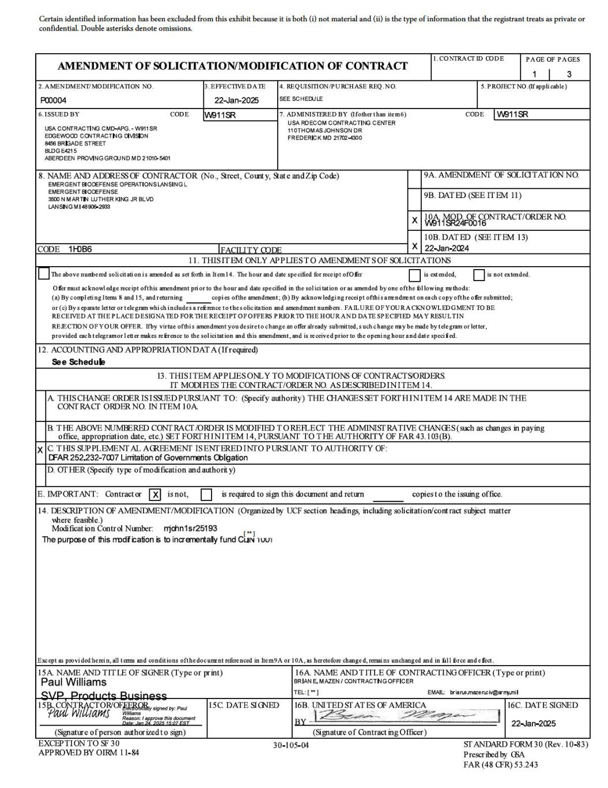
52

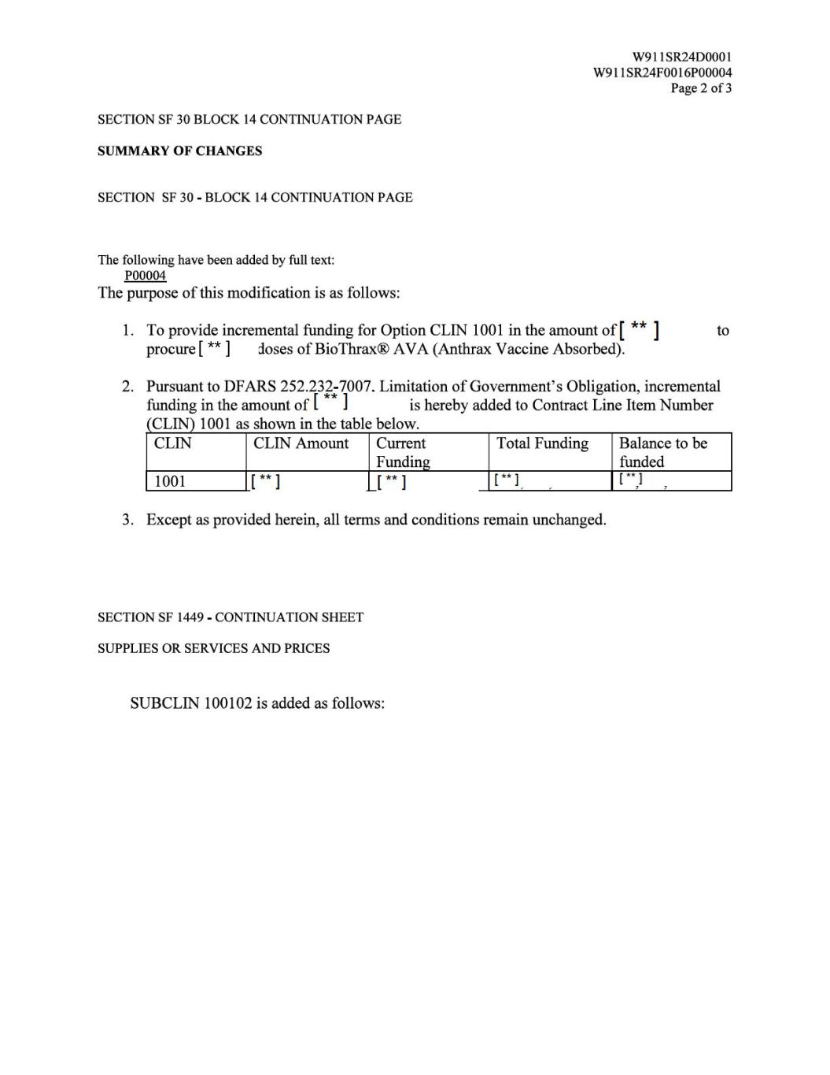
[ ** ]

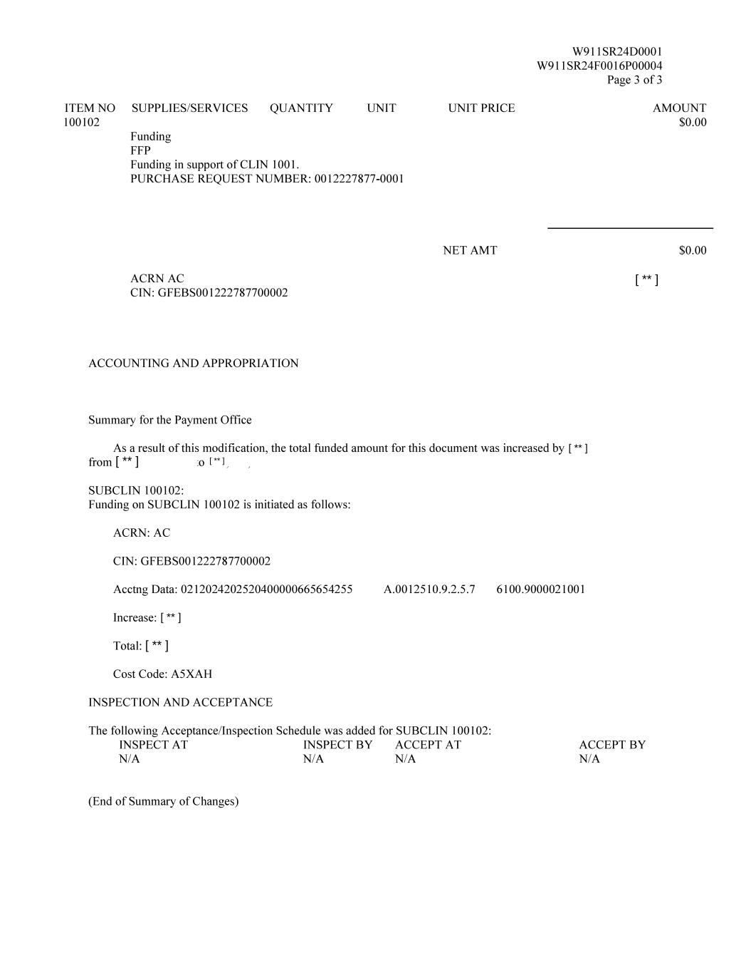
[ ** ] [ ** ] [ ** ] [ ** ] [ ** ] [ ** ]

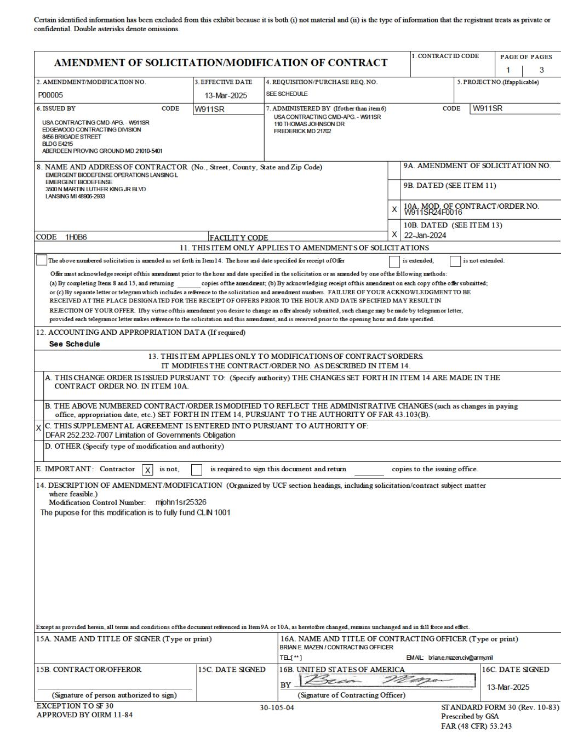

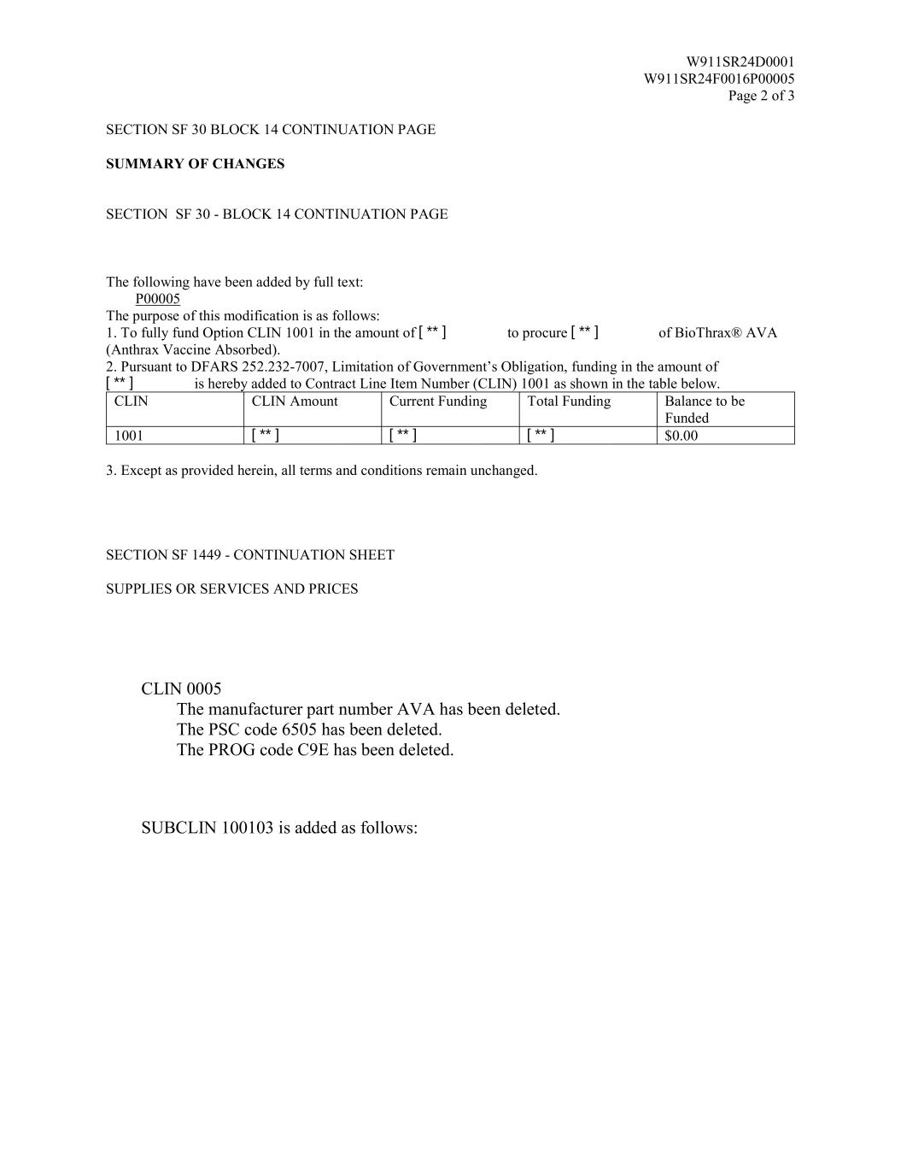
W911SR24D0001 W911SR24F0016P00005 Page 2 of 3 SECTION SF 30 BLOCK 14 CONTINUATION PAGE SUMMARY OF CHANGES SECTION SF 30 - BLOCK 14 CONTINUATION PAGE The following have been added by full text: P00005 The purpose of this modification is as follows: 1. To fully fund Option CLIN 1001 in the amount of to procure of BioThrax® AVA (Anthrax Vaccine Absorbed). 2. Pursuant to DFARS 252.232-7007, Limitation of Government’s Obligation, funding in the amount of is hereby added to Contract Line Item Number (CLIN) 1001 as shown in the table below. CLIN CLIN Amount Current Funding Total Funding Balance to be Funded 1001 $0.00 3. Except as provided herein, all terms and conditions remain unchanged. SECTION SF 1449 - CONTINUATION SHEET SUPPLIES OR SERVICES AND PRICES CLIN 0005 The manufacturer part number AVA has been deleted. The PSC code 6505 has been deleted. The PROG code C9E has been deleted. SUBCLIN 100103 is added as follows: [ ** ] [ ** ] [ ** ] [ ** ] [ ** ] [ ** ]

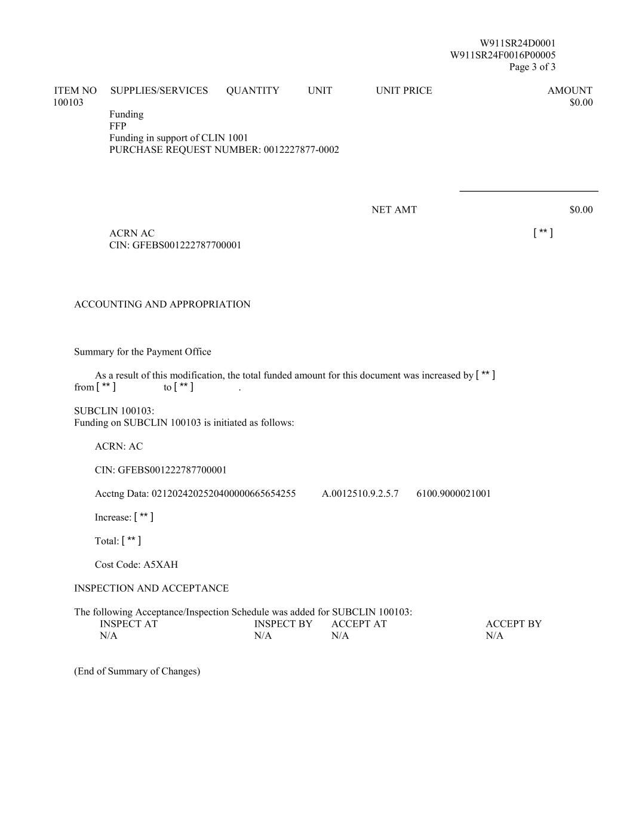
W911SR24D0001 W911SR24F0016P00005 Page 3 of 3 ITEM NO SUPPLIES/SERVICES QUANTITY UNIT UNIT PRICE AMOUNT 100103 $0.00 Funding FFP Funding in support of CLIN 1001 PURCHASE REQUEST NUMBER: 0012227877-0002 NET AMT $0.00 ACRN AC CIN: GFEBS001222787700001 ACCOUNTING AND APPROPRIATION Summary for the Payment Office As a result of this modification, the total funded amount for this document was increased by from to . SUBCLIN 100103: Funding on SUBCLIN 100103 is initiated as follows: ACRN: AC CIN: GFEBS001222787700001 Acctng Data: 0212024202520400000665654255 A.0012510.9.2.5.7 6100.9000021001 Increase: Total: Cost Code: A5XAH INSPECTION AND ACCEPTANCE The following Acceptance/Inspection Schedule was added for SUBCLIN 100103: INSPECT AT INSPECT BY ACCEPT AT ACCEPT BY N/A N/A N/A N/A (End of Summary of Changes) [ ** ] [ ** ] [ ** ] [ ** ] [ ** ] [ ** ]

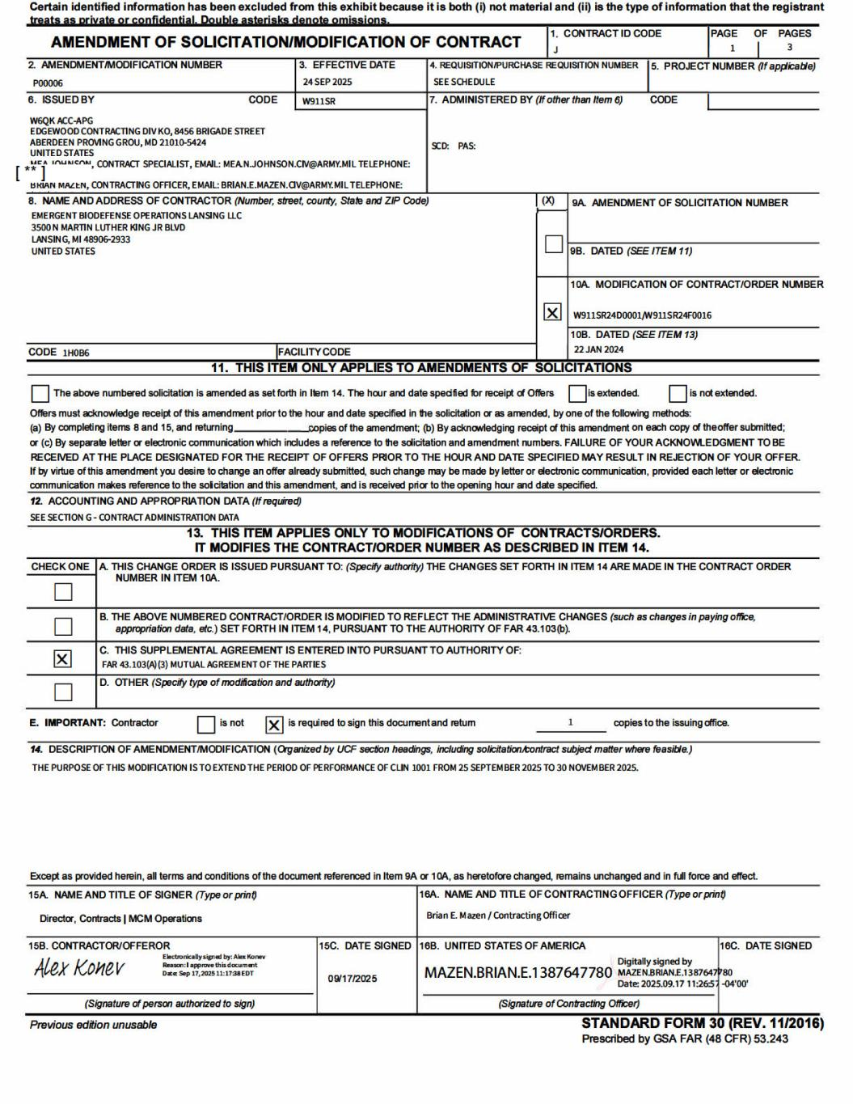

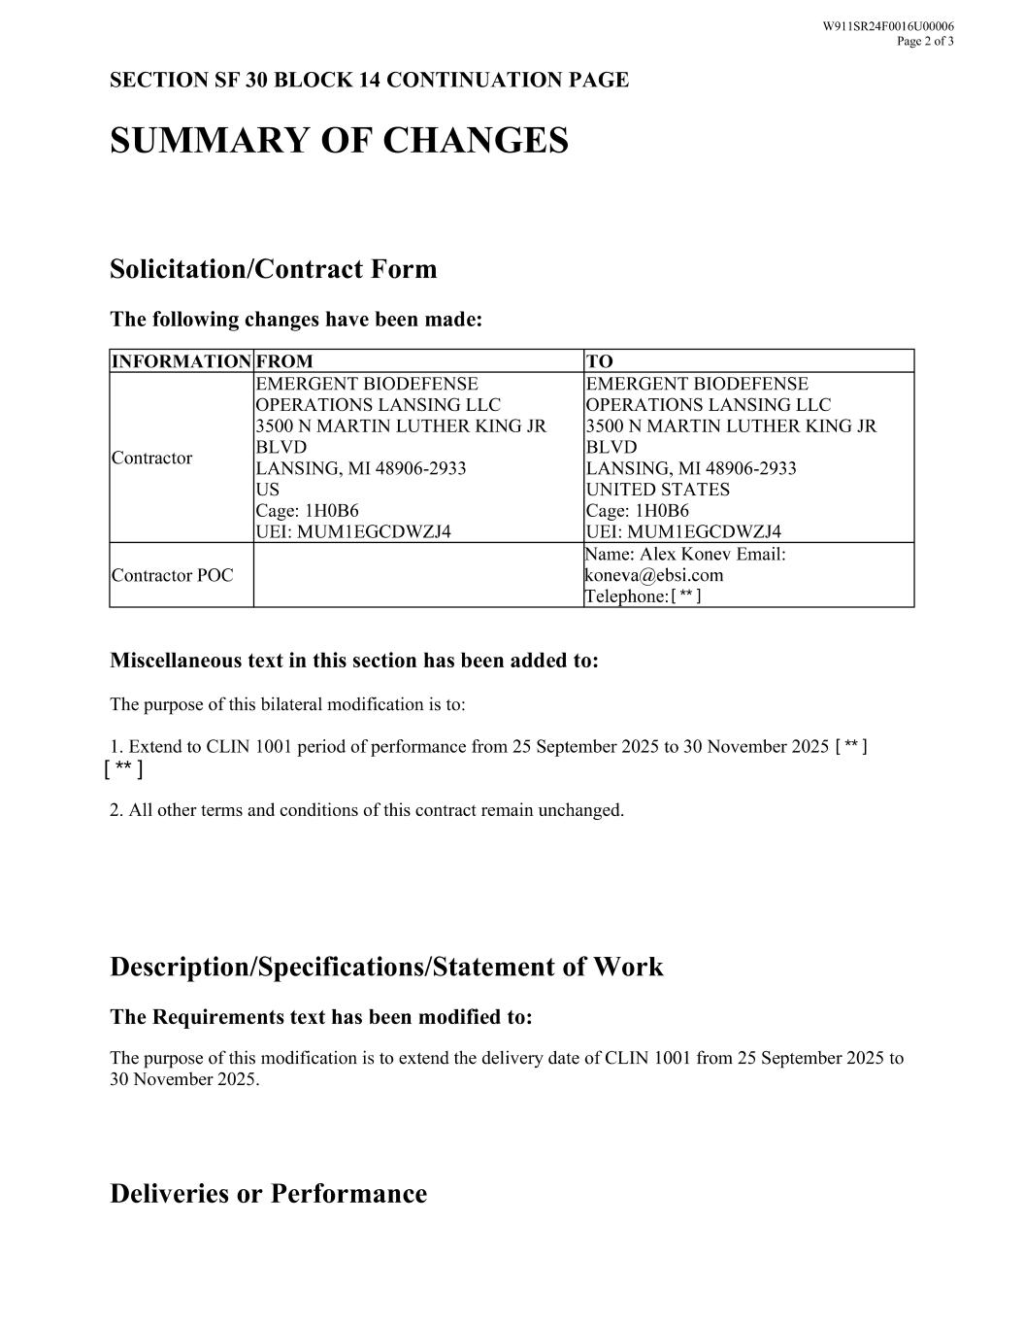
[ ** ] [ ** ] [ ** ]

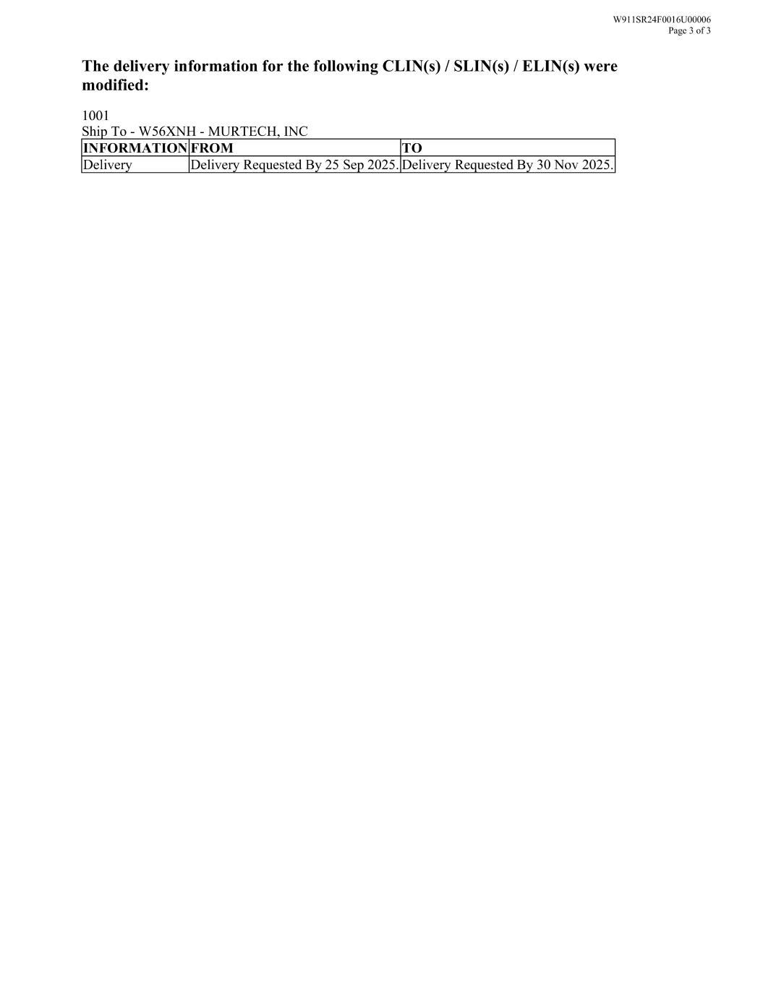

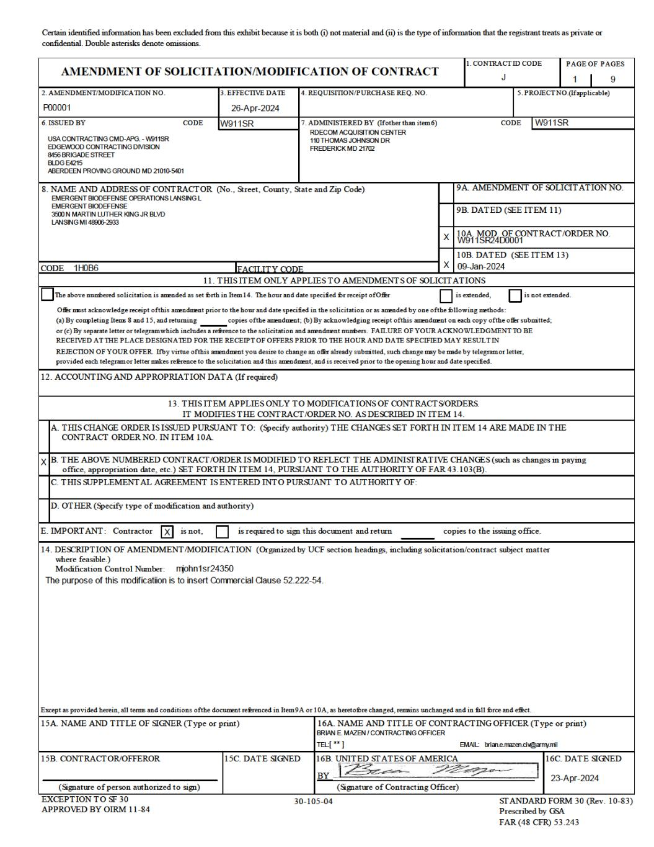

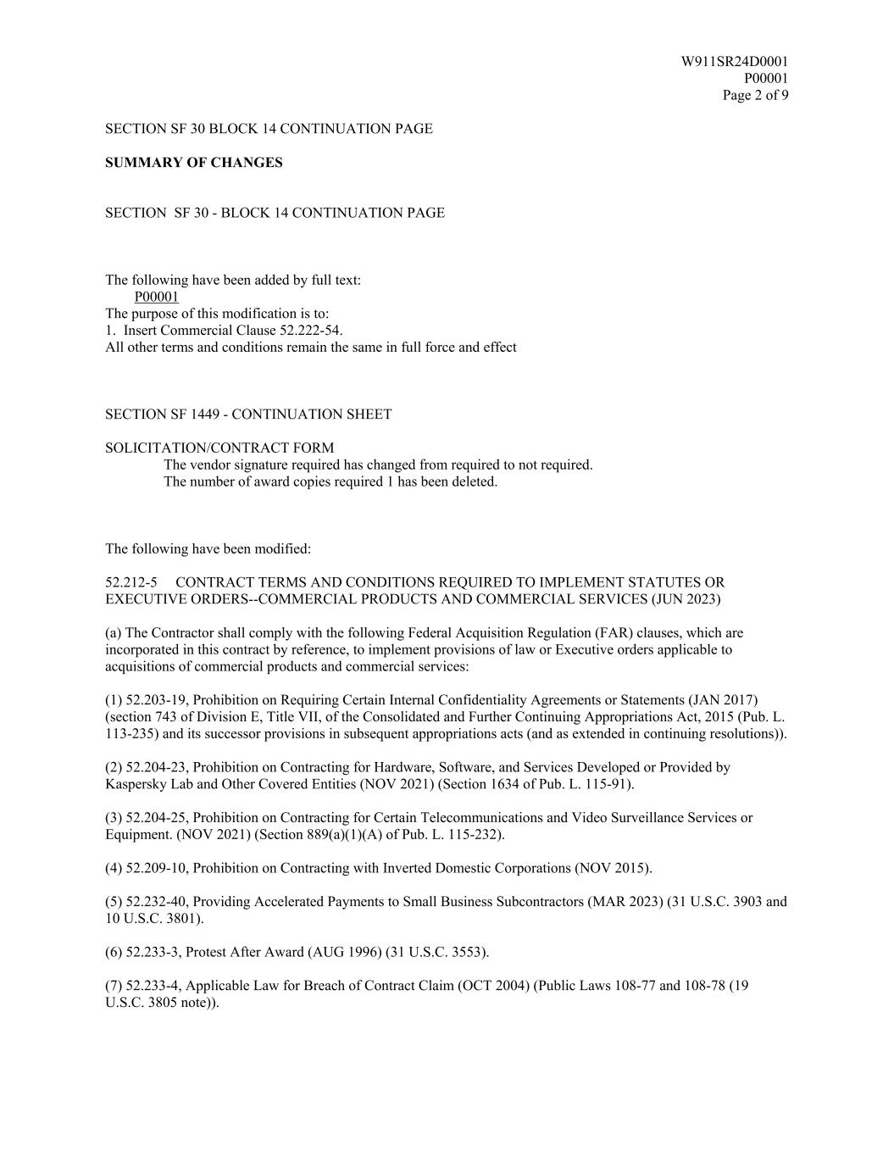
W911SR24D0001 P00001 Page 2 of 9 SECTION SF 30 BLOCK 14 CONTINUATION PAGE SUMMARY OF CHANGES SECTION SF 30 - BLOCK 14 CONTINUATION PAGE The following have been added by full text: P00001 The purpose of this modification is to: 1. Insert Commercial Clause 52.222-54. All other terms and conditions remain the same in full force and effect SECTION SF 1449 - CONTINUATION SHEET SOLICITATION/CONTRACT FORM The vendor signature required has changed from required to not required. The number of award copies required 1 has been deleted. The following have been modified: 52.212-5 CONTRACT TERMS AND CONDITIONS REQUIRED TO IMPLEMENT STATUTES OR EXECUTIVE ORDERS--COMMERCIAL PRODUCTS AND COMMERCIAL SERVICES (JUN 2023) (a) The Contractor shall comply with the following Federal Acquisition Regulation (FAR) clauses, which are incorporated in this contract by reference, to implement provisions of law or Executive orders applicable to acquisitions of commercial products and commercial services: (1) 52.203-19, Prohibition on Requiring Certain Internal Confidentiality Agreements or Statements (JAN 2017) (section 743 of Division E, Title VII, of the Consolidated and Further Continuing Appropriations Act, 2015 (Pub. L. 113-235) and its successor provisions in subsequent appropriations acts (and as extended in continuing resolutions)). (2) 52.204-23, Prohibition on Contracting for Hardware, Software, and Services Developed or Provided by Kaspersky Lab and Other Covered Entities (NOV 2021) (Section 1634 of Pub. L. 115-91). (3) 52.204-25, Prohibition on Contracting for Certain Telecommunications and Video Surveillance Services or Equipment. (NOV 2021) (Section 889(a)(1)(A) of Pub. L. 115-232). (4) 52.209-10, Prohibition on Contracting with Inverted Domestic Corporations (NOV 2015). (5) 52.232-40, Providing Accelerated Payments to Small Business Subcontractors (MAR 2023) (31 U.S.C. 3903 and 10 U.S.C. 3801). (6) 52.233-3, Protest After Award (AUG 1996) (31 U.S.C. 3553). (7) 52.233-4, Applicable Law for Breach of Contract Claim (OCT 2004) (Public Laws 108-77 and 108-78 (19 U.S.C. 3805 note)).

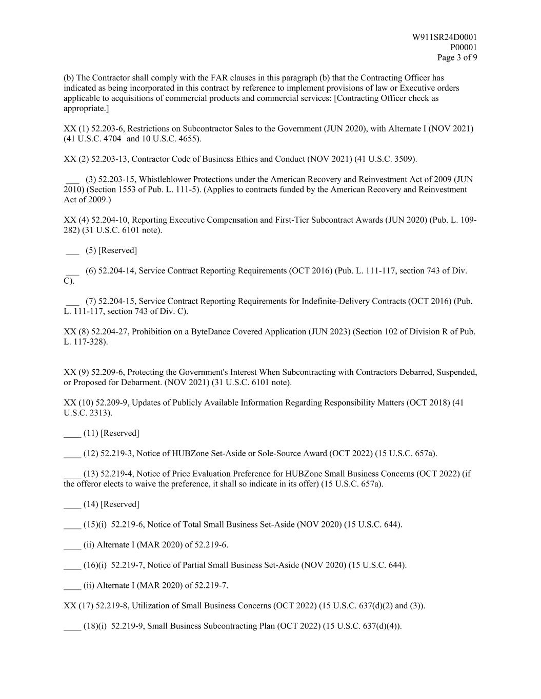
W911SR24D0001 P00001 Page 3 of 9 (b) The Contractor shall comply with the FAR clauses in this paragraph (b) that the Contracting Officer has indicated as being incorporated in this contract by reference to implement provisions of law or Executive orders applicable to acquisitions of commercial products and commercial services: [Contracting Officer check as appropriate.] XX (1) 52.203-6, Restrictions on Subcontractor Sales to the Government (JUN 2020), with Alternate I (NOV 2021) (41 U.S.C. 4704 and 10 U.S.C. 4655). XX (2) 52.203-13, Contractor Code of Business Ethics and Conduct (NOV 2021) (41 U.S.C. 3509). ___ (3) 52.203-15, Whistleblower Protections under the American Recovery and Reinvestment Act of 2009 (JUN 2010) (Section 1553 of Pub. L. 111-5). (Applies to contracts funded by the American Recovery and Reinvestment Act of 2009.) XX (4) 52.204-10, Reporting Executive Compensation and First-Tier Subcontract Awards (JUN 2020) (Pub. L. 109- 282) (31 U.S.C. 6101 note). ___ (5) [Reserved] ___ (6) 52.204-14, Service Contract Reporting Requirements (OCT 2016) (Pub. L. 111-117, section 743 of Div. C). ___ (7) 52.204-15, Service Contract Reporting Requirements for Indefinite-Delivery Contracts (OCT 2016) (Pub. L. 111-117, section 743 of Div. C). XX (8) 52.204-27, Prohibition on a ByteDance Covered Application (JUN 2023) (Section 102 of Division R of Pub. L. 117-328). XX (9) 52.209-6, Protecting the Government's Interest When Subcontracting with Contractors Debarred, Suspended, or Proposed for Debarment. (NOV 2021) (31 U.S.C. 6101 note). XX (10) 52.209-9, Updates of Publicly Available Information Regarding Responsibility Matters (OCT 2018) (41 U.S.C. 2313). ____ (11) [Reserved] ____ (12) 52.219-3, Notice of HUBZone Set-Aside or Sole-Source Award (OCT 2022) (15 U.S.C. 657a). ____ (13) 52.219-4, Notice of Price Evaluation Preference for HUBZone Small Business Concerns (OCT 2022) (if the offeror elects to waive the preference, it shall so indicate in its offer) (15 U.S.C. 657a). ____ (14) [Reserved] ____ (15)(i) 52.219-6, Notice of Total Small Business Set-Aside (NOV 2020) (15 U.S.C. 644). ____ (ii) Alternate I (MAR 2020) of 52.219-6. ____ (16)(i) 52.219-7, Notice of Partial Small Business Set-Aside (NOV 2020) (15 U.S.C. 644). ____ (ii) Alternate I (MAR 2020) of 52.219-7. XX (17) 52.219-8, Utilization of Small Business Concerns (OCT 2022) (15 U.S.C. 637(d)(2) and (3)). ____ (18)(i) 52.219-9, Small Business Subcontracting Plan (OCT 2022) (15 U.S.C. 637(d)(4)).

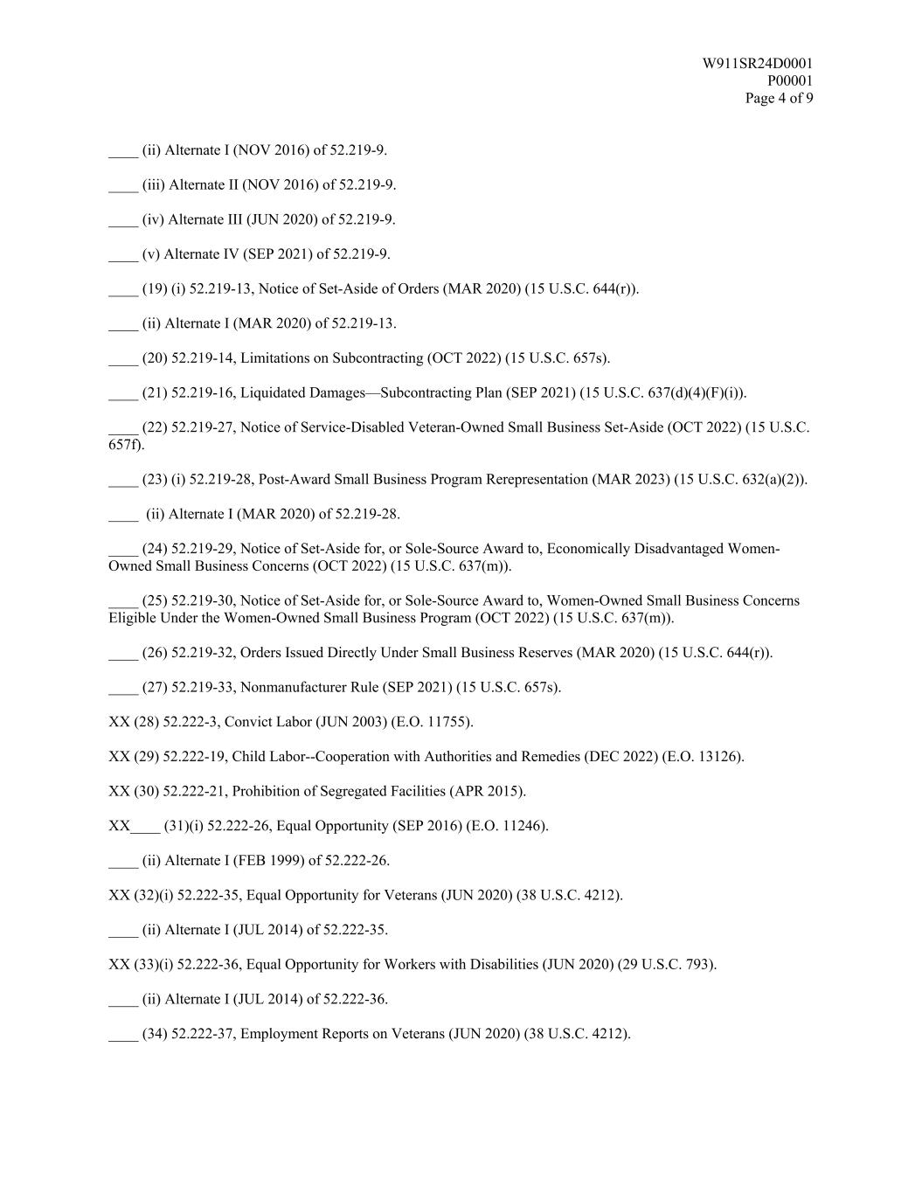
W911SR24D0001 P00001 Page 4 of 9 ____ (ii) Alternate I (NOV 2016) of 52.219-9. ____ (iii) Alternate II (NOV 2016) of 52.219-9. ____ (iv) Alternate III (JUN 2020) of 52.219-9. ____ (v) Alternate IV (SEP 2021) of 52.219-9. ____ (19) (i) 52.219-13, Notice of Set-Aside of Orders (MAR 2020) (15 U.S.C. 644(r)). ____ (ii) Alternate I (MAR 2020) of 52.219-13. ____ (20) 52.219-14, Limitations on Subcontracting (OCT 2022) (15 U.S.C. 657s). ____ (21) 52.219-16, Liquidated Damages—Subcontracting Plan (SEP 2021) (15 U.S.C. 637(d)(4)(F)(i)). ____ (22) 52.219-27, Notice of Service-Disabled Veteran-Owned Small Business Set-Aside (OCT 2022) (15 U.S.C. 657f). ____ (23) (i) 52.219-28, Post-Award Small Business Program Rerepresentation (MAR 2023) (15 U.S.C. 632(a)(2)). ____ (ii) Alternate I (MAR 2020) of 52.219-28. ____ (24) 52.219-29, Notice of Set-Aside for, or Sole-Source Award to, Economically Disadvantaged Women- Owned Small Business Concerns (OCT 2022) (15 U.S.C. 637(m)). ____ (25) 52.219-30, Notice of Set-Aside for, or Sole-Source Award to, Women-Owned Small Business Concerns Eligible Under the Women-Owned Small Business Program (OCT 2022) (15 U.S.C. 637(m)). ____ (26) 52.219-32, Orders Issued Directly Under Small Business Reserves (MAR 2020) (15 U.S.C. 644(r)). ____ (27) 52.219-33, Nonmanufacturer Rule (SEP 2021) (15 U.S.C. 657s). XX (28) 52.222-3, Convict Labor (JUN 2003) (E.O. 11755). XX (29) 52.222-19, Child Labor--Cooperation with Authorities and Remedies (DEC 2022) (E.O. 13126). XX (30) 52.222-21, Prohibition of Segregated Facilities (APR 2015). XX____ (31)(i) 52.222-26, Equal Opportunity (SEP 2016) (E.O. 11246). ____ (ii) Alternate I (FEB 1999) of 52.222-26. XX (32)(i) 52.222-35, Equal Opportunity for Veterans (JUN 2020) (38 U.S.C. 4212). ____ (ii) Alternate I (JUL 2014) of 52.222-35. XX (33)(i) 52.222-36, Equal Opportunity for Workers with Disabilities (JUN 2020) (29 U.S.C. 793). ____ (ii) Alternate I (JUL 2014) of 52.222-36. ____ (34) 52.222-37, Employment Reports on Veterans (JUN 2020) (38 U.S.C. 4212).

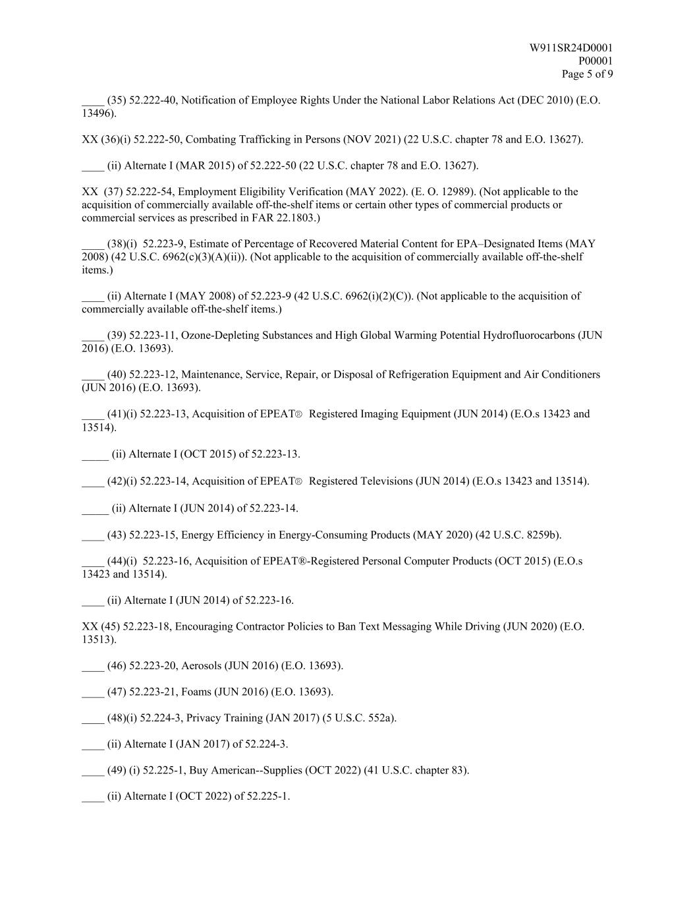
W911SR24D0001 P00001 Page 5 of 9 ____ (35) 52.222-40, Notification of Employee Rights Under the National Labor Relations Act (DEC 2010) (E.O. 13496). XX (36)(i) 52.222-50, Combating Trafficking in Persons (NOV 2021) (22 U.S.C. chapter 78 and E.O. 13627). ____ (ii) Alternate I (MAR 2015) of 52.222-50 (22 U.S.C. chapter 78 and E.O. 13627). XX (37) 52.222-54, Employment Eligibility Verification (MAY 2022). (E. O. 12989). (Not applicable to the acquisition of commercially available off-the-shelf items or certain other types of commercial products or commercial services as prescribed in FAR 22.1803.) ____ (38)(i) 52.223-9, Estimate of Percentage of Recovered Material Content for EPA–Designated Items (MAY 2008) (42 U.S.C. 6962(c)(3)(A)(ii)). (Not applicable to the acquisition of commercially available off-the-shelf items.) ____ (ii) Alternate I (MAY 2008) of 52.223-9 (42 U.S.C. 6962(i)(2)(C)). (Not applicable to the acquisition of commercially available off-the-shelf items.) ____ (39) 52.223-11, Ozone-Depleting Substances and High Global Warming Potential Hydrofluorocarbons (JUN 2016) (E.O. 13693). ____ (40) 52.223-12, Maintenance, Service, Repair, or Disposal of Refrigeration Equipment and Air Conditioners (JUN 2016) (E.O. 13693). ____ (41)(i) 52.223-13, Acquisition of EPEAT® Registered Imaging Equipment (JUN 2014) (E.O.s 13423 and 13514). ____ (ii) Alternate I (OCT 2015) of 52.223-13. ____ (42)(i) 52.223-14, Acquisition of EPEAT® Registered Televisions (JUN 2014) (E.O.s 13423 and 13514). ____ (ii) Alternate I (JUN 2014) of 52.223-14. ____ (43) 52.223-15, Energy Efficiency in Energy-Consuming Products (MAY 2020) (42 U.S.C. 8259b). ____ (44)(i) 52.223-16, Acquisition of EPEAT®-Registered Personal Computer Products (OCT 2015) (E.O.s 13423 and 13514). ____ (ii) Alternate I (JUN 2014) of 52.223-16. XX (45) 52.223-18, Encouraging Contractor Policies to Ban Text Messaging While Driving (JUN 2020) (E.O. 13513). ____ (46) 52.223-20, Aerosols (JUN 2016) (E.O. 13693). ____ (47) 52.223-21, Foams (JUN 2016) (E.O. 13693). ____ (48)(i) 52.224-3, Privacy Training (JAN 2017) (5 U.S.C. 552a). ____ (ii) Alternate I (JAN 2017) of 52.224-3. ____ (49) (i) 52.225-1, Buy American--Supplies (OCT 2022) (41 U.S.C. chapter 83). ____ (ii) Alternate I (OCT 2022) of 52.225-1.

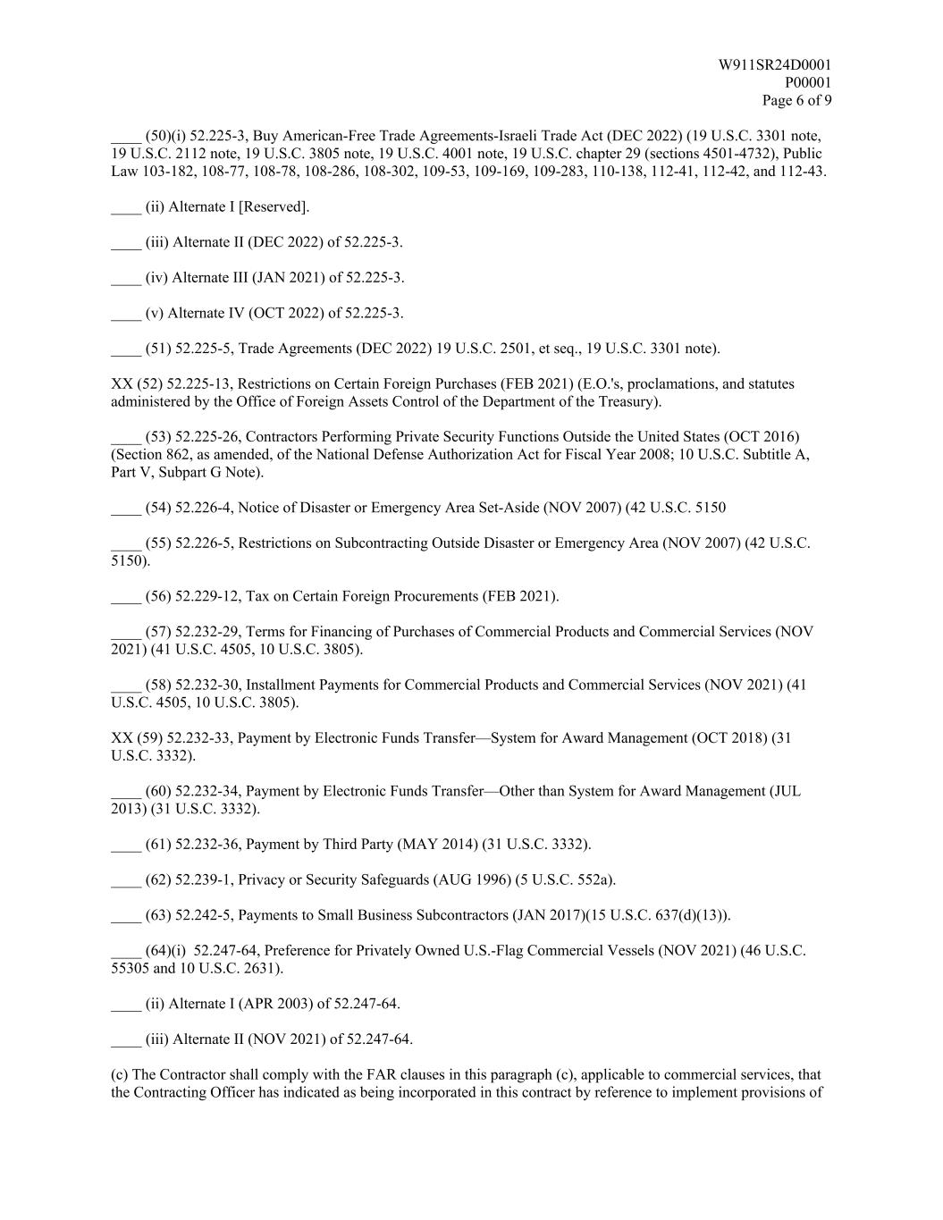
W911SR24D0001 P00001 Page 6 of 9 ____ (50)(i) 52.225-3, Buy American-Free Trade Agreements-Israeli Trade Act (DEC 2022) (19 U.S.C. 3301 note, 19 U.S.C. 2112 note, 19 U.S.C. 3805 note, 19 U.S.C. 4001 note, 19 U.S.C. chapter 29 (sections 4501-4732), Public Law 103-182, 108-77, 108-78, 108-286, 108-302, 109-53, 109-169, 109-283, 110-138, 112-41, 112-42, and 112-43. ____ (ii) Alternate I [Reserved]. ____ (iii) Alternate II (DEC 2022) of 52.225-3. ____ (iv) Alternate III (JAN 2021) of 52.225-3. ____ (v) Alternate IV (OCT 2022) of 52.225-3. ____ (51) 52.225-5, Trade Agreements (DEC 2022) 19 U.S.C. 2501, et seq., 19 U.S.C. 3301 note). XX (52) 52.225-13, Restrictions on Certain Foreign Purchases (FEB 2021) (E.O.'s, proclamations, and statutes administered by the Office of Foreign Assets Control of the Department of the Treasury). ____ (53) 52.225-26, Contractors Performing Private Security Functions Outside the United States (OCT 2016) (Section 862, as amended, of the National Defense Authorization Act for Fiscal Year 2008; 10 U.S.C. Subtitle A, Part V, Subpart G Note). ____ (54) 52.226-4, Notice of Disaster or Emergency Area Set-Aside (NOV 2007) (42 U.S.C. 5150 ____ (55) 52.226-5, Restrictions on Subcontracting Outside Disaster or Emergency Area (NOV 2007) (42 U.S.C. 5150). ____ (56) 52.229-12, Tax on Certain Foreign Procurements (FEB 2021). ____ (57) 52.232-29, Terms for Financing of Purchases of Commercial Products and Commercial Services (NOV 2021) (41 U.S.C. 4505, 10 U.S.C. 3805). ____ (58) 52.232-30, Installment Payments for Commercial Products and Commercial Services (NOV 2021) (41 U.S.C. 4505, 10 U.S.C. 3805). XX (59) 52.232-33, Payment by Electronic Funds Transfer—System for Award Management (OCT 2018) (31 U.S.C. 3332). ____ (60) 52.232-34, Payment by Electronic Funds Transfer—Other than System for Award Management (JUL 2013) (31 U.S.C. 3332). ____ (61) 52.232-36, Payment by Third Party (MAY 2014) (31 U.S.C. 3332). ____ (62) 52.239-1, Privacy or Security Safeguards (AUG 1996) (5 U.S.C. 552a). ____ (63) 52.242-5, Payments to Small Business Subcontractors (JAN 2017)(15 U.S.C. 637(d)(13)). ____ (64)(i) 52.247-64, Preference for Privately Owned U.S.-Flag Commercial Vessels (NOV 2021) (46 U.S.C. 55305 and 10 U.S.C. 2631). ____ (ii) Alternate I (APR 2003) of 52.247-64. ____ (iii) Alternate II (NOV 2021) of 52.247-64. (c) The Contractor shall comply with the FAR clauses in this paragraph (c), applicable to commercial services, that the Contracting Officer has indicated as being incorporated in this contract by reference to implement provisions of

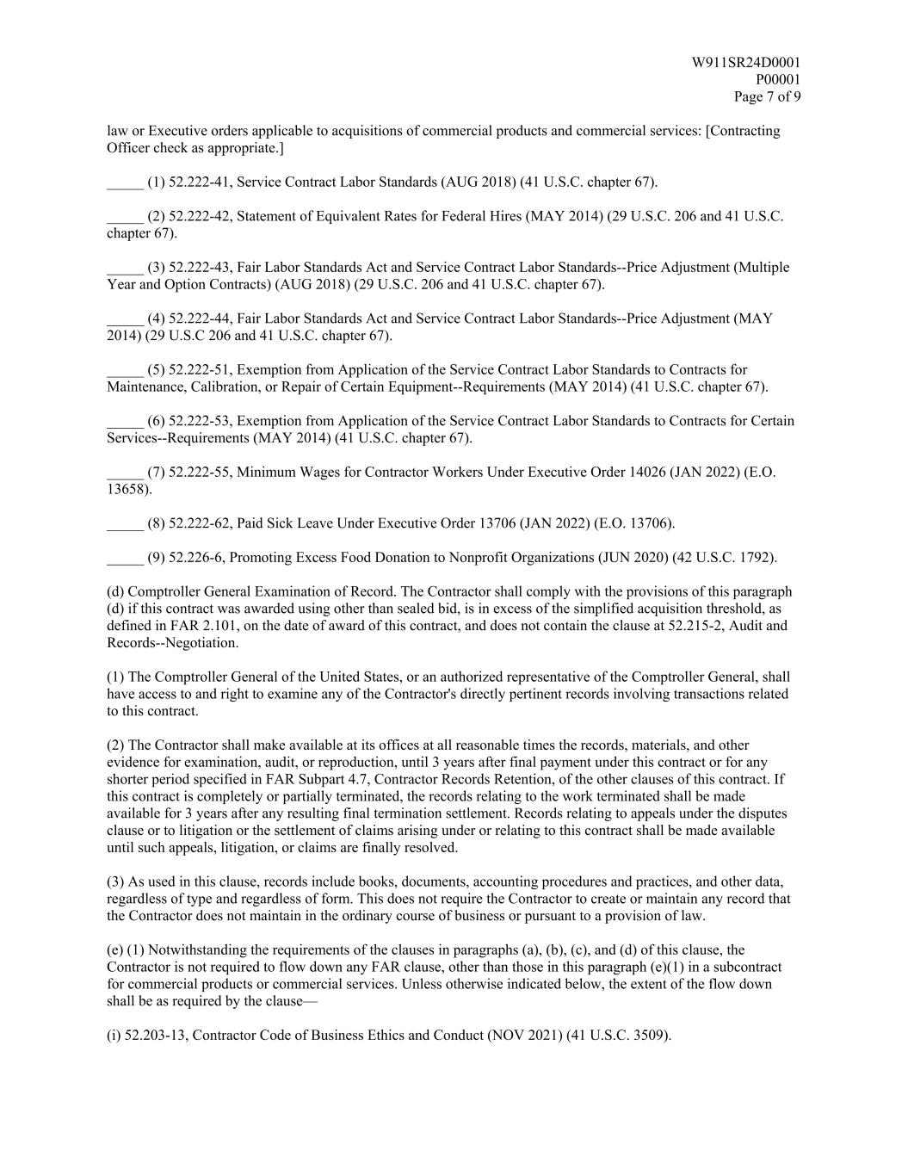
W911SR24D0001 P00001 Page 7 of 9 law or Executive orders applicable to acquisitions of commercial products and commercial services: [Contracting Officer check as appropriate.] _____ (1) 52.222-41, Service Contract Labor Standards (AUG 2018) (41 U.S.C. chapter 67). _____ (2) 52.222-42, Statement of Equivalent Rates for Federal Hires (MAY 2014) (29 U.S.C. 206 and 41 U.S.C. chapter 67). _____ (3) 52.222-43, Fair Labor Standards Act and Service Contract Labor Standards--Price Adjustment (Multiple Year and Option Contracts) (AUG 2018) (29 U.S.C. 206 and 41 U.S.C. chapter 67). _____ (4) 52.222-44, Fair Labor Standards Act and Service Contract Labor Standards--Price Adjustment (MAY 2014) (29 U.S.C 206 and 41 U.S.C. chapter 67). _____ (5) 52.222-51, Exemption from Application of the Service Contract Labor Standards to Contracts for Maintenance, Calibration, or Repair of Certain Equipment--Requirements (MAY 2014) (41 U.S.C. chapter 67). _____ (6) 52.222-53, Exemption from Application of the Service Contract Labor Standards to Contracts for Certain Services--Requirements (MAY 2014) (41 U.S.C. chapter 67). _____ (7) 52.222-55, Minimum Wages for Contractor Workers Under Executive Order 14026 (JAN 2022) (E.O. 13658). _____ (8) 52.222-62, Paid Sick Leave Under Executive Order 13706 (JAN 2022) (E.O. 13706). _____ (9) 52.226-6, Promoting Excess Food Donation to Nonprofit Organizations (JUN 2020) (42 U.S.C. 1792). (d) Comptroller General Examination of Record. The Contractor shall comply with the provisions of this paragraph (d) if this contract was awarded using other than sealed bid, is in excess of the simplified acquisition threshold, as defined in FAR 2.101, on the date of award of this contract, and does not contain the clause at 52.215-2, Audit and Records--Negotiation. (1) The Comptroller General of the United States, or an authorized representative of the Comptroller General, shall have access to and right to examine any of the Contractor's directly pertinent records involving transactions related to this contract. (2) The Contractor shall make available at its offices at all reasonable times the records, materials, and other evidence for examination, audit, or reproduction, until 3 years after final payment under this contract or for any shorter period specified in FAR Subpart 4.7, Contractor Records Retention, of the other clauses of this contract. If this contract is completely or partially terminated, the records relating to the work terminated shall be made available for 3 years after any resulting final termination settlement. Records relating to appeals under the disputes clause or to litigation or the settlement of claims arising under or relating to this contract shall be made available until such appeals, litigation, or claims are finally resolved. (3) As used in this clause, records include books, documents, accounting procedures and practices, and other data, regardless of type and regardless of form. This does not require the Contractor to create or maintain any record that the Contractor does not maintain in the ordinary course of business or pursuant to a provision of law. (e) (1) Notwithstanding the requirements of the clauses in paragraphs (a), (b), (c), and (d) of this clause, the Contractor is not required to flow down any FAR clause, other than those in this paragraph (e)(1) in a subcontract for commercial products or commercial services. Unless otherwise indicated below, the extent of the flow down shall be as required by the clause— (i) 52.203-13, Contractor Code of Business Ethics and Conduct (NOV 2021) (41 U.S.C. 3509).

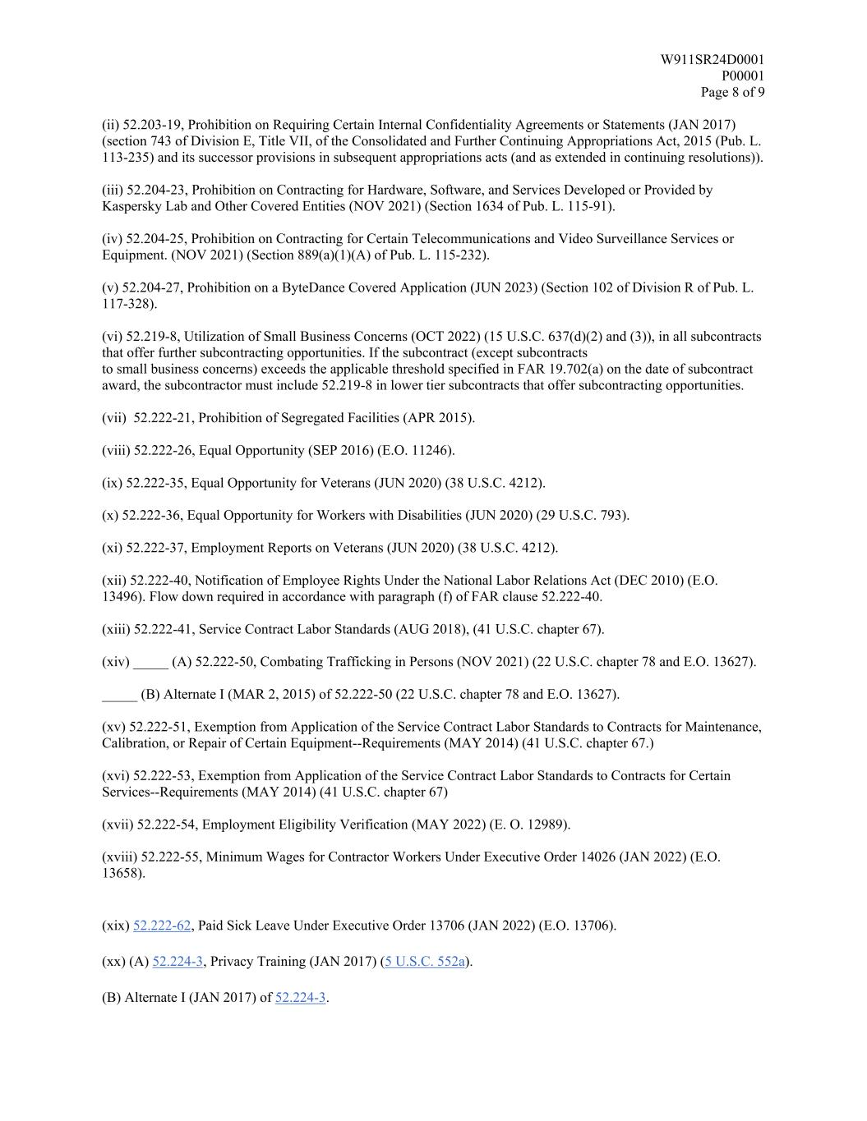
W911SR24D0001 P00001 Page 8 of 9 (ii) 52.203-19, Prohibition on Requiring Certain Internal Confidentiality Agreements or Statements (JAN 2017) (section 743 of Division E, Title VII, of the Consolidated and Further Continuing Appropriations Act, 2015 (Pub. L. 113-235) and its successor provisions in subsequent appropriations acts (and as extended in continuing resolutions)). (iii) 52.204-23, Prohibition on Contracting for Hardware, Software, and Services Developed or Provided by Kaspersky Lab and Other Covered Entities (NOV 2021) (Section 1634 of Pub. L. 115-91). (iv) 52.204-25, Prohibition on Contracting for Certain Telecommunications and Video Surveillance Services or Equipment. (NOV 2021) (Section 889(a)(1)(A) of Pub. L. 115-232). (v) 52.204-27, Prohibition on a ByteDance Covered Application (JUN 2023) (Section 102 of Division R of Pub. L. 117-328). (vi) 52.219-8, Utilization of Small Business Concerns (OCT 2022) (15 U.S.C. 637(d)(2) and (3)), in all subcontracts that offer further subcontracting opportunities. If the subcontract (except subcontracts to small business concerns) exceeds the applicable threshold specified in FAR 19.702(a) on the date of subcontract award, the subcontractor must include 52.219-8 in lower tier subcontracts that offer subcontracting opportunities. (vii) 52.222-21, Prohibition of Segregated Facilities (APR 2015). (viii) 52.222-26, Equal Opportunity (SEP 2016) (E.O. 11246). (ix) 52.222-35, Equal Opportunity for Veterans (JUN 2020) (38 U.S.C. 4212). (x) 52.222-36, Equal Opportunity for Workers with Disabilities (JUN 2020) (29 U.S.C. 793). (xi) 52.222-37, Employment Reports on Veterans (JUN 2020) (38 U.S.C. 4212). (xii) 52.222-40, Notification of Employee Rights Under the National Labor Relations Act (DEC 2010) (E.O. 13496). Flow down required in accordance with paragraph (f) of FAR clause 52.222-40. (xiii) 52.222-41, Service Contract Labor Standards (AUG 2018), (41 U.S.C. chapter 67). (xiv) _____ (A) 52.222-50, Combating Trafficking in Persons (NOV 2021) (22 U.S.C. chapter 78 and E.O. 13627). _____ (B) Alternate I (MAR 2, 2015) of 52.222-50 (22 U.S.C. chapter 78 and E.O. 13627). (xv) 52.222-51, Exemption from Application of the Service Contract Labor Standards to Contracts for Maintenance, Calibration, or Repair of Certain Equipment--Requirements (MAY 2014) (41 U.S.C. chapter 67.) (xvi) 52.222-53, Exemption from Application of the Service Contract Labor Standards to Contracts for Certain Services--Requirements (MAY 2014) (41 U.S.C. chapter 67) (xvii) 52.222-54, Employment Eligibility Verification (MAY 2022) (E. O. 12989). (xviii) 52.222-55, Minimum Wages for Contractor Workers Under Executive Order 14026 (JAN 2022) (E.O. 13658). (xix) 52.222-62, Paid Sick Leave Under Executive Order 13706 (JAN 2022) (E.O. 13706). (xx) (A) 52.224-3, Privacy Training (JAN 2017) (5 U.S.C. 552a). (B) Alternate I (JAN 2017) of 52.224-3.

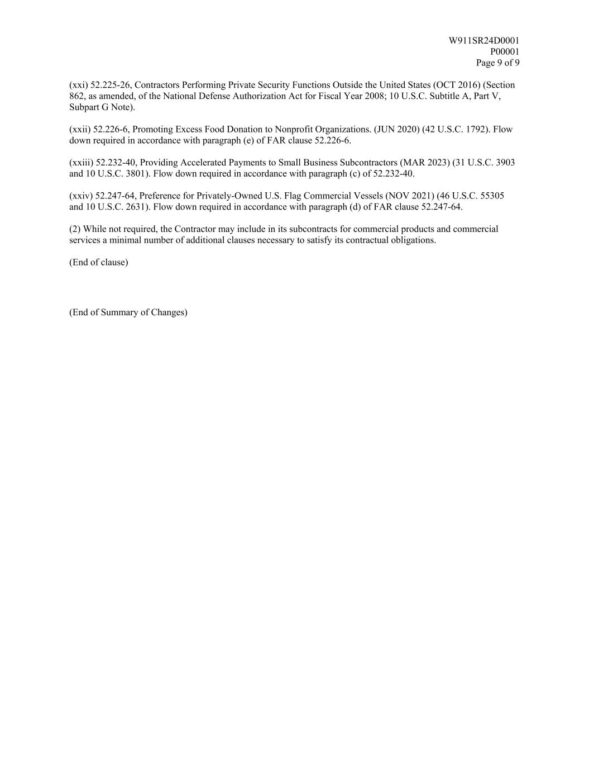
W911SR24D0001 P00001 Page 9 of 9 (xxi) 52.225-26, Contractors Performing Private Security Functions Outside the United States (OCT 2016) (Section 862, as amended, of the National Defense Authorization Act for Fiscal Year 2008; 10 U.S.C. Subtitle A, Part V, Subpart G Note). (xxii) 52.226-6, Promoting Excess Food Donation to Nonprofit Organizations. (JUN 2020) (42 U.S.C. 1792). Flow down required in accordance with paragraph (e) of FAR clause 52.226-6. (xxiii) 52.232-40, Providing Accelerated Payments to Small Business Subcontractors (MAR 2023) (31 U.S.C. 3903 and 10 U.S.C. 3801). Flow down required in accordance with paragraph (c) of 52.232-40. (xxiv) 52.247-64, Preference for Privately-Owned U.S. Flag Commercial Vessels (NOV 2021) (46 U.S.C. 55305 and 10 U.S.C. 2631). Flow down required in accordance with paragraph (d) of FAR clause 52.247-64. (2) While not required, the Contractor may include in its subcontracts for commercial products and commercial services a minimal number of additional clauses necessary to satisfy its contractual obligations. (End of clause) (End of Summary of Changes)

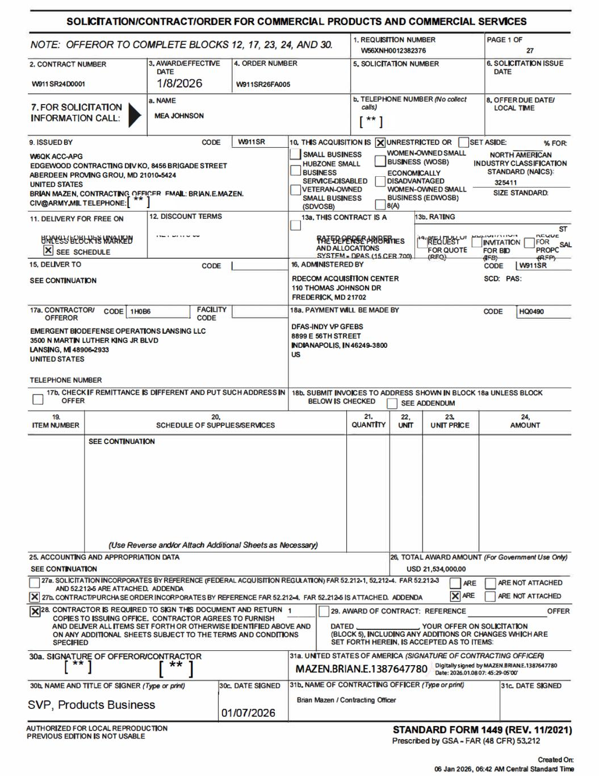

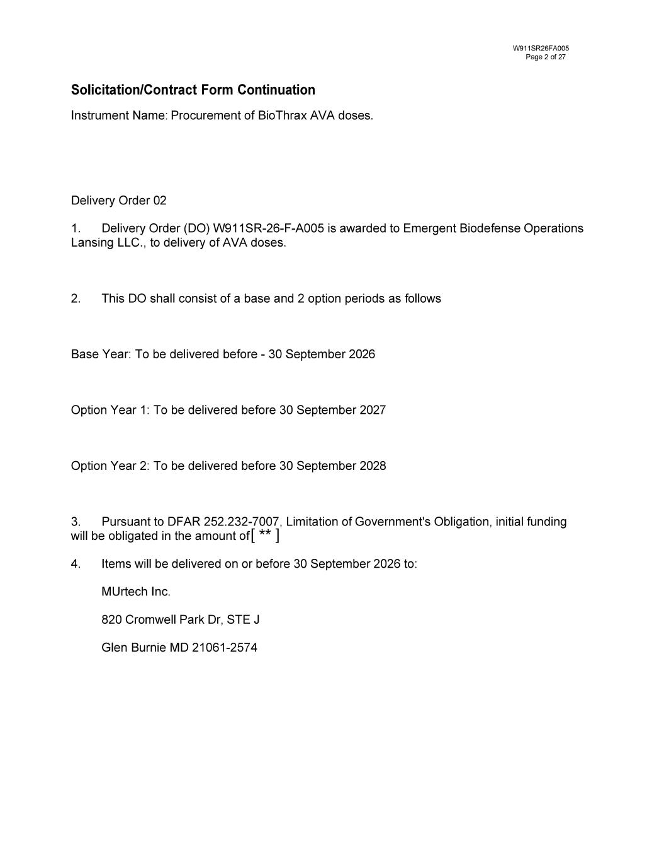
[ ** ]



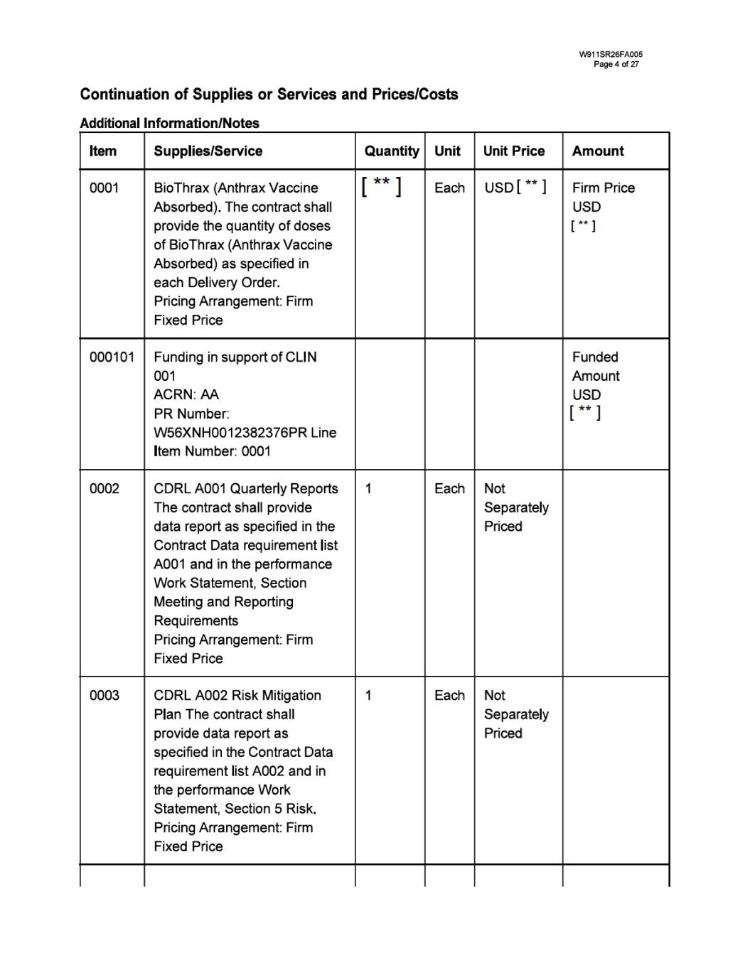

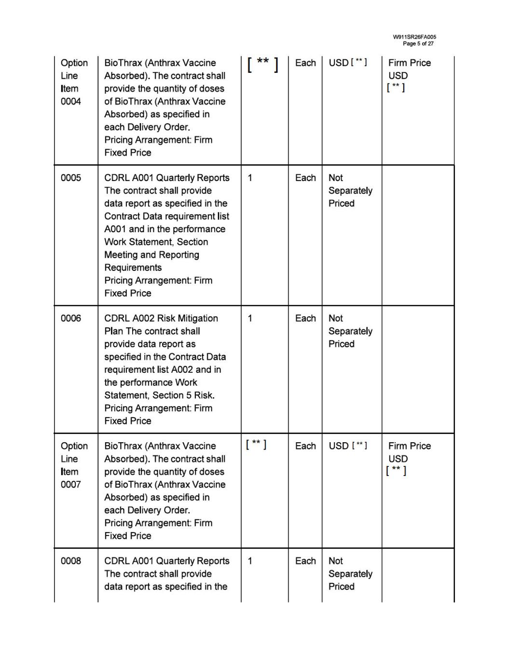

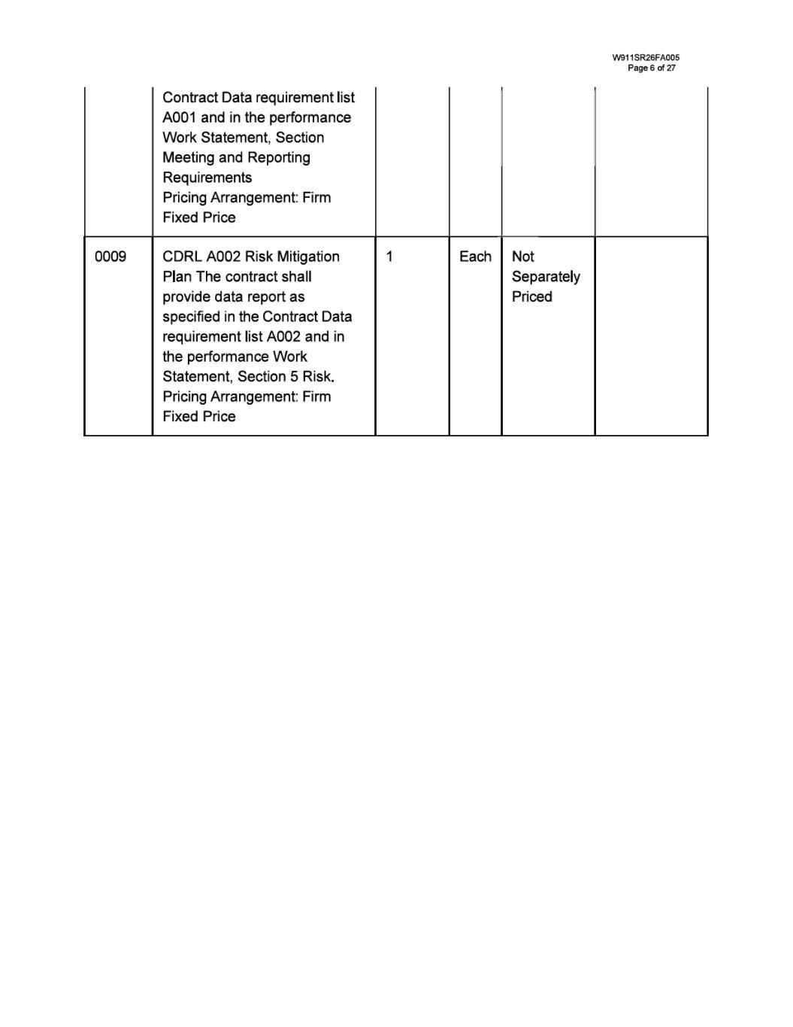

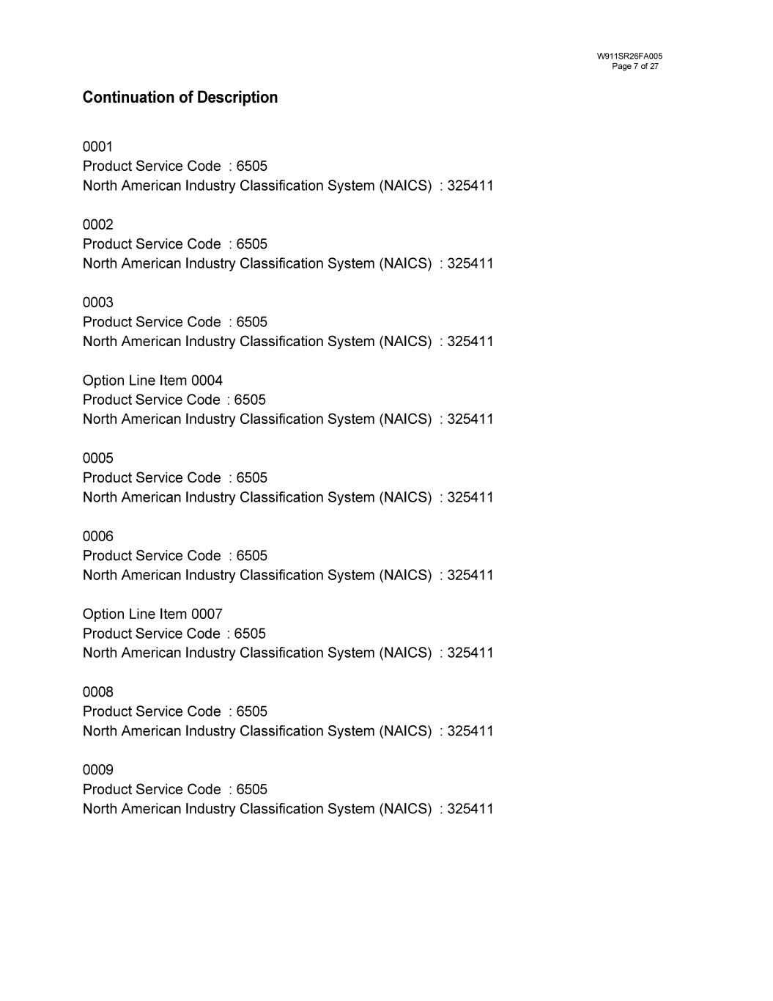

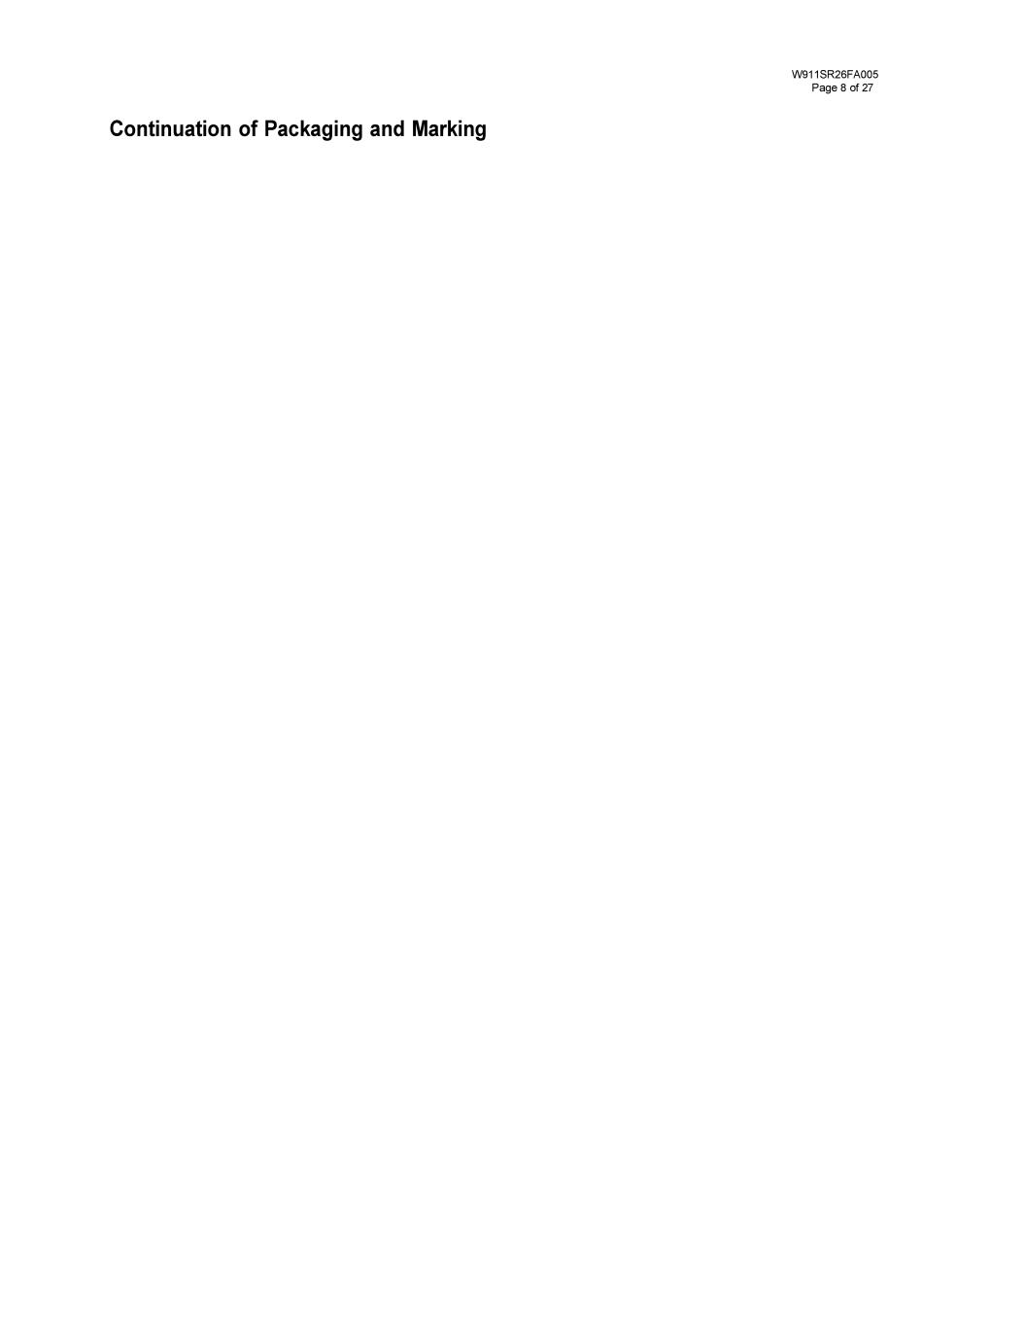

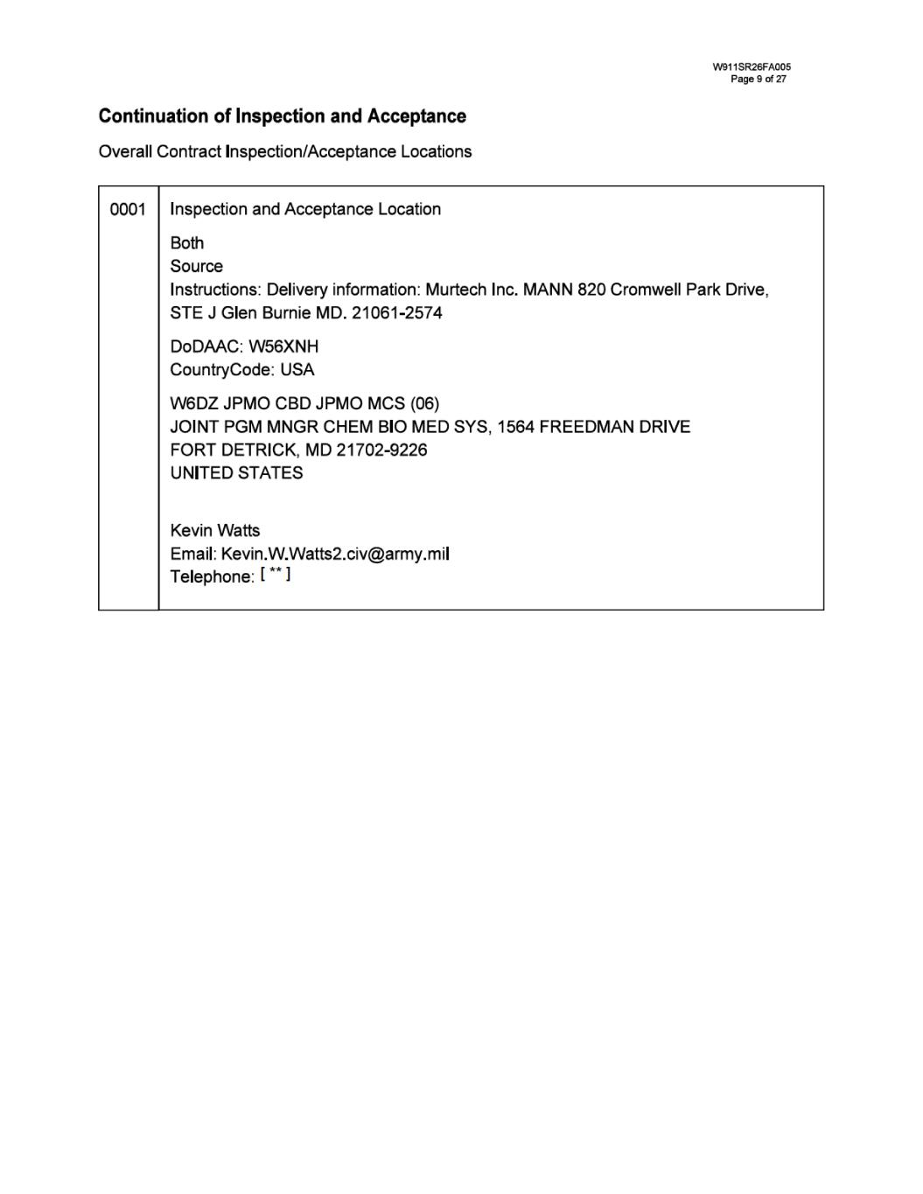

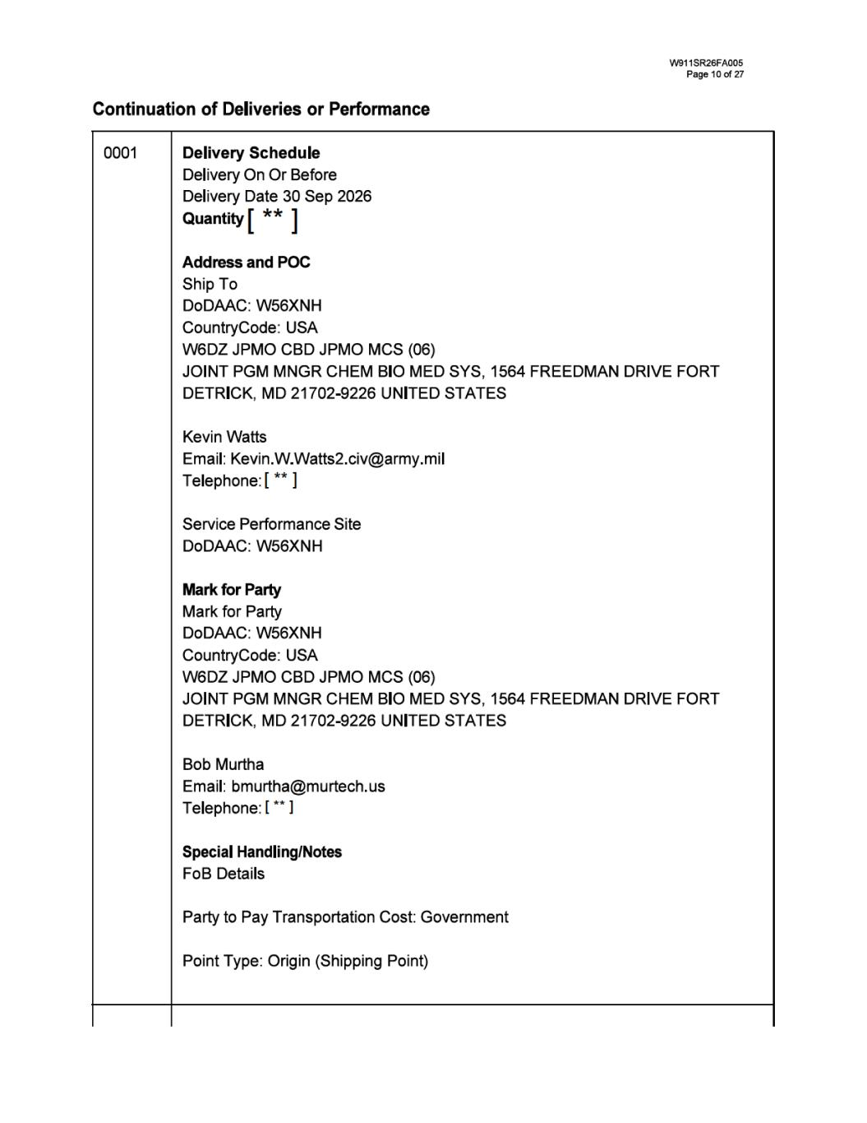

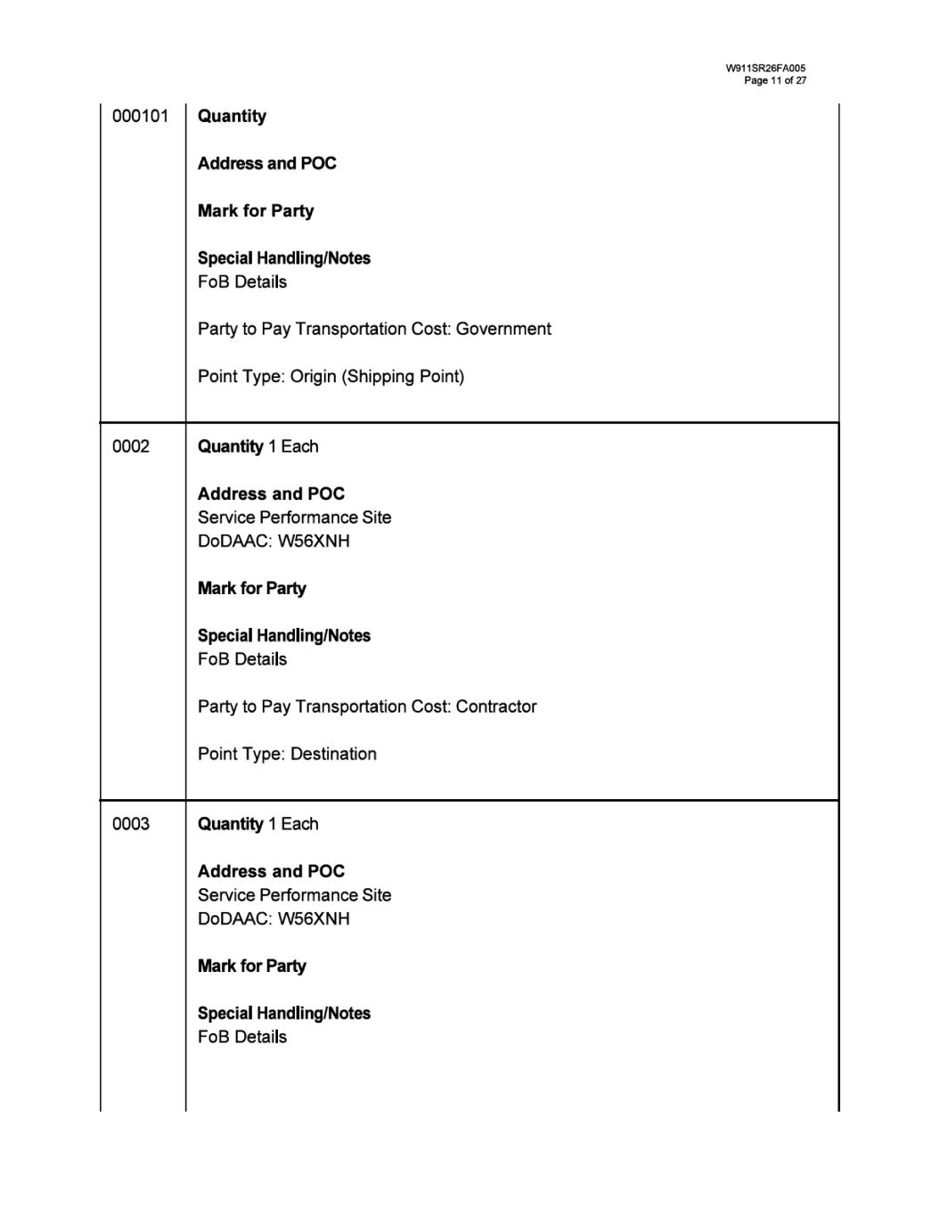

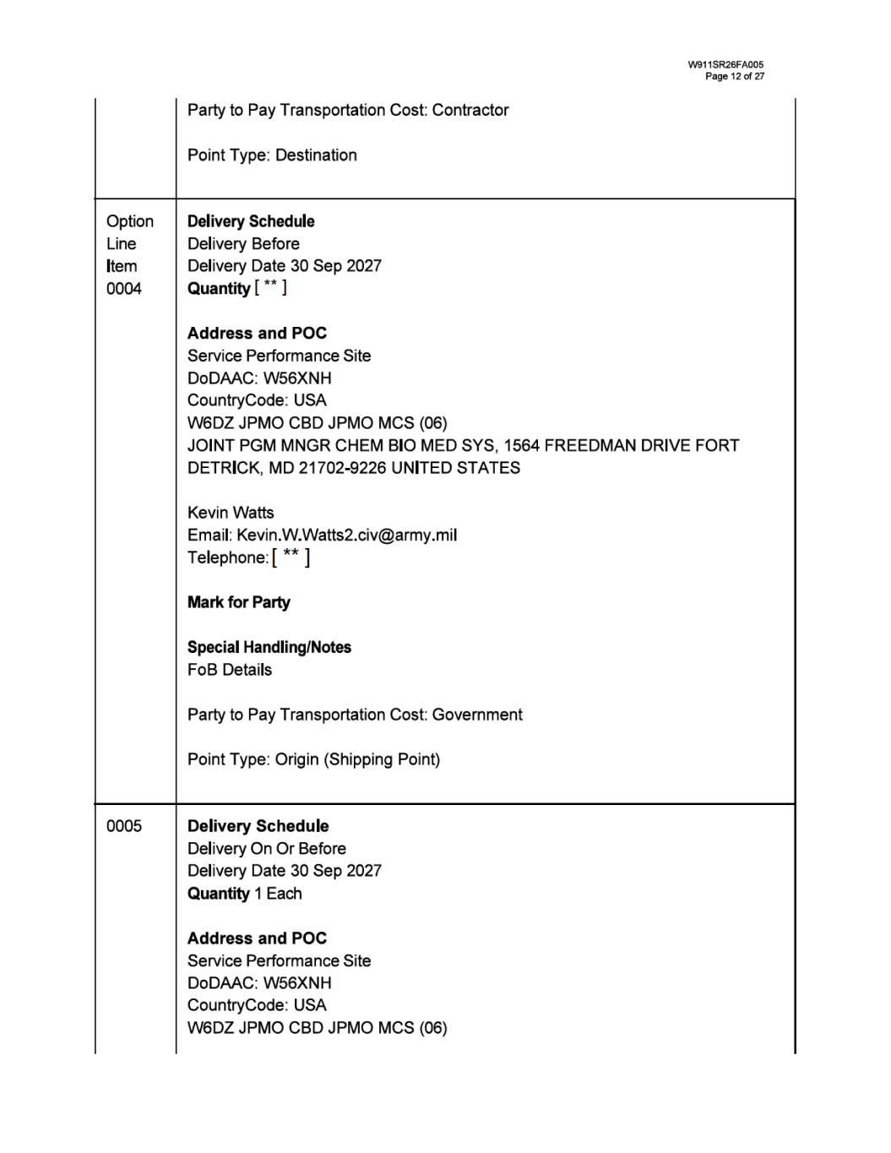

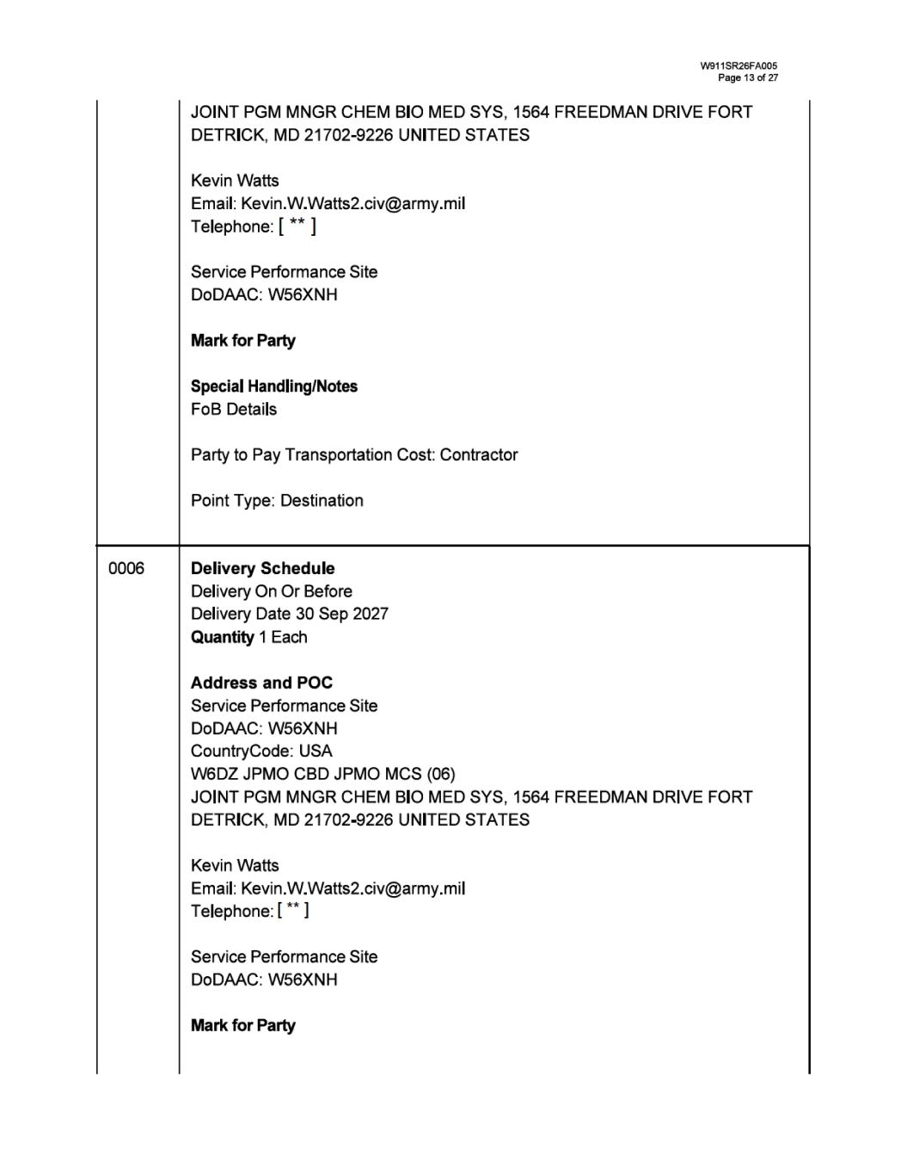

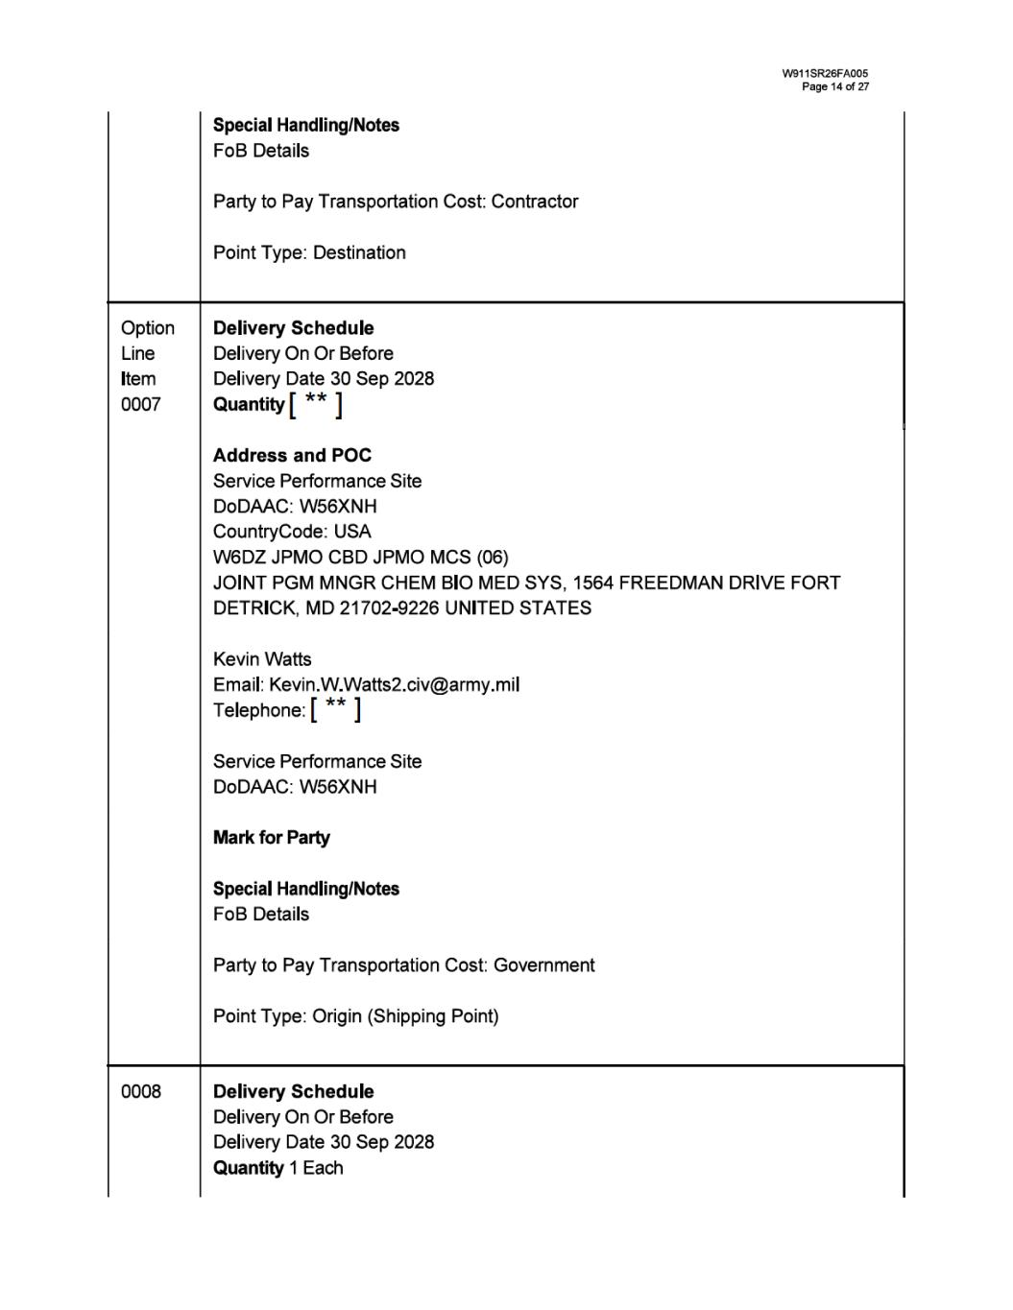

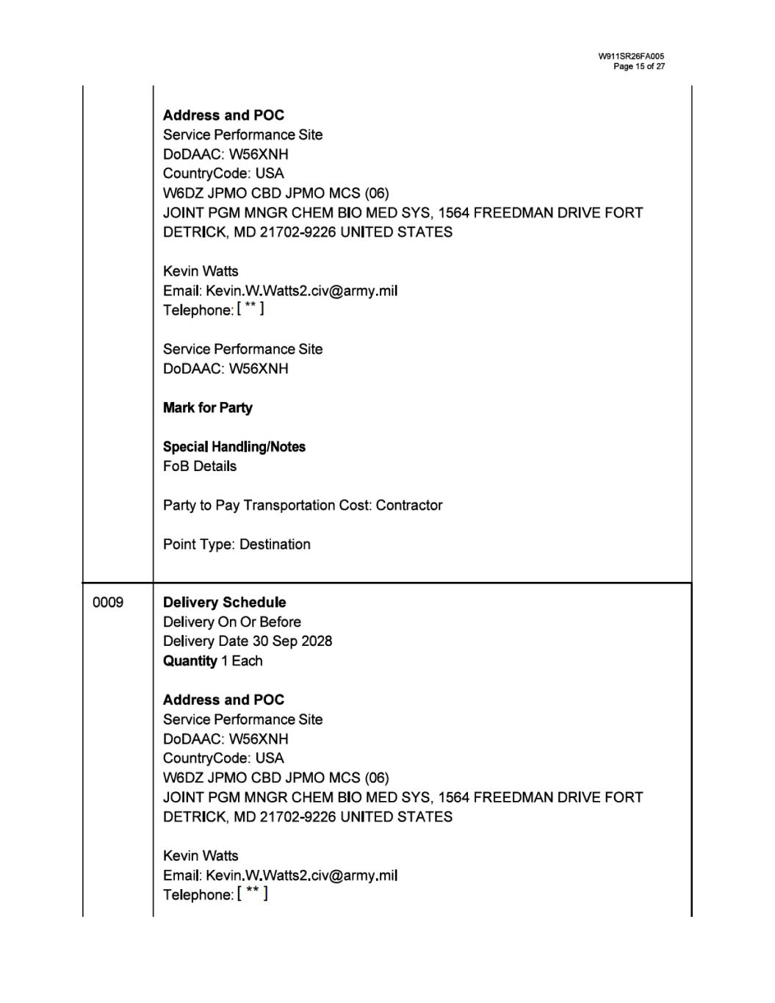

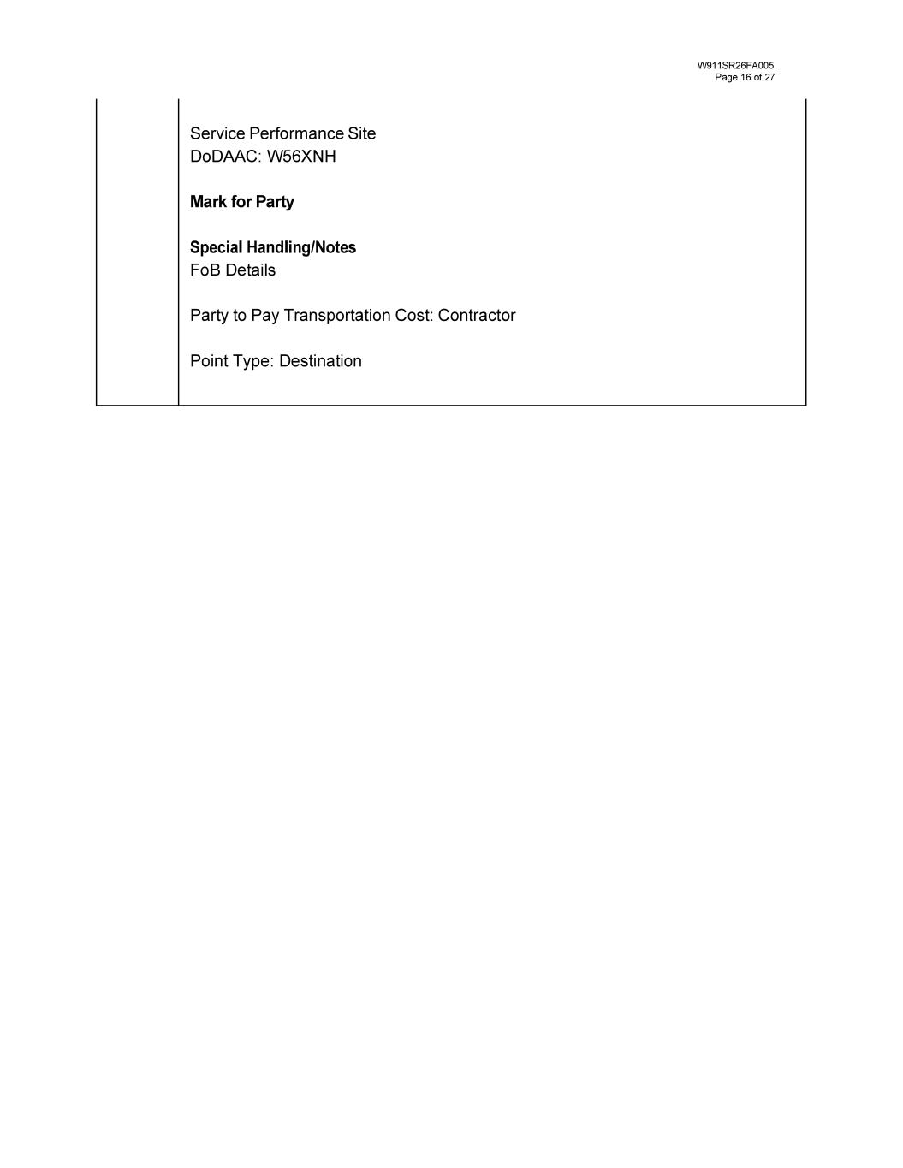

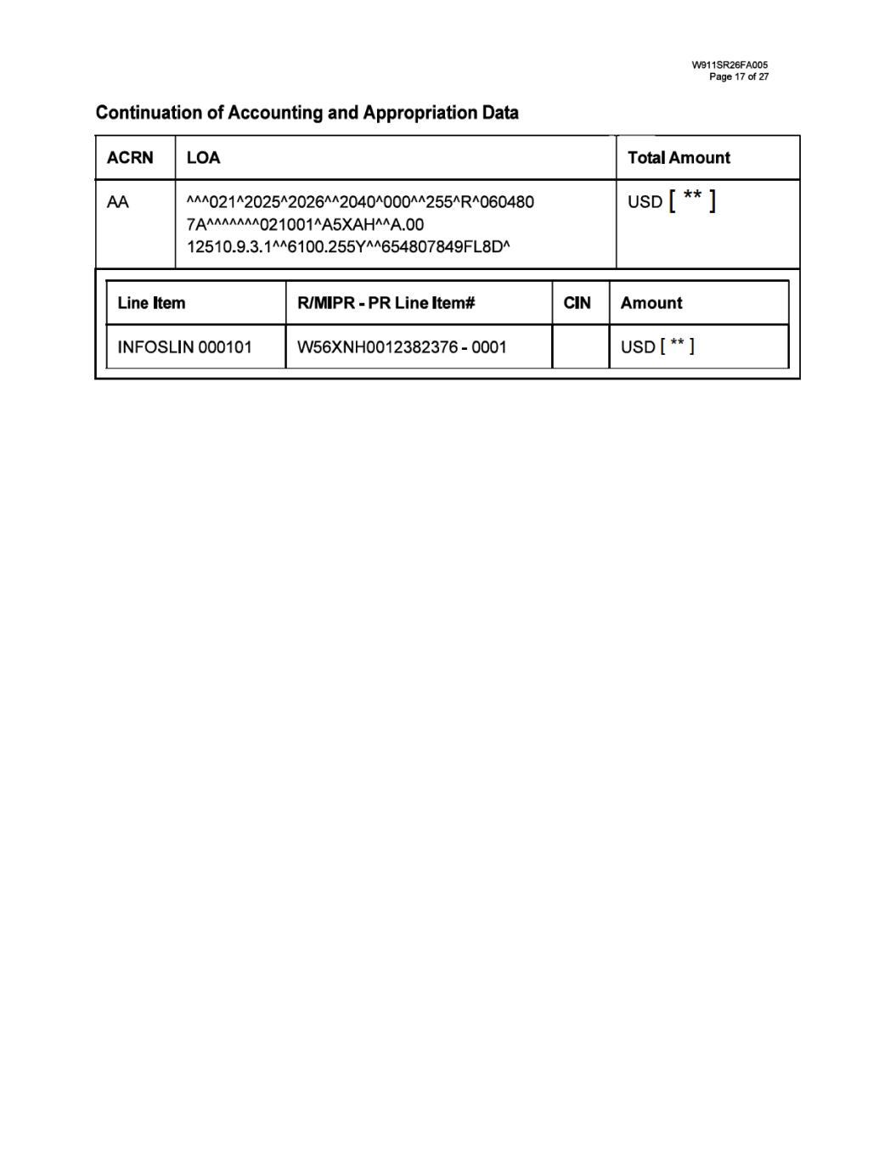

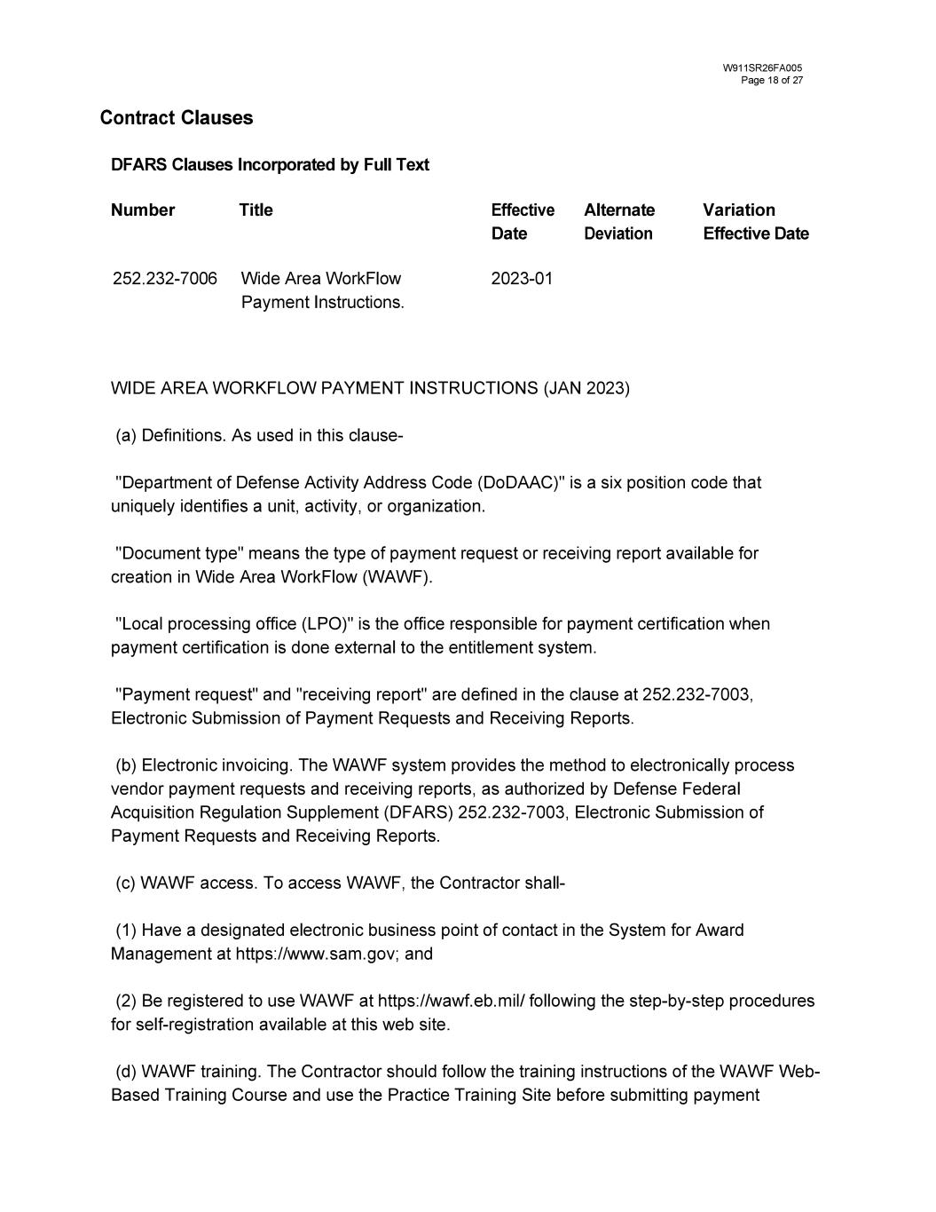

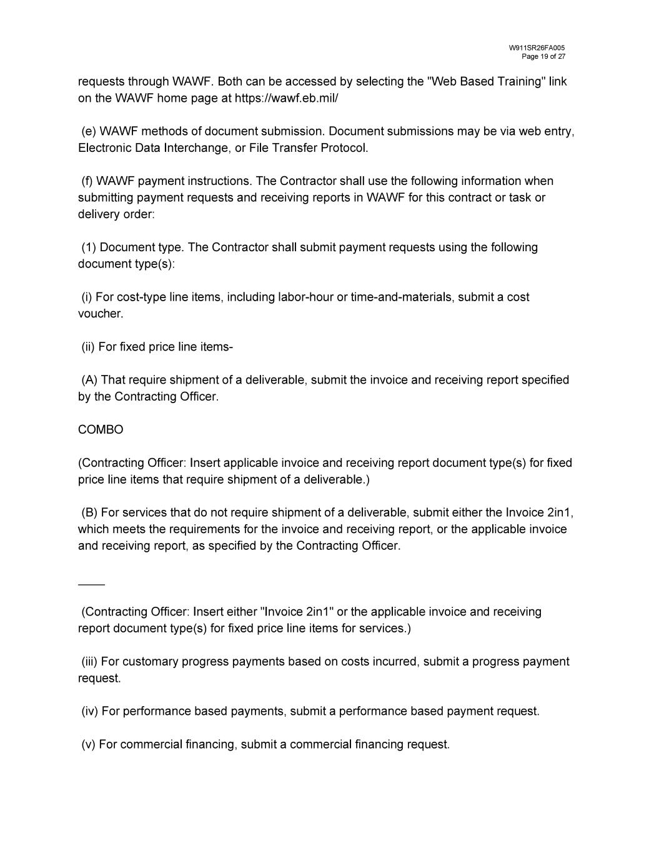

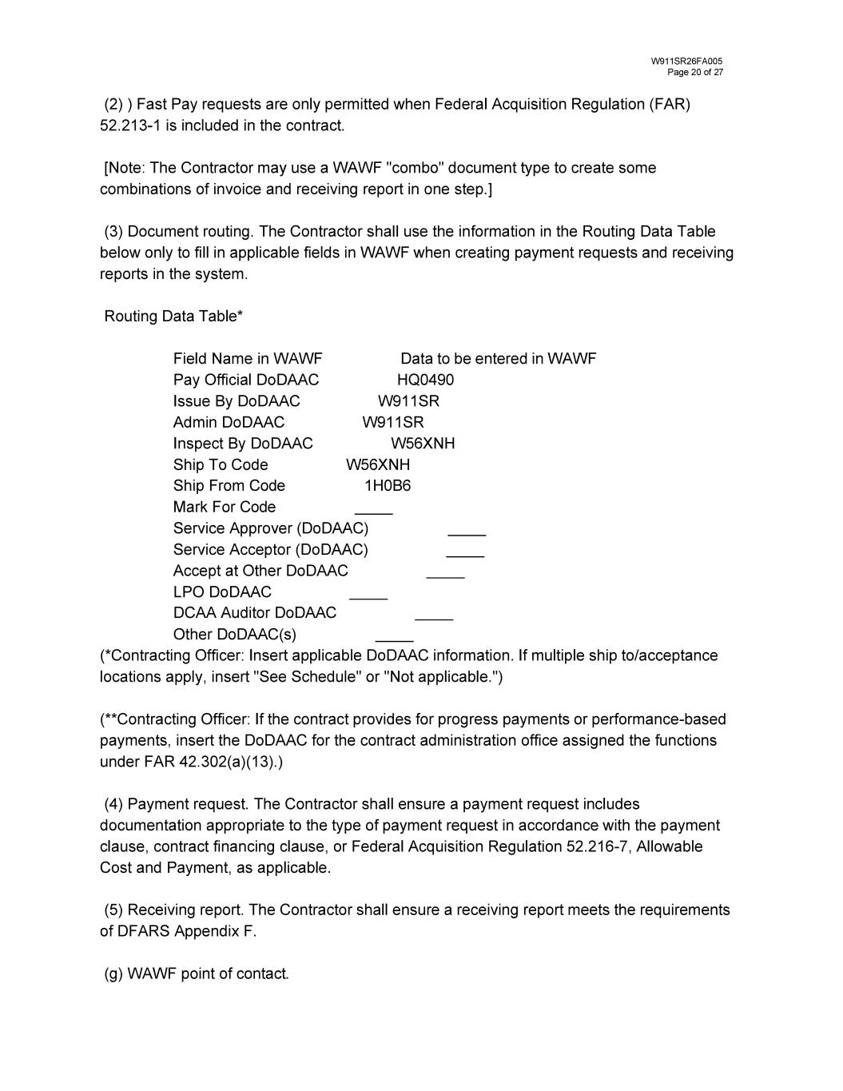

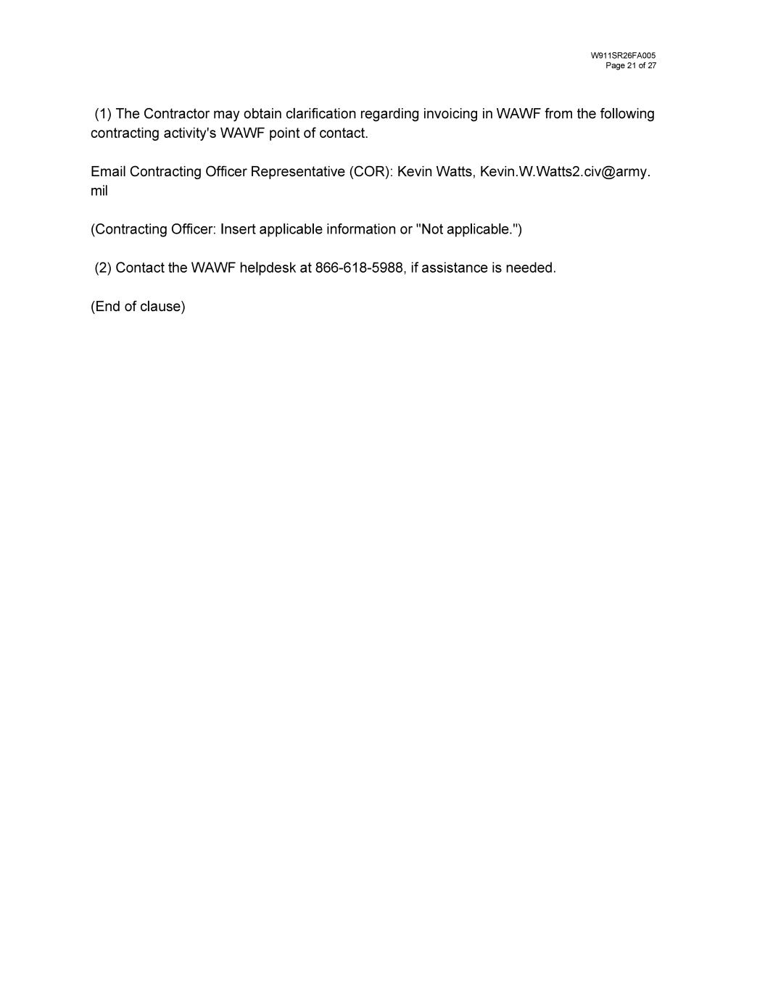

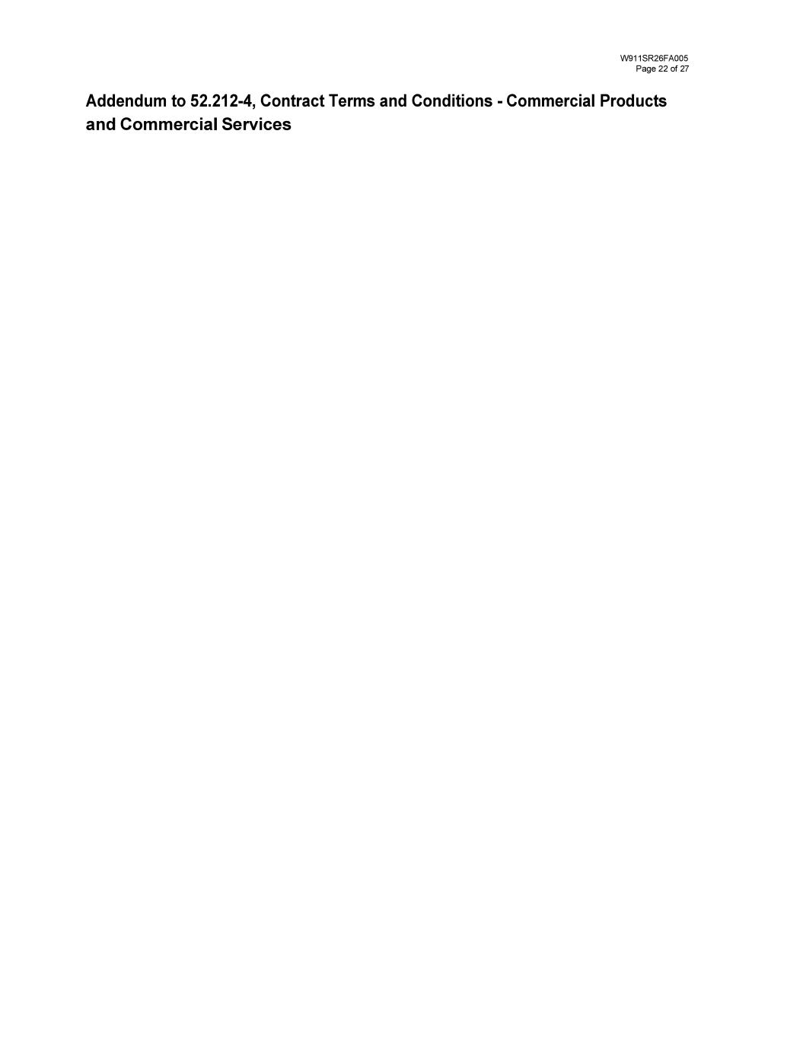

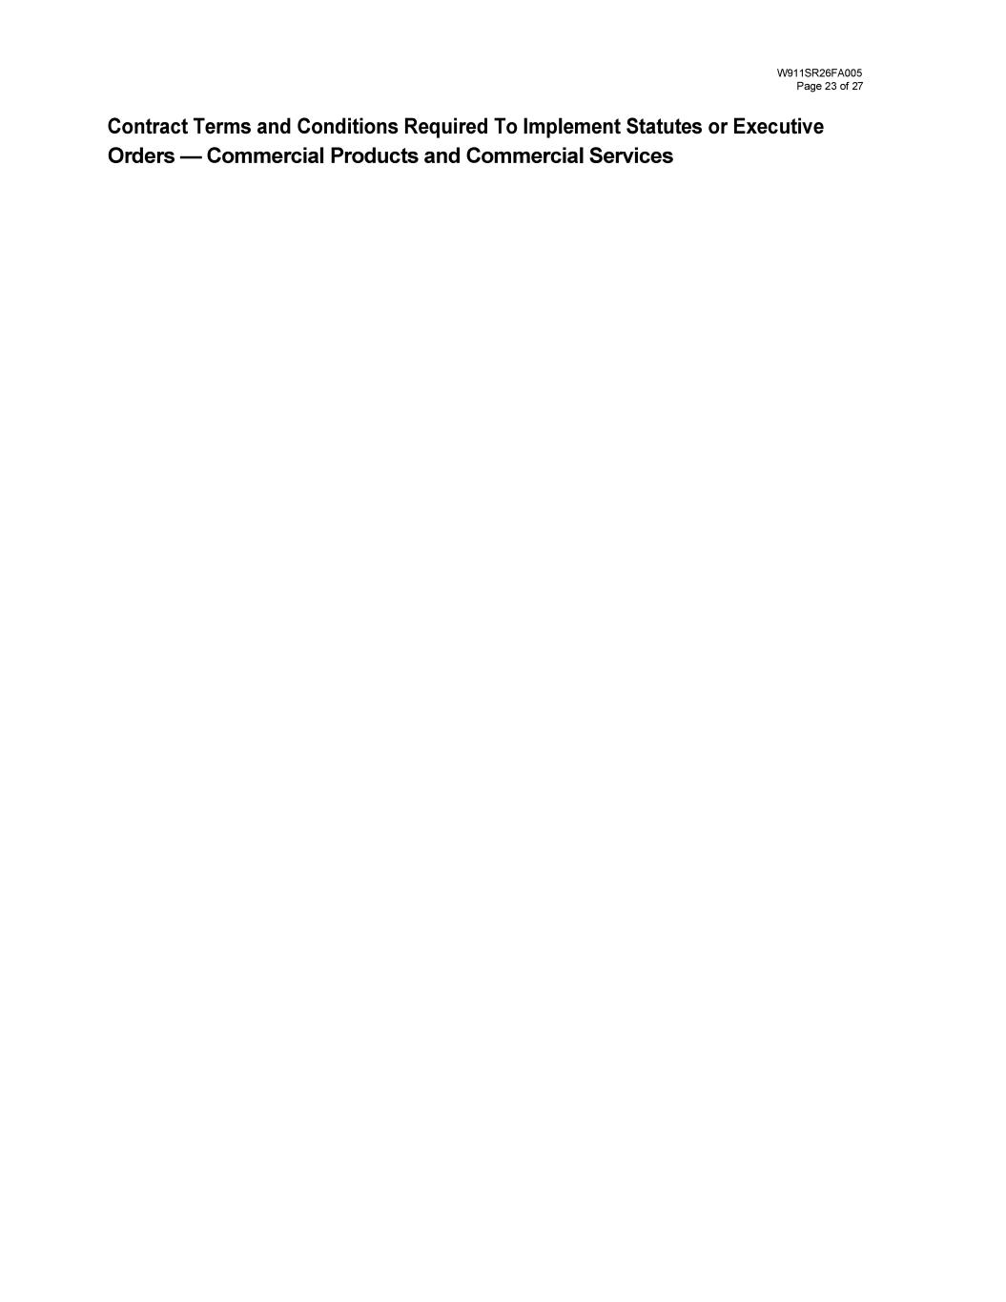

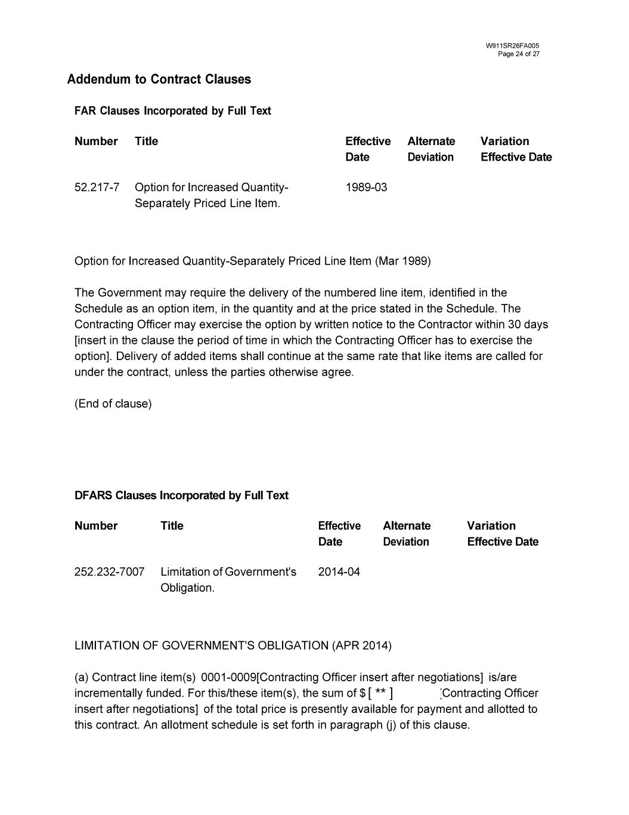
[ ** ]

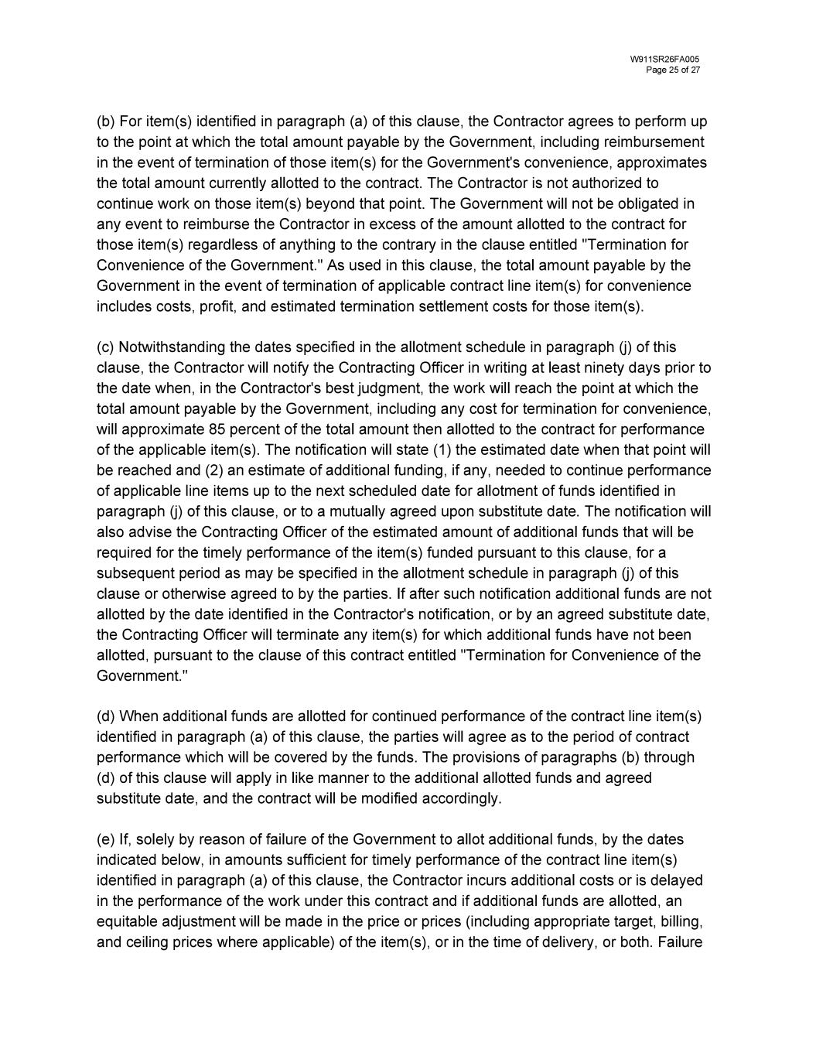

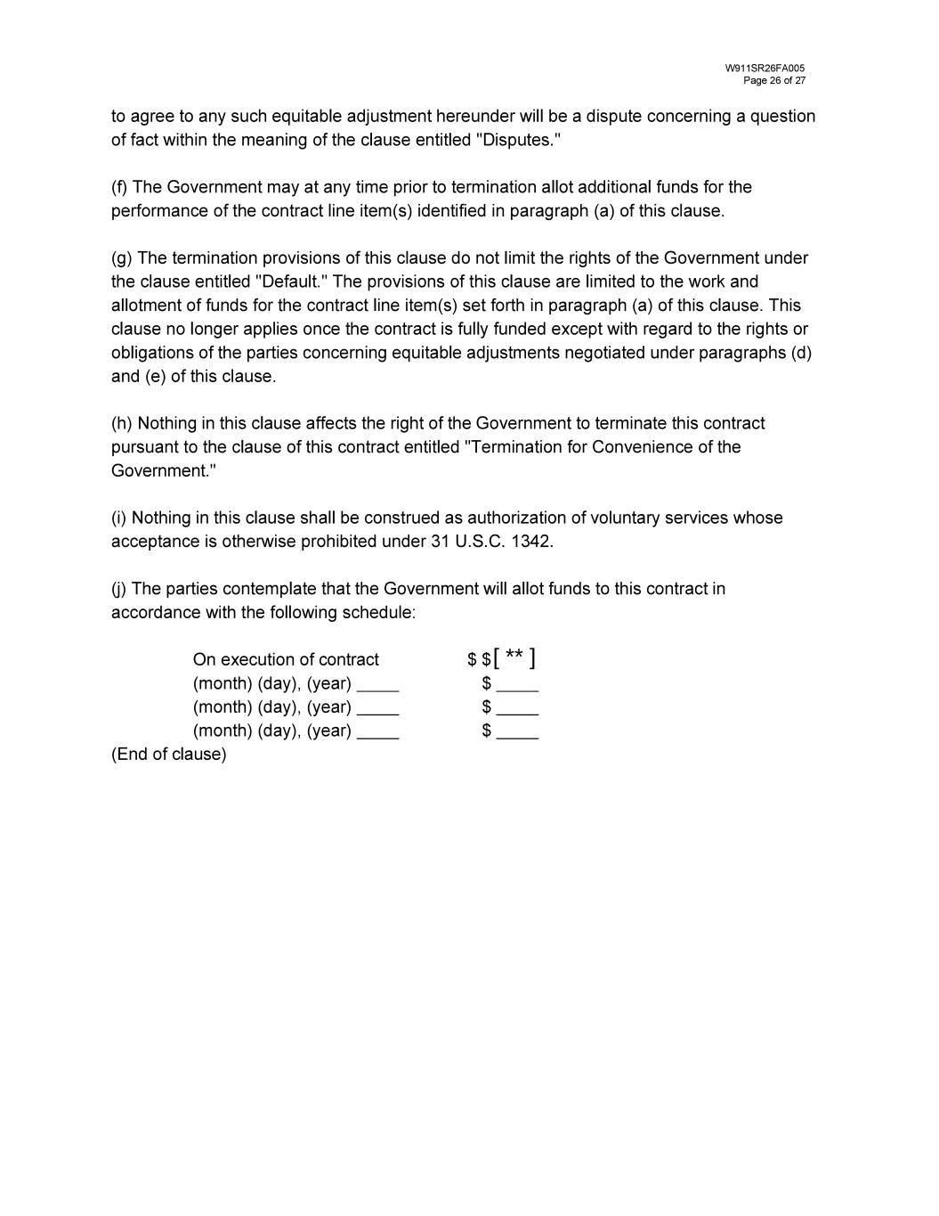
[ ** ]


List of Contract Documents, Exhibits, or Attachments W911SR26FA005 Page27 of27 Certain identified information has been excluded from this exhibit because it is both (i) not material and (ii) is the type of information that the registrant treats as private or confidential. Double asterisks denote omissions.

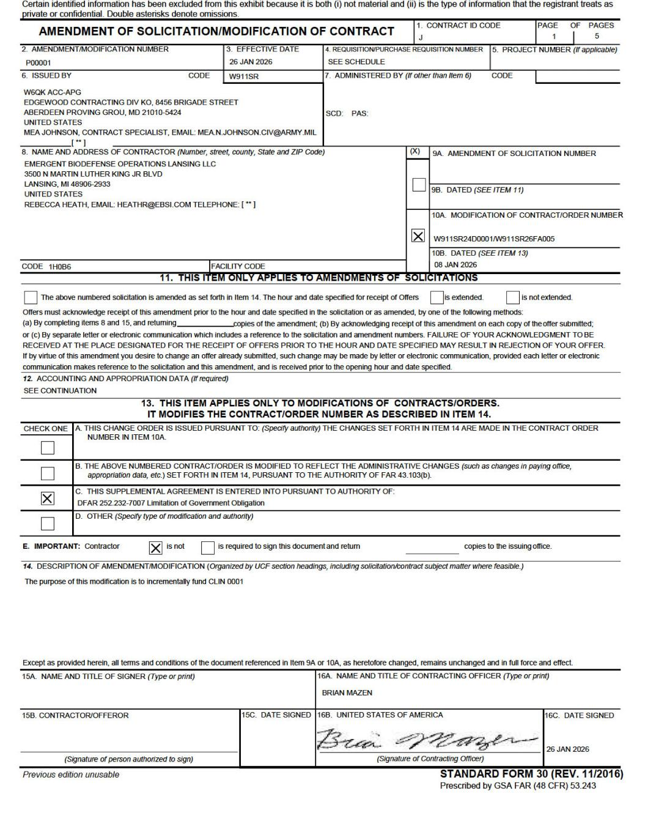

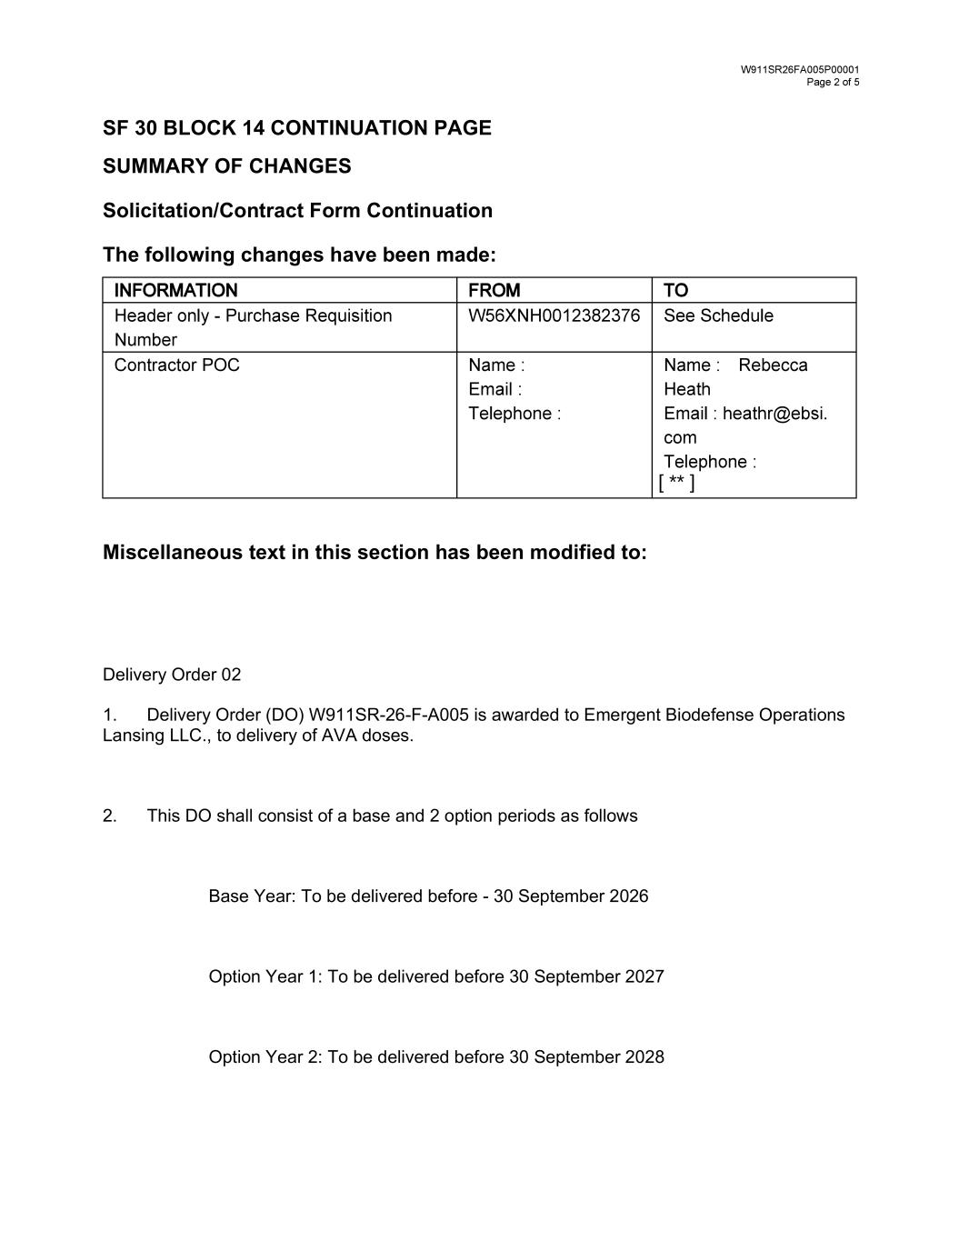
SF 30 BLOCK 14 CONTINUATION PAGE SUMMARY OF CHANGES Solicitation/Contract Form Continuation The following changes have been made: Miscellaneous text in this section has been modified to: Delivery Order 02 1. Delivery Order (DO) W911SR-26-F-A005 is awarded to Emergent Biodefense Operations Lansing LLC., to delivery of AVA doses. 2. This DO shall consist of a base and 2 option periods as follows Base Year: To be delivered before - 30 September 2026 Option Year 1: To be delivered before 30 September 2027 Option Year 2: To be delivered before 30 September 2028 [ ** ]

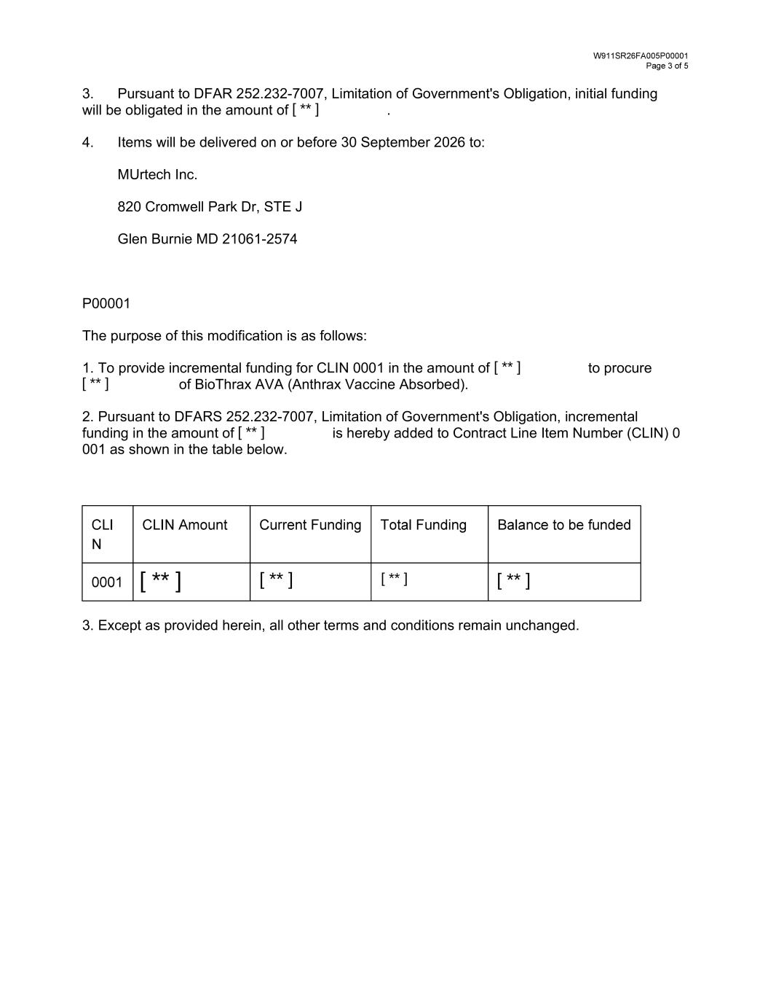
3. Pursuant to DFAR 252.232-7007, Limitation of Government's Obligation, initial funding will be obligated in the amount of . 4. Items will be delivered on or before 30 September 2026 to: MUrtech Inc. 820 Cromwell Park Dr, STE J Glen Burnie MD 21061-2574 P00001 The purpose of this modification is as follows: 1. To provide incremental funding for CLIN 0001 in the amount of to procure of BioThrax AVA (Anthrax Vaccine Absorbed). 2. Pursuant to DFARS 252.232-7007, Limitation of Government's Obligation, incremental funding in the amount of is hereby added to Contract Line Item Number (CLIN) 0 001 as shown in the table below. 3. Except as provided herein, all other terms and conditions remain unchanged. [ ** ] [ ** ] [ ** ] [ ** ] [ ** ] [ ** ] [ ** ] [ ** ]

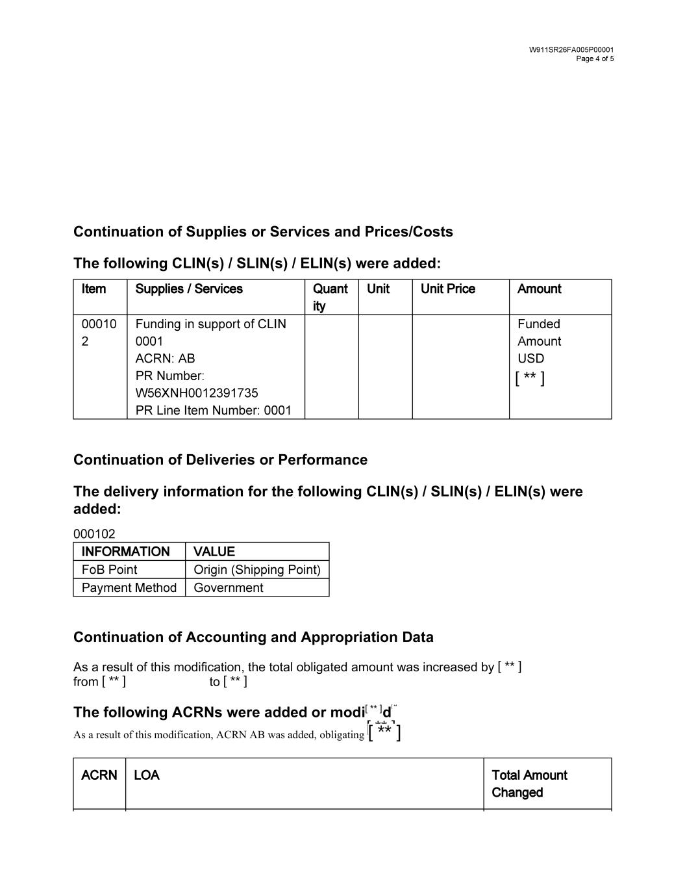
Continuation of Supplies or Services and Prices/Costs The following CLIN(s) / SLIN(s) / ELIN(s) were added: Continuation of Deliveries or Performance The delivery information for the following CLIN(s) / SLIN(s) / ELIN(s) were added: Continuation of Accounting and Appropriation Data As a result of this modification, the total obligated amount was increased by from to The following ACRNs were added or modi d [ ** ] [ ** ] [ ** ] [ ** ][ ** ] [ ** ][ ** ] [ ** ]

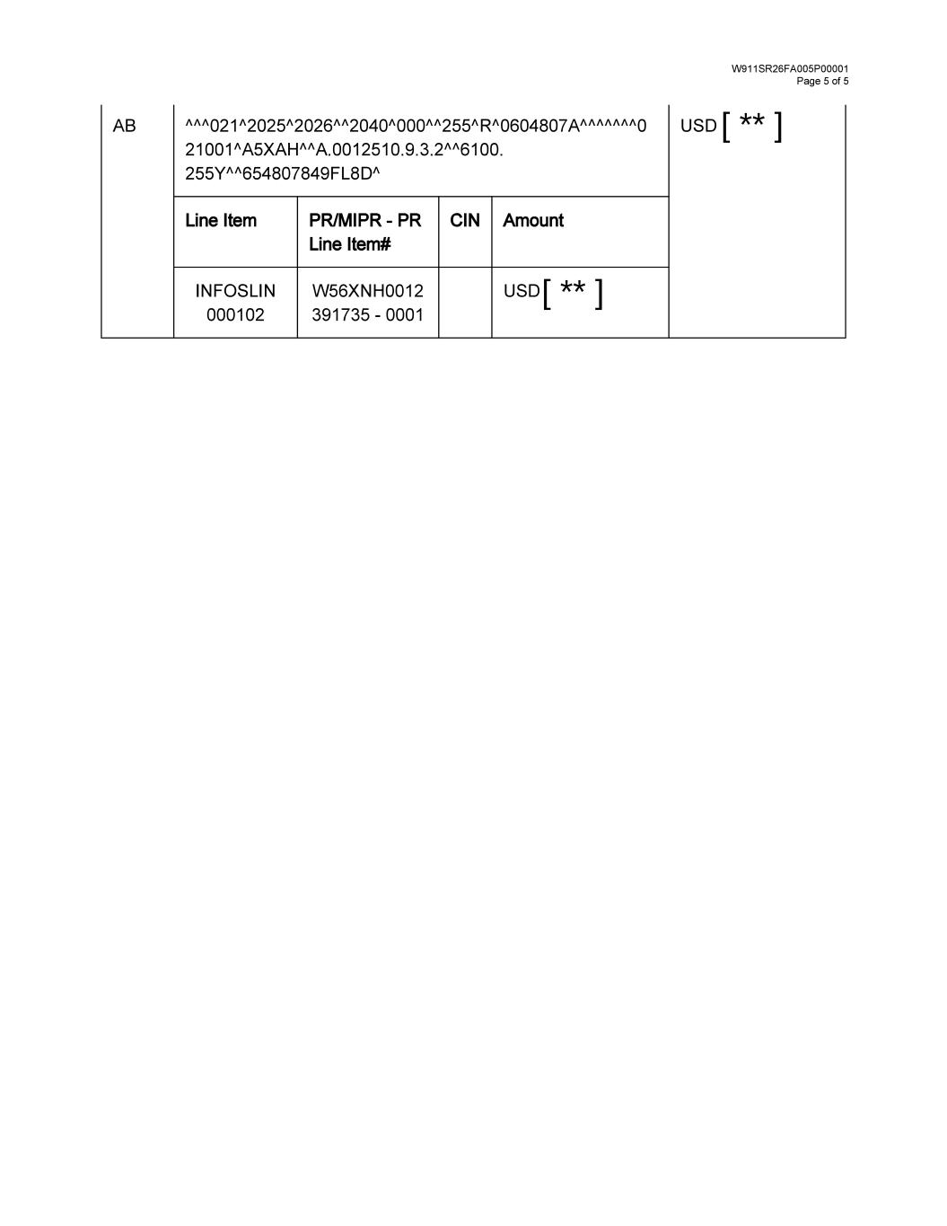
[ ** ] [ ** ]

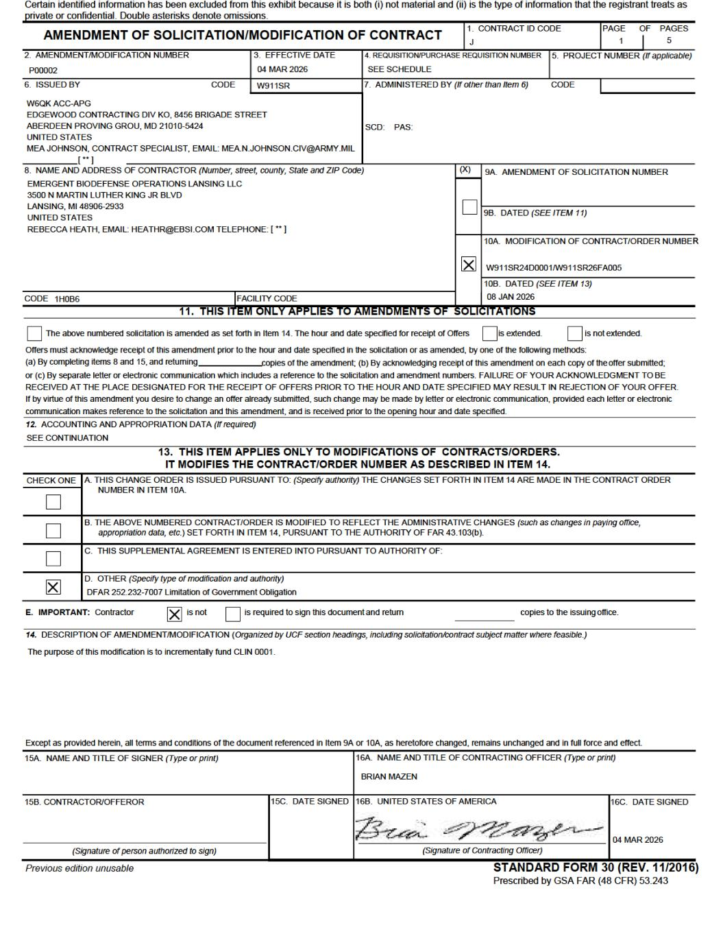

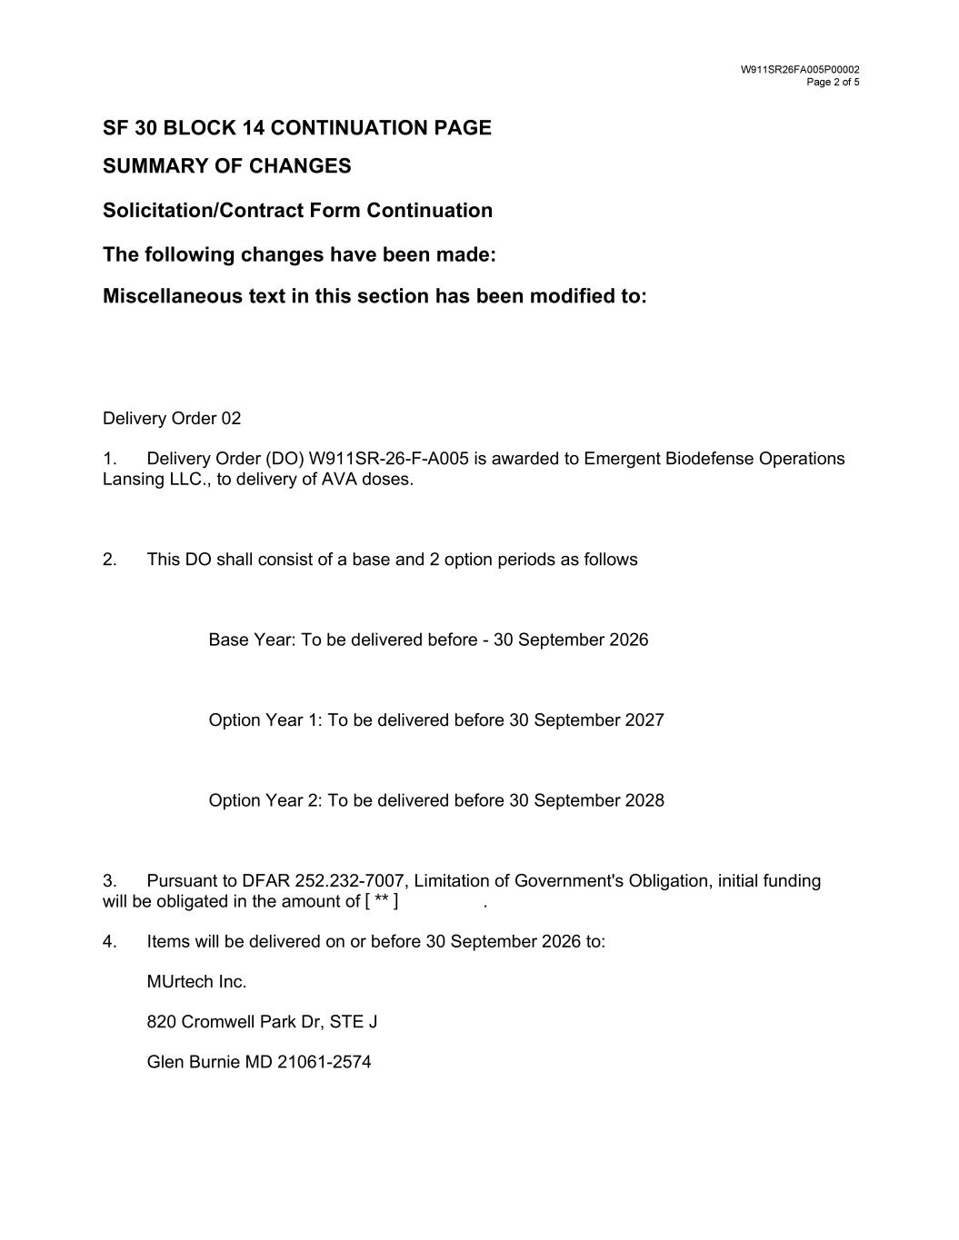
SF 30 BLOCK 14 CONTINUATION PAGE SUMMARY OF CHANGES Solicitation/Contract Form Continuation The following changes have been made: Miscellaneous text in this section has been modified to: Delivery Order 02 1. Delivery Order (DO) W911SR-26-F-A005 is awarded to Emergent Biodefense Operations Lansing LLC., to delivery of AVA doses. 2. This DO shall consist of a base and 2 option periods as follows Base Year: To be delivered before - 30 September 2026 Option Year 1: To be delivered before 30 September 2027 Option Year 2: To be delivered before 30 September 2028 3. Pursuant to DFAR 252.232-7007, Limitation of Government's Obligation, initial funding will be obligated in the amount of . 4. Items will be delivered on or before 30 September 2026 to: MUrtech Inc. 820 Cromwell Park Dr, STE J Glen Burnie MD 21061-2574 [ ** ]

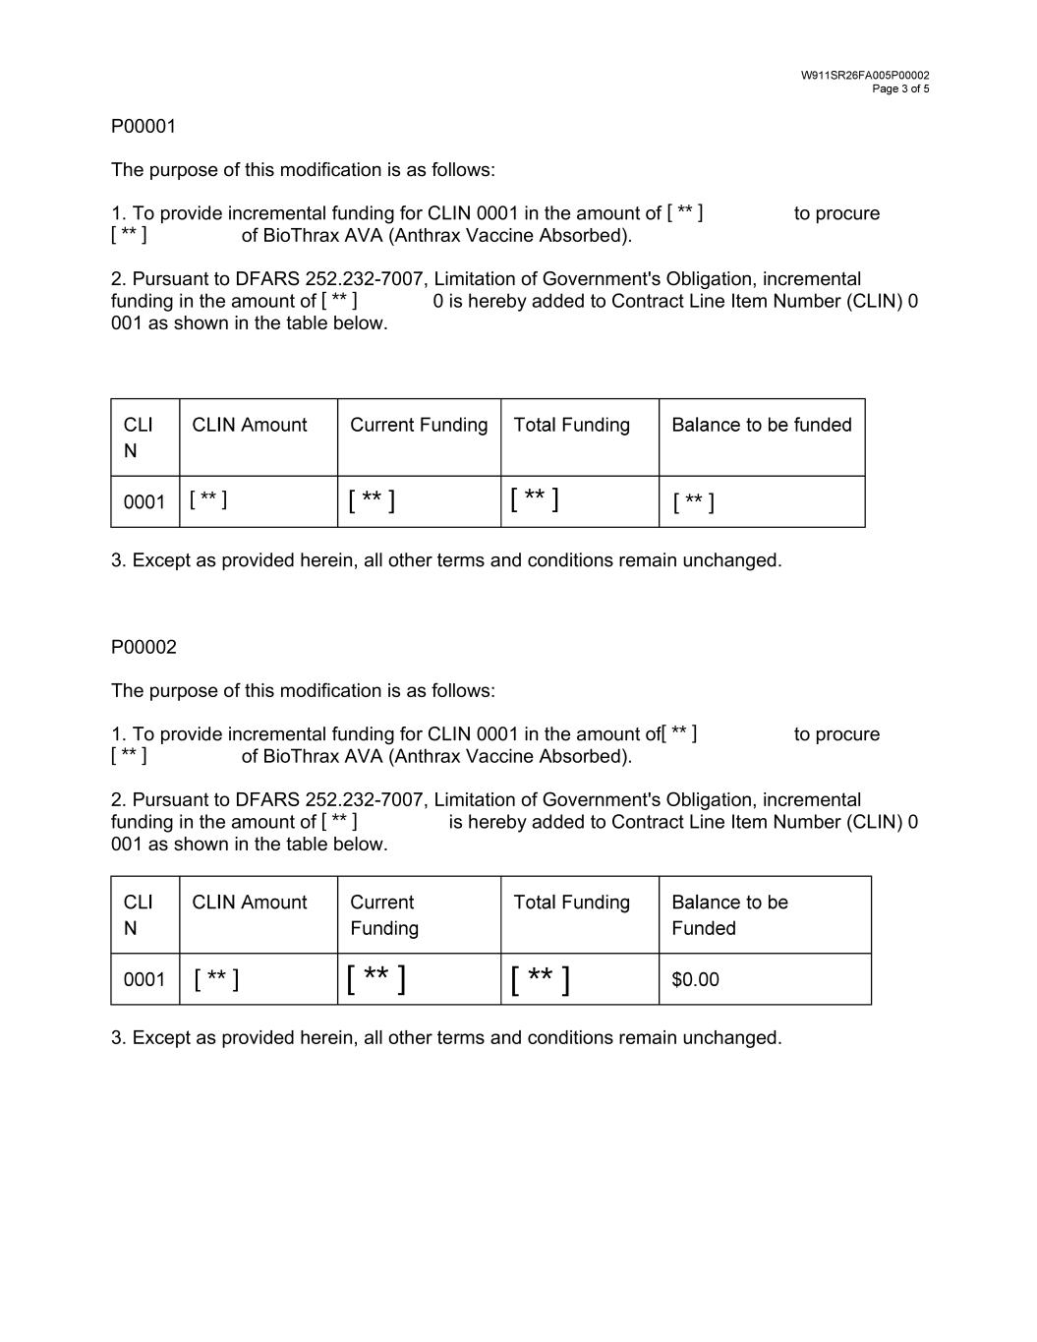
P00001 The purpose of this modification is as follows: 1. To provide incremental funding for CLIN 0001 in the amount of to procure of BioThrax AVA (Anthrax Vaccine Absorbed). 2. Pursuant to DFARS 252.232-7007, Limitation of Government's Obligation, incremental funding in the amount of 0 is hereby added to Contract Line Item Number (CLIN) 0 001 as shown in the table below. 3. Except as provided herein, all other terms and conditions remain unchanged. P00002 The purpose of this modification is as follows: 1. To provide incremental funding for CLIN 0001 in the amount of to procure of BioThrax AVA (Anthrax Vaccine Absorbed). 2. Pursuant to DFARS 252.232-7007, Limitation of Government's Obligation, incremental funding in the amount of is hereby added to Contract Line Item Number (CLIN) 0 001 as shown in the table below. 3. Except as provided herein, all other terms and conditions remain unchanged. [ ** ] [ ** ] [ ** ] [ ** ] [ ** ] [ ** ] [ ** ] [ ** ] [ ** ] [ ** ] [ ** ] [ ** ] [ ** ]

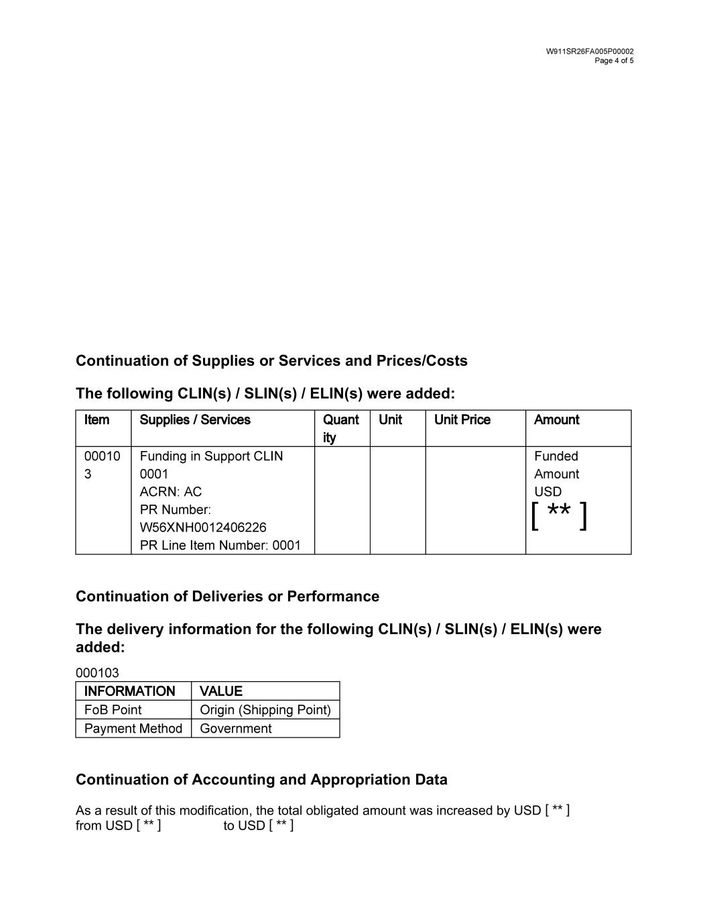
Continuation of Supplies or Services and Prices/Costs The following CLIN(s) / SLIN(s) / ELIN(s) were added: Continuation of Deliveries or Performance The delivery information for the following CLIN(s) / SLIN(s) / ELIN(s) were added: Continuation of Accounting and Appropriation Data As a result of this modification, the total obligated amount was increased by USD from USD to USD [ ** ] [ ** ] [ ** ] [ ** ]

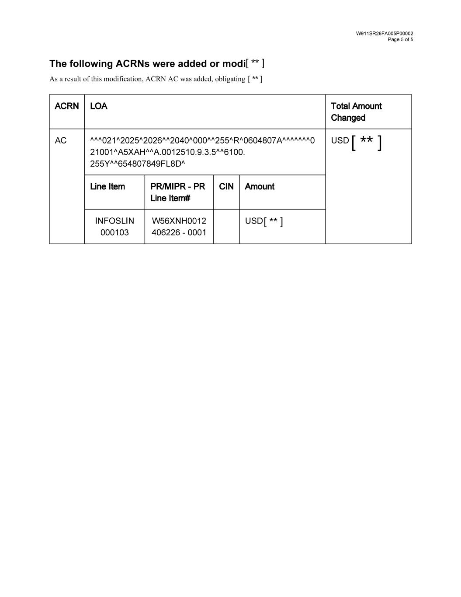
The following ACRNs were added or modi [ ** ] [ ** ] [ ** ] [ ** ]

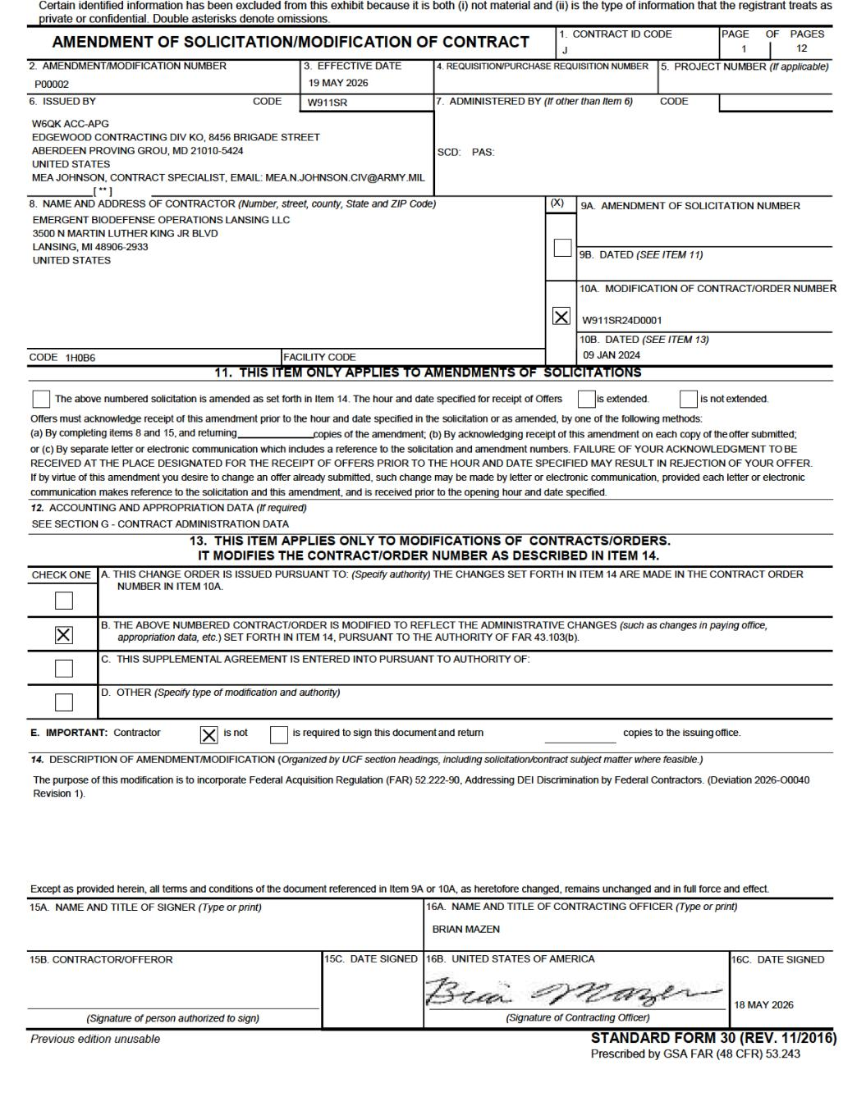

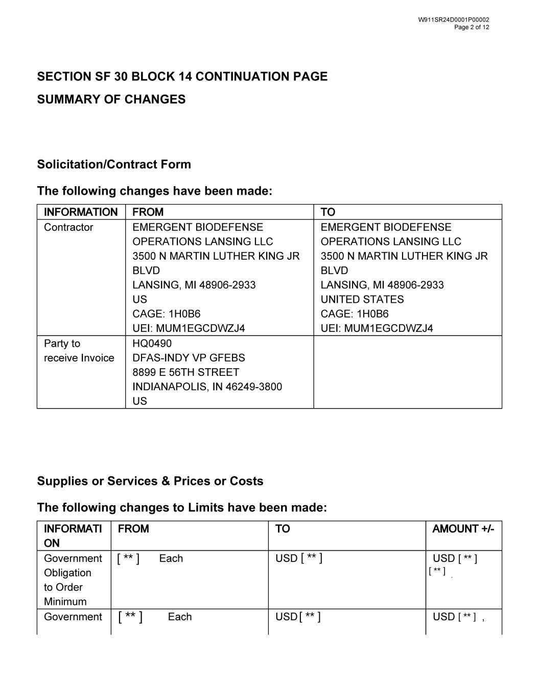
SECTION SF 30 BLOCK 14 CONTINUATION PAGE SUMMARY OF CHANGES Solicitation/Contract Form The following changes have been made: Supplies or Services & Prices or Costs The following changes to Limits have been made: [ ** ] [ ** ][ ** ] [ ** ] [ ** ] [ ** ] [ ** ]

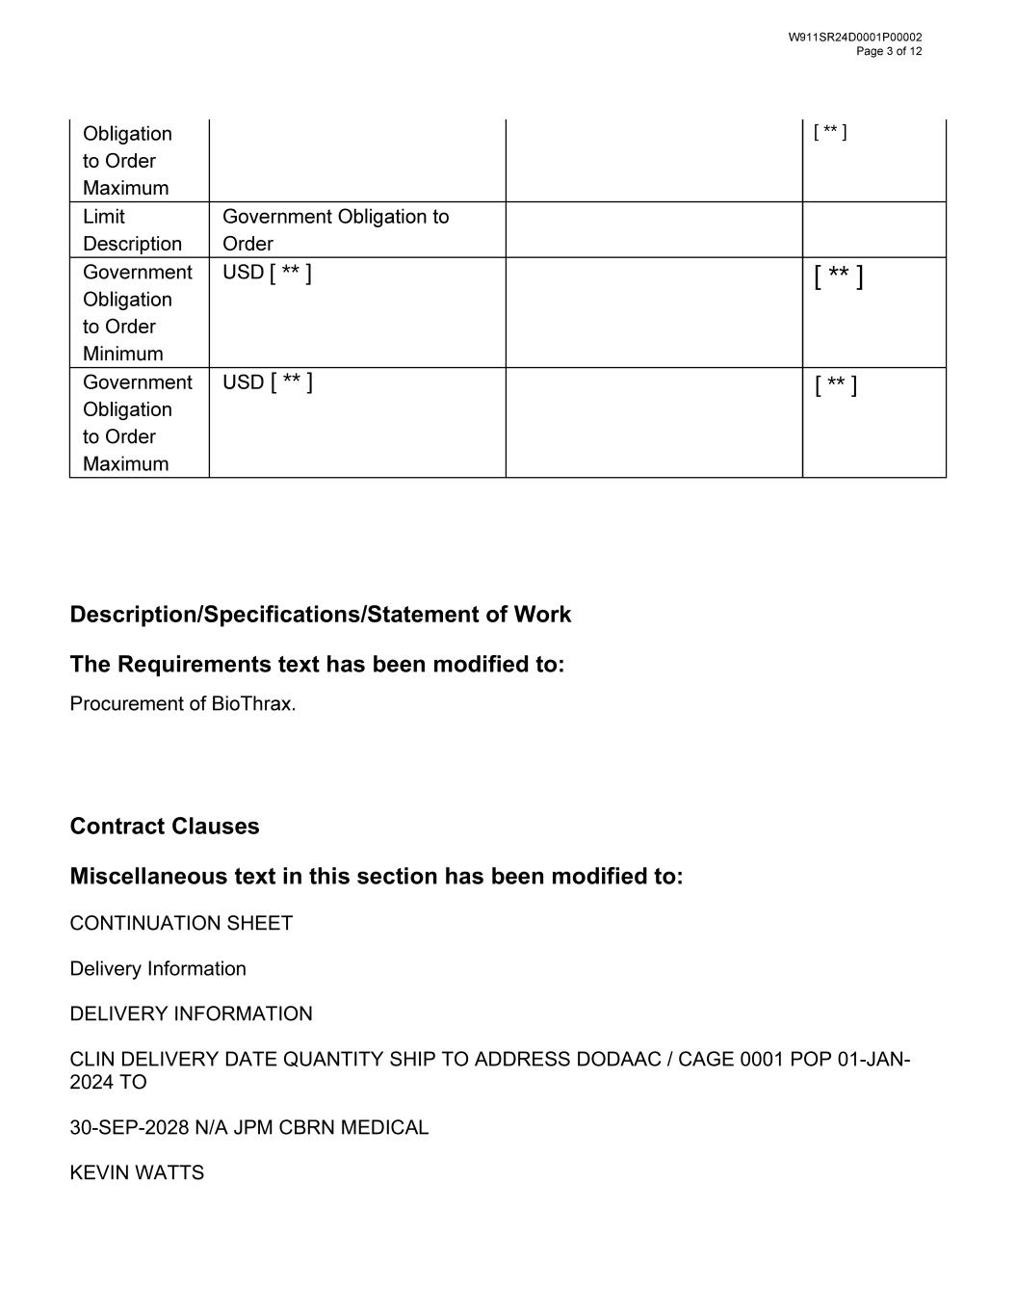
Description/Specifications/Statement of Work The Requirements text has been modified to: Contract Clauses Miscellaneous text in this section has been modified to: CONTINUATION SHEET Delivery Information DELIVERY INFORMATION CLIN DELIVERY DATE QUANTITY SHIP TO ADDRESS DODAAC / CAGE 0001 POP 01-JAN- 2024 TO 30-SEP-2028 N/A JPM CBRN MEDICAL KEVIN WATTS [ ** ] [ ** ] [ ** ] [ ** ] [ ** ]

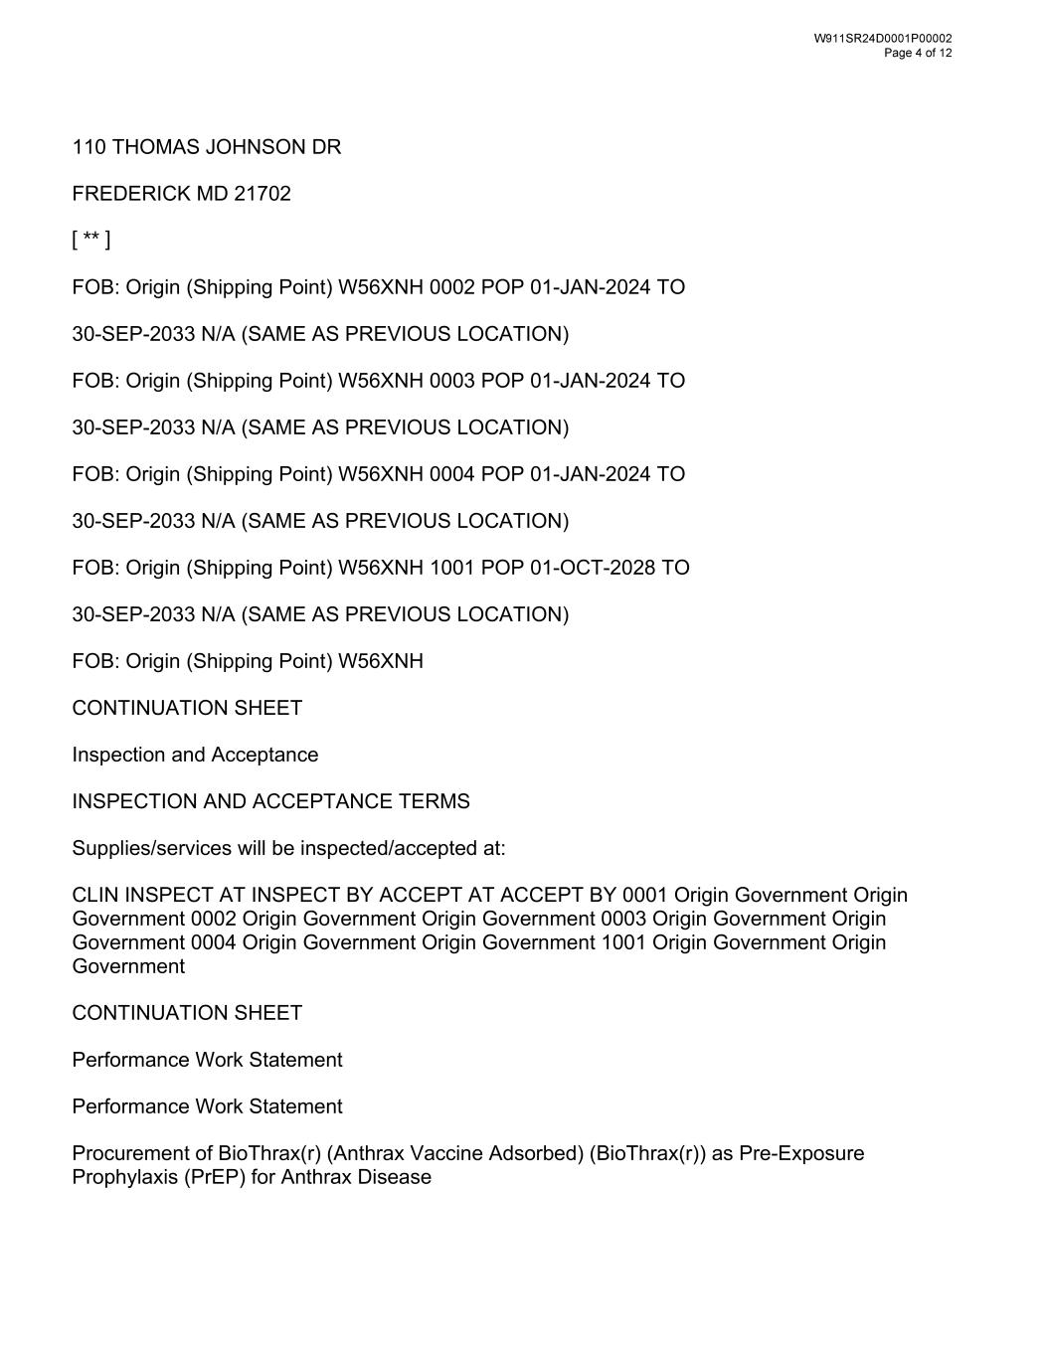
110 THOMAS JOHNSON DR FREDERICK MD 21702 FOB: Origin (Shipping Point) W56XNH 0002 POP 01-JAN-2024 TO 30-SEP-2033 N/A (SAME AS PREVIOUS LOCATION) FOB: Origin (Shipping Point) W56XNH 0003 POP 01-JAN-2024 TO 30-SEP-2033 N/A (SAME AS PREVIOUS LOCATION) FOB: Origin (Shipping Point) W56XNH 0004 POP 01-JAN-2024 TO 30-SEP-2033 N/A (SAME AS PREVIOUS LOCATION) FOB: Origin (Shipping Point) W56XNH 1001 POP 01-OCT-2028 TO 30-SEP-2033 N/A (SAME AS PREVIOUS LOCATION) FOB: Origin (Shipping Point) W56XNH CONTINUATION SHEET Inspection and Acceptance INSPECTION AND ACCEPTANCE TERMS Supplies/services will be inspected/accepted at: CLIN INSPECT AT INSPECT BY ACCEPT AT ACCEPT BY 0001 Origin Government Origin Government 0002 Origin Government Origin Government 0003 Origin Government Origin Government 0004 Origin Government Origin Government 1001 Origin Government Origin Government CONTINUATION SHEET Performance Work Statement Performance Work Statement Procurement of BioThrax(r) (Anthrax Vaccine Adsorbed) (BioThrax(r)) as Pre-Exposure Prophylaxis (PrEP) for Anthrax Disease [ ** ]

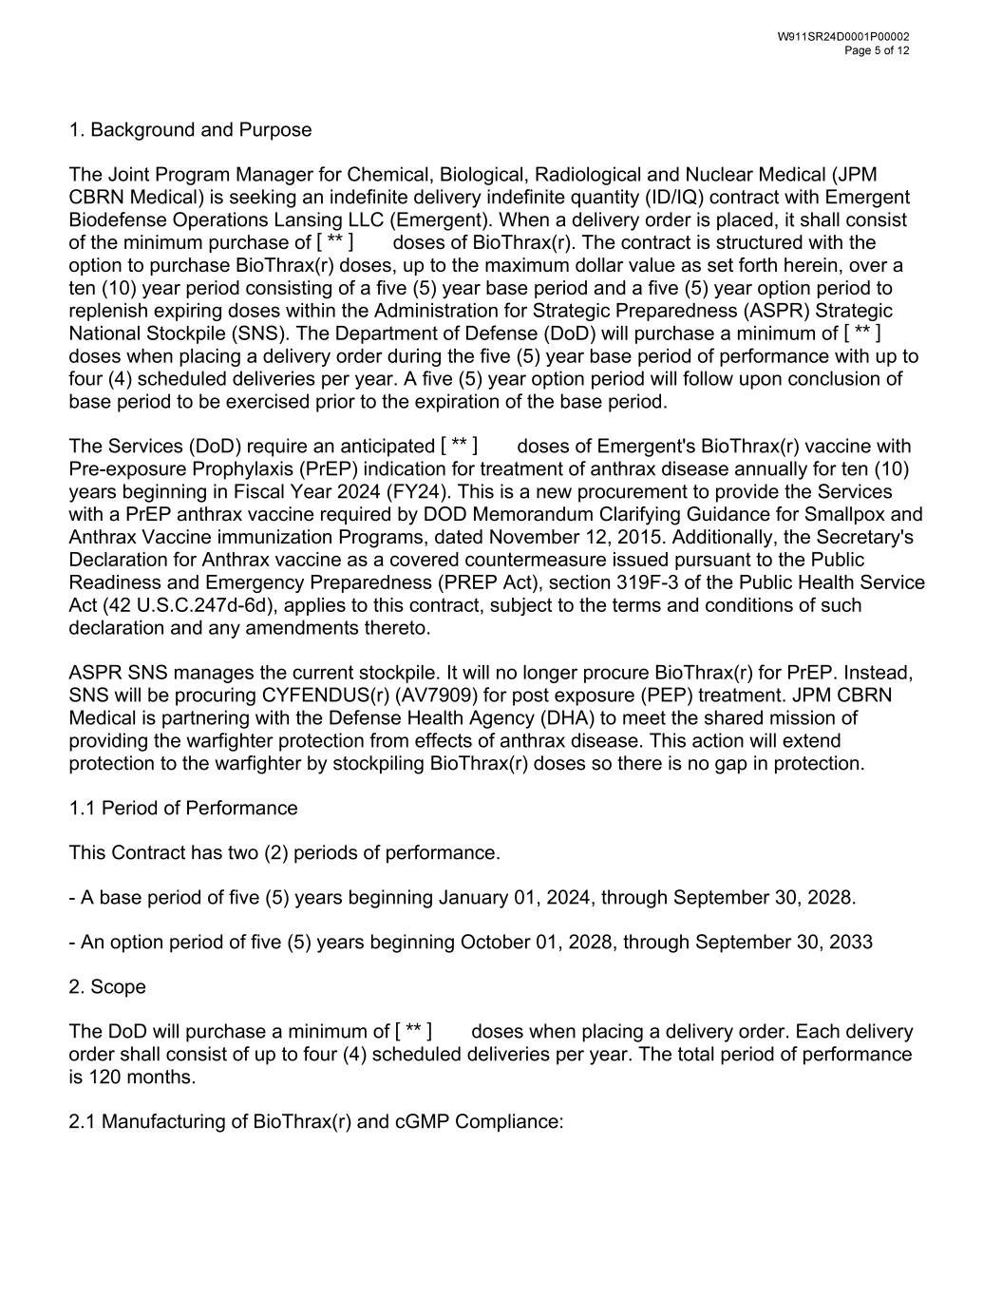
1. Background and Purpose The Joint Program Manager for Chemical, Biological, Radiological and Nuclear Medical (JPM CBRN Medical) is seeking an indefinite delivery indefinite quantity (ID/IQ) contract with Emergent Biodefense Operations Lansing LLC (Emergent). When a delivery order is placed, it shall consist of the minimum purchase of doses of BioThrax(r). The contract is structured with the option to purchase BioThrax(r) doses, up to the maximum dollar value as set forth herein, over a ten (10) year period consisting of a five (5) year base period and a five (5) year option period to replenish expiring doses within the Administration for Strategic Preparedness (ASPR) Strategic National Stockpile (SNS). The Department of Defense (DoD) will purchase a minimum of doses when placing a delivery order during the five (5) year base period of performance with up to four (4) scheduled deliveries per year. A five (5) year option period will follow upon conclusion of base period to be exercised prior to the expiration of the base period. The Services (DoD) require an anticipated doses of Emergent's BioThrax(r) vaccine with Pre-exposure Prophylaxis (PrEP) indication for treatment of anthrax disease annually for ten (10) years beginning in Fiscal Year 2024 (FY24). This is a new procurement to provide the Services with a PrEP anthrax vaccine required by DOD Memorandum Clarifying Guidance for Smallpox and Anthrax Vaccine immunization Programs, dated November 12, 2015. Additionally, the Secretary's Declaration for Anthrax vaccine as a covered countermeasure issued pursuant to the Public Readiness and Emergency Preparedness (PREP Act), section 319F-3 of the Public Health Service Act (42 U.S.C.247d-6d), applies to this contract, subject to the terms and conditions of such declaration and any amendments thereto. ASPR SNS manages the current stockpile. It will no longer procure BioThrax(r) for PrEP. Instead, SNS will be procuring CYFENDUS(r) (AV7909) for post exposure (PEP) treatment. JPM CBRN Medical is partnering with the Defense Health Agency (DHA) to meet the shared mission of providing the warfighter protection from effects of anthrax disease. This action will extend protection to the warfighter by stockpiling BioThrax(r) doses so there is no gap in protection. 1.1 Period of Performance This Contract has two (2) periods of performance. - A base period of five (5) years beginning January 01, 2024, through September 30, 2028. - An option period of five (5) years beginning October 01, 2028, through September 30, 2033 2. Scope The DoD will purchase a minimum of doses when placing a delivery order. Each delivery order shall consist of up to four (4) scheduled deliveries per year. The total period of performance is 120 months. 2.1 Manufacturing of BioThrax(r) and cGMP Compliance: [ ** ] [ ** ] [ ** ] [ ** ]

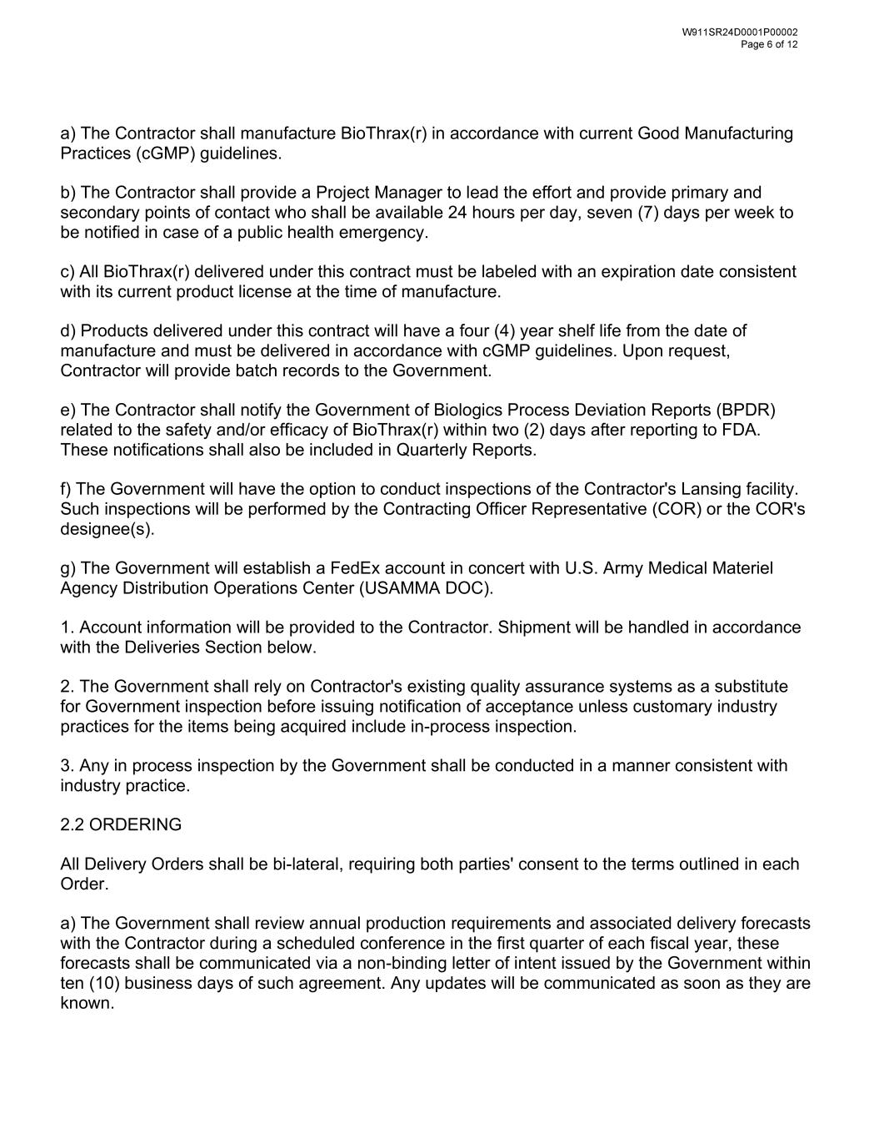
a) The Contractor shall manufacture BioThrax(r) in accordance with current Good Manufacturing Practices (cGMP) guidelines. b) The Contractor shall provide a Project Manager to lead the effort and provide primary and secondary points of contact who shall be available 24 hours per day, seven (7) days per week to be notified in case of a public health emergency. c) All BioThrax(r) delivered under this contract must be labeled with an expiration date consistent with its current product license at the time of manufacture. d) Products delivered under this contract will have a four (4) year shelf life from the date of manufacture and must be delivered in accordance with cGMP guidelines. Upon request, Contractor will provide batch records to the Government. e) The Contractor shall notify the Government of Biologics Process Deviation Reports (BPDR) related to the safety and/or efficacy of BioThrax(r) within two (2) days after reporting to FDA. These notifications shall also be included in Quarterly Reports. f) The Government will have the option to conduct inspections of the Contractor's Lansing facility. Such inspections will be performed by the Contracting Officer Representative (COR) or the COR's designee(s). g) The Government will establish a FedEx account in concert with U.S. Army Medical Materiel Agency Distribution Operations Center (USAMMA DOC). 1. Account information will be provided to the Contractor. Shipment will be handled in accordance with the Deliveries Section below. 2. The Government shall rely on Contractor's existing quality assurance systems as a substitute for Government inspection before issuing notification of acceptance unless customary industry practices for the items being acquired include in-process inspection. 3. Any in process inspection by the Government shall be conducted in a manner consistent with industry practice. 2.2 ORDERING All Delivery Orders shall be bi-lateral, requiring both parties' consent to the terms outlined in each Order. a) The Government shall review annual production requirements and associated delivery forecasts with the Contractor during a scheduled conference in the first quarter of each fiscal year, these forecasts shall be communicated via a non-binding letter of intent issued by the Government within ten (10) business days of such agreement. Any updates will be communicated as soon as they are known.

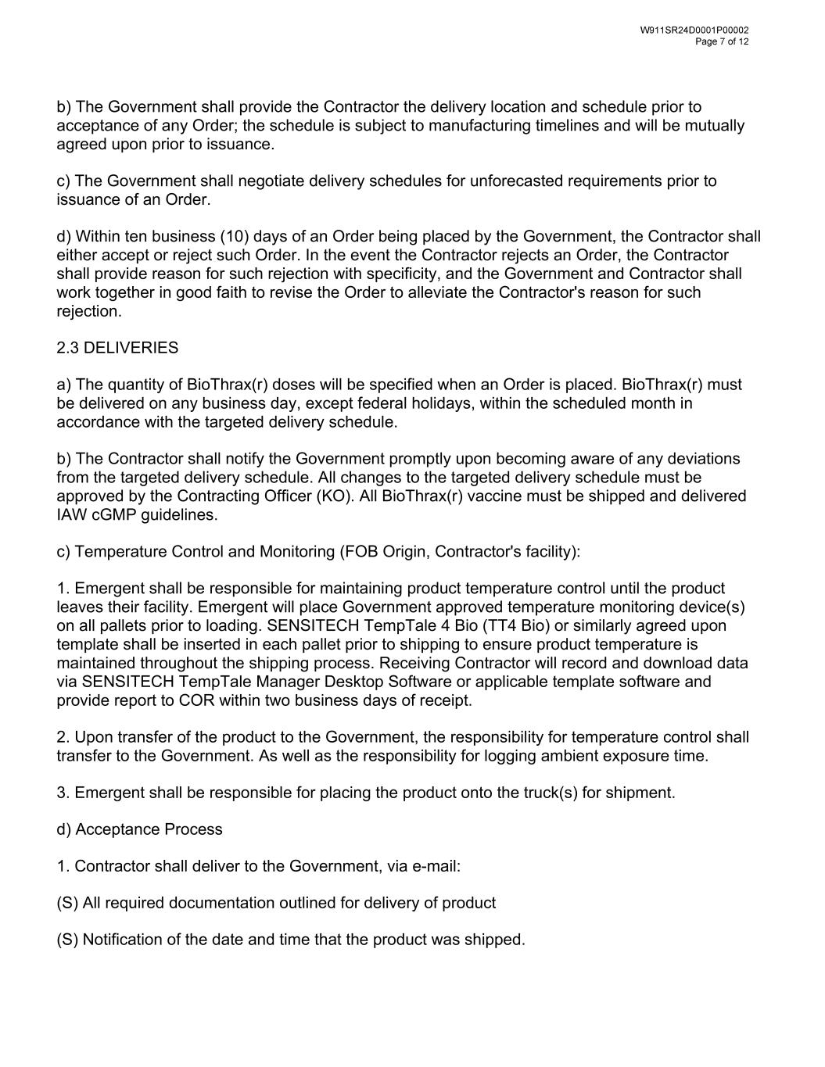
b) The Government shall provide the Contractor the delivery location and schedule prior to acceptance of any Order; the schedule is subject to manufacturing timelines and will be mutually agreed upon prior to issuance. c) The Government shall negotiate delivery schedules for unforecasted requirements prior to issuance of an Order. d) Within ten business (10) days of an Order being placed by the Government, the Contractor shall either accept or reject such Order. In the event the Contractor rejects an Order, the Contractor shall provide reason for such rejection with specificity, and the Government and Contractor shall work together in good faith to revise the Order to alleviate the Contractor's reason for such rejection. 2.3 DELIVERIES a) The quantity of BioThrax(r) doses will be specified when an Order is placed. BioThrax(r) must be delivered on any business day, except federal holidays, within the scheduled month in accordance with the targeted delivery schedule. b) The Contractor shall notify the Government promptly upon becoming aware of any deviations from the targeted delivery schedule. All changes to the targeted delivery schedule must be approved by the Contracting Officer (KO). All BioThrax(r) vaccine must be shipped and delivered IAW cGMP guidelines. c) Temperature Control and Monitoring (FOB Origin, Contractor's facility): 1. Emergent shall be responsible for maintaining product temperature control until the product leaves their facility. Emergent will place Government approved temperature monitoring device(s) on all pallets prior to loading. SENSITECH TempTale 4 Bio (TT4 Bio) or similarly agreed upon template shall be inserted in each pallet prior to shipping to ensure product temperature is maintained throughout the shipping process. Receiving Contractor will record and download data via SENSITECH TempTale Manager Desktop Software or applicable template software and provide report to COR within two business days of receipt. 2. Upon transfer of the product to the Government, the responsibility for temperature control shall transfer to the Government. As well as the responsibility for logging ambient exposure time. 3. Emergent shall be responsible for placing the product onto the truck(s) for shipment. d) Acceptance Process 1. Contractor shall deliver to the Government, via e-mail: (S) All required documentation outlined for delivery of product (S) Notification of the date and time that the product was shipped.

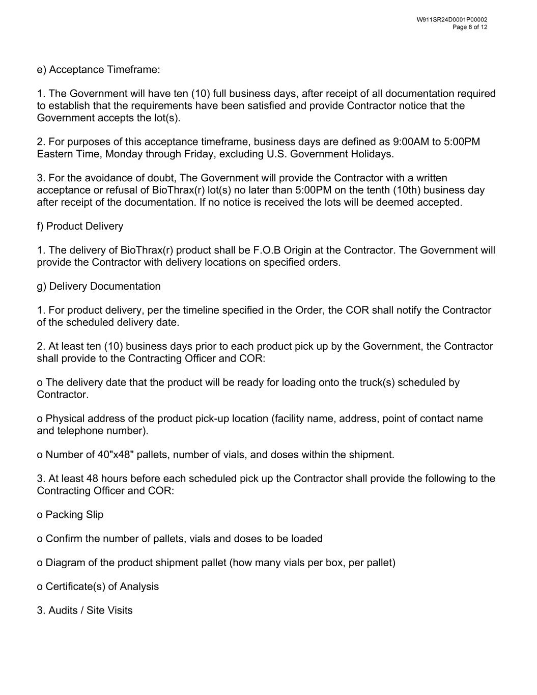
e) Acceptance Timeframe: 1. The Government will have ten (10) full business days, after receipt of all documentation required to establish that the requirements have been satisfied and provide Contractor notice that the Government accepts the lot(s). 2. For purposes of this acceptance timeframe, business days are defined as 9:00AM to 5:00PM Eastern Time, Monday through Friday, excluding U.S. Government Holidays. 3. For the avoidance of doubt, The Government will provide the Contractor with a written acceptance or refusal of BioThrax(r) lot(s) no later than 5:00PM on the tenth (10th) business day after receipt of the documentation. If no notice is received the lots will be deemed accepted. f) Product Delivery 1. The delivery of BioThrax(r) product shall be F.O.B Origin at the Contractor. The Government will provide the Contractor with delivery locations on specified orders. g) Delivery Documentation 1. For product delivery, per the timeline specified in the Order, the COR shall notify the Contractor of the scheduled delivery date. 2. At least ten (10) business days prior to each product pick up by the Government, the Contractor shall provide to the Contracting Officer and COR: o The delivery date that the product will be ready for loading onto the truck(s) scheduled by Contractor. o Physical address of the product pick-up location (facility name, address, point of contact name and telephone number). o Number of 40"x48" pallets, number of vials, and doses within the shipment. 3. At least 48 hours before each scheduled pick up the Contractor shall provide the following to the Contracting Officer and COR: o Packing Slip o Confirm the number of pallets, vials and doses to be loaded o Diagram of the product shipment pallet (how many vials per box, per pallet) o Certificate(s) of Analysis 3. Audits / Site Visits

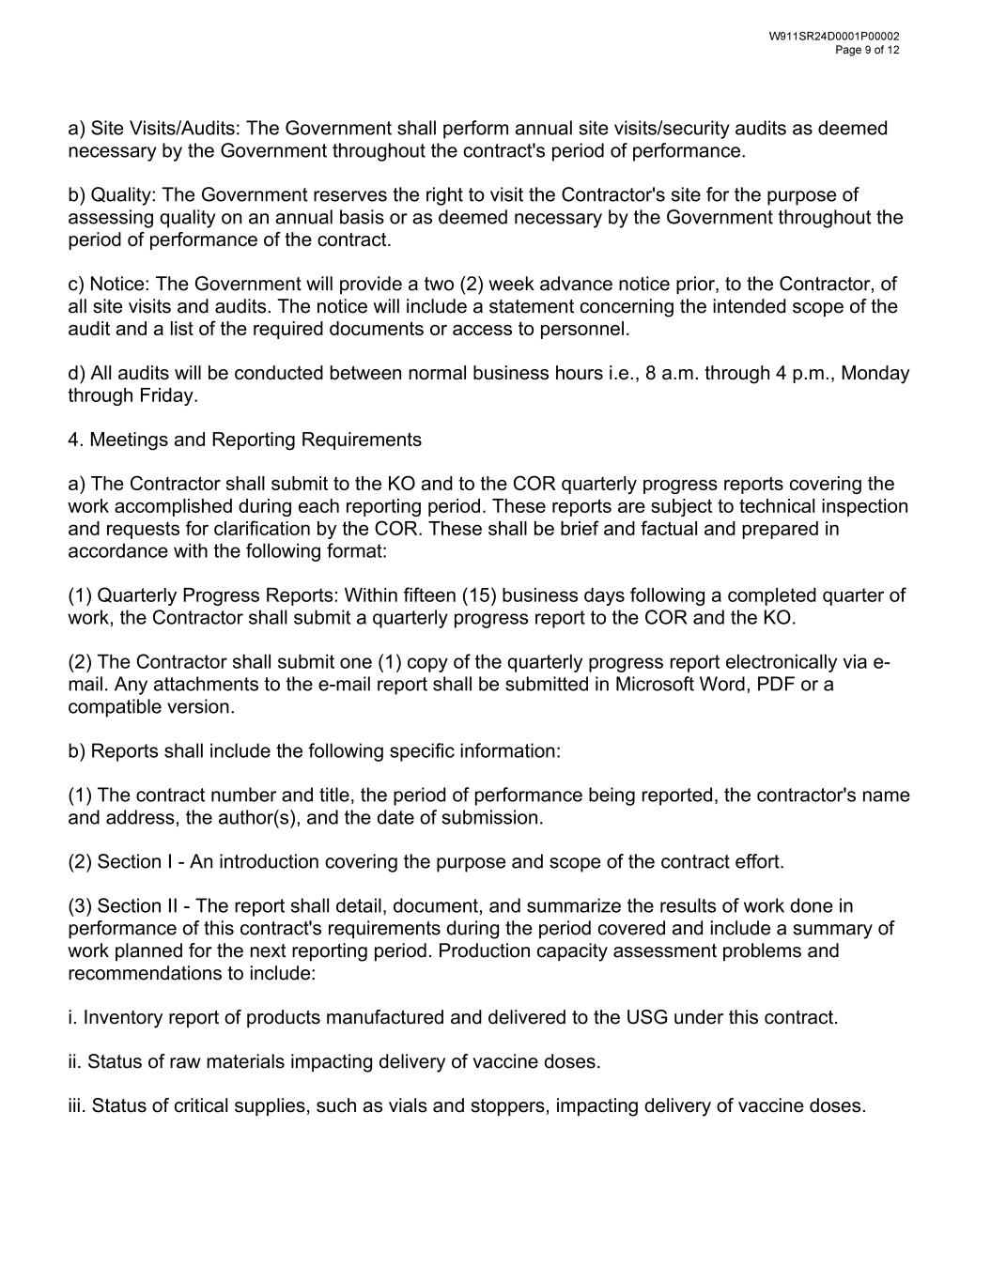
a) Site Visits/Audits: The Government shall perform annual site visits/security audits as deemed necessary by the Government throughout the contract's period of performance. b) Quality: The Government reserves the right to visit the Contractor's site for the purpose of assessing quality on an annual basis or as deemed necessary by the Government throughout the period of performance of the contract. c) Notice: The Government will provide a two (2) week advance notice prior, to the Contractor, of all site visits and audits. The notice will include a statement concerning the intended scope of the audit and a list of the required documents or access to personnel. d) All audits will be conducted between normal business hours i.e., 8 a.m. through 4 p.m., Monday through Friday. 4. Meetings and Reporting Requirements a) The Contractor shall submit to the KO and to the COR quarterly progress reports covering the work accomplished during each reporting period. These reports are subject to technical inspection and requests for clarification by the COR. These shall be brief and factual and prepared in accordance with the following format: (1) Quarterly Progress Reports: Within fifteen (15) business days following a completed quarter of work, the Contractor shall submit a quarterly progress report to the COR and the KO. (2) The Contractor shall submit one (1) copy of the quarterly progress report electronically via e- mail. Any attachments to the e-mail report shall be submitted in Microsoft Word, PDF or a compatible version. b) Reports shall include the following specific information: (1) The contract number and title, the period of performance being reported, the contractor's name and address, the author(s), and the date of submission. (2) Section I - An introduction covering the purpose and scope of the contract effort. (3) Section II - The report shall detail, document, and summarize the results of work done in performance of this contract's requirements during the period covered and include a summary of work planned for the next reporting period. Production capacity assessment problems and recommendations to include: i. Inventory report of products manufactured and delivered to the USG under this contract. ii. Status of raw materials impacting delivery of vaccine doses. iii. Status of critical supplies, such as vials and stoppers, impacting delivery of vaccine doses.

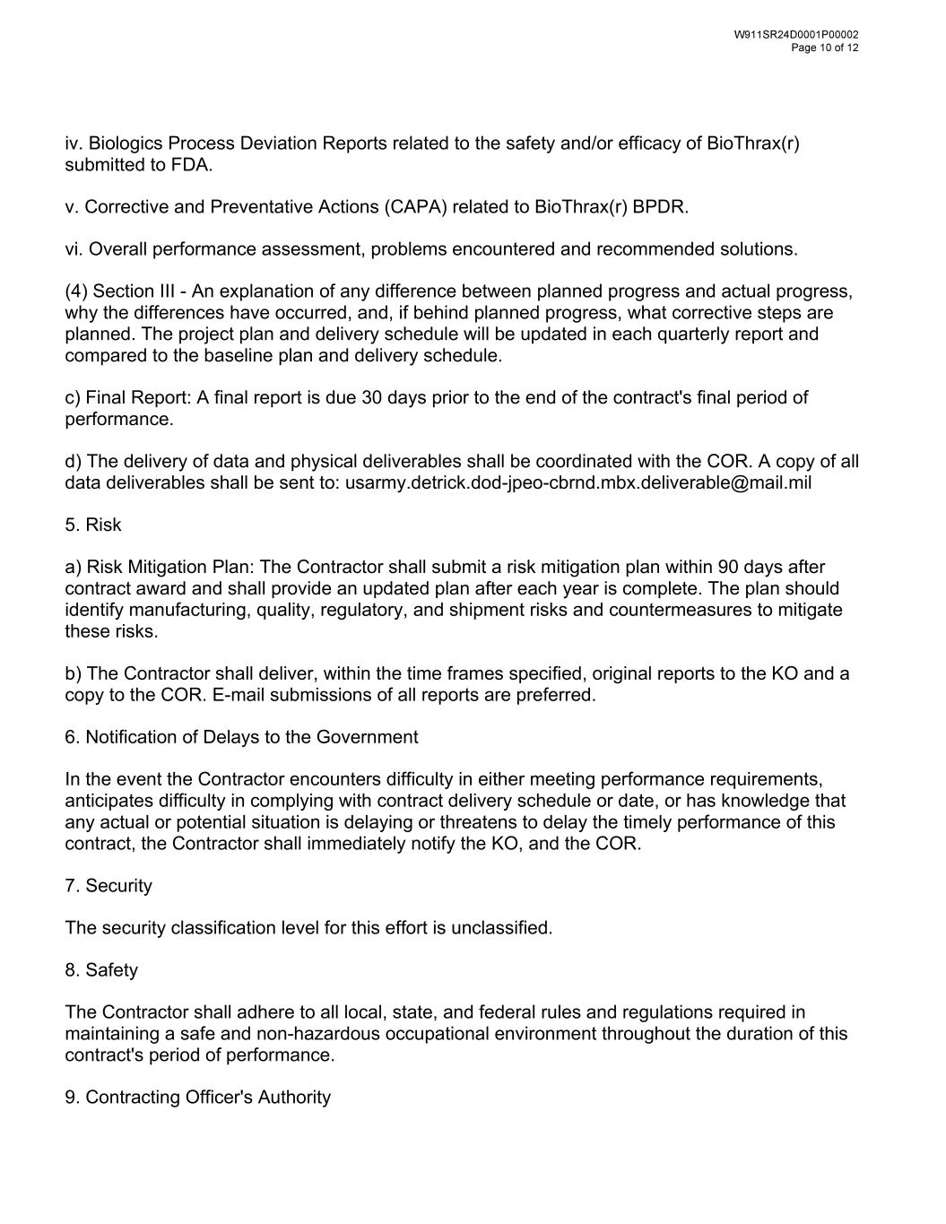
iv. Biologics Process Deviation Reports related to the safety and/or efficacy of BioThrax(r) submitted to FDA. v. Corrective and Preventative Actions (CAPA) related to BioThrax(r) BPDR. vi. Overall performance assessment, problems encountered and recommended solutions. (4) Section III - An explanation of any difference between planned progress and actual progress, why the differences have occurred, and, if behind planned progress, what corrective steps are planned. The project plan and delivery schedule will be updated in each quarterly report and compared to the baseline plan and delivery schedule. c) Final Report: A final report is due 30 days prior to the end of the contract's final period of performance. d) The delivery of data and physical deliverables shall be coordinated with the COR. A copy of all data deliverables shall be sent to: usarmy.detrick.dod-jpeo-cbrnd.mbx.deliverable@mail.mil 5. Risk a) Risk Mitigation Plan: The Contractor shall submit a risk mitigation plan within 90 days after contract award and shall provide an updated plan after each year is complete. The plan should identify manufacturing, quality, regulatory, and shipment risks and countermeasures to mitigate these risks. b) The Contractor shall deliver, within the time frames specified, original reports to the KO and a copy to the COR. E-mail submissions of all reports are preferred. 6. Notification of Delays to the Government In the event the Contractor encounters difficulty in either meeting performance requirements, anticipates difficulty in complying with contract delivery schedule or date, or has knowledge that any actual or potential situation is delaying or threatens to delay the timely performance of this contract, the Contractor shall immediately notify the KO, and the COR. 7. Security The security classification level for this effort is unclassified. 8. Safety The Contractor shall adhere to all local, state, and federal rules and regulations required in maintaining a safe and non-hazardous occupational environment throughout the duration of this contract's period of performance. 9. Contracting Officer's Authority

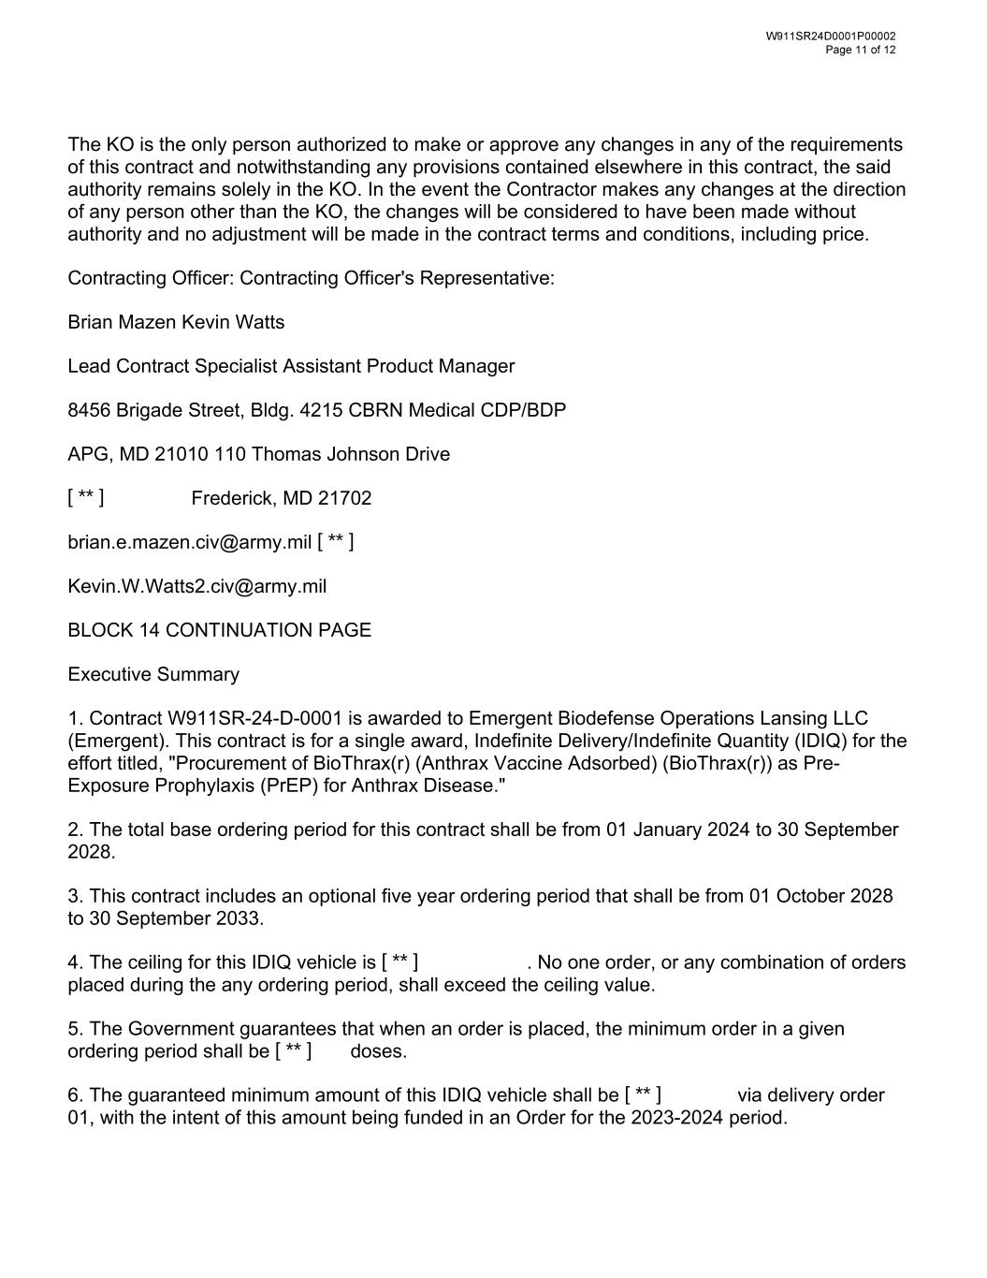
The KO is the only person authorized to make or approve any changes in any of the requirements of this contract and notwithstanding any provisions contained elsewhere in this contract, the said authority remains solely in the KO. In the event the Contractor makes any changes at the direction of any person other than the KO, the changes will be considered to have been made without authority and no adjustment will be made in the contract terms and conditions, including price. Contracting Officer: Contracting Officer's Representative: Brian Mazen Kevin Watts Lead Contract Specialist Assistant Product Manager 8456 Brigade Street, Bldg. 4215 CBRN Medical CDP/BDP APG, MD 21010 110 Thomas Johnson Drive Frederick, MD 21702 brian.e.mazen.civ@army.mil Kevin.W.Watts2.civ@army.mil BLOCK 14 CONTINUATION PAGE Executive Summary 1. Contract W911SR-24-D-0001 is awarded to Emergent Biodefense Operations Lansing LLC (Emergent). This contract is for a single award, Indefinite Delivery/Indefinite Quantity (IDIQ) for the effort titled, "Procurement of BioThrax(r) (Anthrax Vaccine Adsorbed) (BioThrax(r)) as Pre- Exposure Prophylaxis (PrEP) for Anthrax Disease." 2. The total base ordering period for this contract shall be from 01 January 2024 to 30 September 2028. 3. This contract includes an optional five year ordering period that shall be from 01 October 2028 to 30 September 2033. 4. The ceiling for this IDIQ vehicle is . No one order, or any combination of orders placed during the any ordering period, shall exceed the ceiling value. 5. The Government guarantees that when an order is placed, the minimum order in a given ordering period shall be doses. 6. The guaranteed minimum amount of this IDIQ vehicle shall be via delivery order 01, with the intent of this amount being funded in an Order for the 2023-2024 period. [ ** ] [ ** ] [ ** ] [ ** ] [ ** ]

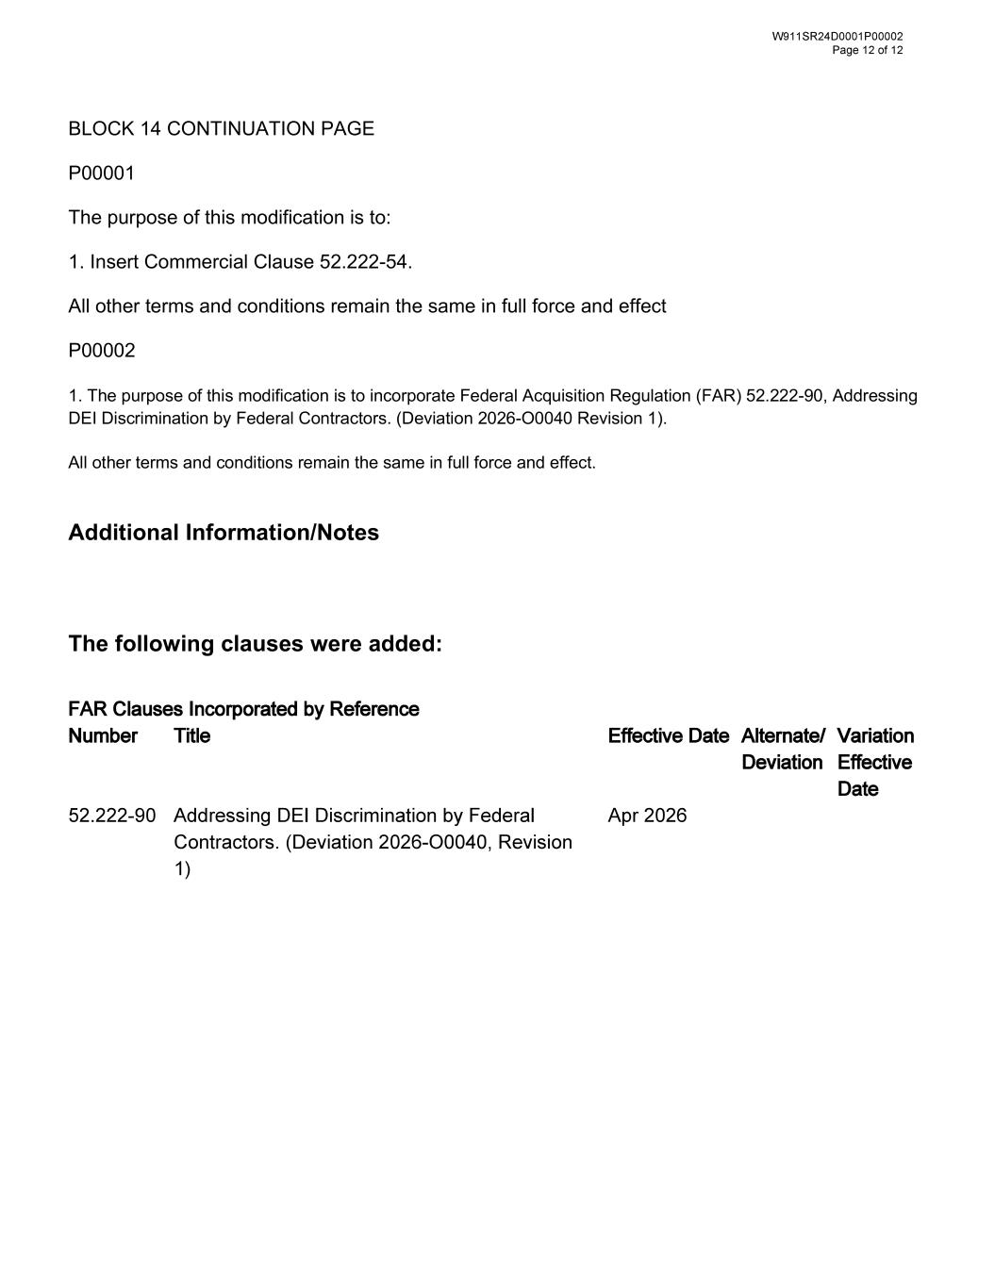
BLOCK 14 CONTINUATION PAGE P00001 The purpose of this modification is to: 1. Insert Commercial Clause 52.222-54. All other terms and conditions remain the same in full force and effect P00002 1. The purpose of this modification is to incorporate Federal Acquisition Regulation (FAR) 52.222-90, Addressing DEI Discrimination by Federal Contractors. (Deviation 2026-O0040 Revision 1). All other terms and conditions remain the same in full force and effect. Additional Information/Notes The following clauses were added:

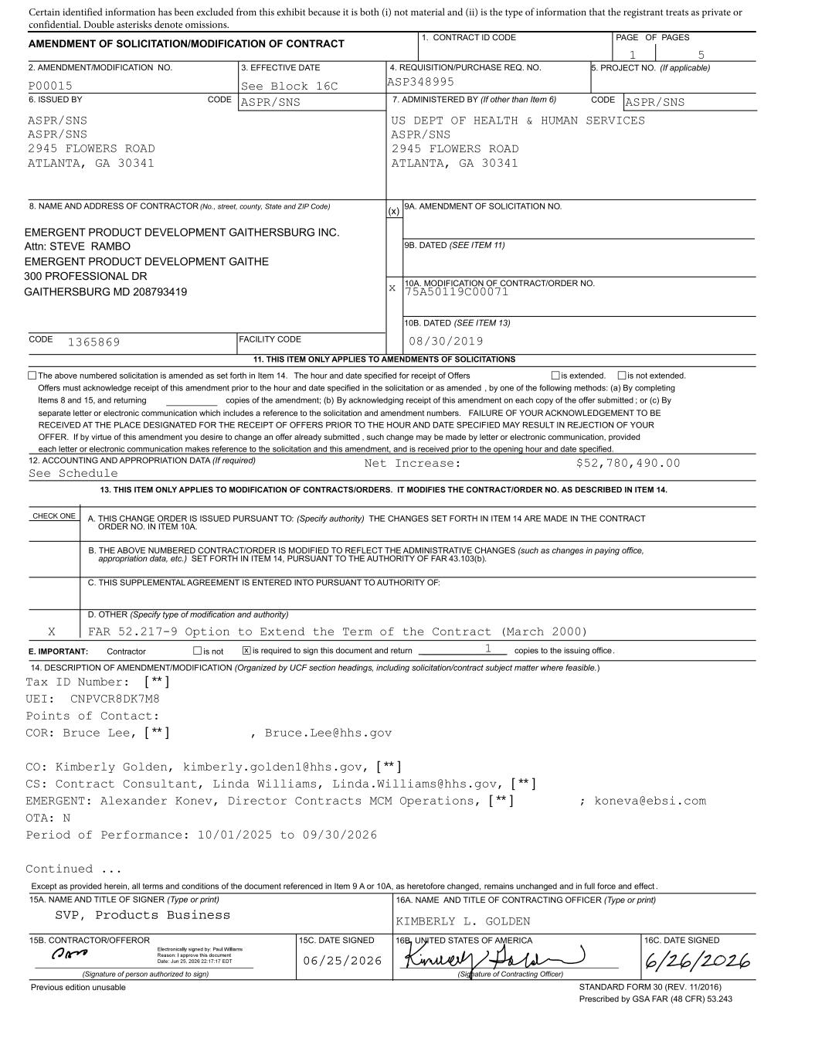
  ☒ ☒    □                              □ ☒☒                                    □     ☒ ☒     ☒       ☒                ☒   SVP, Products Business 06/25/2026 [ ** ] [ ** ] [ ** ] [ ** ] [ ** ] Certain identified information has been excluded from this exhibit because it is both (i) not material and (ii) is the type of information that the registrant treats as private or confidential. Double asterisks denote omissions.

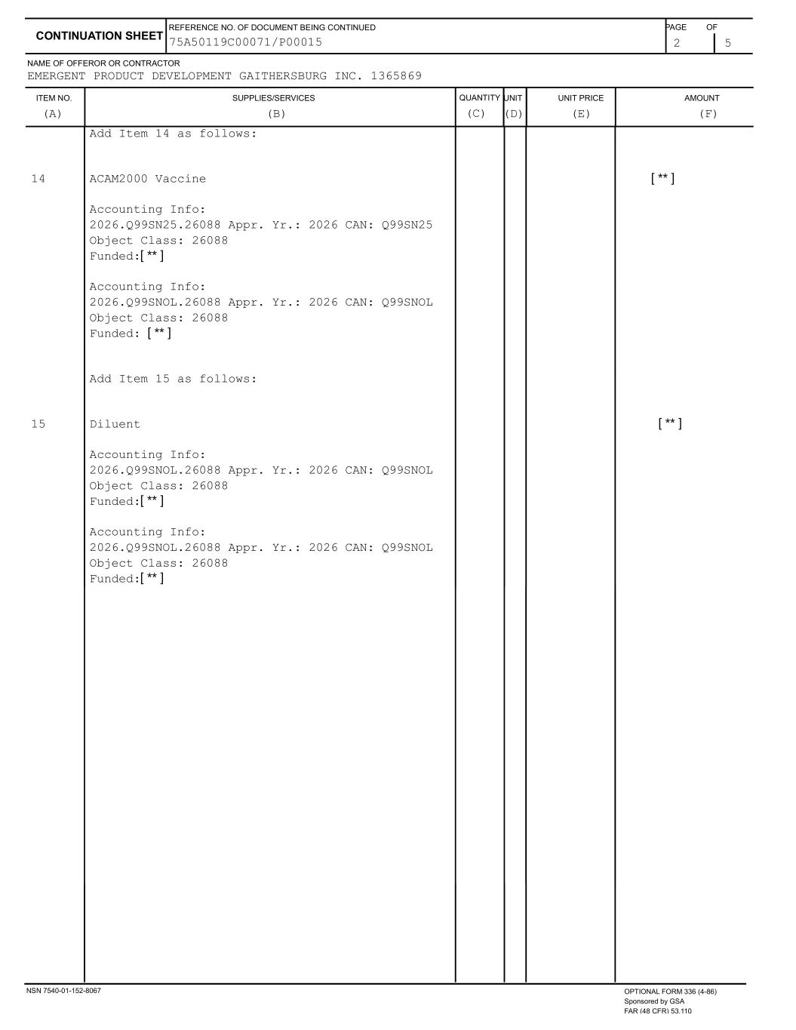
                                                  [ ** ] [ ** ] [ ** ] [ ** ] [ ** ] [ ** ][ ** ]

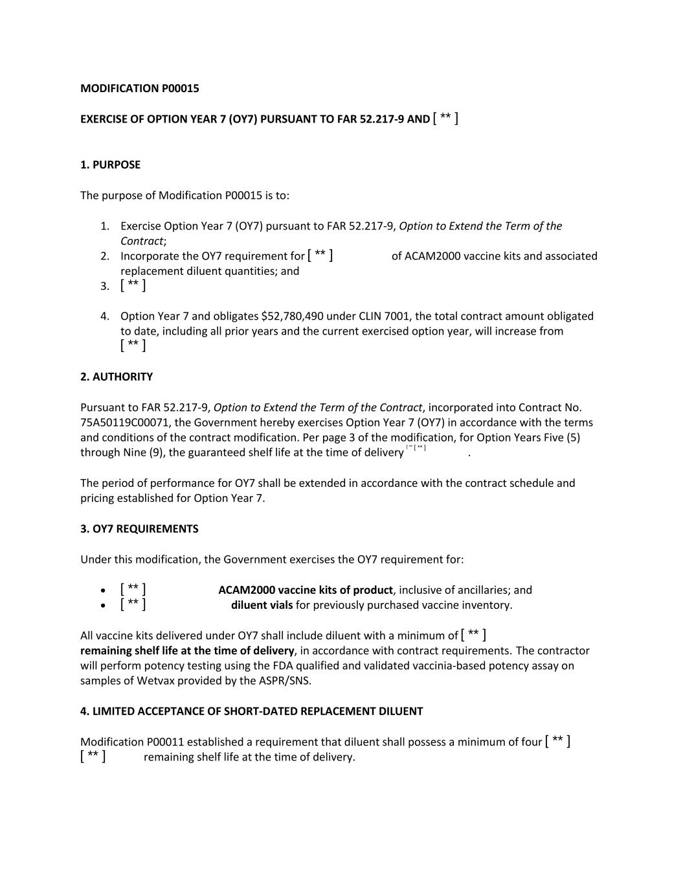
MODIFICATION P00015 EXERCISE OF OPTION YEAR 7 (OY7) PURSUANT TO FAR 52.217-9 AND 1. PURPOSE The purpose of Modification P00015 is to: 1. Exercise Option Year 7 (OY7) pursuant to FAR 52.217-9, Option to Extend the Term of the Contract; 2. Incorporate the OY7 requirement for of ACAM2000 vaccine kits and associated replacement diluent quantities; and 3. 4. Option Year 7 and obligates $52,780,490 under CLIN 7001, the total contract amount obligated to date, including all prior years and the current exercised option year, will increase from 2. AUTHORITY Pursuant to FAR 52.217-9, Option to Extend the Term of the Contract, incorporated into Contract No. 75A50119C00071, the Government hereby exercises Option Year 7 (OY7) in accordance with the terms and conditions of the contract modification. Per page 3 of the modification, for Option Years Five (5) through Nine (9), the guaranteed shelf life at the time of delivery . The period of performance for OY7 shall be extended in accordance with the contract schedule and pricing established for Option Year 7. 3. OY7 REQUIREMENTS Under this modification, the Government exercises the OY7 requirement for: ACAM2000 vaccine kits of product, inclusive of ancillaries; and diluent vials for previously purchased vaccine inventory. All vaccine kits delivered under OY7 shall include diluent with a minimum of remaining shelf life at the time of delivery, in accordance with contract requirements. The contractor will perform potency testing using the FDA qualified and validated vaccinia-based potency assay on samples of Wetvax provided by the ASPR/SNS. 4. LIMITED ACCEPTANCE OF SHORT-DATED REPLACEMENT DILUENT Modification P00011 established a requirement that diluent shall possess a minimum of four remaining shelf life at the time of delivery. [ ** ] [ ** ] [ ** ] [ ** ] [ ** ][ ** ] [ ** ] [ ** ] [ ** ] [ ** ] [ ** ]

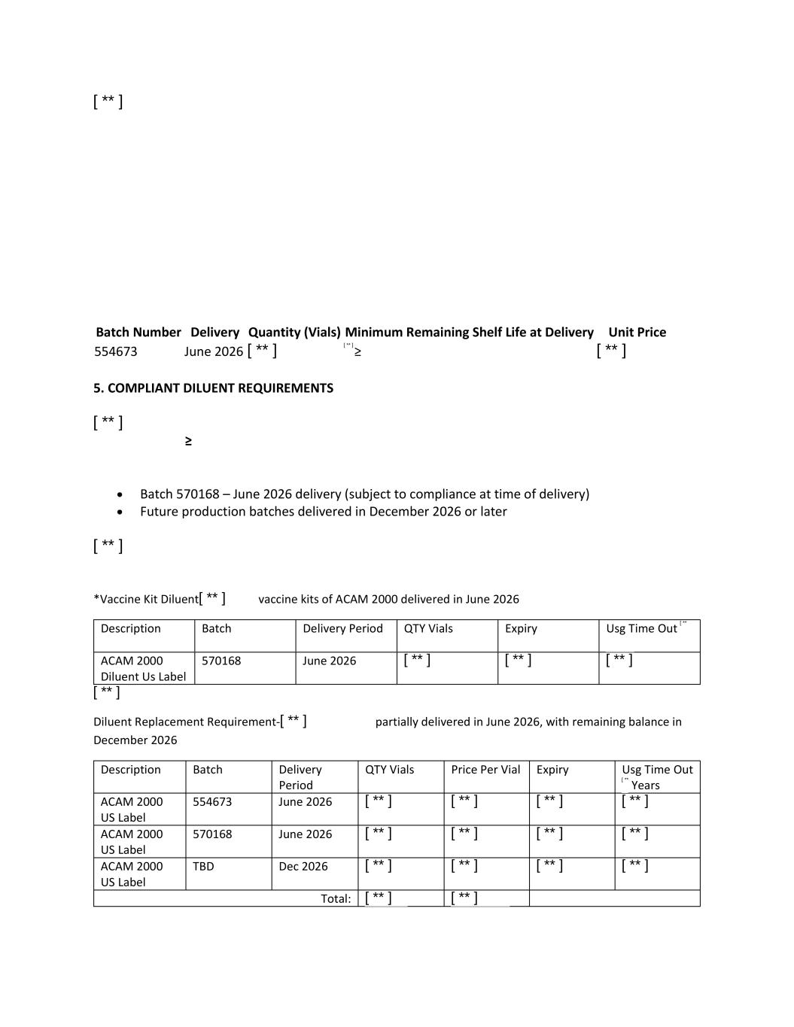
Batch Number Delivery Quantity (Vials) Minimum Remaining Shelf Life at Delivery Unit Price 554673 June 2026 5. COMPLIANT DILUENT REQUIREMENTS Batch 570168 – June 2026 delivery (subject to compliance at time of delivery) Future production batches delivered in December 2026 or later *Vaccine Kit Diluent vaccine kits of ACAM 2000 delivered in June 2026 Description Batch Delivery Period QTY Vials Expiry Usg Time Out ACAM 2000 Diluent Us Label 570168 June 2026 Diluent Replacement Requirement- partially delivered in June 2026, with remaining balance in December 2026 Description Batch Delivery Period QTY Vials Price Per Vial Expiry Usg Time Out Years ACAM 2000 US Label 554673 June 2026 ACAM 2000 US Label 570168 June 2026 ACAM 2000 US Label TBD Dec 2026 Total: [ ** ] [ ** ] [ ** ] [ ** ] [ ** ] [ ** ] [ ** ] [ ** ] [ ** ] [ ** ] [ ** ] [ ** ] [ ** ] [ ** ] [ ** ] [ ** ] [ ** ] [ ** ] [ ** ] [ ** ] [ ** ] [ ** ][ ** ][ ** ][ ** ] [ ** ] [ ** ] [ ** ]

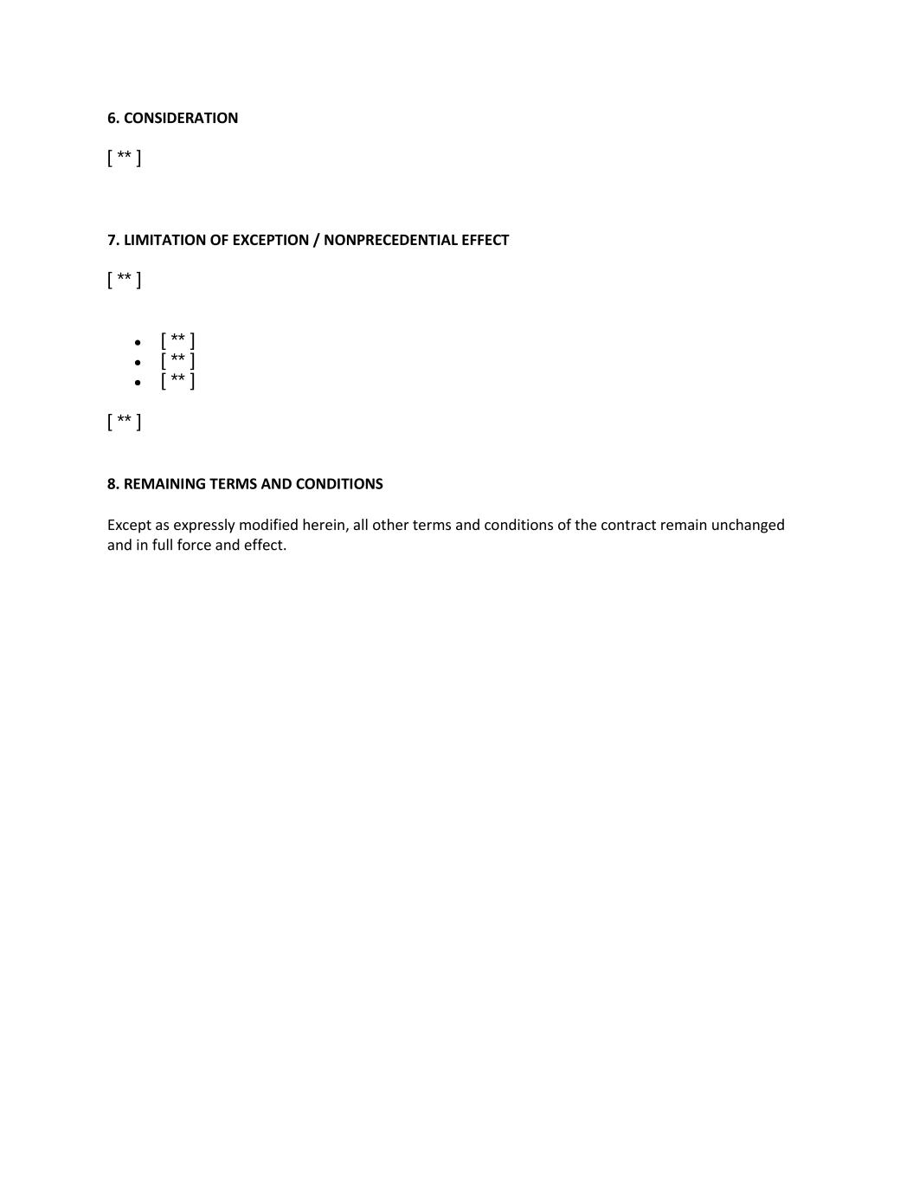
6. CONSIDERATION 7. LIMITATION OF EXCEPTION / NONPRECEDENTIAL EFFECT 8. REMAINING TERMS AND CONDITIONS Except as expressly modified herein, all other terms and conditions of the contract remain unchanged and in full force and effect. [ ** ] [ ** ] [ ** ] [ ** ] [ ** ] [ ** ]

EXHIBIT 31.1
CERTIFICATION
I, Joseph C. Papa, certify that:

(1) I have reviewed this Quarterly Report on Form 10-Q of Emergent BioSolutions Inc.;

(2) Based on my knowledge, this report does not contain any untrue statement of a material fact or omit to state a material fact necessary to make the statements made, in light of the circumstances under which such statements were made, not misleading with respect to the period covered by this report;

(3) Based on my knowledge, the financial statements, and other financial information included in this report, fairly present in all material respects the financial condition, results of operations and cash flows of the registrant as of, and for, the periods presented in this report;

(4) The registrant's other certifying officer and I are responsible for establishing and maintaining disclosure controls and procedures (as defined in Exchange Act Rules 13a-15(e) and 15d-15(e)) and internal control over financial reporting (as defined in Exchange Act Rules 13a-15(f) and 15d-15(f)) for the registrant and have:

(a) Designed such disclosure controls and procedures, or caused such disclosure controls and procedures to be designed under our supervision, to ensure that material information relating to the registrant, including its consolidated subsidiaries, is made known to us by others within those entities, particularly during the period in which this report is being prepared;

(b) Designed such internal control over financial reporting, or caused such internal control over financial reporting to be designed under our supervision, to provide reasonable assurance regarding the reliability of financial reporting and the preparation of financial statements for external purposes in accordance with generally accepted accounting principles;

(c) Evaluated the effectiveness of the registrant's disclosure controls and procedures and presented in this report our conclusions about the effectiveness of the disclosure controls and procedures, as of the end of the period covered by this report based on such evaluation; and

(d) Disclosed in this report any change in the registrant's internal control over financial reporting that occurred during the registrant's most recent fiscal quarter (the registrant's fourth fiscal quarter in the case of an annual report) that has materially affected, or is reasonably likely to materially affect, the registrant's internal control over financial reporting; and

(5) The registrant's other certifying officer and I have disclosed, based on our most recent evaluation of internal control over financial reporting, to the registrant's auditors and the audit committee of the registrant's board of directors (or persons performing the equivalent functions):

(a) All significant deficiencies and material weaknesses in the design or operation of internal control over financial reporting which are reasonably likely to adversely affect the registrant's ability to record, process, summarize and report financial information, and

(b) Any fraud, whether or not material, that involves management or other employees who have a significant role in the registrant's internal control over financial reporting.

Date: August 5, 2026

/s/Joseph C. Papa
Joseph C. Papa
President and Chief Executive Officer

EXHIBIT 31.2
CERTIFICATION
I, Richard S. Lindahl, certify that:

(1) I have reviewed this Quarterly Report on Form 10-Q of Emergent BioSolutions Inc.;

(2) Based on my knowledge, this report does not contain any untrue statement of a material fact or omit to state a material fact necessary to make the statements made, in light of the circumstances under which such statements were made, not misleading with respect to the period covered by this report;

(3) Based on my knowledge, the financial statements, and other financial information included in this report, fairly present in all material respects the financial condition, results of operations and cash flows of the registrant as of, and for, the periods presented in this report;

(4) The registrant's other certifying officer and I are responsible for establishing and maintaining disclosure controls and procedures (as defined in Exchange Act Rules 13a-15(e) and 15d-15(e)) and internal control over financial reporting (as defined in Exchange Act Rules 13a-15(f) and 15d-15(f)) for the registrant and have:

(a) Designed such disclosure controls and procedures, or caused such disclosure controls and procedures to be designed under our supervision, to ensure that material information relating to the registrant, including its consolidated subsidiaries, is made known to us by others within those entities, particularly during the period in which this report is being prepared;

(b) Designed such internal control over financial reporting, or caused such internal control over financial reporting to be designed under our supervision, to provide reasonable assurance regarding the reliability of financial reporting and the preparation of financial statements for external purposes in accordance with generally accepted accounting principles;

(c) Evaluated the effectiveness of the registrant's disclosure controls and procedures and presented in this report our conclusions about the effectiveness of the disclosure controls and procedures, as of the end of the period covered by this report based on such evaluation; and

(d) Disclosed in this report any change in the registrant's internal control over financial reporting that occurred during the registrant's most recent fiscal quarter (the registrant's fourth fiscal quarter in the case of an annual report) that has materially affected, or is reasonably likely to materially affect, the registrant's internal control over financial reporting; and

(5) The registrant's other certifying officer and I have disclosed, based on our most recent evaluation of internal control over financial reporting, to the registrant's auditors and the audit committee of the registrant's board of directors (or persons performing the equivalent functions):

(a) All significant deficiencies and material weaknesses in the design or operation of internal control over financial reporting which are reasonably likely to adversely affect the registrant's ability to record, process, summarize and report financial information, and

(b) Any fraud, whether or not material, that involves management or other employees who have a significant role in the registrant's internal control over financial reporting.

Date: August 5, 2026

/s/RICHARD S. LINDAHL
Richard S. Lindahl
Chief Financial Officer

EXHIBIT 32.1

CERTIFICATION PURSUANT TO 18 U.S.C. SECTION 1350, AS ADOPTED PURSUANT TO
SECTION 906 OF THE SARBANES-OXLEY ACT OF 2002

In connection with the Quarterly Report on Form 10-Q of Emergent BioSolutions Inc. (the "Company") for the period ended June 30, 2026 as filed with the Securities and Exchange Commission on the date hereof (the "Report"), the undersigned, Joseph C. Papa, President and Chief Executive Officer of the Company, hereby certifies, pursuant to 18 U.S.C. Section 1350, that:

(1) The Report fully complies with the requirements of Section 13(a) or 15(d) of the Securities Exchange Act of 1934; and

(2) The information contained in the Report fairly presents, in all material respects, the financial condition and results of operations of the Company.

Date: August 5, 2026

/s/Joseph C. Papa
Joseph C. Papa
President and Chief Executive Officer

EXHIBIT 32.2
CERTIFICATION PURSUANT TO 18 U.S.C. SECTION 1350, AS ADOPTED PURSUANT TO
SECTION 906 OF THE SARBANES-OXLEY ACT OF 2002

In connection with the Quarterly Report on Form 10-Q of Emergent BioSolutions Inc. (the "Company") for the period ended June 30, 2026 as filed with the Securities and Exchange Commission on the date hereof (the "Report"), the undersigned, Richard S. Lindahl, Chief Financial Officer of the Company, hereby certifies, pursuant to 18 U.S.C. Section 1350, that:

(1) The Report fully complies with the requirements of Section 13(a) or 15(d) of the Securities Exchange Act of 1934; and

(2) The information contained in the Report fairly presents, in all material respects, the financial condition and results of operations of the Company.

Date: August 5, 2026

/s/RICHARD S. LINDAHL
Richard S. Lindahl
Chief Financial Officer

