UNITED STATES

SECURITIES AND EXCHANGE COMMISSION

WASHINGTON, D.C. 20549

____________________

FORM 8-K

CURRENT REPORT

Pursuant to Section 13 or 15(d) of the

Securities Exchange Act of 1934

Date of report (Date of earliest event reported): August 6, 2007

Emergent BioSolutions Inc.

(Exact Name of Registrant as Specified in Charter)

Delaware | 001-33137 | 14-1902018
(State or Other Jurisdiction | (Commission | (IRS Employer
of Incorporation) | File Number) | Identification No.)
2273 Research Boulevard, Suite 400, Rockville, Maryland |  | 20850
(Address of Principal Executive Offices) |  | (Zip Code)
 | (301) 795-1800
 | Registrant’s telephone number, including area code:

Not applicable

(Former Name or Former Address, if Changed Since Last Report)

Check the appropriate box below if the Form 8-K filing is intended to simultaneously satisfy the filing obligation of the registrant under any of the following provisions (see General Instruction A.2. below):

o Written communications pursuant to Rule 425 under the Securities Act (17 CFR 230.425)

o Soliciting material pursuant to Rule 14a-12 under the Exchange Act (17 CFR 240.14a-12)

o Pre-commencement communications pursuant to Rule 14d-2(b) under the Exchange Act (17 CFR 240.14d-2(b))

o Pre-commencement communications pursuant to Rule 13e-4(c) under the Exchange Act (17 CFR 240.13e-4(c))

Item 2.02 Results of Operations and Financial Conditions.

On August 6, 2007, Emergent BioSolutions Inc. (the “Company”) reported financial results for the three and six months ended June 30, 2007. The full text of the press release issued in connection with the announcement is attached as Exhibit 99.1 to this Current Report on Form 8-K.

The information in Item 2.02 of this Form 8-K, including Exhibit 99.1 hereto, shall not be deemed “filed” for purposes of Section 18 of the Securities Exchange Act of 1934, as amended (the “Exchange Act”), or otherwise subject to the liabilities of that section, nor shall it be deemed incorporated by reference in any filing under the Securities Act of 1933, as amended, or the Exchange Act, except as expressly set forth by specific reference in such a filing.

Item 9.01 Financial Statements and Exhibits

- Exhibits

See Exhibit Index attached hereto.

SIGNATURE

Pursuant to the requirements of the Securities Exchange Act of 1934, the registrant has duly caused this report to be signed on its behalf by the undersigned hereunto duly authorized.

Date: August 7, 2007 EMERGENT BIOSOLUTIONS INC.

By: /s/R. Don Elsey

R. Don Elsey

Chief Financial Officer and SVP of Finance

Exhibit Index

Exhibit Number |  |  | Description
99.1 |  |  | Press release dated August 6, 2007.


FOR IMMEDIATE RELEASE

Investors Contact:

Robert G. Burrows

Vice President, Investor Relations

Emergent BioSolutions Inc.

301-795-1877

burrowsr@ebsi.com

EMERGENT BIOSOLUTIONS REPORTS FINANCIAL RESULTS FOR SECOND QUARTER 2007 -- Year over year growth in product revenues of $14.3 million to $22.5 million
ROCKVILLE, MD., August 6, 2007—Emergent BioSolutions Inc. (NYSE: EBS), a biopharmaceutical company focused on developing, manufacturing and commercializing immunobiotics to prevent or treat disease, announced today its financial results for the second quarter ended June 30, 2007.

Total revenues for the period grew by $11.7 million to $23.2 million from $11.4 million in the comparable period in 2006, driven primarily by a 169 percent increase in the number of doses of BioThrax® (Anthrax Vaccine Adsorbed) delivered during the quarter to the U.S. Department of Defense (the DoD) for active immunization of military personnel. The company also announced that the net loss for the second quarter of 2007 was $5.0 million, or $0.17 per share, compared to a net loss of $3.1 million, or $0.14 per share, for the comparable period in 2006, driven primarily by a $9.9 million increase in operating expenses during the current quarter.

Commenting on the financial results, R. Don Elsey, senior vice president and chief financial officer of Emergent BioSolutions Inc., said, “Year-to-date, Emergent BioSolutions is generating financial results that are in line with our internal expectations. Our revenues have outpaced 2006, and our R&D and G&A expenditures are as expected and reflect our ongoing commitment to invest in our product pipeline and manufacturing infrastructure as we continue to progress our product candidates, as we have previously indicated. As a result, our year-to-date net loss is currently better than the comparable period for 2006. We remain confident that both of the contracts for new supply agreements for BioThrax with our U.S. government customers will be signed and we expect this will be accomplished before the end of the third quarter, which should position us well for strong financial performance in the future.”

2Q 2007 Highlights

The company’s achievements during the second quarter of 2007 included:
- delivery of 900,000 doses of BioThrax to the DoD, thus completing the company’s current delivery obligation to the DoD;

- receipt of a Presolicitation Notice and a subsequent Request For Proposal on April 18 and May 7, respectively, from DoD to procure a minimum of 1.0 million to a maximum of 3.7 million doses of BioThrax in each of one base period plus three optional ordering periods for a total of up to 14.7 million doses, for which negotiations are ongoing;
- receipt of a Presolicitation Notice and a subsequent Request For Proposal on April 18 and May 3, respectively, from the U.S. Department of Health and Human Services (HHS) to procure 10.4 million doses of BioThrax, with an option for an additional 8.35 million doses, over a three year period, for which negotiations are ongoing;

1

- signing of a $30 million loan agreement with HSBC to be used to fund the continued expansion of the company’s manufacturing facilities in Lansing, Michigan, replacing an existing $15 million HSBC credit facility; and
- expansion of the board of directors and the subsequent appointment of Dr. Sue Bailey as a Class III director for a two year term that will expire at the 2009 annual meeting of stockholders.

Product Sales

For the second quarter of 2007, product sales increased by $14.3 million to $22.5 million from $8.2 million in the comparable period in 2006, primarily due to a 169 percent increase in the number of doses of BioThrax delivered and a 2 percent increase in the average sales price per dose. Product sales for the second quarter of 2007 consisted of BioThrax sales to the DoD of $22.5 million.

For the six month period of 2007, product sales increased by $27.6 million to $48.0 million from $20.4 million in the comparable period in 2006, primarily due to a 143 percent increase in the number of doses of BioThrax delivered, partially offset by a 3% decrease in the average sales price per dose. Product sales for the six month period of 2007 consisted of BioThrax sales to HHS of $21.7 million and sales to the DoD of $26.2 million.

Contracts and Grant Revenues

For the second quarter of 2007, contracts and grant revenues decreased by $2.6 million to $668,000 from $3.2 million in the comparable period in 2006. Contracts and grant revenues for the second quarter of 2007 consisted of $668,000 from recognition of the upfront payment received in 2006 and development program revenue from the Sanofi Pasteur collaboration relating to the company’s meningitis B vaccine candidate.

For the six month period of 2007, contracts and grant revenues decreased by $1.6 million to $1.7 million from $3.3 million in the comparable period in 2006. Contracts and grant revenues for the second quarter of 2007 consisted of $1.7 million from recognition of the upfront payment received in 2006 and development program revenue from the Sanofi Pasteur collaboration.

Cost of Product Sales

For the second quarter of 2007, cost of product sales increased by $4.3 million to $5.8 million from $1.5 million for the comparable period in 2006. For the six month period of 2007, cost of product sales increased by $7.0 million to $11.4 million from $4.4 million for the comparable period in 2006. The increase for both the second quarter and six month period of 2007 was primarily attributable to the increase in the number of BioThrax doses delivered, coupled with increased costs associated with the company’s annual production shut-down, the related impact on production yield and the write-off of waste during the period.

Research and Development

For the second quarter of 2007, research and development expenses increased by $6.6 million to $13.3 million from $6.7 million for the comparable period in 2006. This increase primarily reflects increased expenses of $3.8 million in the biodefense segment, $2.4 million in the commercial segment and approximately $472,000 in other research and development expense.

For the six month period of 2007, research and development expenses increased by $13.2 million to $28.9 million from $15.7 million for the comparable period in 2006. This increase primarily reflects increased expenses of $9.1 million in the biodefense segment, $3.3 million in the commercial segment and approximately $791,000 in other research and development expense.

The increase in biodefense spending was attributable to increased efforts by the company on all of its biodefense programs as it completed various studies and began subsequent studies and trials. The increase in spending for BioThrax enhancements is related to conducting animal efficacy studies to

2

support applications for marketing approval of these enhancements, which the company expects to submit to the FDA in late 2008 or 2009. The increase in spending for the immune globulin candidate development related primarily to costs associated with the plasma collection and fractionation program for the anthrax immune globulin. The increase in spending for the recombinant botulinum vaccine program, which is in preclinical development, resulted from advancing this program to the process development stage. The increase in spending for the next generation anthrax vaccine program, which has product candidates in preclinical and Phase I clinical development, resulted from feasibility studies and formulation development of product candidates.

The increase in commercial spending primarily reflects additional personnel and contract service costs. The increase spending for the typhoid vaccine candidate resulted from the ongoing Phase II study in Vietnam, which commenced in the first quarter 2007. The increase in spending for the hepatitis B therapeutic vaccine candidate resulted from conducting the Phase II clinical trial, which commenced in the first quarter 2007. The increase in spending for the group B streptococcus vaccine candidate resulted from costs associated with preparation for Phase I clinical trials for two of the protein components of the vaccine candidate.

The increase in other research and development expenses was primarily attributable to spending associated with preclinical programs that were acquired from ViVacs GmbH in July 2006.

Selling, General and Administrative

For the second quarter of 2007, selling, general and administrative expenses increased by $3.2 million to $12.7 million from $9.4 million for the comparable period in 2006. SG&A expenses related to the biodefense segment increased by $2.4 million, while SG&A expenses related to the commercial segment increased by $858,000.

For the six month period of 2007, selling, general and administrative expenses increased by $4.7 million to $23.9 million from $19.2 million for the comparable period in 2006. SG&A expenses related to the biodefense segment increased by $2.8 million, while SG&A expenses related to the commercial segment increased by $1.9 million.

The increase for the second quarter and six month period of 2007 in both segments was primarily attributable to an increase in general and administrative expenses resulting from the addition of personnel related to the company’s transition to a publicly traded company and increased legal and other professional services for the company’s headquarters organization.

Financial Condition and Liquidity

Cash and cash equivalents at June 30, 2007 was $34.0 million versus $76.4 million at December 31, 2006. The net decrease in cash and cash equivalents resulted primarily from capital expenditures and cash used in operations, including research and development expenses, the payment of 2006 income taxes and the repayment of an existing revolving line of credit, offset by collection of accounts receivable related primarily to amounts due from HHS and the DoD that were billed in December 2006 and received in January 2007.

On June 29, 2007, the company entered into a loan agreement with HSBC Realty Credit Corporation under which HSBC provided the company with a term loan of $30 million. This loan replaced an existing loan arrangement with HSBC under which HSBC had provided a $10 million term loan and a $5 million revolving line of credit. On July 3, 2007, the company received and recorded $14.8 million in net proceeds related to the new loan agreement.

2007 Financial Expectations

For 2007, the company reaffirms its expectation for full year total revenue growth of 10 to 15 percent and full year positive net earnings.

3

Conference Call & Webcast

Company management will host a conference call at 5:00 pm Eastern on August 6, 2007 to discuss these financial results and to provide an update on business developments, including the status of the BioThrax procurement contract negotiations with HHS and DoD. Interested parties may participate in the live teleconference by dialing 800/299-7928 or 617/614-3926 or via a webcast accessible at www.emergentbiosolutions.com, under “Investors”. A replay of the teleconference will be available on the company website or by dialing 888/286-8010 or 617/801-6888 and using the passcode 25894369, approximately one hour after the teleconference concludes. The replay will be available through August 20.

About Emergent BioSolutions Inc.

Emergent BioSolutions Inc. is a biopharmaceutical company dedicated to one simple mission—to protect life. We develop, manufacture and commercialize immunobiotics, consisting of vaccines and therapeutics that assist the body’s immune system to prevent or treat disease. Our biodefense business focuses on immunobiotics for use against biological agents that are potential weapons of bioterrorism and biowarfare. Our marketed product, BioThrax® (Anthrax Vaccine Adsorbed), is the only vaccine approved by the U.S. Food and Drug Administration for the prevention of anthrax infection. Our commercial business focuses on immunobiotics for use against infectious diseases and other medical conditions that have resulted in significant unmet or underserved public health needs. More information on the company is available at www.emergentbiosolutions.com.

Safe Harbor Statement

This press release includes forward-looking statements within the meaning of the Private Securities Litigation Reform Act of 1995. Any statements, other than statements of historical fact, including statements regarding our strategy, future operations, future financial position, future revenues, projected costs, prospects, plans and objectives of management, including our expected revenue growth and net earnings for 2007, and any other statements containing the words "believes", "expects", "anticipates", "plans", "estimates" and similar expressions, are forward-looking statements. There are a number of important factors that could cause the company's actual results to differ materially from those indicated by such forward-looking statements, including our ability to obtain new BioThrax® sales contracts with the U.S. government; our plans for future sales of BioThrax; our plans to pursue label expansions and improvements for BioThrax; our plans to expand our manufacturing facilities and capabilities; the rate and degree of market acceptance and clinical utility of our products; our ongoing and planned development programs, preclinical studies and clinical trials; our ability to identify and acquire or in license products and product candidates that satisfy our selection criteria; the potential benefits of our existing collaboration agreements and our ability to enter into selective additional collaboration arrangements; the timing of and our ability to obtain and maintain regulatory approvals for our product candidates; our commercialization, marketing and manufacturing capabilities and strategy; our intellectual property portfolio; our estimates regarding expenses, future revenue, capital requirements and needs for additional financing; and other factors identified in the company's Quarterly Report on Form 10-Q for the quarter ended March 31, 2007 and subsequent reports filed with the SEC. The company disclaims any intention or obligation to update any forward-looking statements as a result of developments occurring after the date of this press release.

Financial Statements Follow

4

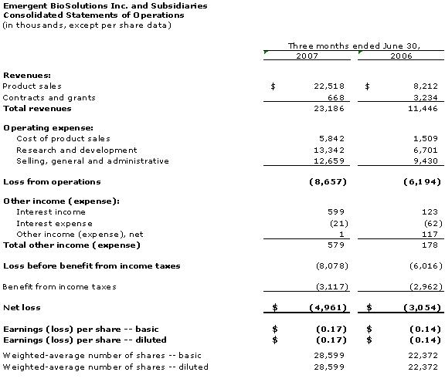

5

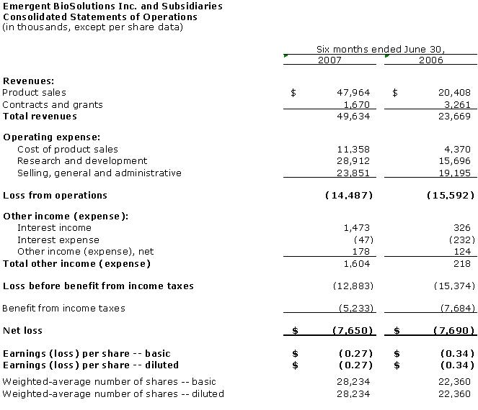

6

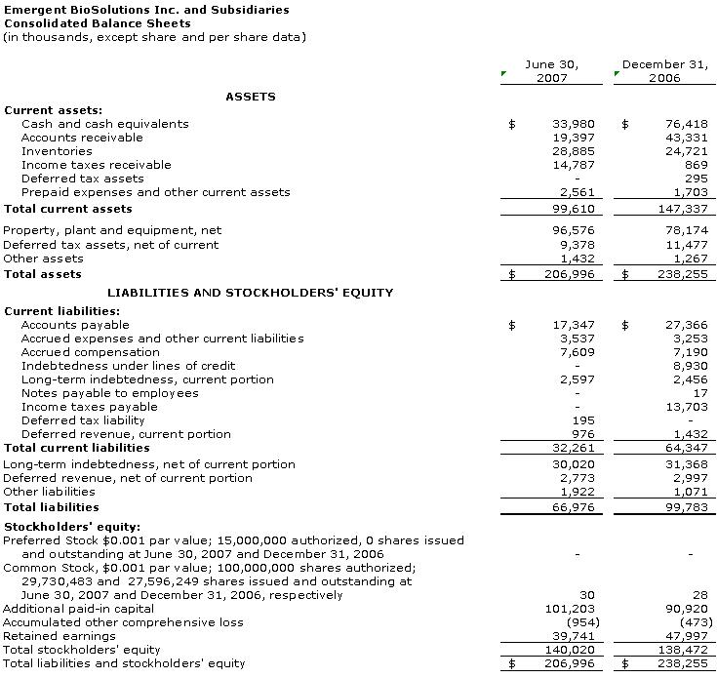

7

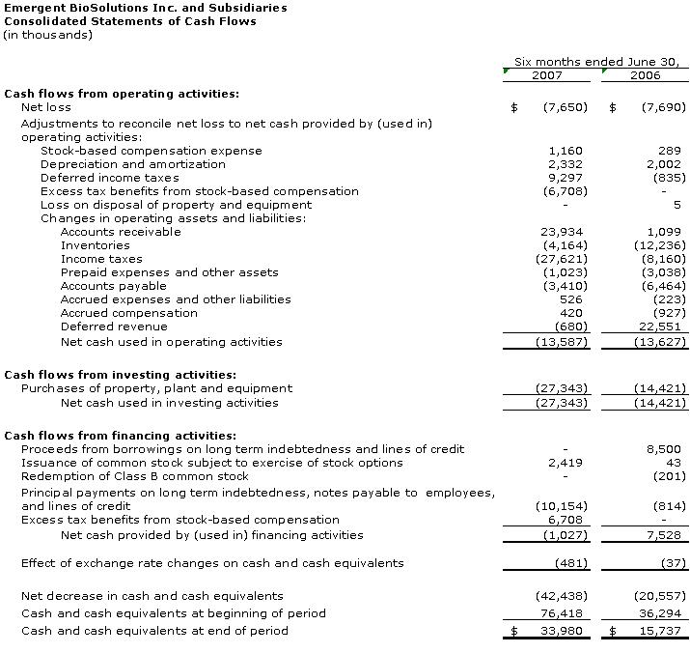

8

