UNITED STATES

SECURITIES AND EXCHANGE COMMISSION

WASHINGTON, D.C. 20549

____________________

FORM 8-K

CURRENT REPORT

Pursuant to Section 13 or 15(d) of the

Securities Exchange Act of 1934

Date of report (Date of earliest event reported): November 2, 2007

Emergent BioSolutions Inc.

(Exact Name of Registrant as Specified in Charter)

Delaware | 001-33137 | 14-1902018
(State or Other Jurisdiction | (Commission | (IRS Employer
of Incorporation) | File Number) | Identification No.)
2273 Research Boulevard, Suite 400, Rockville, Maryland |  | 20850
(Address of Principal Executive Offices) |  | (Zip Code)
 | (301) 795-1800
 | Registrant’s telephone number, including area code:

Not applicable

(Former Name or Former Address, if Changed Since Last Report)

Check the appropriate box below if the Form 8-K filing is intended to simultaneously satisfy the filing obligation of the registrant under any of the following provisions (see General Instruction A.2. below):

o Written communications pursuant to Rule 425 under the Securities Act (17 CFR 230.425)

o Soliciting material pursuant to Rule 14a-12 under the Exchange Act (17 CFR 240.14a-12)

o Pre-commencement communications pursuant to Rule 14d-2(b) under the Exchange Act (17 CFR 240.14d-2(b))

o Pre-commencement communications pursuant to Rule 13e-4(c) under the Exchange Act (17 CFR 240.13e-4(c))

Item 2.02 Results of Operations and Financial Conditions.

On November 2, 2007, Emergent BioSolutions Inc. (the “Company”) reported financial results for the three and nine months ended September 30, 2007. The full text of the press release issued in connection with the announcement is attached as Exhibit 99.1 to this Current Report on Form 8-K.

The information in Item 2.02 of this Form 8-K, including Exhibit 99.1 hereto, shall not be deemed “filed” for purposes of Section 18 of the Securities Exchange Act of 1934, as amended (the “Exchange Act”), or otherwise subject to the liabilities of that section, nor shall it be deemed incorporated by reference in any filing under the Securities Act of 1933, as amended, or the Exchange Act, except as expressly set forth by specific reference in such a filing.

Item 9.01 Financial Statements and Exhibits

- Exhibits

See Exhibit Index attached hereto.

SIGNATURE

Pursuant to the requirements of the Securities Exchange Act of 1934, the registrant has duly caused this report to be signed on its behalf by the undersigned hereunto duly authorized.

Date: November 2, 2007 EMERGENT BIOSOLUTIONS INC.

By: /s/R. Don Elsey

R. Don Elsey

Chief Financial Officer and SVP of Finance

 |  |  |  | Exhibit Index
Exhibit Number |  |  | Description
99.1 |  |  | Press release dated November 2, 2007.


FOR IMMEDIATE RELEASE

Investors Contact:

Robert G. Burrows

Vice President, Investor Relations

301-795-1877

BurrowsR@ebsi.com

Media Contact:

Tracey Schmitt

Director, Corporate Communications

301-795-1800

SchmittT@ebsi.com

EMERGENT BIOSOLUTIONS REPORTS FINANCIAL RESULTS FOR THIRD QUARTER 2007

- Raises full year 2007 revenue guidance to reflect annual growth of 16 to 18 percent

- On track to deliver up to 6 million doses under new contract with HHS by year end

ROCKVILLE, MD., November 2, 2007—Emergent BioSolutions Inc. (NYSE: EBS) announced today its financial results for the third quarter ended September 30, 2007. In addition, the company is raising its 2007 revenue guidance to now anticipate full year total revenue growth of between 16 percent to 18 percent. The Company continues to anticipate positive full year net earnings.

Total revenues for the third quarter of 2007 grew by $1.5 million to $43.6 million and for the nine months ended September 30, 2007 grew by $27.4 million to $93.3 million. The company also announced net income for the third quarter of 2007 of $2.8 million, or $0.10 per share. For the nine months ended September 30, 2007, the company announced a net loss of $4.8 million, or $0.17 per share.

Commenting on the financial results, R. Don Elsey, the company’s senior vice president and chief financial officer, said, “Based on the strength of our revenues and the new multi-year contract with HHS, we have revised upward our expectations for annual revenue growth for 2007. We continue to push forward the development of our product pipeline, while maintaining a commitment to sustain our trend of annual profitability.”

3Q 2007 Highlights

The company’s achievements during the third quarter of 2007 included:
- Signing of a $448 million three-year contract with the U.S. Department of Health and Human Services (HHS) comprised of:

- $400 million firm fixed-price for delivery of 18.75 million doses of BioThrax for inclusion in the strategic national stockpile (SNS);

- $34 million for receipt of regulatory approval of 4-year expiry dating for BioThrax payable through a combination of a lump-sum payment reflecting a price per dose increase for certain doses delivered prior to approval and an increase in the per dose price to be paid for doses delivered following approval;

1

•

•

- up to $11.5 million in milestone payments in connection with advancement towards a post-exposure prophylaxis (PEP) indication for BioThrax; and,
- $2.2 million for logistics services and other related support.

Completion of first delivery of doses of BioThrax to HHS under the new contract, which generated revenues of $42 million; and

Receipt of a $9.5 million development contract from NIAID/BARDA to fund continued development of the company’s anthrax therapeutic.

Product Sales

For the third quarter of 2007, product sales increased by $931,000 to $41.8 million from $40.9 million in the comparable period in 2006, primarily due to a 43 percent increase in the number of doses of BioThrax delivered, offset by a 29 percent decrease in the average sales price per dose attributable to a discounted price provided to HHS due to the limited remaining shelf life for those specific doses delivered. This discount will apply to some portion of the doses remaining to be sold and delivered to HHS during 2007. We do not expect this discount to apply to any other doses to be sold and delivered to HHS under the contract.

For the nine month period of 2007, product sales increased by $28.5 million to $89.8 million from $61.3 million in the comparable period in 2006, primarily due to a 76 percent increase in the number of doses of BioThrax delivered, offset by a 17 percent decrease in the average price per dose attributable to factors as explained above. Product sales for the nine month period of 2007 consisted of BioThrax sales to HHS of $63.5 million and sales to the DoD of $26.2 million.

Contracts and Grant Revenues

For the third quarter of 2007, contracts and grant revenues increased by $539,000 to $1.9 million from $1.3 million in the comparable period in 2006. Contracts and grant revenues for the third quarter of 2007 consisted of $545,000 from the Sanofi Pasteur collaboration related to recognition of deferred revenue associated with the upfront payment received in 2006 as well as development service revenue, grant revenue from the U.S. National Institutes of Health (NIH) of $893,000 and grant revenue from the Wellcome Trust of $423,000.

For the nine month period of 2007, contracts and grant revenues decreased by $1.1 million to $3.5 million from $4.6 million in the comparable period in 2006. Contracts and grant revenues for the nine month period of 2007 consisted of $2.2 million from the Sanofi Pasteur collaboration related to recognition of deferred revenue associated with the upfront payment received in 2006 as well as development service revenue, grant revenue from NIH of $893,000 and grant revenue from the Wellcome Trust of $423,000.

Cost of Product Sales

For the third quarter of 2007, cost of product sales increased by $4.1 million to $11.4 million from $7.3 million for the comparable period in 2006. For the nine month period of 2007, cost of product sales increased by $11.1 million to $22.8 million from $11.6 million for the comparable period in 2006. The increase for both the third quarter and nine month period of 2007 was primarily attributable to the increase in the number of BioThrax doses delivered, coupled with increased costs associated with the company’s annual production shut-down, the related impact on production yield and the write-off of waste during the period.

Research and Development

For the third quarter of 2007, research and development expenses decreased by $768,000 to $12.8 million from $13.5 million for the comparable period in 2006. This reflects decreased expenses of $2.4

2

million in the biodefense segment, increased expenses of $1.5 million in the commercial segment, and increased expenses of $186,000 in other research and development expense.

For the nine month period of 2007, research and development expenses increased by $12.4 million to $41.7 million from $29.2 million for the comparable period in 2006. This increase reflects increased expenses of $6.7 million in the biodefense segment, $4.7 million in the commercial segment and approximately $977,000 in other research and development expense.

Selling, General and Administrative

For the third quarter of 2007, selling, general and administrative expenses increased by $3.9 million to $15.0 million from $11.2 million for the comparable period in 2006. SG&A expenses related to the biodefense segment increased by $2.7 million, while SG&A expenses related to the commercial segment increased by $1.2 million.

For the nine month period of 2007, selling, general and administrative expenses increased by $8.5 million to $38.9 million from $30.4 million for the comparable period in 2006. SG&A expenses related to the biodefense segment increased by $5.5 million, while SG&A expenses related to the commercial segment increased by $3.1 million.

The increase for the third quarter and nine month period of 2007 in both segments was primarily attributable to an increase in general and administrative expenses resulting from the addition of personnel related to the company’s transition to a publicly traded company and increased legal and other professional services for the company’s headquarters organization.

Financial Condition and Liquidity

Cash and cash equivalents at September 30, 2007 was $24.3 million versus $76.4 million at December 31, 2006. The net decrease in cash and cash equivalents resulted primarily from capital expenditures and cash used in operations, including research and development expenses and the payment of 2006 income taxes. In addition, accounts receivable at September 30, 2007 was $42.0 million, representing amounts billed for doses sold and delivered to HHS in September under the new contract.

Conference Call & Webcast

Company management will host a conference call at 9:00 am Eastern on November 2, 2007 to discuss these financial results and the revision of 2007 financial guidance. Interested parties may participate in the live teleconference by dialing 888/713-4218 or 617/213-4870 or via a webcast accessible at www.emergentbiosolutions.com, under “Investors”. A replay of the teleconference will be available on the company website or by dialing 888/286-8010 or 617/801-6888 and using the passcode 57520280, approximately one hour after the teleconference concludes. The replay will be available through November 16.

About Emergent BioSolutions Inc.

Emergent BioSolutions Inc. is a biopharmaceutical company dedicated to one simple mission—to protect life. We develop, manufacture and commercialize immunobiotics, consisting of vaccines and therapeutics that assist the body’s immune system to prevent or treat disease. Our biodefense business focuses on immunobiotics for use against biological agents that are potential weapons of bioterrorism and biowarfare. Our marketed product, BioThrax® (Anthrax Vaccine Adsorbed), is the only vaccine approved by the U.S. Food and Drug Administration for the prevention of anthrax infection. Our commercial business focuses on immunobiotics for use against infectious diseases and other medical conditions that have resulted in significant unmet or underserved public health needs. More information on the company is available at www.emergentbiosolutions.com.

3

Safe Harbor Statement

This press release includes forward-looking statements within the meaning of the Private Securities Litigation Reform Act of 1995. Any statements, other than statements of historical fact, including statements regarding our strategy, future operations, future financial position, future revenues, projected costs, prospects, plans and objectives of management, including our expected revenue growth and net earnings for 2007, and any other statements containing the words "believes", "expects", "anticipates", "plans", "estimates" and similar expressions, are forward-looking statements. There are a number of important factors that could cause the company's actual results to differ materially from those indicated by such forward-looking statements, including our ability to obtain new BioThrax® sales contracts with the U.S. government; our plans for future sales of BioThrax; our plans to pursue label expansions and improvements for BioThrax; our plans to expand our manufacturing facilities and capabilities; the rate and degree of market acceptance and clinical utility of our products; our ongoing and planned development programs, preclinical studies and clinical trials; our ability to identify and acquire or in license products and product candidates that satisfy our selection criteria; the potential benefits of our existing collaboration agreements and our ability to enter into selective additional collaboration arrangements; the timing of and our ability to obtain and maintain regulatory approvals for our product candidates; our commercialization, marketing and manufacturing capabilities and strategy; our intellectual property portfolio; our estimates regarding expenses, future revenue, capital requirements and needs for additional financing; and other factors identified in the company's Quarterly Report on Form 10-Q for the quarter ended September 30, 2007 and subsequent reports filed with the SEC. The company disclaims any intention or obligation to update any forward-looking statements as a result of developments occurring after the date of this press release.

Financial Statements Follow

4

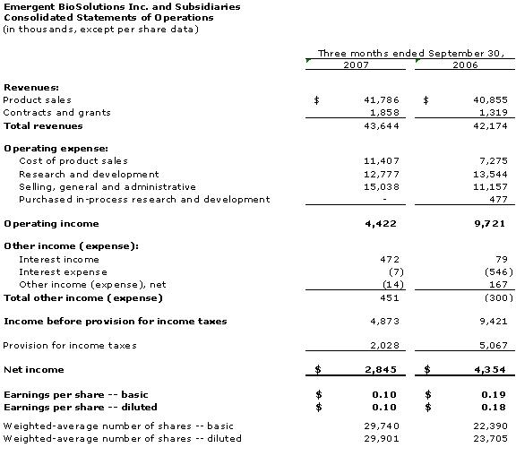

5

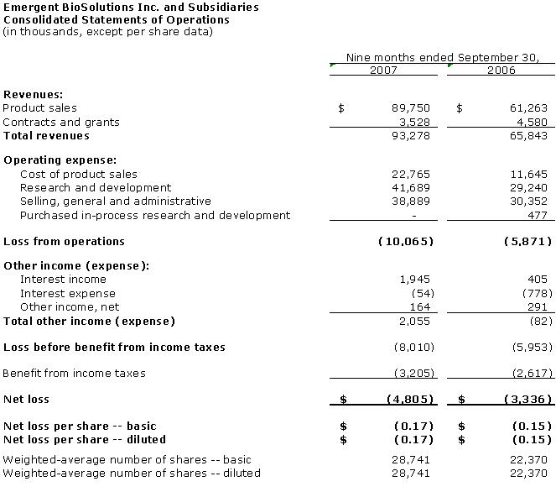

6

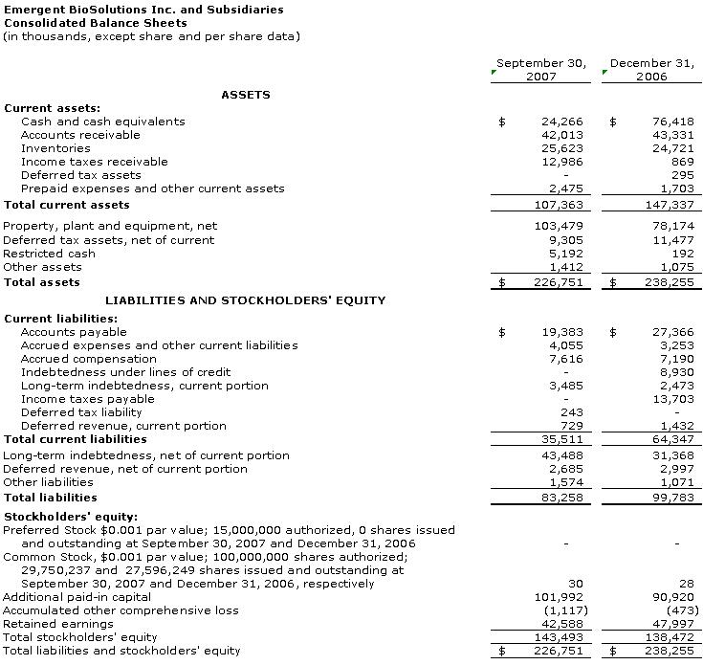

7

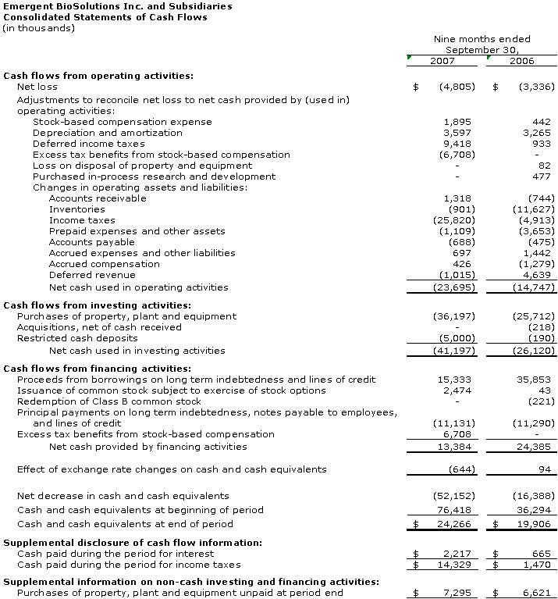

8

