UNITED STATES

SECURITIES AND EXCHANGE COMMISSION

WASHINGTON, D.C. 20549

____________________

FORM 8-K

CURRENT REPORT

Pursuant to Section 13 or 15(d) of the

Securities Exchange Act of 1934

Date of report (Date of earliest event reported): August 7, 2008

Emergent BioSolutions Inc.

(Exact Name of Registrant as Specified in Charter)

Delaware | 001-33137 | 14-1902018
(State or Other Jurisdiction | (Commission | (IRS Employer
of Incorporation) | File Number) | Identification No.)
2273 Research Boulevard, Suite 400, Rockville, Maryland |  | 20850
(Address of Principal Executive Offices) |  | (Zip Code)
Registrant’s telephone number, including area code: (301) 795-1800
 | Not applicable
(Former Name or Former Address, if Changed Since Last Report)

Check the appropriate box below if the Form 8-K filing is intended to simultaneously satisfy the filing obligation of the registrant under any of the following provisions (see General Instruction A.2. below):

o Written communications pursuant to Rule 425 under the Securities Act (17 CFR 230.425)

o Soliciting material pursuant to Rule 14a-12 under the Exchange Act (17 CFR 240.14a-12)

o Pre-commencement communications pursuant to Rule 14d-2(b) under the Exchange Act (17 CFR 240.14d-2(b))

o Pre-commencement communications pursuant to Rule 13e-4(c) under the Exchange Act (17 CFR 240.13e-4(c))

Item 2.02. Results of Operations and Financial Condition.

On August 7, 2008, Emergent BioSolutions Inc. (the “Company”) announced financial and operating results for the period ended June 30, 2008. The full text of the press release issued in connection with the announcement is attached as Exhibit 99.1 to this Current Report on Form 8-K.

The information in Item 2.02 of this Form 8-K, including Exhibit 99.1 hereto, shall not be deemed “filed” for purposes of Section 18 of the Securities Exchange Act of 1934, as amended (the “Exchange Act”), or otherwise subject to the liabilities of that section, nor shall it be deemed incorporated by reference in any filing under the Securities Act of 1933, as amended, or the Exchange Act, except as expressly set forth by specific reference in such a filing.

Item 9.01. Financial Statements and Exhibits.

- Exhibits.

See Exhibit Index attached hereto.

1

SIGNATURE

Pursuant to the requirements of the Securities Exchange Act of 1934, the registrant has duly caused this report to be signed on its behalf by the undersigned hereunto duly authorized.

Date: August 8, 2008 | EMERGENT BIOSOLUTIONS INC.
 | By: /s/ R. Don Elsey_____________
 |  | R. Don Elsey
 |  | Senior Vice President Finance, Chief
 |  | Financial Officer and Treasurer

 |  | EXHIBIT INDEX
Exhibit No. |  | Description
99.1 |  | Press release dated August 7, 2008



FOR IMMEDIATE RELEASE

Investors Contact:

Robert G. Burrows

Vice President, Investor Relations

301-795-1877

BurrowsR@ebsi.com

Media Contact:

Tracey Schmitt

Director, Corporate Communications

301-795-1800

SchmittT@ebsi.com

EMERGENT BIOSOLUTIONS REPORTS FINANCIAL RESULTS FOR SECOND QUARTER 2008

- Continued delivery of BioThrax® doses under current HHS contract drives 88 percent increase in Q2 2008 revenue over Q2 2007

- Recent acquisitions expand anthrax franchise

- Financial outlook for 2008 is reaffirmed

ROCKVILLE, MD., August 07, 2008—Emergent BioSolutions Inc. (NYSE: EBS) announced today its financial results for the second quarter ended June 30, 2008.

Total revenues for the second quarter of 2008 grew 88 percent to $43.5 million from $23.2 million in 2007, primarily driven by growth in sales of BioThrax® (Anthrax Vaccine Adsorbed). Net income for the second quarter of 2008 was $1.8 million, or $0.06 per share, in comparison to a net loss of $5.0 million, or $0.17 per share, for the comparable period in 2007.

R. Don Elsey, Emergent BioSolutions’ chief financial officer, said, “Our financial performance for the second quarter and first half of 2008 reflects significant progress toward attaining our financial goals for the year. We continue to deliver doses of BioThrax for inclusion in the SNS pursuant to our current multi-year contract with the U.S. Government. Not only are we expanding our internal manufacturing and product development infrastructure, we are investing in strategic acquisitions and partnerships that serve to further bolster our product pipeline. Our acquisition of both a human monoclonal antibody as a therapeutic for anthrax infection and an advanced recombinant protective antigen anthrax vaccine during the first half of this year strengthens our anthrax franchise and enables us to offer solutions to the three phases of anthrax infection.”

Mr. Elsey continued, “With respect to our proposed acquisition of the assets of Protein Sciences, bringing the transaction to closure is taking longer than expected. FluBlok® would be a good opportunity for us to leverage our core expertise in product development, manufacturing and government contracting in pursuit of creating value for our pipeline. We continue to be committed to working toward achieving a positive resolution in the near term. One possible solution may be to restructure the transaction as a merger and to offer additional up front consideration.”

Second Quarter 2008 Highlights

The company achieved the following during the second quarter of 2008:

- Acquired rPA 102, an advanced recombinant protective antigen anthrax vaccine candidate; 1

- Initiated a Phase IIb clinical trial in healthy patients in the U.S. using the company’s oral typhoid vaccine candidate; and
- Signed an asset purchase agreement to acquire Protein Sciences’ Phase III recombinant flu vaccine candidate, FluBlok®, and related novel platform technology.

Product Sales

For the second quarter of 2008, product sales increased by $19.8 million, or 88 percent, to $42.3 million from

$22.5 million for the comparable period of 2007, primarily due to a 98 percent increase in the number of doses of BioThrax delivered. Product sales for the second quarter of 2008 consisted of BioThrax sales to HHS of $41.9 million and aggregate international and other sales of $0.4 million.

For the six month period of 2008, product sales increased by $35.9 million, or 75 percent, to $83.8 million from

$48.0 million for the comparable period of 2007, primarily due to an 82 percent increase in the number of doses of BioThrax delivered. Product sales for the six month period of 2008 consisted of BioThrax sales to HHS of $83.1 million and aggregate international and other sales of $0.7 million.

Contracts and Grants Revenues

For the second quarter of 2008, contracts and grants revenues increased by $0.5 million, or 74 percent, to $1.2 million from $0.7 million for the comparable period of 2007. Contracts and grants revenues for the second quarter of 2008 consisted of $0.8 million from the Sanofi Pasteur collaboration related to recognition of deferred revenue associated with the upfront payment received in 2006 as well as development service revenue all in conjunction with the company’s meningitis B vaccine candidate, and $0.4 million from the National Institute of Allergy and Infectious Diseases (NIAID).

For the six month period of 2008, contracts and grants revenues increased by $0.7 million, or 42 percent, to $2.4 million from $1.7 million for the comparable period of 2007. Contracts and grants revenues for the six month period of 2008 consisted of $1.6 million in recognition of deferred revenue associated with the upfront payment received in 2006 as well as development service revenue from the Sanofi Pasteur collaboration, and $0.8 million from the NIAID.

Cost of Product Sales

For the second quarter of 2008, cost of product sales increased by $2.8 million, or 49 percent, to $8.7 million from $5.8 million for the comparable period of 2007. For the six month period of 2008, cost of product sales increased by $5.3 million, or 47 percent, to $16.7 million from $11.4 million for the comparable period in 2007. The increase for both the second quarter and six month period of 2008 was primarily due to a 98 percent and 82 percent increase, respectively, in the number of doses of BioThrax delivered, partially offset by decreased costs associated with improved production yield.

Research and Development

For the second quarter of 2008, research and development expenses increased by $3.9 million, or 29 percent, to $17.2 million from $13.3 million for the comparable period of 2007. This increase reflects higher contract service costs and asset and technology acquisition costs, and includes increased expenses of $2.6 million on product candidates that are categorized in the biodefense segment, $0.9 million on product candidates categorized in the commercial segment and $0.4 million in other research and development expenses, which are in support of technology platforms and central research and development activities.

For the six month period of 2008, research and development expenses decreased by $0.2 million, or 1 percent, to $28.7 million from $28.9 million for the comparable period of 2007. This decrease reflects lower contract service costs, and includes decreased expenses of $3.2 million on product candidates that are categorized in the biodefense segment, partially offset by increased expenses of $2.3 million

2

on product candidates categorized in the commercial segment and $0.7 million in other research and development expenses, which are in support of technology platforms and central research and development activities.

Selling, General and Administrative

For the second quarter of 2008, selling, general and administrative expenses increased by $2.4 million, or 19 percent, to $15.0 million from $12.7 million for the comparable period of 2007. This increase is primarily attributable to an increase of approximately $2.1 million resulting from the addition of personnel and increased legal and other professional services related to the company’s headquarters and staff organization to support operations as a public company and the overall growth of the business, and an increase of $0.2 million in sales and marketing expenses related to the growth of staff and an increase in selling and marketing activities.

For the six month period of 2008, selling, general and administrative expenses increased by $3.2 million, or 14 percent, to $27.1 million from $23.9 million for the comparable period of 2007. This increase is primarily attributable to an increase of approximately $2.8 million resulting from the addition of personnel and increased legal and other professional services related to the company’s headquarters and staff organization to support operations as a public company and the overall growth of the business, and an increase of $0.4 million in sales and marketing expenses related to the growth of staff and an increase in selling and marketing activities.

Financial Condition and Liquidity

Cash and cash equivalents at June 30, 2008 was $84.0 million compared to $105.7 million at December 31, 2007 and $92.7 million at March 31, 2008. The net decrease in cash and cash equivalents resulted primarily from net cash used in operating activities and investing activities of $0.7 million and $22.5 million, respectively, offset by net cash provided by financing activities of $1.6 million.

Financial Outlook for 2008

For 2008, the company reaffirms its expectations for full year total revenues of $180 to $195 million, but with a revised bias toward the lower end of the range. The company also reaffirms net income of approximately $20 million.

Conference Call & Webcast

Company management will host a conference call at 9:00 am Eastern on August 7, 2008 to discuss these financial results, recent business developments and the outlook for 2008. The conference call, which will be open to all interested parties, will be webcast and can be accessed from the Investor Relations section of the Company’s website at www.emergentbiosolutions.com, under “Investors”. Participants can also access the call by dialing 888.680.0892 or 617.213.4858 (international) and providing passcode 19956266.

Emergent BioSolutions is offering call participants a pre-registration option that expedites access to the call and minimizes hold times. Pre-registrants will be issued a pin number to be used when dialing into the live call which will provide quick access to the conference call by bypassing the operator upon connection. Pre-registration is not mandatory. To take advantage of pre-registration, proceed to the following website: https://www.theconferencingservice.com/prereg/key.process?key=PF9C6EMLD.

A replay of the conference call will be available approximately one hour following the conclusion of the call through August 21, by dialing 888/286-8010 or 617/801-6888 and passcode 58119499. The webcast will be archived on the company’s website, www.emergentbiosolutions.com, under “Investors”.

About Emergent BioSolutions Inc.

3

Emergent BioSolutions Inc. is a leading biopharmaceutical company dedicated to one simple mission—to protect life. Emergent develops, manufactures and commercializes vaccines and biotherapeutics that assist the body’s immune system to prevent or treat disease. Emergent’s products target infectious diseases and other medical conditions that have resulted in significant unmet or underserved public health needs. The company’s marketed product, BioThrax® (Anthrax Vaccine Adsorbed), is the only vaccine approved by the U.S. Food and Drug Administration for the prevention of anthrax infection. www.emergentbiosolutions.com.

Safe Harbor Statement

This press release includes forward-looking statements within the meaning of the Private Securities Litigation Reform Act of 1995. Any statements, other than statements of historical fact, including statements regarding our strategy, future operations, future financial position, future revenues, projected costs, prospects, plans and objectives of management, including our expected revenue growth and net earnings for 2008, and any other statements containing the words “believes”, “expects”, “anticipates”, “plans”, “estimates” and similar expressions, are forward-looking statements. There are a number of important factors that could cause the company's actual results to differ materially from those indicated by such forward-looking statements, including our ability to obtain new BioThrax® sales contracts with the U.S. government; our plans for future sales of BioThrax; our plans to pursue label expansions and improvements for BioThrax; our plans to expand our manufacturing facilities and capabilities; the rate and degree of market acceptance and clinical utility of our products; our ongoing and planned development programs, preclinical studies and clinical trials; our ability to identify and acquire or in license products and product candidates that satisfy our selection criteria; the potential benefits of our existing collaboration agreements and our ability to enter into selective additional collaboration arrangements; the timing of and our ability to obtain and maintain regulatory approvals for our product candidates; our commercialization, marketing and manufacturing capabilities and strategy; our intellectual property portfolio; our estimates regarding expenses, future revenue, capital requirements and needs for additional financing; and other factors identified in the company’s current report on Form 10-Q for the quarter ended March 31, 2008 and subsequent reports filed with the SEC. The company disclaims any intention or obligation to update any forward-looking statements as a result of developments occurring after the date of this press release.

Financial Statements Follow

4

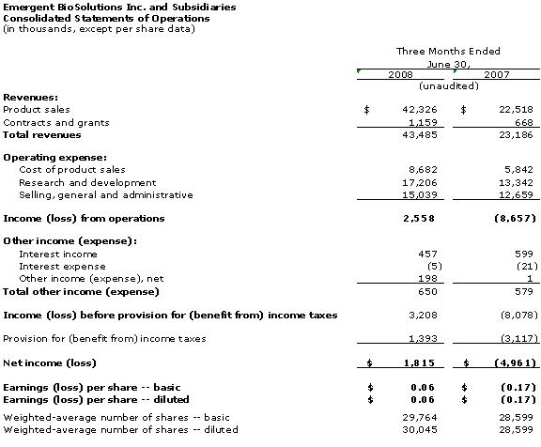

5

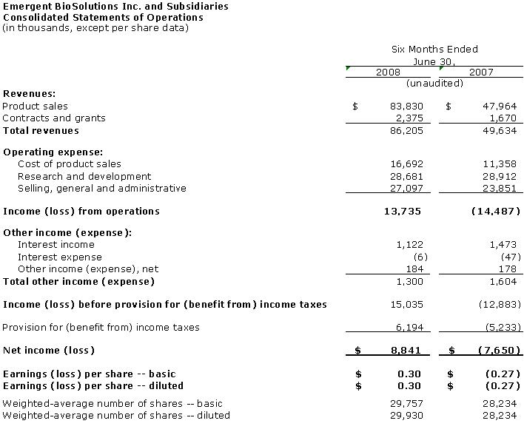

6

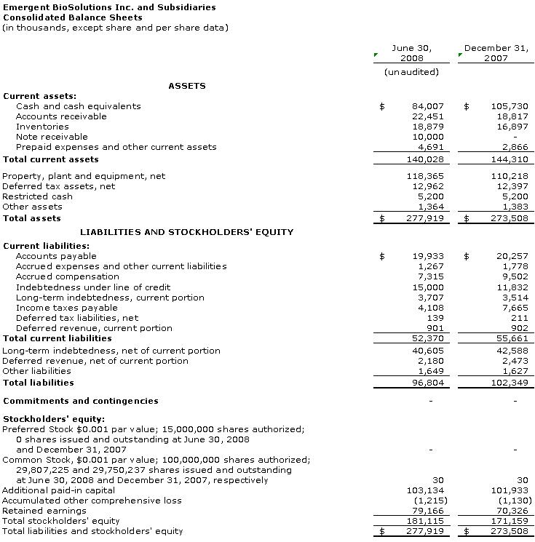

7

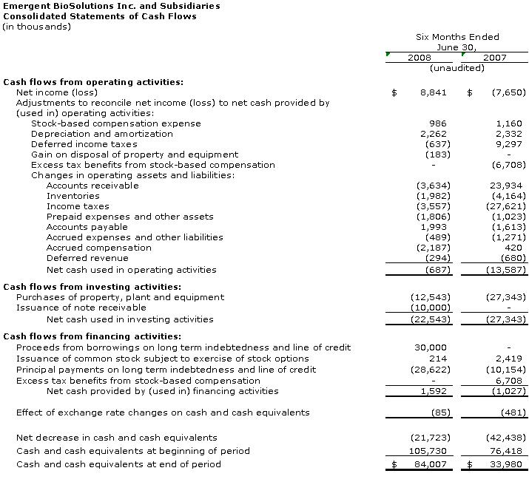

8

