UNITED STATES

SECURITIES AND EXCHANGE COMMISSION

WASHINGTON, D.C. 20549

____________________

FORM 8-K

CURRENT REPORT

Pursuant to Section 13 or 15(d) of the

Securities Exchange Act of 1934

Date of report (Date of earliest event reported): May 9, 2007

Emergent BioSolutions Inc.

(Exact Name of Registrant as Specified in Charter)

Delaware | 001-33137 | 14-1902018
(State or Other Jurisdiction | (Commission | (IRS Employer
of Incorporation) | File Number) | Identification No.)
2273 Research Boulevard, Suite 400, Rockville, Maryland |  | 20850
(Address of Principal Executive Offices) |  | (Zip Code)
 | (301) 795-1800
 | Registrant’s telephone number, including area code

Not applicable

(Former Name or Former Address, if Changed Since Last Report)

Check the appropriate box below if the Form 8-K filing is intended to simultaneously satisfy the filing obligation of the registrant under any of the following provisions (see General Instruction A.2. below):

o Written communications pursuant to Rule 425 under the Securities Act (17 CFR 230.425)

o Soliciting material pursuant to Rule 14a-12 under the Exchange Act (17 CFR 240.14a-12)

o Pre-commencement communications pursuant to Rule 14d-2(b) under the Exchange Act (17 CFR 240.14d-2(b))

o Pre-commencement communications pursuant to Rule 13e-4(c) under the Exchange Act (17 CFR 240.13e-4(c))

Item 2.02. Results of Operations and Financial Condition.

On May 9, 2007, Emergent BioSolutions Inc. (the “Company”) reported financial results for the three months ended March 31, 2007. The full text of the press release issued in connection with the announcement is attached as Exhibit 99.1 to this Current Report on Form 8-K.

The information in Item 2.02 of this Form 8-K, including Exhibit 99.1 hereto, shall not be deemed “filed” for purposes of Section 18 of the Securities Exchange Act of 1934, as amended (the “Exchange Act”), or otherwise subject to the liabilities of that section, nor shall it be deemed incorporated by reference in any filing under the Securities Act of 1933, as amended, or the Exchange Act, except as expressly set forth by specific reference in such a filing.

Item 9.01. Financial Statements and Exhibits.

- Exhibits.

See Exhibit Index attached hereto.

1

SIGNATURE

Pursuant to the requirements of the Securities Exchange Act of 1934, the registrant has duly caused this report to be signed on its behalf by the undersigned hereunto duly authorized.

Date: May 10, 2007 | EMERGENT BIOSOLUTIONS INC.
 | By: /s/ R. Don Elsey_____________
 |  | R. Don Elsey
 |  | Vice President Finance, Chief
 |  | Financial Officer and Treasurer

EXHIBIT INDEX

 | Exhibit No. |  | Description
 | 99.1 |  | Press release dated May 9, 2007

EXHIBIT 99.1


FOR IMMEDIATE RELEASE

Investors/Media Contact:

Robert G. Burrows

Vice President, Corporate Communications

Emergent BioSolutions Inc.

301-795-1877

burrowsr@ebsi.com

EMERGENT BIOSOLUTIONS REPORTS FINANCIAL RESULTS FOR FIRST QUARTER 2007

Year over year total revenues grew by $14.2 million to $26.4 million

ROCKVILLE, MD, May 9, 2007—Emergent BioSolutions Inc. (NYSE: EBS) announced today that total revenues for the first quarter of 2007 grew by $14.2 million to $26.4 million from $12.2 million in the comparable period in 2006, driven primarily by a 125 percent increase in the number of doses of BioThrax® (Anthrax Vaccine Adsorbed) delivered during the quarter to the U.S. Department of Health and Human Services (HHS) for inclusion in the strategic national stockpile and to the U.S. Department of Defense (the DoD) for active immunization of military personnel.

The company also announced today that the net loss for the first quarter of 2007 was $2.7 million, or $0.10 per share, compared to a net loss of $4.6 million, or $0.21 per share, for the comparable period in 2006.

1Q 2007 Highlights

The company’s achievements during the first quarter of 2007 included:

- delivery of approximately 1.1 million doses of BioThrax, consisting of 905,000 doses delivered ahead of schedule to HHS for the strategic national stockpile and 150,000 doses delivered to the DoD;
- receipt of Fast Track designation by the U.S. Food and Drug Administration (FDA) for BioThrax as a post-exposure prophylaxis against anthrax infection;

- finalization of a license agreement with Coley Pharmaceutical Group for the use of Coley’s VaxImmuneTM vaccine adjuvant compound for use in Emergent BioSolutions’ development of new anthrax vaccines;

- filing of an Investigational New Drug Application (IND) with FDA for a Phase I clinical trial to evaluate the safety and pharmacokinetics of the company’s anthrax immune globulin clinical candidate (Note: The animal efficacy studies, together with this Phase I safety and pharmacokinetic clinical trial, are expected to be sufficient to gain FDA approval.); and

- initiation of a Phase II clinical trial in adolescents and children for the company’s typhoid vaccine candidate.

Product Sales

For the first quarter of 2007, product sales increased by $13.3 million to $25.4 million from $12.2 million in the comparable period in 2006, primarily due to a 125 percent increase in the number of doses of BioThrax delivered. Product sales for the first quarter of 2007 consisted of BioThrax sales to HHS of $21.7 million and sales to the DoD of $3.7 million.

1


Contracts and Grant Revenues

For the first quarter of 2007, contracts and grant revenues increased by $975,000 to $1.0 million from $27,000 in the comparable period in 2006. Contracts and grant revenues for the first quarter of 2007 consisted of $1.0 million in amortization of the upfront payment received in 2006 and development program revenue from the Sanofi Pasteur collaboration relating to the company’s meningitis B vaccine candidate.

Cost of Product Sales

For the first quarter of 2007, cost of product sales increased by $2.7 million to $5.5 million from $2.9 million for the comparable period in 2006. This increase was attributable to the increase in the number of BioThrax doses delivered, partially offset by improved utilization of existing manufacturing capacity for BioThrax. The increase in the number of doses delivered resulted in an increase in costs of approximately $3.1 million. Manufacturing efficiencies resulted in a cost savings of approximately $0.4 million.

Research and Development

For the first quarter of 2007, research and development expenses increased by $6.6 million to $15.6 million from $9.0 million for the comparable period in 2006. This increase primarily reflects increased expenses of $5.4 million in the biodefense segment, $0.9 million in the commercial segment and $0.3 million in other research and development expense. The increase in biodefense spending was attributable to increased efforts related to advancing various studies and trials on all biodefense programs. The increase in commercial spending primarily reflects additional personnel and contract service costs related to the clinical development of the company’s commercial product candidates.

Selling, General and Administrative

For the first quarter of 2007, selling, general and administrative expenses increased by $1.4 million to $11.2 million from $9.8 million for the comparable period in 2006. SG&A expenses related to the biodefense segment increased by $0.4 million to $8.9 million for the first quarter of 2007 from $8.4 million for the same period in 2006. SG&A expenses related to the commercial segment increased by $1.0 million to $2.3 million for the first quarter of 2007 from $1.3 million for the same period in 2006. The increase in both segments was primarily attributable to an increase in general and administrative expenses of approximately $1.2 million resulting from the addition of personnel related to the company’s transition to a publicly traded company and increased legal and other professional services for the company’s headquarters.

Taxes

For the first quarter of 2007, benefit from income taxes decreased by $2.6 million to $2.1 million from $4.7 million for the comparable period in 2006. The effective tax rate for the first quarter of 2007 was 44 percent, compared to an effective tax rate of 50 percent for the comparable period in 2006.

Financial Condition and Liquidity

Cash and cash equivalents at March 31, 2007 was $67.6 million versus $76.4 million at December 31, 2006. The net decrease in cash and cash equivalents resulted primarily from capital expenditures and cash used in operations, including research and development expenses, the payment of 2006 income taxes and the repayment of an existing revolving line of credit, offset by collection of accounts receivable related primarily to amounts due from HHS and the DoD that were billed in December 2006 and received in January 2007.

2

2007 Financial Expectations

For 2007, the company reaffirms its expectation for full year total revenue growth of 10 to 15 percent and continued full year positive net earnings.

About Emergent BioSolutions Inc.

Emergent BioSolutions Inc. is a biopharmaceutical company dedicated to one simple mission—to protect life. We develop, manufacture and commercialize immunobiotics, consisting of vaccines and therapeutics that assist the body’s immune system to prevent or treat disease. Our biodefense business focuses on immunobiotics for use against biological agents that are potential weapons of bioterrorism and biowarfare. Our marketed product, BioThrax® (Anthrax Vaccine Adsorbed), is the only vaccine approved by the U.S. Food and Drug Administration for the prevention of anthrax infection. Our commercial business focuses on immunobiotics for use against infectious diseases and other medical conditions that have resulted in significant unmet or underserved public health needs. More information on the company is available at www.emergentbiosolutions.com.

Safe Harbor Statement

This press release includes forward-looking statements within the meaning of the Private Securities Litigation Reform Act of 1995. Any statements, other than statements of historical fact, including statements regarding our strategy, future operations, future financial position, future revenues, projected costs, prospects, plans and objectives of management, including our expected revenue growth and net earnings for 2007, and any other statements containing the words “believes”, “expects”, “anticipates”, “plans”, “estimates” and similar expressions, are forward-looking statements. There are a number of important factors that could cause the company’s actual results to differ materially from those indicated by such forward-looking statements, including our performance under BioThrax® sales contracts with the U.S. government, including the timing of deliveries under these contracts; our ability to obtain new BioThrax sales contracts with the U.S. government; our plans for future sales of BioThrax; our plans to pursue label expansions and improvements for BioThrax; our plans to expand our manufacturing facilities and capabilities; the rate and degree of market acceptance and clinical utility of our products; our ongoing and planned development programs, preclinical studies and clinical trials; our ability to identify and acquire or in license products and product candidates that satisfy our selection criteria; the potential benefits of our existing collaboration agreements and our ability to enter into selective additional collaboration arrangements; the timing of and our ability to obtain and maintain regulatory approvals for our product candidates; our commercialization, marketing and manufacturing capabilities and strategy; our intellectual property portfolio; our estimates regarding expenses, future revenue, capital requirements and needs for additional financing; and other factors identified in the company’s Annual Report on Form 10-K for the year ended December 31, 2006 and subsequent reports filed with the SEC. The company disclaims any intention or obligation to update any forward-looking statements as a result of developments occurring after the date of this press release.

Financial Statements Follow

3

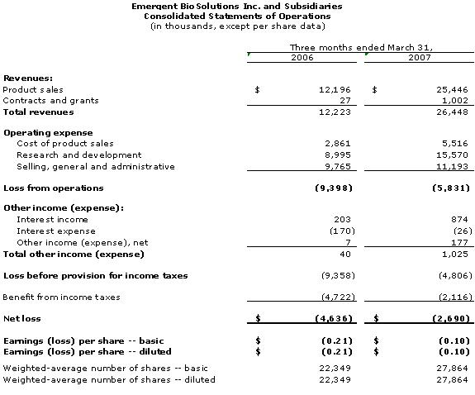

4

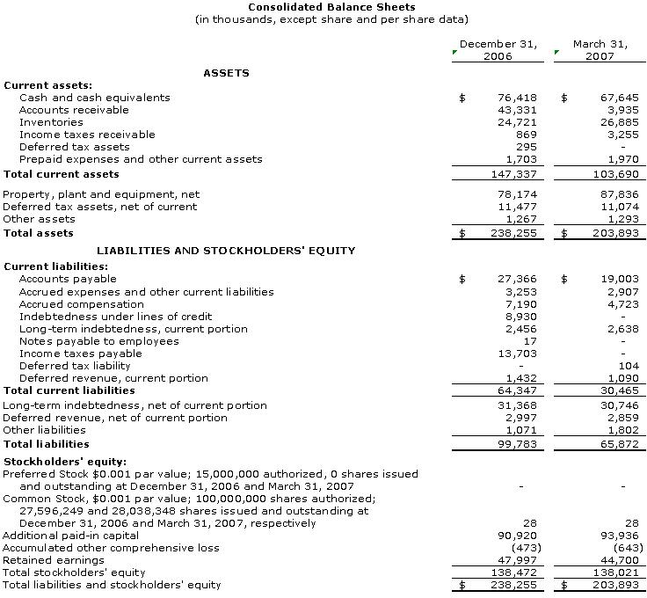

5

