UNITED STATES

SECURITIES AND EXCHANGE COMMISSION

WASHINGTON, D.C. 20549

FORM 8-K

CURRENT REPORT

Pursuant to Section 13 or 15(d) of the Securities Exchange Act of 1934

Date of Report (Date of earliest event reported): May 15, 2023

EMERGENT BIOSOLUTIONS INC.

(Exact name of registrant as specified in its charter)

Delaware | 001-33137 | 14-1902018
(State or other jurisdiction | (Commission File Number) | (IRS Employer
of incorporation) |  | Identification No.)

400 Professional Drive, Suite 400,

Gaithersburg, Maryland 20879

(Address of principal executive offices, including zip code)

(240) 631-3200

(Registrant’s telephone number, including area code)

N/A

(Former name or former address, if changed since last report)

Check the appropriate box below if the Form 8-K filing is intended to simultaneously satisfy the filing obligation of the registrant under any of the following provisions (see General Instruction A.2.

below):

- Written communications pursuant to Rule 425 under the Securities Act (17 CFR 230.425)

- Soliciting material pursuant to Rule 14a-12 under the Exchange Act (17 CFR 240.14a-12)

- Pre-commencement communications pursuant to Rule 14d-2(b) under the Exchange Act (17 CFR 240.14d-2(b))

- Pre-commencement communications pursuant to Rule 13e-4(c) under the Exchange Act (17 CFR 240.13e-4(c)) Securities registered pursuant to Section 12(b) of the Act:
Title of each class | Trading Symbol(s) | Name of each exchange on which registered
Common Stock, Par Value $0.001 per share | EBS | New York Stock Exchange

Indicate by check mark whether the registrant is an emerging growth company as defined in Rule 405 of the Securities Act of 1933 (§230.405 of this chapter) or Rule 12b-2 of the Securities Exchange Act of 1934 (§240.12b-2 of this chapter).

Emerging growth company ☐

If an emerging growth company, indicate by check mark if the registrant has elected not to use the extended transition period for complying with any new or revised financial accounting standards provided pursuant to Section 13(a) of the Exchange Act. ☐

Item 2.01 Completion of Acquisition or Disposition of Assets

On May 15, 2023, pursuant to the Purchase and Sale Agreement (the “Purchase and Sale Agreement”), by and between Emergent BioSolutions Inc., through its wholly owned subsidiaries Emergent International Inc. and Emergent Travel Health Inc. (collectively, “Emergent” or “Company”) and Bavarian Nordic (the “Buyer”), the Company completed the previously announced sale of the Company’s travel health business (the “Business”), including rights to Vivotif®, the licensed typhoid vaccine; Vaxchora®, the licensed cholera vaccine; the development-stage chikungunya vaccine candidate CHIKV VLP; the Company’s manufacturing site in Bern, Switzerland; and certain of its development facilities in San Diego, California.

At the closing, Buyer paid a cash purchase price of $270 million, exclusive of customary closing adjustments for cash, indebtedness, working capital and transaction expenses of the business at closing (the "Purchase Price"). Bavarian Nordic may also be required to pay milestone payments of up to $80 million related to the development of CHIKV VLP and receipt of marketing approval and authorization in the U.S. and Europe, and earn-out payments of up to $30 million based on aggregate net sales of Vaxchora and Vivotif in calendar year 2026.

The description of the Transaction does not purport to be complete and is qualified in its entirety by reference to the full text of the Purchase and Sale Agreement which was attached as Exhibit 10.204 to the Company's Annual Report on Form 10-K for the year ended December 31, 2022 filed on March 1, 2023, and is incorporated herein by reference as Exhibit 2.1. The Purchase and Sale Agreement is intended to provide investors with information regarding its material terms. It is not intended to provide any other financial information about the Company or its subsidiaries or affiliates. The representations, warranties, and covenants contained in the Purchase and Sale Agreement were made only for purposes of that agreement and as of specific dates, are solely for the benefit of the parties to the Purchase and Sale Agreement, may be subject to limitations agreed upon by the parties, including being qualified by confidential disclosures made for the purposes of allocating contractual risk between the parties to the Purchase and Sale Agreement instead of establishing these matters as facts, and may be subject to standards of materiality applicable to the parties that differ from those applicable to investors. Investors should not rely on the representations, warranties, or covenants or any description thereof as characterizations of the actual state of facts or condition of the entities being acquired or any of their subsidiaries or affiliates. Moreover, information concerning the subject matter of the representations, warranties, and covenants may have changed after the date of the Purchase and Sale Agreement.

Item 7.01 Regulation FD Disclosure.

On May 15, 2023, Emergent issued a press release announcing the closing of the Transaction, which is furnished as Exhibit 99.1 hereto.

The information contained in this Item 7.01 shall not be deemed "filed" for the purposes of Section 18 of the Securities Exchange Act of 1934, as amended (the "Exchange Act"), or incorporated by reference in any filing, under the Securities Act of 1933, as amended, or the Exchange Act, except as shall be expressly set forth by specific reference in such a filing.

Item 9.01 Financial Statements and Exhibits.

(b) Pro Forma Financial Information.

The following unaudited pro forma condensed consolidated financial information of Emergent BioSolutions Inc. in connection with the Transaction, including the notes thereto, is filed as Exhibit 99.2 hereto and incorporated herein by reference:

- Unaudited pro forma condensed consolidated balance sheet as of March 31,2023

- Unaudited pro forma condensed consolidated statements of operations for the three months ended March 31, 2023 and the year ended December 31, 2022

(d) Exhibits.
 | Exhibit No. |  |  |  | Description
 | 2.1*+ |  |  | Purchase and Sale Agreement, dated February 15, 2023 by and between Emergent BioSolutions Inc., through its wholly owned subsidiaries Emergent International Inc. and
 |  |  |  | Emergent Travel Health Inc. and Bavarian Nordic (incorporated by reference to Exhibit 10.204 of the Company’s Annual Report on Form 10-K for the year ended
 |  |  |  | December 31, 2022, filed on March 1, 2023).
99.1 |  |  |  | Press release, dated May 15, 2023.
99.2 |  |  |  | Unaudited pro forma condensed financial information of Emergent BioSolutions Inc.
104 |  |  |  | Cover Page Interactive Data File (embedded within the Inline XBRL document).

- Schedules and exhibits to the Purchase and Sale Agreement have been omitted pursuant to Item 601(a)(5) of Regulation S-K. A copy of any omitted schedule and/or exhibit will be furnished to the Securities and Exchange Commission upon request.

- Certain confidential portions of this exhibit were omitted by means of marking such portions with asterisks because the identified confidential portions (i) are not material and (ii) would be competitively harmful if publicly disclosed.

SIGNATURES

Pursuant to the requirements of the Securities Exchange Act of 1934, the registrant has duly caused this report to be signed on its behalf by the undersigned hereunto duly authorized.

EMERGENT BIOSOLUTIONS INC.

Dated: May 15, 2023 By: /s/ RICHARD S. LINDAHL
Name: Richard S. Lindahl
Title: Executive Vice President, Chief Financial
Officer and Treasurer

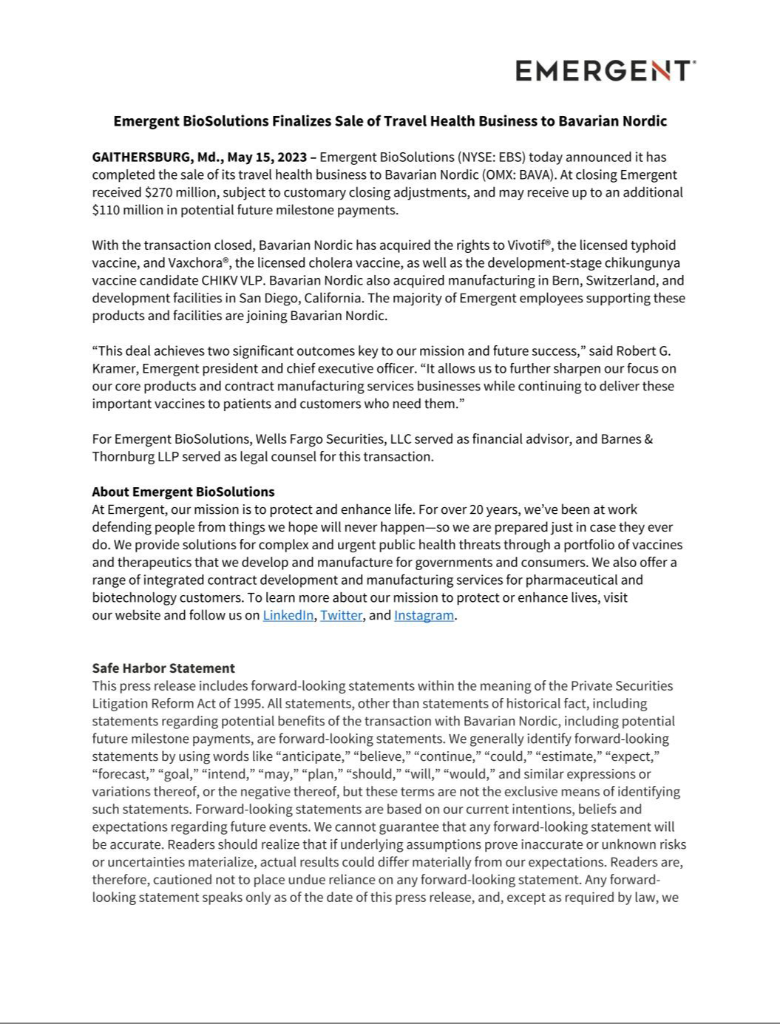

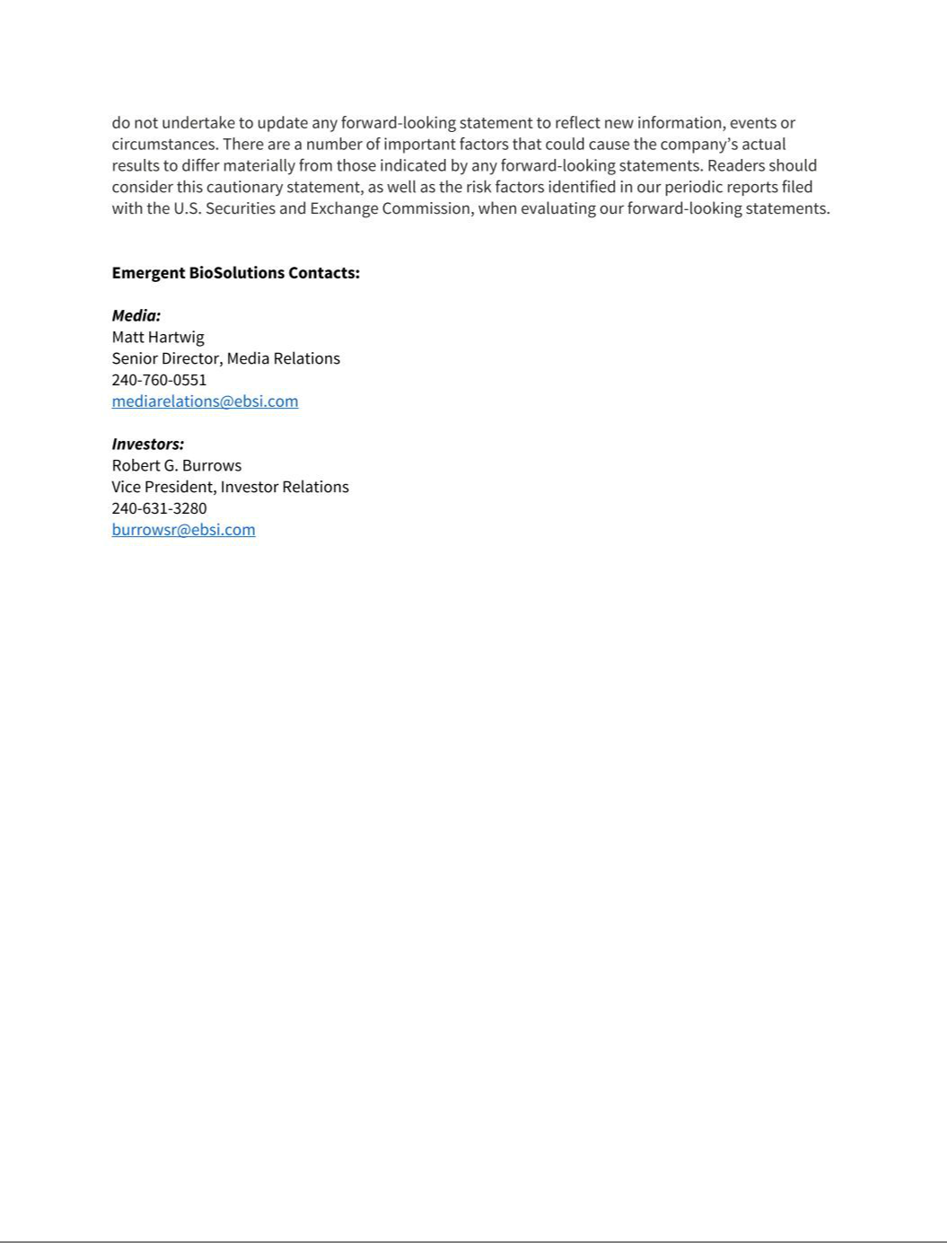

Emergent BioSolutions Inc. and Subsidiaries

Unaudited Pro Forma Condensed Consolidated Financial Information

On February 15, 2023, Emergent BioSolutions Inc. (“Emergent”), through its wholly owned subsidiaries Emergent International Inc. and Emergent Travel Health Inc. (collectively the “Company”) entered into a Purchase and Sale Agreement (the “Definitive Agreement”) with Bavarian Nordic (“Bavarian”) for the sale of the Company’s travel health business (the “Travel Health” or the “Business”), including rights to (i) Vivotif®, the licensed typhoid vaccine, (ii) Vaxchora®, the licensed cholera vaccine, (iii) the development-stage chikungunya vaccine candidate CHIKV VLP, and (iv) the Company’s manufacturing site in Bern, Switzerland and certain of its development facilities in San Diego, California — (collectively, the “Business Disposition”). Under the Definitive Agreement, Bavarian will pay a cash purchase price of $270.0 million at closing, subject to customary adjustments for cash, indebtedness, working capital and transaction expenses of the business at closing; Bavarian will also pay milestone payments of up to $80.0 million related to the development of CHIKV VLP and receipt of marketing approval and authorization in the US and Europe, as well as earnout payments of up to $30.0 million based on aggregate net sales of Vaxchora and Vivotif in calendar year 2026. On May 15, 2023, the Company successfully completed the Business Disposition and, after closing adjustments, received approximately $270.0 million in gross cash proceeds from Bavarian, subject to limited post-closing adjustments.

The following unaudited pro forma consolidated financial information is presented in accordance with the rules specified by Article 11 of Regulation S-X promulgated by the U.S. Securities and Exchange Commission (the “SEC”) and has been prepared subject to the assumptions and adjustments as described in the notes thereto. Specifically, the unaudited pro forma consolidated financial information set forth below reflects the effects of the Business Disposition on Emergent’s (i) Condensed Consolidated Balance Sheet as of March 31, 2023 as if the Business disposition had occurred on that date, and (ii) Condensed Consolidated Statement of Operations for the three months ended March 31, 2023 and year ended December 31, 2022, as if the Business Disposition had occurred on January 1, 2023 and January 1, 2022, respectively. Management believes that the assumptions used and adjustments made are reasonable under the circumstances and given the information available.

The following unaudited pro forma consolidated financial information is for illustrative and informational purposes only and is not necessarily indicative of the financial condition or results of operations of the Company that would have occurred if the Business Disposition had occurred on the dates indicated, nor is it indicative of the future financial condition or results of operations of the Company. The unaudited Pro Forma Consolidated Statements of Operations also do not reflect the gain from the Business Disposition, potential actions to reduce corporate overhead, potential tax or hedging strategies in the Business Disposition. In addition, the unaudited Pro Forma Consolidated Statements of Operations do not include any adjustments with respect to certain expenses recorded that were related to non-recurring events both related and unrelated to the Business Disposition.

The unaudited pro forma consolidated financial information should be read in conjunction with:

- The accompanying notes to the unaudited pro forma condensed consolidated financial statements;

- Emergent’s audited consolidated financial statements included in the Company’s Annual Report on Form 10-K for the year ended December 31, 2022;

- Emergent’s unaudited consolidated financial statements included in the Company’s Quarterly Report on Form 10-Q for the quarter ended March 31, 2023; and

- The risks described under "Cautionary Note Regarding Forward-Looking Statements" and under “Risk Factors” in the Company’s Annual Report on Form 10-K for the year ended December 31, 2022, and any updates to those risks or new risks contained in the Company’s subsequent Quarterly Reports on Form 10-Q and Current Reports on Form 8-K filed with the SEC.

Capitalized terms used and not defined in the Company’s unaudited Pro Forma Condensed Consolidated Balance Sheet as of March 31, 2023 and the accompanying notes thereto and in the Company’s unaudited Pro Forma Condensed Consolidated statement of operations for the three months ended March 31, 2023 and the accompanying notes thereto have the meanings ascribed to them in the Company’s Quarterly Report on Form 10-Q for the period ended March 31, 2023 filed with the SEC. Capitalized terms used and not defined in the Company’s unaudited pro forma condensed consolidated statement of operations for the year ended December 31, 2022 and the accompanying notes thereto have the meanings ascribed to them in the Company’s Annual Report on Form 10-K for the year ended December 31, 2022 filed with the SEC.

Pro Forma Condensed Consolidated Balance Sheet

As of March 31, 2023

(in millions, except per share data)

(unaudited)

 | Emergent BioSolutions Inc. |  |  | Travel Health Business |  |  |  | Emergent BioSolutions Inc.
 |  |  |  | Disposition Adjustments
 |  | Historical (A) |  | (B) | Pro Forma Adjustments |  |  |  | Pro Forma
ASSETS
Current assets:
Cash and cash equivalents | $ | 430.2 | $ | — $ |  | — |  | $ | 430.2
Accounts receivable, net |  | 155.9 |  | — |  | — |  |  | 155.9
Inventories, net |  | 367.9 |  | — |  | — |  |  | 367.9
Prepaid expenses and other current assets |  | 41.7 |  | — |  | — |  |  | 41.7
Assets held for sale |  | 225.6 |  | (225.6) |  | — |  |  | —
Total current assets |  | 1,221.3 |  | (225.6) |  | — |  |  | 995.7
Property, plant and equipment, net |  | 716.8 |  | — |  | — |  |  | 716.8
Intangible assets, net |  | 608.9 |  | — |  | — |  |  | 608.9
Goodwill |  | 218.2 |  | — |  | — |  |  | 218.2
Other assets |  | 184.6 |  | — |  | — |  |  | 184.6
Total assets | $ | 2,949.8 | $ | (225.6) | $ | — |  | $ | 2,724.2
LIABILITIES AND STOCKHOLDERS' EQUITY
Current liabilities:
Accounts payable | $ | 124.2 |  | — |  | — |  | $ | 124.2
Accrued expenses |  | 21.3 |  | — |  | — |  |  | 21.3
Accrued compensation |  | 56.8 |  | — |  | — |  |  | 56.8
Debt, current portion |  | 950.7 |  | — |  | (266.0) | C |  | 684.7
Other current liabilities |  | 25.2 |  | — |  | 16.0 | D |  | 41.2
Liabilities held for sale |  | 37.5 |  | (37.5) |  | — |  |  | —
Total current liabilities |  | 1,215.7 |  | (37.5) |  | (250.0) |  |  | 928.2
Debt, net of current portion |  | 447.7 |  | — |  | — |  |  | 447.7
Deferred tax liability |  | 59.7 |  | — |  | — |  |  | 59.7
Other liabilities |  | 24.1 |  | — |  | — |  |  | 24.1
Total liabilities |  | 1,747.2 |  | (37.5) |  | (250.0) |  |  | 1,459.7
Stockholders’ equity:
Preferred stock, $0.001 par value; 15.0 shares authorized, no shares |  | — |  | — |  | — |  |  | —
issued and outstanding |  | — |  | — |  | — |  |  | —
Common stock, $0.001 par value; 200.0 shares authorized, 56.0 shares |  | 0.1 |  | — |  | — |  |  | 0.1
issued; 50.4 shares outstanding, respectively. |  | 0.1 |  | — |  | — |  |  | 0.1
Treasury stock, at cost, 5.6 common shares, respectively |  | (227.7) |  | — |  | — |  |  | (227.7)
Additional paid-in capital |  | 878.2 |  | — |  | — |  |  | 878.2
Accumulated other comprehensive income (loss), net |  | 1.0 |  | — |  | — |  |  | 1.0
Retained earnings |  | 551.0 |  | (188.1) |  | 250.0 | D |  | 612.9
Total stockholders’ equity |  | 1,202.6 |  | (188.1) |  | 250.0 |  |  | 1,264.5
Total liabilities and stockholders’ equity | $ | 2,949.8 | $ | (225.6) | $ | — |  | $ | 2,724.2

The accompanying notes are an integral part of these unaudited pro forma consolidated financial statements.

Pro Forma Condensed Consolidated Statement of Operations

For the Three Months Ended March 31, 2023

(in millions, except per share data)

(unaudited)

 | Emergent BioSolutions Inc. |  |  | Travel Health Business |  |  |  | Emergent BioSolutions Inc.
 |  |  |  | Disposition Adjustments
 |  | Historical (A) |  | (B) |  | Pro Forma Adjustments |  |  | Pro Forma
Revenues:
Product sales, net | $ | 143.4 | $ | (5.8) | $ | — |  | $ | 137.6
CDMO:
Services |  | 13.4 |  | — |  | — |  |  | 13.4
Leases |  | 1.8 |  | — |  | — |  |  | 1.8
Total CDMO |  | 15.2 |  | — |  | — |  |  | 15.2
Contracts and grants |  | 6.5 |  | — |  | — |  |  | 6.5
Total revenues |  | 165.1 |  | (5.8) |  | — |  |  | 159.3
Operating expenses:
Cost of product sales |  | 102.9 |  | (6.7) |  | — |  |  | 96.2
Cost of CDMO |  | 52.2 |  | — |  | — |  |  | 52.2
Research and development |  | 40.6 |  | (19.2) |  | — |  |  | 21.4
Selling, general and administrative |  | 100.5 |  | (4.8) |  | 4.0 | E |  | 99.7
Amortization of intangible assets |  | 17.0 |  | (0.9) |  | — |  |  | 16.1
Total operating expenses |  | 313.2 |  | (31.6) |  | — |  |  | 281.6
Income (loss) from operations |  | (148.1) |  | 25.8 |  | (4.0) |  |  | (126.3)
Other income (expense):
Interest expense |  | (17.9) |  | — |  | 4.2 | F |  | (13.7)
Other, net |  | 4.9 |  | 1.0 |  | — |  |  | 5.9
Total other income (expense), net |  | (13.0) |  | 1.0 |  | 4.2 |  |  | (7.8)
Income (loss) before income taxes |  | (161.1) |  | 26.8 |  | 0.2 |  |  | (134.1)
Income tax provision |  | 21.9 |  | 19.9 |  | — | G |  | 41.8
Net income (loss) | $ | (183.0) | $ | 6.9 | $ | 0.2 |  | $ | (175.9)

Net income (loss) per common share
Basic | $ | (3.65)
Diluted | $ | (3.65)
Shares used in computing net income (loss) per common share
Basic |  | 50.2
Diluted |  | 50.2

The accompanying notes are an integral part of these unaudited pro forma consolidated financial statements.

- (3.50)

- (3.50)

50.2

50.2

Pro Forma Consolidated Statement of Operations

For the Year Ended December 31, 2022

(in millions, except per share data)

(unaudited)

 | Emergent BioSolutions Inc. |  |  | Travel Health Business |  |  |  | Emergent BioSolutions Inc.
 |  |  |  | Disposition Adjustments
 |  | Historical (A) |  | (B) |  | Pro Forma Adjustments |  |  | Pro Forma
Revenues:
Product sales, net | $ | 966.2 | $ | (13.0) | $ | — |  | $ | 953.2
CDMO:
Services |  | 108.4 |  | — |  | — |  |  | 108.4
Leases |  | 4.9 |  | — |  | — |  |  | 4.9
Total CDMO |  | 113.3 |  | — |  | — |  |  | 113.3
Contracts and grants |  | 41.4 |  | — |  | — |  |  | 41.4
Total revenues |  | 1,120.9 |  | (13.0) |  | — |  |  | 1,107.9
Operating expenses:
Cost of product sales |  | 424.1 |  | (18.8) |  | — |  |  | 405.3
Cost of CDMO |  | 269.6 |  | — |  | — |  |  | 269.6
Research and development |  | 193.0 |  | (94.7) |  | — |  |  | 98.3
Selling, general and administrative |  | 340.3 |  | (11.2) |  | 4.0 | E |  | 333.1
Goodwill impairment |  | 6.7 |  | — |  | — |  |  | 6.7
Amortization of intangible assets |  | 59.9 |  | (6.9) |  | — |  |  | 53.0
Total operating expenses |  | 1,293.6 |  | (131.6) |  | 4.0 |  |  | 1,166.0
Income (loss) from operations |  | (172.7) |  | 118.6 |  | (4.0) |  |  | (58.1)
Other income (expense):
Interest expense |  | (37.3) |  | — |  | 8.1 | F |  | (29.2)
Other, net |  | (11.7) |  | 0.2 |  | — |  |  | (11.5)
Total other income (expense), net |  | (49.0) |  | 0.2 |  | 8.1 |  |  | (40.7)
Income (loss) before income taxes |  | (221.7) |  | 118.8 |  | 4.1 |  |  | (98.8)
Income tax provision (benefit) |  | 2.1 |  | (5.4) |  | 0.9 | G |  | (2.4)
Net income (loss) | $ | (223.8) | $ | 124.2 | $ | 3.2 |  | $ | (96.4)

Net income (loss) per common share
Basic | $ | (4.47)
Diluted | $ | (4.47)
Shares used in computing net income (loss) per common share
Basic |  | 50.1
Diluted |  | 50.1

The accompanying notes are an integral part of these unaudited pro forma consolidated financial statements.

- (1.92)

- (1.92)

50.1

50.1

NOTES TO UNAUDITED PRO FORMA CONDENSED CONSOLIDATED FINANCIAL INFORMATION

(unaudited, dollar amounts in tables in millions)

Note 1. Basis of Presentation

The Company’s unaudited pro forma condensed consolidated financial information has been compiled from underlying financial statements prepared pursuant to the rules and regulations of the U.S. Securities and Exchange Commission (the “SEC”) and in conformity with accounting principles generally accepted in the United States of America (“U.S. GAAP”). They reflect the completed travel health business disposition, including the receipt of $270.0 million of cash consideration, adjusted for working capital and other certain closing adjustments. The unaudited pro forma condensed consolidated financial information should be read in conjunction with:

- The accompanying notes to the unaudited pro forma condensed consolidated financial statements;

- The Company’s unaudited condensed consolidated financial statements included in the Company’s Quarterly Report on Form 10-Q for the period ended March 31, 2023;

- The Company’s s audited consolidated financial statements included in the Company’s Annual Report on Form 10-K for the year ended December 31, 2022; and

- The risks described under "Cautionary Note Regarding Forward-Looking Statements" and under "Risk Factors" in the Company’s Annual Report on Form 10-K for the year ended December 31, 2022 and any updates to those risk or new risks contained in the Company’s subsequent Quarterly Reports on Form 10-Q and Current Reports on Form 8-K filed with the SEC.

These unaudited pro forma condensed consolidated financial statements do not purport to be indicative of the financial position or results of earnings of the Company as of such date or for such periods, nor are they necessarily indicative of future results.

Note 2. Pro Forma Adjustments

The following are notes to the unaudited pro forma financial information as of March 31, 2023 and December 31, 2022:

- Reflects amounts as originally reported by the Company in its Annual Report on Form 10-K for the year ended December 31, 2022 and the Quarterly Report on Form 10-Q for the quarter ended March 31, 2023.

- Represents the operations, assets, liabilities and equity of Travel Health included within the Company’s consolidated financial statements as well as the impact of the removal of the Travel Health business on the effective tax rate.

- Adjustment reflects the expected pay down of the Revolving Credit Facility with cash proceeds from the sale of the Travel Health business, net of estimated transaction costs:

Total proceeds from sale of Travel Health | $ | 270.0
Less: Transaction costs |  | (4.0)
Net proceeds used to pay down debt | $ | 266.0

The Company is entitled to contingent consideration from the sale tied to certain earn-out and milestone payments in future periods. The Company accounts for this contingent consideration using the loss recovery method and, as such, the $270.0 million of total proceeds excludes any potential contingent consideration.

NOTES TO UNAUDITED PRO FORMA CONDENSED CONSOLIDATED FINANCIAL INFORMATION

(unaudited, dollar amounts in tables in millions)

- Adjustment reflects the pro forma gain of $78.0 million ($62.0 million net of tax) arising from the transaction as if it had occurred as of March 31, 2023:

Gross proceeds from sale of Travel Health | $ |  | 270.0
Less: Carrying value of Travel Health |  |  | (188.1)
Less: Transaction costs |  |  | (4.0)
 | Pro forma gain before tax | $ | 78.0
Income tax provision |  |  | (16.0)
 | Pro forma net gain after tax | $ | 61.9

The amount of the actual gain and related tax effect will be calculated based on the net book value of the sold business as of the closing of the transaction and therefore, could differ from the current estimate. See footnote (G) regarding the basis for the income tax effect.

- Adjustment reflects $4.0 million of transaction expenses incurred related to the sale of Travel Health.

- Adjustment reflects the reduction of $8.1 million and $4.2 million of interest expense for the year ending December 31, 2022 and three months ending March 31, 2023, respectively, as a result of the expected pay down of the Revolving Credit Facility.

- Adjustment reflects the estimated income tax effect of the pro forma adjustments at the US statutory rate. Management believes the statutory rate is a reasonable basis to estimate the tax adjustments necessary for the pro forma. Management understands the effect rate may differ from estimates when producing actual operating results. Note that the tax effect of adjustments for the three months ended March 31, 2023 is inconsequential.

