SEC Form 3
FORM 3 | UNITED STATES SECURITIES AND EXCHANGE COMMISSION
 | Washington, D.C. 20549
 | Washington, D.C. 20549 |  | OMB APPROVAL
 | INITIAL STATEMENT OF BENEFICIAL OWNERSHIP OF SECURITIES
 | INITIAL STATEMENT OF BENEFICIAL OWNERSHIP OF SECURITIES |  | OMB Number: | 3235-0104
 |  |  | Estimated average burden
 | Filed pursuant to Section 16(a) of the Securities Exchange Act of 1934 |  | hours per response: | 0.5

or Section 30(h) of the Investment Company Act of 1940
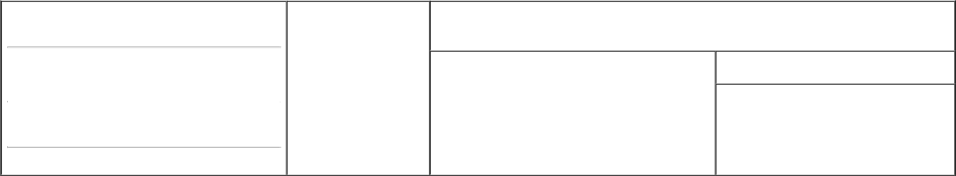

1. Name and Address of Reporting Person* | 2. Date of Event Requiring
Smith Karen L. | Statement (Month/Day/Year)
Smith Karen L. | 05/21/2020

3. Issuer Name and Ticker or Trading Symbol

Emergent BioSolutions Inc. [ EBS ]

 | (Last) | (First) | (Middle)
 | 400 PROFESSIONAL DRIVE, SUITE 400
(Street)
 | GAITHERSBURG, MD |  | 20879

- Relationship of Reporting Person(s) to Issuer (Check all applicable)

 | Director | 10% Owner
X | Officer (give title | Other (specify below)
X | below) | Other (specify below)

EVP, Chief Medical Officer

- If Amendment, Date of Original Filed (Month/Day/Year)

- Individual or Joint/Group Filing (Check Applicable Line) X Form filed by One Reporting Person

Form filed by More than One Reporting Person

(City) (State) (Zip)

Table I - Non-Derivative Securities Beneficially Owned

1. Title of Security (Instr. 4) | 2. Amount of Securities Beneficially | 3. Ownership Form: | 4. Nature of Indirect Beneficial Ownership (Instr. 5)
 | Owned (Instr. 4) | Direct (D) or Indirect
 |  | (I) (Instr. 5)

 | Common Stock |  |  |  | 6,310⁽¹⁾ | D
 |  |  | Table II - Derivative Securities Beneficially Owned
 |  | (e.g., puts, calls, warrants, options, convertible securities)
 | 1. Title of Derivative Security (Instr. 4) |  | 2. Date Exercisable and |  | 3. Title and Amount of Securities Underlying |  | 4. | 5. Ownership | 6. Nature of Indirect Beneficial
 |  |  | Expiration Date |  | Derivative Security (Instr. 4) |  | Conversion | Form: Direct | Ownership (Instr. 5)
 |  |  | (Month/Day/Year) |  |  |  | or Exercise | (D) or Indirect
 |  |  |  |  |  |  | Price of | (I) (Instr. 5)
 |  |  |  |  |  | Amount or | Price of | (I) (Instr. 5)
 |  |  |  |  |  | Amount or | Derivative
 |  |  | Date | Expiration | Title | Number of | Security
 |  |  | Exercisable | Date | Title | Shares
 | Employee Stock Options (Right to Buy) | (2) |  | 05/07/2027 | Common Stock | 12,619 | 79.25 | D
 | Explanation of Responses:


- Consists of 3,155 unvested PSUs and 3,155 unvested RSUs granted from the Emergent Stock Incentive Plan. Each RSU and each PSU represents a right to receive one share of common stock. The PSUs vest upon achievement with respect to adjusted EBITDA as a percentage of GAAP revenue on a cumulative basis over the three-year period beginning on January 1, 2020 and ending on December 31, 2022, as certified by the Compensation Committee following the performance period. The RSUs vest annually in three equal installments beginning on the day prior to the anniversary date of the grant, or 05/07/2020.

- Vests in three equal installments beginning on the day prior to the anniversary date of the grant, or 05/07/2020.

Remarks:

Exhibit list: Ex 24.1 - Power of Attorney

 | S. Scott Lieberman, Attorney-in-fact |  |  | 05/28/2020
 | ** Signature of Reporting Person |  | Date
Reminder: Report on a separate line for each class of securities beneficially owned directly or indirectly.
* If the form is filed by more than one reporting person, see Instruction 5 (b)(v).
** Intentional misstatements or omissions of facts constitute Federal Criminal Violations See 18 U.S.C. 1001 and 15 U.S.C. 78ff(a).
Note: File three copies of this Form, one of which must be manually signed. If space is insufficient, see Instruction 6 for procedure.
Persons who respond to the collection of information contained in this form are not required to respond unless the form displays a currently valid OMB Number.



