UNITED STATES

SECURITIES AND EXCHANGE COMMISSION

WASHINGTON, D.C. 20549

____________________

FORM 8-K

CURRENT REPORT

Pursuant to Section 13 or 15(d) of the

Securities Exchange Act of 1934

Date of report (Date of earliest event reported): March 21, 2007

Emergent BioSolutions Inc.

(Exact Name of Registrant as Specified in Charter)

Delaware | 001-33137 | 14-1902018
(State or Other Jurisdiction | (Commission | (IRS Employer
of Incorporation) | File Number) | Identification No.)
2273 Research Boulevard, Suite 400, Rockville, Maryland |  | 20850
(Address of Principal Executive Offices) |  | (Zip Code)

Registrant’s telephone number, including area code: (301) 795-1800

Not applicable

(Former Name or Former Address, if Changed Since Last Report)

Check the appropriate box below if the Form 8-K filing is intended to simultaneously satisfy the filing obligation of the registrant under any of the following provisions (see General Instruction A.2. below):

o Written communications pursuant to Rule 425 under the Securities Act (17 CFR 230.425)

o Soliciting material pursuant to Rule 14a-12 under the Exchange Act (17 CFR 240.14a-12)

o Pre-commencement communications pursuant to Rule 14d-2(b) under the Exchange Act (17 CFR 240.14d-2(b))

o Pre-commencement communications pursuant to Rule 13e-4(c) under the Exchange Act (17 CFR 240.13e-4(c))

Item 2.02. Results of Operations and Financial Condition.

On March 22, 2007, Emergent BioSolutions Inc. (the “Company”) announced financial and operating results for the year ended December 31, 2006. The full text of the press release issued in connection with the announcement is attached as Exhibit 99.1 to this Current Report on Form 8-K.

The information in Item 2.02 of this Form 8-K, including Exhibit 99.1 hereto, shall not be deemed “filed” for purposes of Section 18 of the Securities Exchange Act of 1934, as amended (the “Exchange Act”), or otherwise subject to the liabilities of that section, nor shall it be deemed incorporated by reference in any filing under the Securities Act of 1933, as amended, or the Exchange Act, except as expressly set forth by specific reference in such a filing.

Item 5.02. Departure of Directors or Certain Officers; Election of Directors; Appointment of Certain Officers; Compensatory Arrangements of Certain Officers.

On March 21, 2007, the Company’s board of directors appointed Daniel J. Abdun-Nabi to serve as president of the Company effective as of April 1, 2007. Mr. Abdun-Nabi, age 52, has served as senior vice president corporate affairs, general counsel and secretary of the Company since December 2004. Mr. Abdun-Nabi served as vice president and general counsel of the Company from May 2004 to December 2004. Mr. Abdun-Nabi will continue to serve as secretary of the Company.

Previously, Mr. Abdun-Nabi served as general counsel for IGEN International, Inc., a biotechnology company, and its successor BioVeris Corporation, from September 1999 to May 2004. Prior to joining IGEN, Mr. Abdun-Nabi served as senior vice president, legal affairs, general counsel and secretary of North American Vaccine, Inc. Mr. Abdun-Nabi received an L.L.M. in taxation from Georgetown University Law Center, a J.D. from the University of San Diego School of Law and a B.A. in political science from the University of Massachusetts, Amherst.

There are no family relationships between Mr. Abdun-Nabi and any executive officer or director of the Company.

Fuad El-Hibri, who has served as chief executive officer of the Company and chairman of the board of directors since June 2004 and as president of the Company since March 2006, will continue to serve as chief executive officer of the Company and chairman of the board of directors.

On March 21, 2007, Steven N. Chatfield, Ph.D., chief scientific officer of the Company and president of Emergent Product Development UK Limited, notified the Company of his decision to resign from his positions with the Company and Emergent Product Development UK Limited effective as of August 31, 2007. In connection with Dr. Chatfield’s departure, the Company’s Compensation Committee has provided for the acceleration of vesting of the entire unvested portion of an outstanding stock option held by Dr. Chatfield as of the date that is 15 calendar days prior to Dr. Chatfield’s departure date. This stock option, which was granted on February 9, 2005 for the purchase of 57,542 shares of common stock of the Company at a price per share of $2.74, has a vesting schedule that provided for vesting in three equal annual installments on December 31, 2005, 2006 and 2007. Accordingly, the vesting of 19,180 shares of common stock, which were scheduled to vest on December 31, 2007, will be accelerated such that the stock option will become immediately exercisable in full for all unvested shares as of August 16, 2007.

1

Item 9.01. Financial Statements and Exhibits.

- Exhibits.

See Exhibit Index attached hereto.

2

SIGNATURE

Pursuant to the requirements of the Securities Exchange Act of 1934, the registrant has duly caused this report to be signed on its behalf by the undersigned hereunto duly authorized.

Date: March 22, 2007 | EMERGENT BIOSOLUTIONS INC.
 | By: /s/ R. Don Elsey_____________
 |  | R. Don Elsey
 |  | Vice President Finance, Chief
 |  | Financial Officer and Treasurer

EXHIBIT INDEX

Exhibit No. |  | Description
99.1 |  | Press release dated March 22, 2007


FOR IMMEDIATE RELEASE

Investors/Media Contact:

Robert G. Burrows

Vice President, Corporate Communications

Emergent BioSolutions Inc.

301-795-1877

burrowsr@ebsi.com

EMERGENT BIOSOLUTIONS REPORTS FINANCIAL RESULTS FOR 2006

Total revenues grew 17 percent to approximately $153 million; fifth consecutive year of profitability

ROCKVILLE, MD, March 22, 2007—Emergent BioSolutions Inc. (NYSE: EBS) announced today that total revenues for 2006 grew 17 percent to $152.7 million from $130.7 million in 2005, driven by the delivery of over 6 million doses of BioThrax® (Anthrax Vaccine Adsorbed) during the year to the U.S. Department of Health and Human Services (HHS) for inclusion in the strategic national stockpile and to the U.S. Department of Defense (DoD) for use in DoD’s active immunization program.

The company also announced today that net income for 2006 was $22.8 million, or $0.99 per share, versus $15.8 million, or $0.77 per share for 2005.

“2006 was a record year for Emergent BioSolutions both in our total revenues and net income and represented our fifth consecutive year of profitability,” said Fuad El-Hibri, chairman and chief executive officer of Emergent BioSolutions. “During the year we also made significant progress in advancing our product development programs, in expanding our manufacturing capacity, and in establishing ourselves as a leader in the biodefense industry. Our mission of protecting lives through the development, manufacturing and commercialization of immunobiotics remains our guiding principle. We look forward to building upon these achievements in 2007.”

2006 Company Highlights

During 2006, the company’s performance was driven by key accomplishments in the areas of corporate and business development, manufacturing and product development, including the following:
- Completed an initial public offering raising approximately $58 million;

- Completed a contract modification with HHS for the delivery of an additional 5 million doses of BioThrax, with over 4 million doses delivered by December 2006;
- Signed a contract amendment with DoD for the delivery of approximately 1 million additional doses of BioThrax, with final delivery scheduled by September 2007;
- Finalized a license and development agreement with Sanofi Pasteur for the continued development of a meningitis B vaccine;

- Gained access to a MVA (modified vaccinia Ankara) technology platform through the acquisition of Vivacs GmbH;

- Received certification and designation of BioThrax as a qualified anti-terrorism technology by the Department of Homeland Security, the first vaccine to receive this recognition;
- Completed delivery of doses of BioThrax to HHS under the company’s initial 5 million dose contract ahead of schedule;

1

•

•

•

•

•

•

•

•

Completed the construction phase of the large-scale manufacturing facility in Lansing, Michigan;

Secured a development grant from the National Institute of Allergies and Infectious Diseases (NIAID) of up to $3.7 million to support the Anthrax Immune Globulin (AIG) program;
Manufactured the first consistency lot of the company’s AIG product candidate;

Completed a Phase I clinical trial for the company’s group B streptococcus vaccine candidate;

Signed a clinical trial agreement with NIAID to conduct the next Phase I trial for the company’s group B streptococcus vaccine candidate; Completed a Phase I clinical trial in adults for the company’s typhoid vaccine candidate;

Initiated a Phase II clinical trial in adolescents and children for the company’s typhoid vaccine candidate; and Initiated a Phase II clinical trial in chronic carriers for the company’s hepatitis B therapeutic vaccine candidate.

Product Sales

For 2006, product sales increased $20.7 million, or 16 percent, to $148.0 million from $127.3 million for 2005, primarily due to an 18 percent increase in the number of doses of BioThrax delivered. Product sales in 2006 consisted of BioThrax sales to HHS of $109.8 million, sales to DoD of $37.4 million and aggregate international and other sales of $0.8 million.

Contracts and Grants Revenue

For 2006, contracts and grants revenue increased by $1.3 million, or 39 percent, to $4.7 million in 2006 from $3.4 million in 2005. Contracts and grant revenues for 2006 consisted of $3.2 million in upfront and development program revenue from the Sanofi Pasteur collaboration and $1.5 million in grant revenue from the Wellcome Trust.

Cost of Product Sales

For 2006, cost of product sales decreased by $7.5 million, or 24 percent, to $24.1 million from $31.6 million for 2005. The decrease was attributable to improved utilization of existing manufacturing capacity for BioThrax, partially offset by an increase of BioThrax doses delivered. Manufacturing efficiencies resulted in a cost savings of approximately $13.1 million. The increase in the number of doses delivered resulted in an increase in costs of approximately $5.6 million.

Research and Development

For 2006, research and development expenses increased by $27.1 million to $45.5 million from $18.4 million for 2005. This increase reflects increased expenses of $11.9 million in the biodefense segment and $15.9 million in the commercial segment, offset by a reduction of $0.6 million in other research and development expense. The biodefense spending was attributable to increased efforts on all biodefense programs related to advancing various studies and trials. The commercial spending was attributable to increased efforts across all five products within the commercial portfolio. The decrease in other research and development expenses was primarily attributable to discontinuation of certain preclinical programs.

Selling, General and Administrative

For 2006, selling, general and administrative expenses increased by $1.8 million, or 4 percent, to $44.6 million from $42.8 million for 2005. SG&A expenses related to the biodefense segment decreased by $0.5 million to $35.0 million for 2006 from $35.5 million for 2005. SG&A expenses related to the commercial segment increased by $2.3 million, or 32 percent, to $9.6 million for 2006 from $7.3 million for 2005. The increase in the commercial segment was primarily attributable to an increase in selling, general and administrative expenses of $1.0 million resulting from the addition of personnel and increased legal and other professional services for the company’s headquarters, and an increase of $0.9 million related to the addition of personnel for the company’s commercial development subsidiary in the UK.

2

Taxes

For 2006, provision for income taxes increased by $9.9 million to $15.2 million from $5.3 million for 2005. The effective tax rate for 2006 was 40 percent, compared to an effective tax rate of 25 percent for 2005. The increase in the company’s effective annual tax rate resulted primarily from foreign and state net operating losses and an increase in permanent differences, including incentive stock options.

Financial Condition and Liquidity

Cash and cash equivalents at December 31, 2006 was $76.4 million versus $36.3 million at December 31, 2005. The net increase in cash and cash equivalents resulted primarily from the proceeds from the initial public offering and additions to indebtedness, partially offset by capital expenditures and cash used in operations, including research and development expenses.

Conference Call & Webcast

Company management will host a conference call at 10:00 am ET on March 22, 2007 to discuss these financial results. The dial in numbers will be: domestic

- 202-0886, international (617) 213-8841. To listen to a live webcast of the conference call, please go to the “Investors” link in the company website at www.emergentbiosolutions.com.

A replay of this call will be available from 12:00 pm ET on March 22, 2007 until close of business April 5, 2007 at the following numbers: domestic (888) 286-8010, international (617) 801-6888. The Passcode for access to the replays is 16852790. An archived webcast of the conference call will be available under the “Investors” section of the company’s website at www.emergentbiosolutions.com.

About Emergent BioSolutions Inc.

Emergent BioSolutions Inc. is a biopharmaceutical company focused on the development, manufacture and commercialization of immunobiotics, consisting of vaccines and therapeutics that induce or assist the body’s immune system to prevent or treat disease. The company’s biodefense business is focused on immunobiotics for use against biological agents that are potential weapons of bioterrorism. The company’s commercial business is focused on development, manufacture and commercialization of immunobiotics for use against infectious diseases. These immunobiotics are designed to address significant unmet or underserved public health needs. More information on the company is available at www.emergentbiosolutions.com.

Safe Harbor Statement

This press release includes forward-looking statements within the meaning of the Private Securities Litigation Reform Act of 1995. Any statements, other than statements of historical fact, our strategy, future operations, future financial position, future revenues, projected costs, prospects, plans and objectives of management and any other statements containing the words “believes”, “expects”, “anticipates”, “plans”, “estimates” and similar expressions are forward-looking statements. There are a number of important factors that could cause the company’s actual results to differ materially from those indicated by such forward-looking statements, including our performance under existing BioThrax® sales contracts with the U.S. government, including the timing of deliveries under these contracts; our ability to obtain new BioThrax sales contracts with the U.S. government; our plans for future sales of BioThrax; our plans to pursue label expansions and improvements for BioThrax; our plans to expand our manufacturing facilities and capabilities; the rate and degree of market acceptance and clinical utility of our products; our ongoing and planned development programs, preclinical studies and clinical trials; our ability to identify and acquire or in license products and product candidates that satisfy our selection criteria; the potential benefits of our existing collaboration agreements and our ability to enter into selective additional collaboration arrangements; the timing of and our ability to obtain and maintain regulatory approvals for our product candidates; our commercialization, marketing and manufacturing capabilities and strategy; our intellectual property portfolio; our estimates regarding expenses, future revenue, capital requirements and needs for

3

additional financing; and other factors identified in the company’s Registration Statement on Form S-1 and subsequent reports filed with the SEC. The company disclaims any intention or obligation to update any forward-looking statements as a result of developments occurring after the date of this press release.

Financial Statements Follow

4

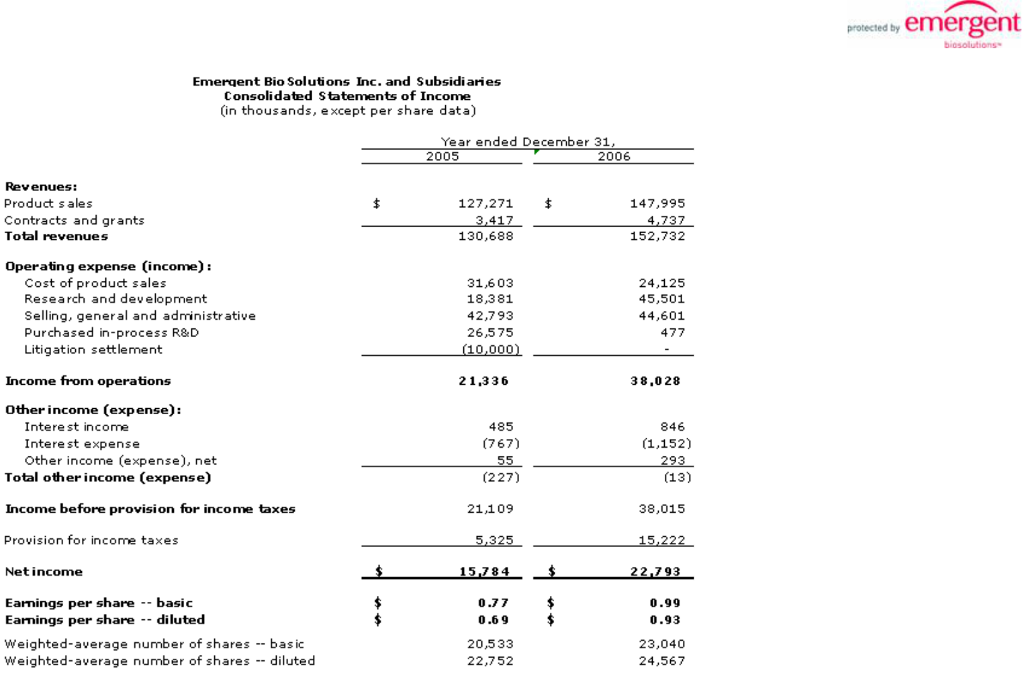

5

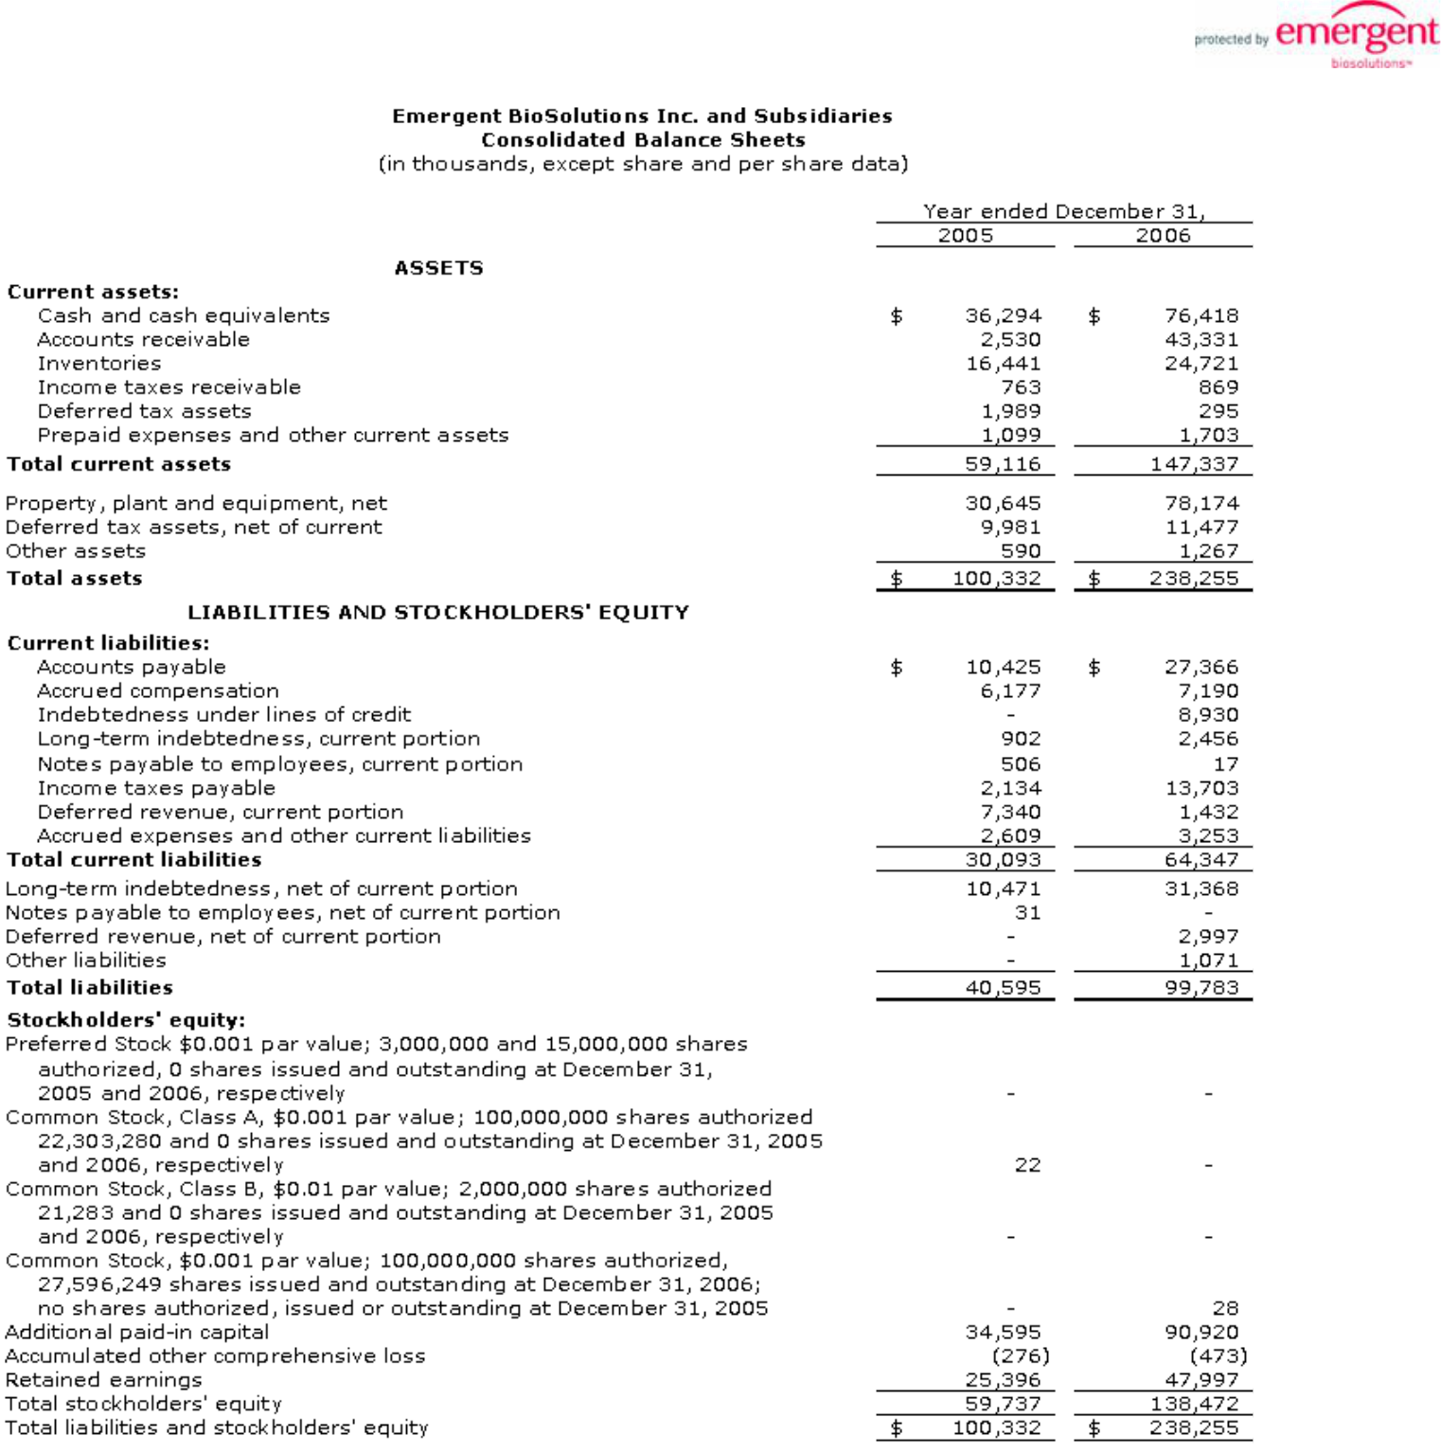

6

